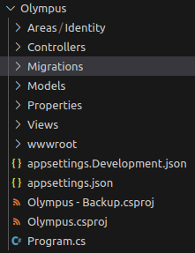
1. Screenshot from Visual Studio:

2. Creds:

VM pwd: ZX74waQU5GDxj%
Users:
- loganmiller216@cedarville.edu : Dog-h1t-wh0le-ba$h-trashcan (student)
- jgrady@cedarville.edu : Dell-b0mb-zootop!a (student)
- kaidendelsing@cedarville.edu : Hit-da-tr3nch3s-men! (student)
- profdude@cedarville.edu : Stupid-v0ting-machines! (faculty)
- dabigboss@cedarville.edu : W!sh-you-had-my-p0wers? (admin)

