We'll cover the following:
- System Requirements
- Use Case Diagram
- Class Diagram
- Activity Diagram
- Sequence Diagram
- Code
Amazon (amazon.com) is the world’s largest online retailer. The company was originally a bookseller but has expanded to sell a wide variety of consumer goods and digital media. For the sake of this problem, we will focus on their online retail business where users can sell/buy their products.

System Requirements
We will be designing a system with the following requirements:
- Users should be able to add new products to sell.
- Users should be able to search for products by their name or category.
- Users can search and view all the products, but they will have to become a registered member to buy a product.
- Users should be able to add/remove/modify product items in their shopping cart.
- Users can check out and buy items in the shopping cart.
- Users can rate and add a review for a product.
- The user should be able to specify a shipping address where their order will be delivered.
- Users can cancel an order if it has not shipped.
- Users should get notifications whenever there is a change in the order or shipping status.
- Users should be able to pay through credit cards or electronic bank transfer.
- Users should be able to track their shipment to see the current state of their order.

Use Case Diagram
We have four main Actors in our system:
- Admin: Mainly responsible for account management and adding or modifying new product categories.
- Guest: All guests can search the catalog, add/remove items to the shopping cart, as well as become registered members.
- Member: Members can perform all the activities that guests can, in addition to which, they can place orders and add new products to sell.
- System: Mainly responsible for sending notifications for orders and shipping updates.
Here are the top use cases of the Online Shopping System:
- Add/update products; whenever a product is added or modified, we will update the catalog.
- Search for products by their name or category.
- Add/remove product items in the shopping cart.
- Check-out to buy product items in the shopping cart.
- Make a payment to place an order.
- Add a new product category.
- Send notifications to members with shipment updates.
Here is the use case diagram of our Online Shopping System:

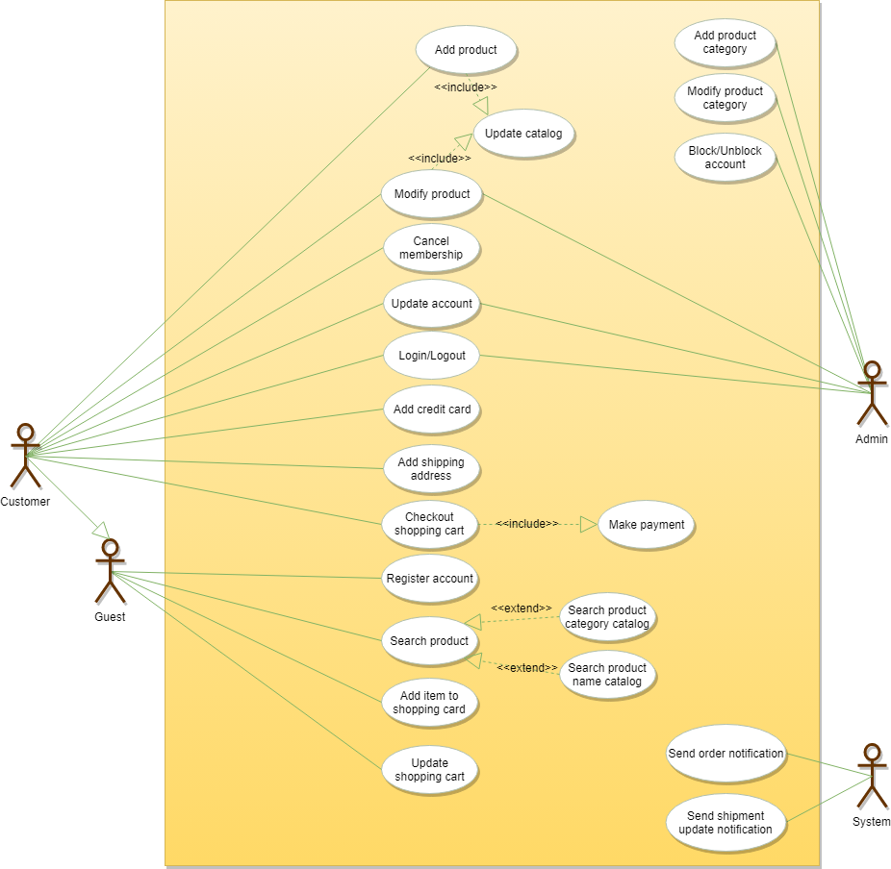

Class Diagram
Here are the descriptions of the different classes of our Online Shopping System:
- Account: There are two types of registered accounts in the system: one will be an Admin, who is responsible for adding new product categories and blocking/unblocking members; the other, a Member, who can buy/sell products.
- Guest: Guests can search for and view products, and add them in the shopping cart. To place an order they have to become a registered member.
- Catalog: Users of our system can search for products by their name or category. This class will keep an index of all products for faster search.
- ProductCategory: This will encapsulate the different categories of products, such as books, electronics, etc.
- Product: This class will encapsulate the entity that the users of our system will be buying and selling. Each Product will belong to a ProductCategory.
- ProductReview: Any registered member can add a review about a product.
- ShoppingCart: Users will add product items that they intend to buy to the shopping cart.
- Item: This class will encapsulate a product item that the users will be buying or placing in the shopping cart. For example, a pen could be a product and if there are 10 pens in the inventory, each of these 10 pens will be considered a product item.
- Order: This will encapsulate a buying order to buy everything in the shopping cart.
- OrderLog: Will keep a track of the status of orders, such as unshipped, pending, complete, canceled, etc.
- ShipmentLog: Will keep a track of the status of shipments, such as pending, shipped, delivered, etc.
- Notification: This class will take care of sending notifications to customers.
- Payment: This class will encapsulate the payment for an order. Members can pay through credit card or electronic bank transfer.
- 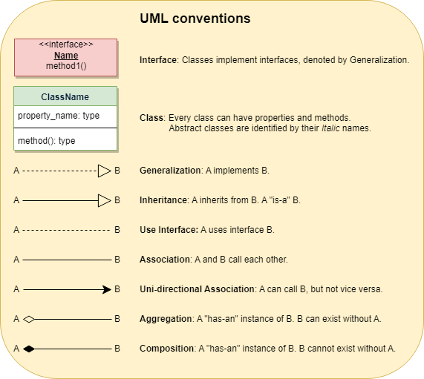
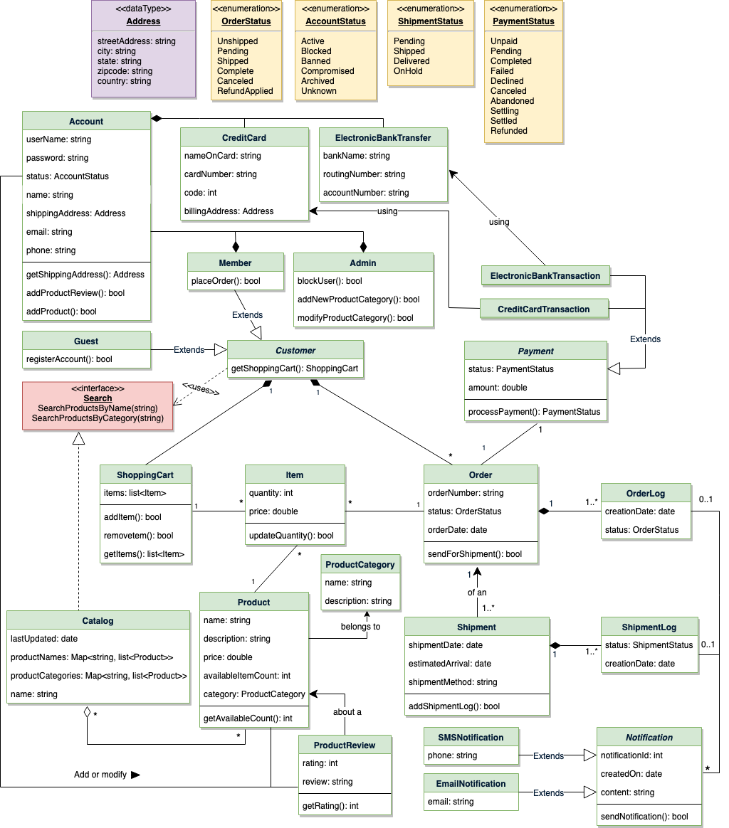

Activity Diagram
Following is the activity diagram for a user performing online shopping:

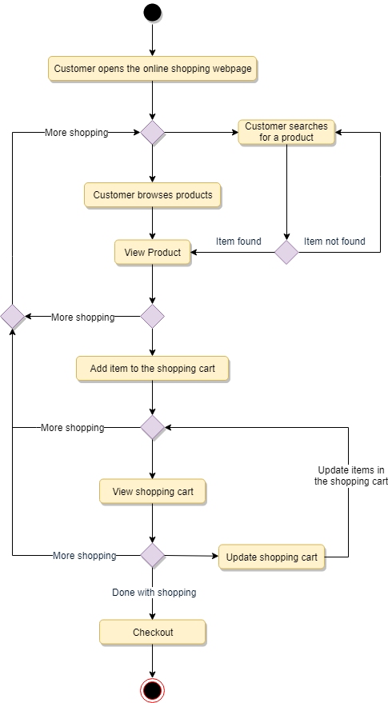

Sequence Diagram
- Here is the sequence diagram for searching from the catalog:
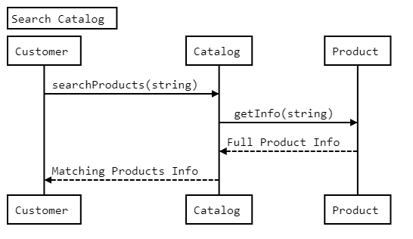

- Here is the sequence diagram for adding an item to the shopping cart:
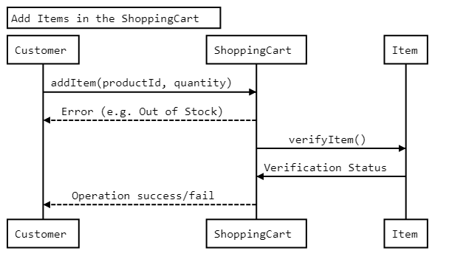

Here is the sequence diagram for checking out to place an order
