**BRONX LUGGAGE**

Bronx luggage has been in business for 27 years with over 60 years of experience. The owners and management of bronx luggage will match you with one of the many brands that will best fill your luggage needs.  We are an authorized briggs & riley repair center and the only authorized dealer in the festival marketplace.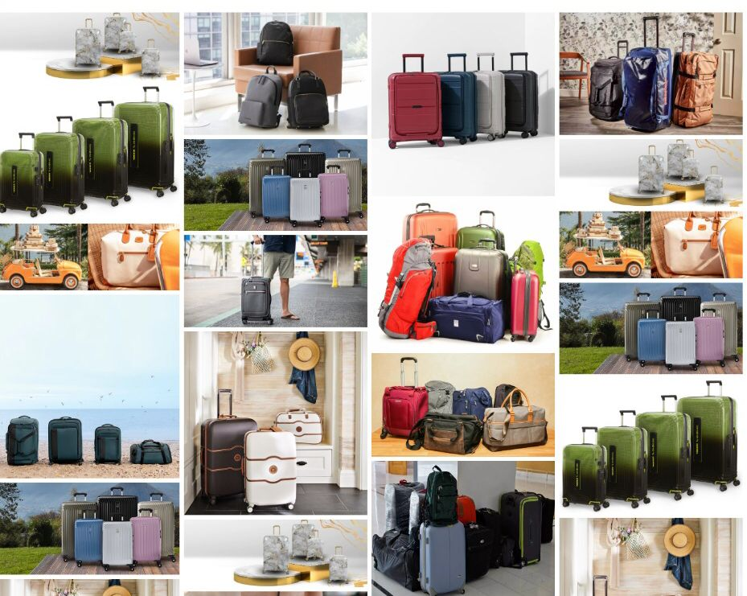

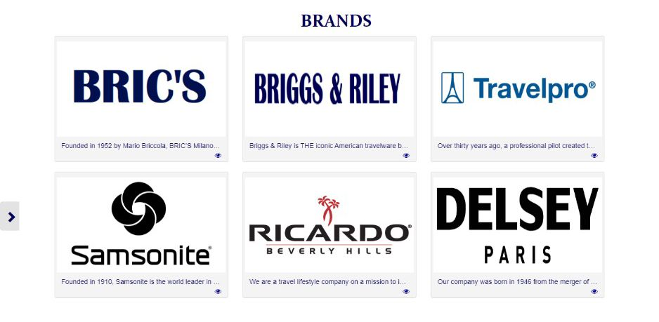Different brands with a lot of varieties

**Group Members**

* Raziuddin
* Abdul basit
* Bisma mukhtar
* Muhammad Hammad

**TABLE OF CONTENT**

**TABLE OF CONTENT**

Acknowledgment…………………………………..03

Certificate……………………………………...…….. 04

Introduction ……………………………………..….. 05

Objectives …………………………………...……….. 06

Problem Statement..………………………….... 07

Requirement Specifications. .………...……. 08

Task sheet………………………………………….... 09

**ACKNOWLEDGMENT**

**ACKNOWLEDGEMENT**

We are Thankful to ALMIGHTY ALLAH that by HIS Grace we have been successful. We are presenting our site (E-Projeect) **Bronx Luggage**. We have tried our best to take all relevant and necessary topics into our consideration so that this project may become comprehensive.

This is our First Year Semester E-Project. We have tried our level best & developed in Dreamweaver. We have been assigned to make a website namely **Bronx Luggage** our first semester E-Project. We tried to observe the coding and its outlook on Dreamweaver. We find it easy to utilize the editor.

We would like to thank **Sir Sohail Shah** for their guidance and for giving us time from their busy schedule.

We also express our sincere gratitude to E-Project team from Aptech Head Office, for their valuable guidance and support for the completion of this project. We earnestly hope that this project will provide all the necessary information required by the user to fulfill his/her inspiration. However, suggestion and feedbacks for improvements will be thankfully welcomed & acknowledged.

**THANK YOU!**

**Introduction**

The thirst for learning, upgrading technical skills and applying the concepts in real

life environment at a fast pace is what the industry demands from IT professionals

today. However busy work schedules, far-flung locations, unavailability of convenient

time-slots pose as major barriers when it comes to applying the concepts into

realism. And hence the need to look out for alternative means of implementation in

the form of laddered approach.

The above truly pose as constraints especially for our students too! With their busy

schedules, it is indeed difficult for our students to keep up with the genuine and

constant need for integrated application which can be seen live especially so in the

field of IT education where technology can change on the spur of a moment. Well,

technology does come to our rescue at such times!!

Keeping the above in mind and in tune with our constant endeavour to use

Technology in our training model, we at Aptech have thought of revolutionizing the

way our students learn and implement the concepts using tools themselves by

providing a live and synchronous eProject learning environment!

So what is this eProject?

eProject is a step-by-step learning environment that closely simulates the classroom

and Lab based learning environment into actual implementation. It is a project

implementation at your fingertips!! An electronic, live juncture on the machine that

allows you to

o Practice step by step i.e. laddered approach.

o Build a larger more robust application.

o Usage of certain utilities in applications designed by user.

o Single program to unified code leading to a complete application.

o Learn implementation of concepts in a phased manner.

o Enhance skills and add value.

o Work on real life projects.

o Give a real life scenario and help to create applications more complicated and

useful.

o Mentoring through email support.

The students at the centre are expected to complete this eProject and send complete

project along with the documentation to eProjects Team

Looking forward to a positive response from your end!!

**Objectives of the project**

The Objective of this program is to give a sample project to work on real life

projects. These applications help you build a larger more robust application.

The objective is not to teach you JSON/JavaScript/Dreamweaver/HTML5 but to

provide you with a real life scenario and help you create basic applications using the

tools.

You can revise the chapters before you start with the project.

This project is meant for students who have completed the module of HTML5. These

programs should be done in the Lab sessions with assistance of the faculty if

required.

It is very essential that a student has a clear understanding of the subject. Students

should go through the project and solve the assignments as per requirements given.

Kindly get back to eProjects Team in case of any doubts regarding the application or

its objectives.

**Problem Statement**

The beauty of receiving high quality luggage is a truly amazing feeling. Great luggage can

be passed down from family members who are experienced travelers. A high-quality set

of luggage will last a lifetime.

Bronx Luggage, located in the Festival Marketplace, offers a wide selection of luggage

from affordable sets to the best brands on the market for all of your travel needs. We

also stock Backpacks, travel accessories, briefcases and much more.

You are supposed to create a Single-Page-Application and responsive Website for

them with the below mentioned requirement specifications.

The website is to be developed for the Windows Platform using HTML5, JSON,

Angular JS, JavaScript and Geolocation. The site should work well in all leading

browsers including Chrome, IE and Firefox etc.

**Functional Requirement Specification:**

The portal will be designed as a Single-Page-Application and responsive Website with

a set of pages and menus that represent choice of activities to be performed. The

pages, menus, and other visual elements must be designed in a visually appealing

manner with attractive fonts, colors, and animations.

All of these should also be laid out in a responsive manner

The Web site is to be created based on the following requirements.

1) The Home Page should be created making use of Sections with a suitable

logo, the header section can be added which will show images of various

Luggage’s and Bags.

2) The site must contain the sections to navigate through various types of

Luggage, Bags and BackPacks etc.

3) Filter for various sizes, colour, price, brands should be provided.

4) Site should have different section for Men and Women with products placed

accordingly.

5) Specification and Pricing of Bags should be added along with the images.

6) Website should provide section for various brands offered in the store.

7) Ratings by the user for products should be allowed by the user.

8) Gallery section should be added for viewing different images.

9) Feedback must be allowed to enter by the viewer

10) Site map, Gallery, about us, Contact us link must be added.

11) About Us and Contact Us: This menu option should display Email id, address,

and contact number of the organization who is developing the system.

Over and above this, the portal should implement the following functionalities:

• Display a continuous scrolling ticker at the bottom of the page with current date,

time, and location (hint: Use geolocation features of HTML5).

• Display a visitor count at the top right corner of the page beside a logo image.

• The menu options should change color on hover and also after clicking.

• Fade in and fade out options can be used for the menus.

**Hardware/ Software Requirements**

Hardware

• Intel Core i3/i5 Processor or higher

• 8 GB RAM or above

• Color SVGA

• 500 GB Hard Disk space

• Mouse

• Keyboard

Software

Technologies to be used:

• Frontend: HTML5, CSS, Bootstrap, JavaScript, jQuery, AngularJS, XML

• Data Store: JSON files or TXT files

Other Requirements:

• Operating Portal: Windows

• Browsers: Edge, Chrome, Mozilla Firefox, Safari

|  |  |  |  |
| --- | --- | --- | --- |
| S.NO | TASKS | GROUP MEMBERS | STATUS |
| 1. | Project Leader | Raziuddin | DONE |
| 2. | Analysis | Basit, Hammad | DONE |
| 3. | Data Searching | Abdul Basit | DONE |
| 4. | Developed | Raziuddin | DONE |
| 5. | Designed | Bisma Mukhtar | DONE |
| 6. | Testing | Abdul Basit | DONE |
| 7. | Documentation | Bisma mukhtar | DONE |
| 8. | Presentation | Raziuddin | DONE |
| 9. | Final Testing | Hammad | DONE |
| 10. | Submission | Raziuddin, Basit, Bisma, Hammad | DONE |

**TASK SHEET**

**HOME PAGE**

A home page is the primary web page that a visitor will view when they navigate to a website via a search engine, and it may also function as a landing page to attract visitors. In some cases, the home page is a site directory, particularly when a website has multiple home pages.

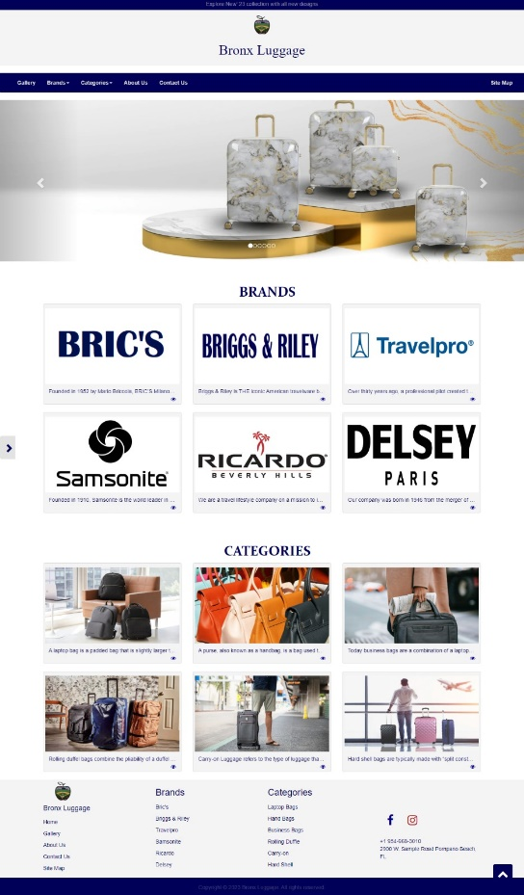

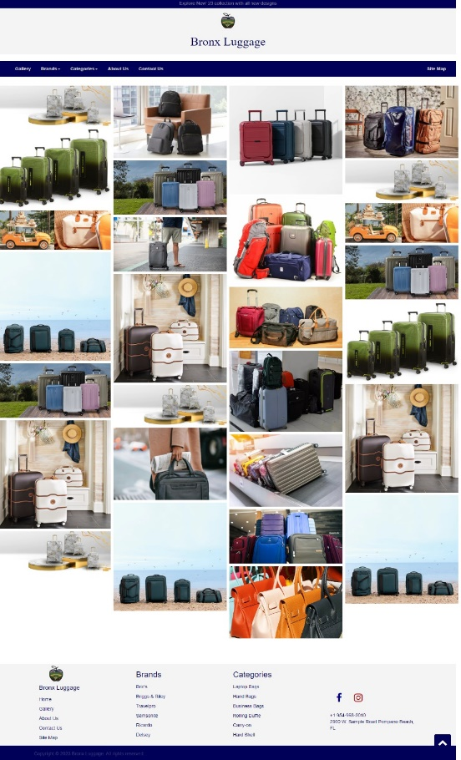

**GALLERY**

Gallery is a page which contain large numbers of media content almost always, images with little or no supporting text.



**Bronx Luggage**

 offers some very high quality

but affordable luggage collections including you best source in Broward for a wide range of luggage from Briggs and Riley, Travelpro, Samsonite, Ricardo Beverly Hills, Delsey Paris and many others.

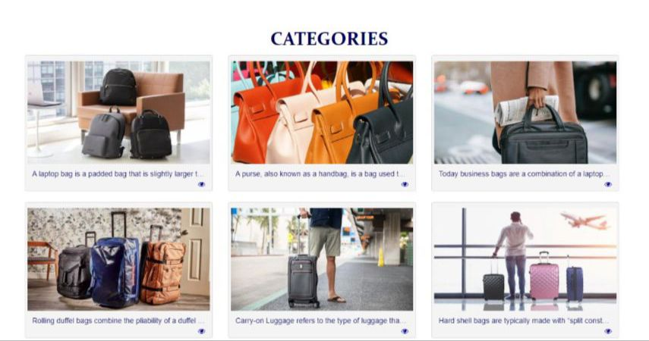

Our rolling suitcase, duffle bags are the ultimate duo for any traveler. Wherever Your Travels Take You, Our Gear Will Help You Get There.

**CONTACT US**

A Contact Us page is essential to building a brand's website as it allows visitors to contact you easily without leaving their browser. They also give you the opportunity to capture leads and improve customer service. Generally, visitors can also leave feedback or ask questions through these channels.

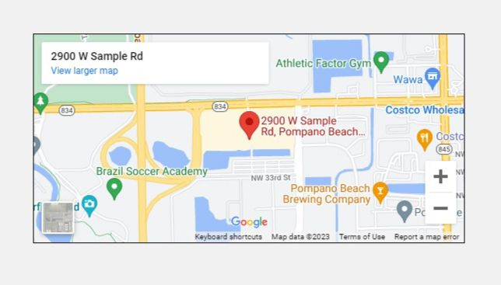

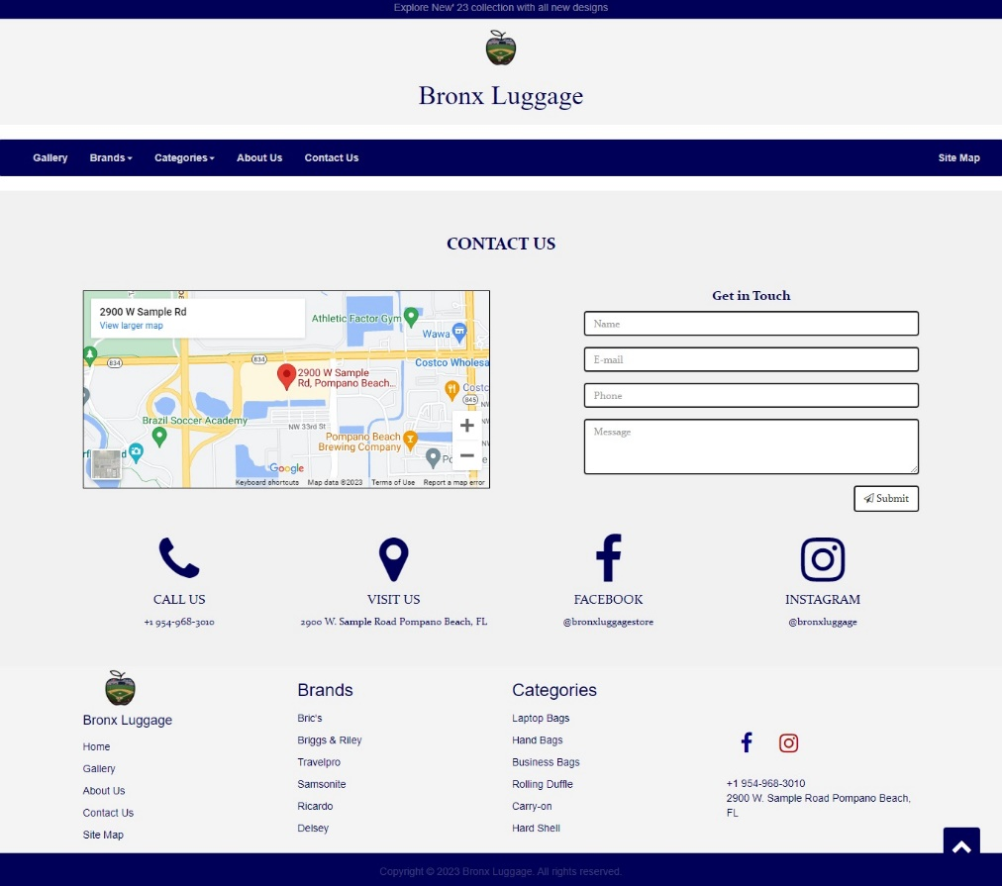 In contact us page we’ve also included location map

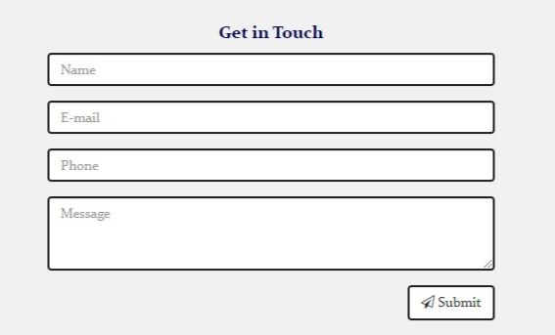

We’ve also included form. form is used to collect user input. The user input is most often sent to a server for processing.

**ABOUT US**

The primary purpose of an about us page is to inform the reader about the company and its operations. This is a straightforward goal that nearly all businesses have to fulfill in some fashion or another. However, there are other reasons why about us pages are common fixtures on business websites.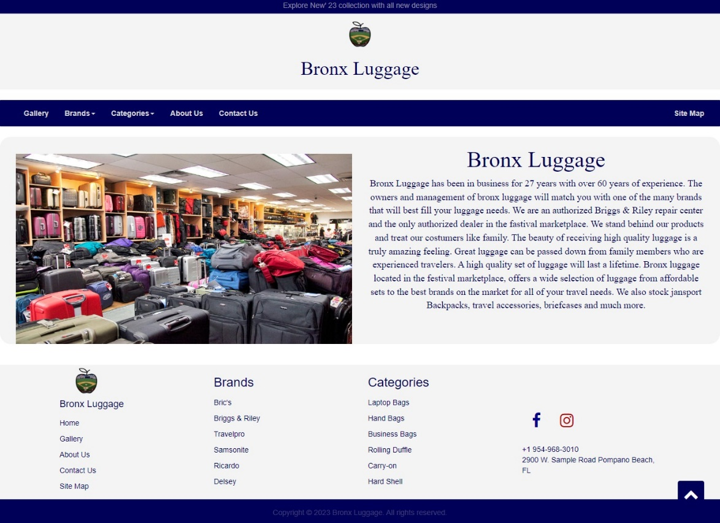

**SITE MAP**

A sitemap is a file where you provide information about the pages, videos, and other files on your site, and the relationships between them. Search engines like Google read this file to crawl your site more efficiently.

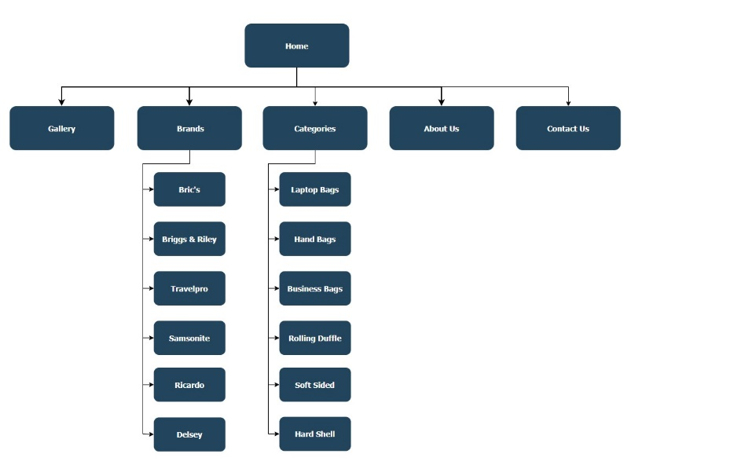**THANK YOU**