Accounting Management System

Overview
The Accounting Management System is a Java-based application developed using Object-Oriented Programming (OOP) principles. It helps users manage personal finances by tracking income, categorizing expenses, and generating financial reports. It also includes a secure login system and visual reporting features such as pie charts.

Key Features
• User Authentication System:
- Register with Name, CNIC, Salary, and Password
- Unique account number generated from CNIC
- Secure login using account number and password
- Each CNIC is unique and cannot be duplicated
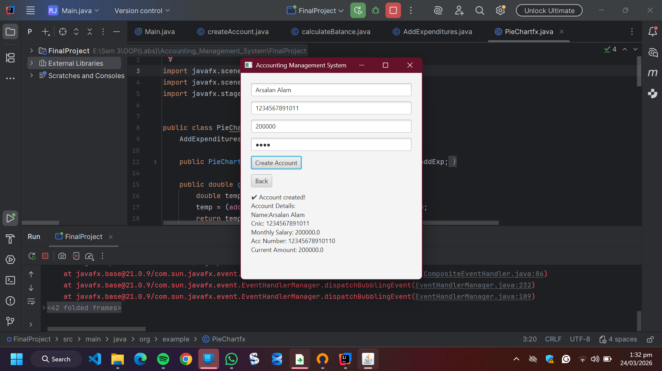

• Financial Management:
- Add monthly salary
- Record daily expenses (Groceries, Rent, Medical, Others)
- Add money back into account
- Automatic balance calculation
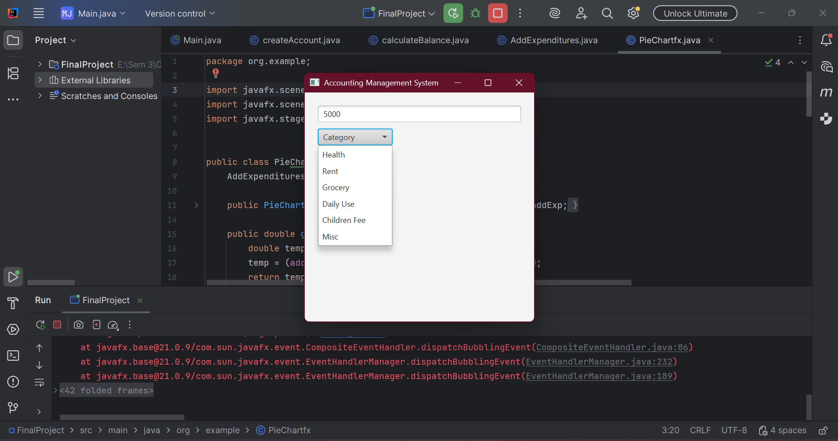
• Reports & Visualization:
- Detailed report with totals, percentages, and remaining balance
- Pie chart for expense distribution
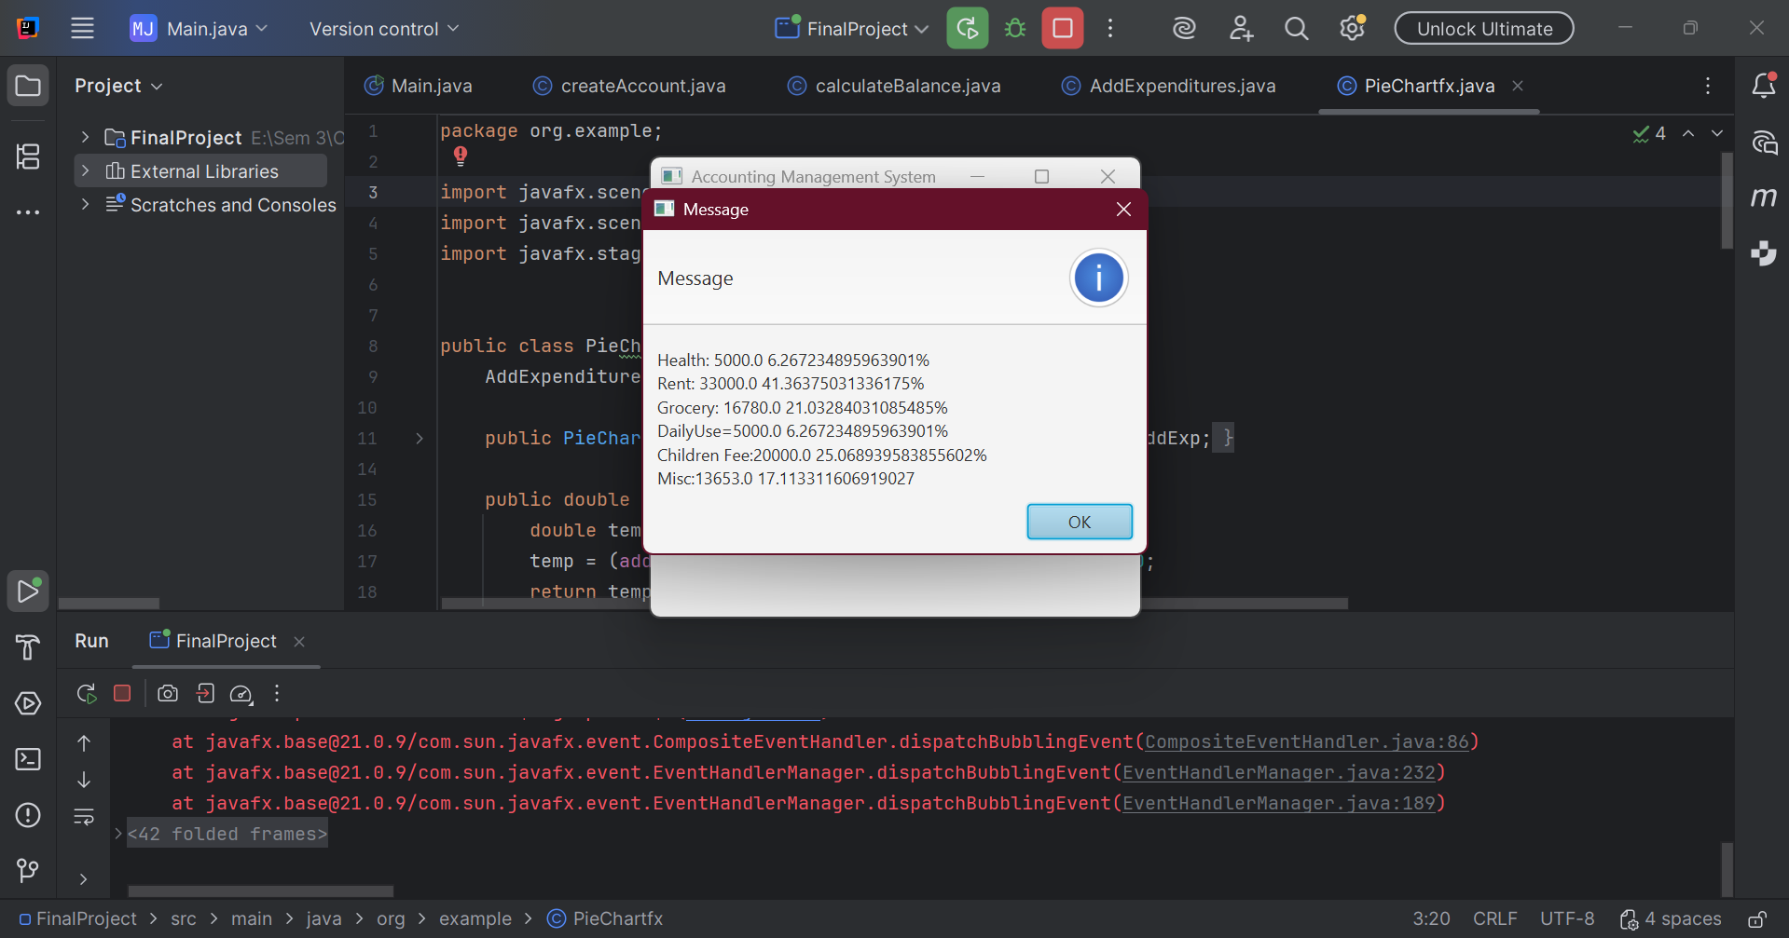
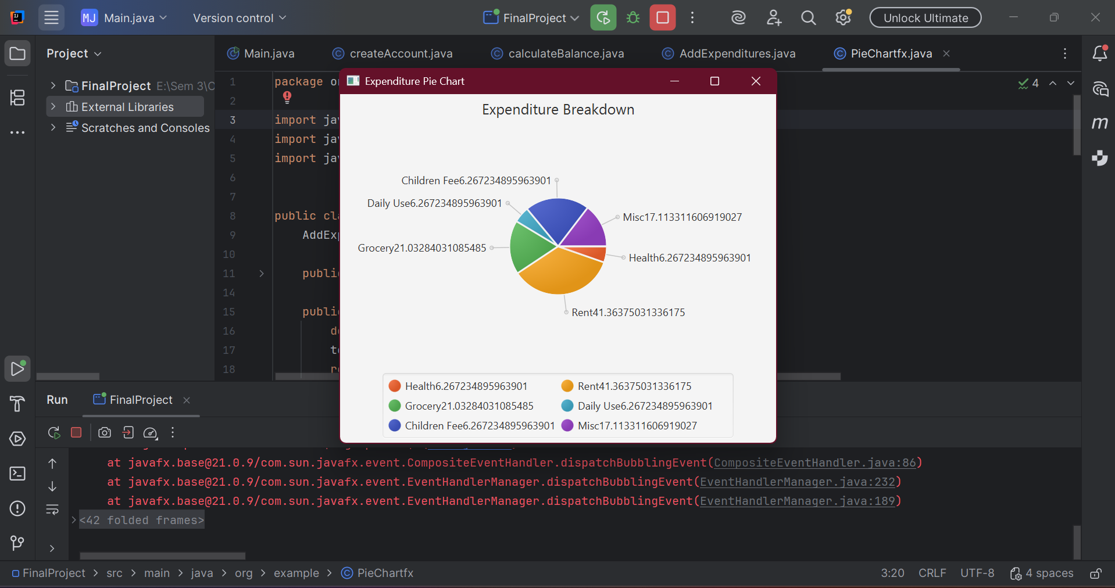
• Balance Management:
- Remaining balance carried forward to next month

Technologies Used
• Java (OOP)
• JavaFX (if used)
• Concepts: Classes, Objects, Encapsulation, Arrays, Functions

System Workflow
1. User Registration (Name, CNIC, Salary, Password)
2. System generates unique account number
3. User logs in
4. User adds expenses
5. User can add balance
6. Generate report or pie chart
7. Remaining balance carried forward

Installation
1. Clone repository:
git clone https://github.com/arsalanalam47/AccountingManagementSystem.git
2. Open in IDE (IntelliJ / VS Code / Eclipse)
3. Run:
javac Main.java
java Main

Future Improvements
• Database integration
• Password encryption
• Mobile app version
• Export reports (PDF/Excel)
• Advanced analytics

Author
Arsalan Alam
Computer Engineering Student
Interested in Software Development & Embedded Systems

