Advanced Neuroscience – Homework 03

Arsalan Firoozi – 97102225

1. By using the script_mean_firing_rates_gratings.m file, I generated the PSTH plots of neurons from spike times. By this approach, neurons with signal to noise ratio less than 1.5 or with firing rate of less than 1 spike/sec are excluded. PSTH plots are generated by the last 1 second of 1.28s. Bin width of PSTH plots are 20ms.

I have selected the most active neuron in each array by finding the maximum activity in 12 orientations after considering the sum of firings in each neuron and trials.

Data points of tuning curves are extracted by considering the highest firing rate in the mean PSTH of the neuron.

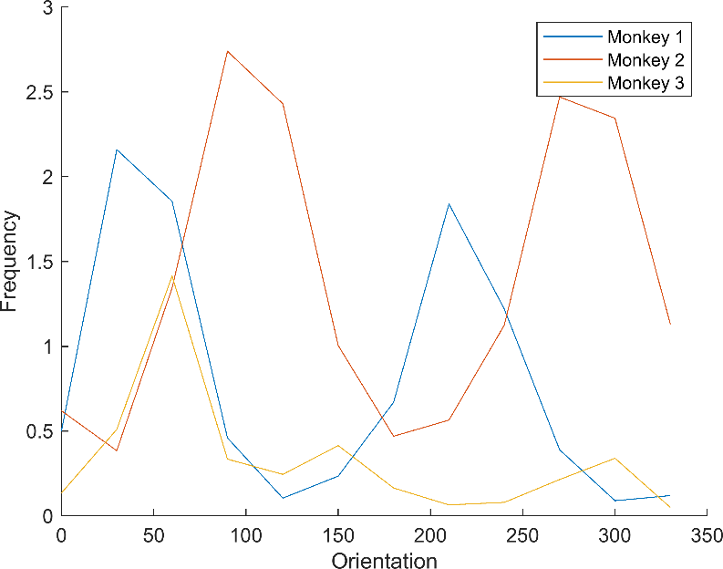

1. Since the data is extracted using a 10*10 array, we can have a plot containing the preferred orientation of neurons in the location of electrodes. So I have found the neurons extracted from each unit and considered the preferred orientation of the neuron as the preferred orientation of neurons in the electrode’s location.

I expect to have a fully 10*10 plot; But because of excluding the data of some neurons due to the insufficient SNR and firing rate, in many locations we have no data for finding the preferred orientation. So in these locations, we have Nan value. Because of showing angles and the character of being periodic, I have used a cyclic color bar:

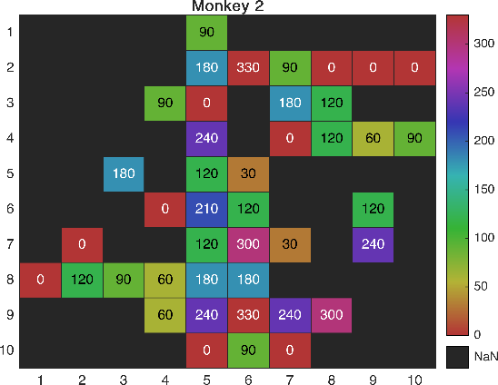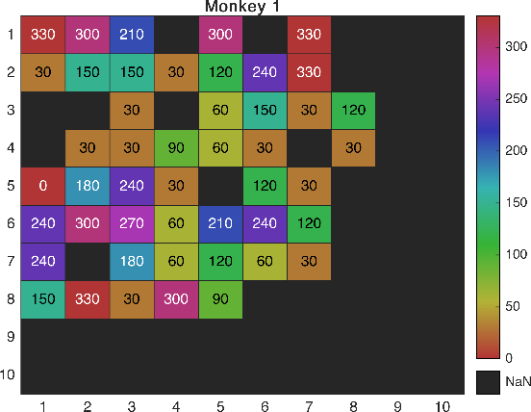

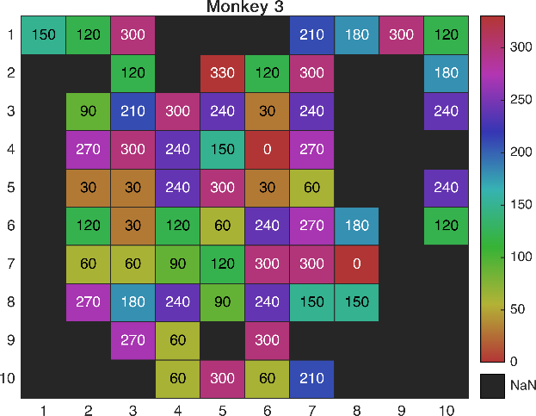

We can see that the most neighbors of each cell has the tendency to have orientation like each other. But I expected to see more accurate plot like maps reported here:

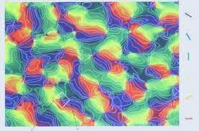

Maybe more spatial accuracy and more neurons for finding the orientation is needed to have a result like this one.

1. I have tried to investigate the relation of signal correlation and noise correlation by the approach presented in the paper and have a result like the fig 3.

For each pair of neurons, I have generated signal correlation by measuring the correlation between tuning curves of neurons and also generated noise correlation by measuring the correlation of sum of the firing rates in each trial and each orientation (12 x 200). Also as the paper said here, I have used Z-score for each orientation:

“For each stimulus orientation, we normalized the response to a mean of zero and unit variance (Z-score), and calculated rsc after combining responses to all stimuli.”

For generating the Fig. 3 of the paper, once I separated the data into 4 classes by distance of the recorded neurons and investigate the relation between them. And once I separated the data into 4 classes by the signal correlation. I’ve also generated a contour map of the noise correlation in a 2d plot of distance and signal correlation.

Results for each monkey are shown below:

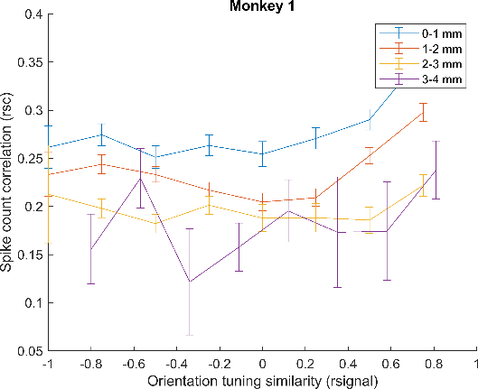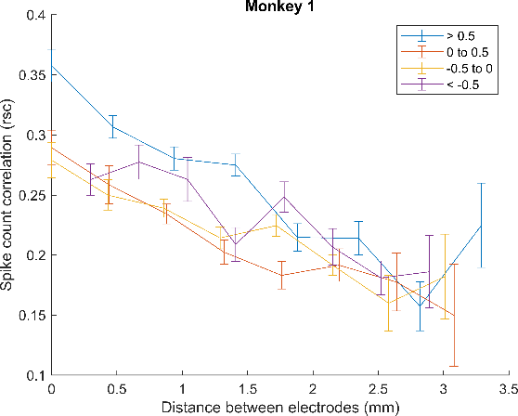

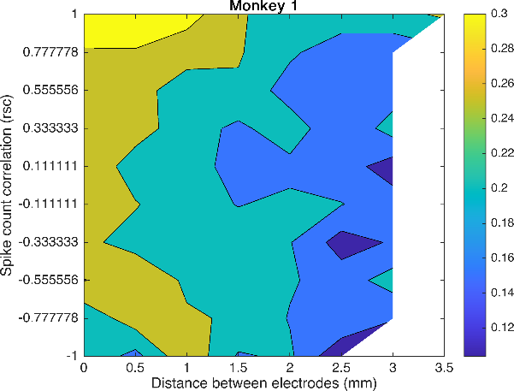

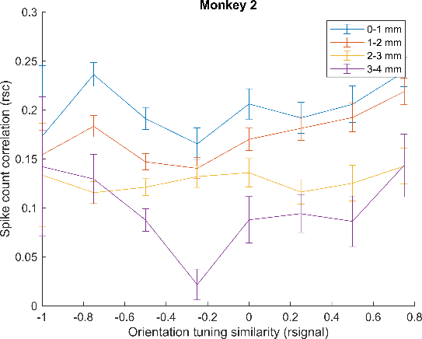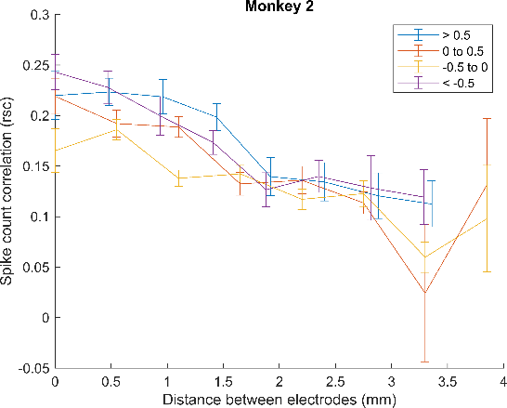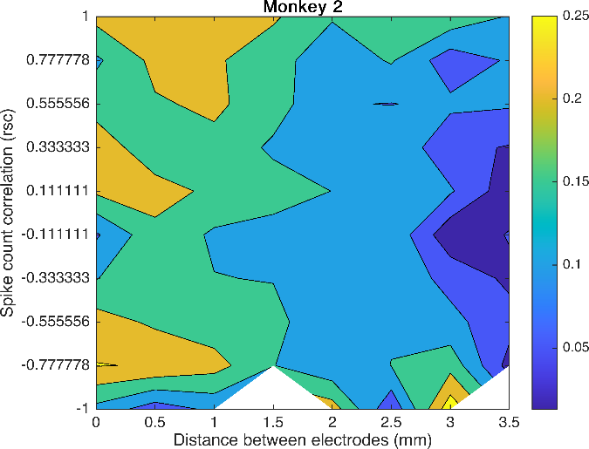

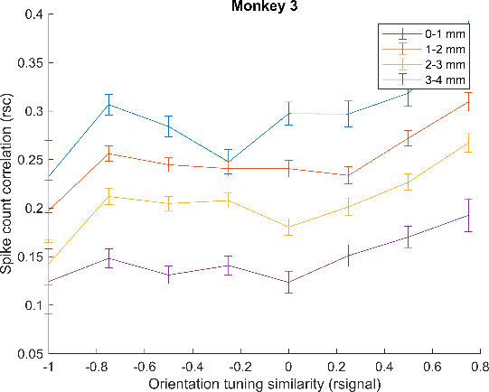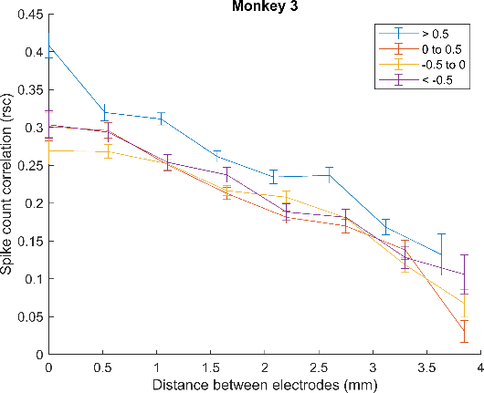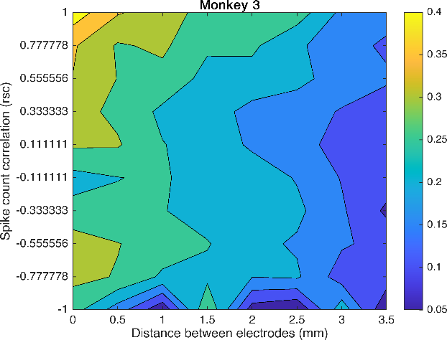

The result is similar to the paper and shows that we have dependency of neurons activity and signal/noise correlation to distance. It seems that lower distance have higher correlation in comparison with higher distance.

1. As discussed in the session, We know that by having an stimulus, the Fano factor and the activity of neurons changes; So that the noise reduces and changes in a way that the noise correlation reduces after stimulation (Evoked) and before stimulation (Spontaneous):



This is also reported in the result section of the paper that the sensory input can reduce the correlation of the ongoing activity:

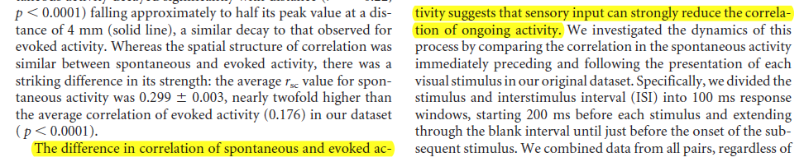

So the stimulus causes the significant change in noise correlation of evoked period and spontaneous period.