Software Requirements Specification Template
CS 309—OOAD

Home Food

Software Requirements Specification

Version: 1

3/11/2016

Muhammad Arsalan Inam 13k-2190
Hamza Shaikh 13k-2200

Instructor:

Miss Amber Yaseen Khan

Revision History

Date | Description | Author | Comments
3/11/16 | Version: 1 | M. Arsalan Inam | First Version of SRS

Document Approval

The following Software Requirements Specification has been accepted and approved by the following:
Signature | Printed Name | Title | Date
 | M.Arsalan Inam | Lead Software Eng. | 3/9/2016
 | Miss Amber Khan | Instructor, | 3/9/2016

Table of Contents

Revision History ii
Document Approval ii
1. Introduction 1
1.1 Purpose 1
1.2 Scope 1
1.3 Definitions, Acronyms, and Abbreviations 1
1.4 References 1
1.5 Overview 1
2. General Description 2
2.1 Product Perspective 2
2.2 Product Functions 2
2.3 User Characteristics 2
2.4 General Constraints 2
2.5 Assumptions and Dependencies 2
3. Specific Requirements 2
3.1 External Interface Requirements 3
3.1.1 User Interfaces 3
3.1.2 Hardware Interfaces 3
3.1.3 Software Interfaces 3
3.1.4 Communications Interfaces 3
3.2 Functional Requirements 3
3.2.1 <Functional Requirement or Feature #1> 3
3.2.2 <Functional Requirement or Feature #2> 3
3.3 Use Cases 3
3.3.1 Use Case #1 3
3.3.2 Use Case #2 3
3.4 Classes / Objects 3
3.4.1 <Class / Object #1> 3
3.4.2 <Class / Object #2> 3
3.5 Non-Functional Requirements 4
3.5.1 Performance 4
3.5.2 Reliability 4
3.5.3 Availability 4
3.5.4 Security 4
3.5.5 Maintainability 4
3.5.6 Portability 4
3.6 Inverse Requirements 4
3.7 Design Constraints 4
3.8 Logical Database Requirements 4
3.9 Other Requirements 4
4. Analysis Models 4
4.1 Sequence Diagrams 5
4.3 Colllabration DIAgram 5
5

1. Introduction
This document will provide the overall scope and perspective of the project. This document contains the purpose and goals of the project. This document contains all the requirements of the system. In this SRS document we’ll define the basic flow of the system and its needs. All the specific requirements and needs are also mentioned in it.

1.1 Purpose
The purpose of this document is to define the system and its requirements. All the functionalities that will be performed by the system are described in this document. This document is written for our instructor and for the people who are concerned with this project and its needs.

1.2 Scope
The aim of the project is to prepare a web based Home Food Management System for the people
- who cannot go outside to do business and wants to do business at home
- who can order home food of their desired Cook/Chef at their desired place.

In this system, every Cook/Chef will have an unique username through which only he/she can access the system and its database. The User/Customer have buttons on the main screen. The system will take him/her to the Sign Up/Login Page. Once the User/Customer is registered to the website, he/she can avail all the functions which are especially designed for Customer to avail the services. User/Customer can easily
- Search their desired Cook/Chef by their username
- Select which type of Food they want
- Select the location where the food is going to be delivered.

The Cook/Chef can update their food list weekly so that User/Customer can get to know the details of upcoming week's menu list. When the weekly list is being updated by the Cook/Chef, the User/Customer can easily order on the weekly basis or daily basis.

1.3 Definitions, Acronyms, and Abbreviations
The terms used in the system are:
- Login: Login is mandatory for both Cook/Chef and User/Customer.
- Username: Every Cook/Chef will have a unique username.
- Location: Location will help Customer and Cook to deliver food nearby easily.
- Cook/Chef’s info: This section contains all the information about the experience and personal information of Cook/Chef. Admin can alter the information here also.
- Food Price: it will show the different prices of different Chefs.

1.5 Overview
The remaining part of SRS contains use case model, sequence diagram, system sequence
diagram and collaboration diagram and etc.

2. General Description
This section will give an overview of the whole system. The system will be explained in its context to show how the system interacts with other systems and introduce the basic functionality of it. It will also describe what type of User that will use the system and what functionality is available for each type. At last, the constraints and assumptions for the system will be presented.

2.1 Product Perspective
This system consist of a web application portal, which will be used for managing the information about the Cook/Chef and the User/Customer as a whole.
Web Application
Home Food

Data Base
Data Base Server
Figure: 1

Figure: 1

The web application will need to have an active internet connection for startup as the user has to login in the first place to access any functionality of application .
Since this is a data-centric product it will need somewhere to store the data. For that, a database will be used. The web application portal will communicate with the database, see figure. The web application will add and modify data. All of the database communication will go over the Internet.

2.2 Product Functions
With this web application, the users will be able to insert , update and delete information of the Food and their information. The database shall update respectively. This application will provide functionality to manage the Business and it will store all of its information. It will also provide information about the best Chef/Cook of the week and best Dish/Food of the week.

2.3 User Characteristics
There are three types of users that will interact with the system: Cook/Chef, Admin and User/Customer. Each of these three types of users has different use of the system so each of them has their own requirements.

- Cook/Chef can add, delete and update all the information of food etc. They can interact with the Customer to sell their Food at Customer's desired location. They can generate bills. They can ask customer for review about their food quality and how much they like the food quality.
- User/Customer can view their desired food of all Cook/Chef. They can contact Cook/Chef to deliver the food where they want. They can add weekly schedule or daily basis schedule of food to be delivered at their desired place. They can rate the food quality which will help other Users/Customers to see who is offering the best quality food in this web application.
- Admin can add, delete and update the profiles of all the Cook/Chef and User/Customer.

2.4 General Constraints
This application will be constrained by the capacity of the database. Since the database is shared on multiple Computers, it may be forced to queue incoming requests and therefore increase the time it takes to fetch data.
The Internet connection is also a constraint for this application. Since the application fetches data from the database over the Internet, so it is crucial that there is an Internet connection for the application to function.

2.5 Assumptions and Dependencies
An assumption about the product is that it will always have a high performance internet connection. If the internet is down or something and there may be few functions unable to access as they would require they would require high bandwidth and low pings.

Since this application is a web based application, it is dependent on the good and high speed web browser like Google Chrome, Mozilla Firefox, Safari etc.

3. Specific Requirements

This section contains all of the functional and quality requirements of the system. It gives a detailed description of the system and all its features.

3.1 External Interface Requirements
This section provides a detailed description of all inputs into and outputs from the system. It also gives a description of the hardware, software and communication interfaces and provides basic prototypes of the user interface.

3.1.1 User Interfaces
A first-time user of the application should see the log-in/Sign-Up page when he/she opens the application. If the user has no account, he/she will Sign-Up, Otherwise he/she can log in to the page.

After Log-In, they can access different options available on the application. They can easily search a Cook/Chef by entering username of the Cook/Chef or they can also view all the Cook/Chef present in this application.

In the 'Cook/Chef ' section, Every Cook/Chef will have their own personal section which will show their food, Image of the food, Price of food and some description about the food. If the User/Customer likes the food, he/she can add the food to the cart.

In the 'Contact Cook/Chef' section, The User/Customer can contact his/her desired Cook/Chef. The user/customer can order on the weekly or daily basis.

Cook/Chef will have an individual admin panel, through which they can add, delete or update food and information.

The website owner will only have an admin panel, which will show the data base of all the Chef/Cook and User/Customer.

3.1.2 Hardware Interfaces
Since this web application does not have any designated hardware, it does not have any direct hardware interfaces. the hardware connection to the database server is managed by the underlying operating system on the web server.

3.1.3 Software Interfaces
The web application communicates with the database in order to fetch information about patients , see Figure 1. The communication between the database and the web portal consists of operation concerning both reading and modifying the data.

3.1.4 Communications Interfaces
The communication between the different parts of the system is important since they depend on each other. However, in what way the communication is achieved is not important for the system and is therefore handled by the underlying operating systems for the web application.

3.2 Functional Requirements

This section includes the requirements that specify all the fundamental actions of the software system

3.2.1 <Functional Requirement or Feature # 1>
3.2.1.1 Introduction : User Sign Up
3.2.1.2 Inputs : Sign Up Form
3.2.1.3 Processing : Sign Up Form processes in database
3.2.1.4 Outputs : Notification sent to user if he/she is registered successfully or not
3.2.1.5 Error Handling : Database will generate an error message if a user is already registered

3.2.2 <Functional Requirement or Feature # 2>
3.2.2.1 Introduction : User Log In
3.2.2.2 Inputs : Log In Form
3.2.2.3 Processing : Log In Form processes in database
3.2.2.4 Outputs : Notification sent to user if he/she is logged in successfully or not
3.2.2.5 Error Handling : Database will generate an error message if a user enters wrong username or password

3.2.3 <Functional Requirement or Feature # 3>
3.2.3.1 Introduction : Edit Food Menu
3.2.3.2 Inputs : Add Menu, Modify Menu, Delete Menu
3.2.3.3 Processing : Edit Menu processes in database
3.2.3.4 Outputs : Notification sent to user if he/she has edited Menu successfully or not
3.2.3.5 Error Handling : Database will generate an error if the internet stops working

3.2.4 <Functional Requirement or Feature # 4>
3.2.4.1 Introduction : Order Food
3.2.4.2 Inputs : Add order, Delete Order, Modify Order
3.2.4.3 Processing : Order food processes in database
3.2.4.4 Outputs : Notification sent to user if he/she has ordered successfully or not
3.2.4.5 Error Handling : Database will generate an error message if the internet stops working

3.2.5 <Functional Requirement or Feature #5>
3.2.5.1 Introduction : Billing
3.2.5.2 Inputs : View Bill, Cancel Bill, Generate Bill
3.2.5.3 Processing : Billing processes in database
3.2.5.4 Outputs : Bill sent to the Customer if he/she ordered food correctly
3.2.5.5 Error Handling : Database will generate an error message if a user does not order the food correctly

3.2.6 <Functional Requirement or Feature #6>
3.2.6.1 Introduction : Log Out
3.2.6.2 Inputs : Log Out Button
3.2.6.3 Processing : Log Out processes in database
3.2.6.4 Outputs : Notification sent to user if he/she is logged out correctly or not
3.2.6.5 Error Handling : Database will generate an error message if internet stops working

3.3 Use Cases
Use Case Diagram :

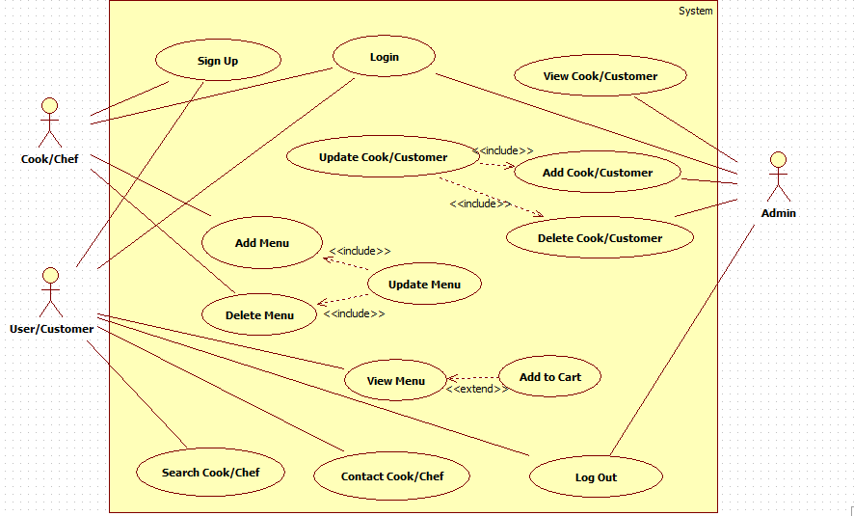

Description of Use Case:

- Sign-Up: For the first time User
- Log-In: Cook, Customer and admin must log in to the application
- Add Menu: Cook/Chef can add a food in the menu sections
- Delete Menu: Cook/Chef can delete a food in the menu sections
- Update Menu: This function will automatically update the data base
- View Menu: User/Customer can view the menu of food
- Add to Cart: User/Customer can order food from menu if he wants
- Search Cook/Chef: User/Customer can search the Cook/Chef by username
- Contact Cook/Chef: User/Customer can contact Cook/Chef
- View Cook/Customer: Admin can view the list of all Cooks and Customers
- Add Cook/Customer: Admin can add any Cook or Customer
- Delete Cook/Customer: Admin can delete any Cook or Customer
- Update Cook/Customer: This function will automatically update the data base
- Log-Out: Cook, Customer and admin can log out to the application

3.4 Classes / Objects
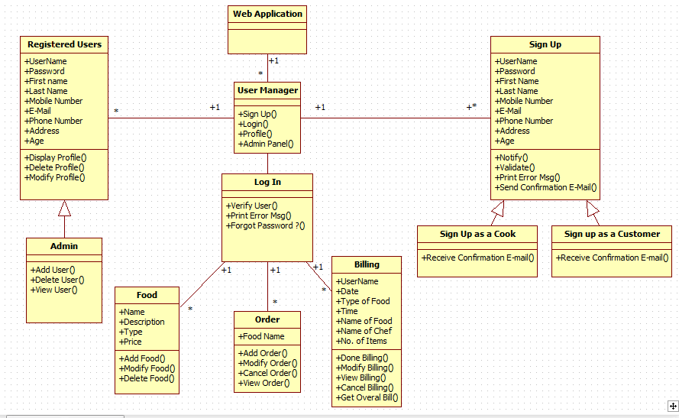

3.5 Non-Functional Requirements
Non-functional requirements may exist for the following attributes.

3.5.1 Performance
Response time and Performance must be faster

3.5.2 Reliability
The application and database must be reliable

3.5.3 Availability
The application should be available 24*7

3.5.4 Security
The personal data stored in the data base should be secured and protected

3.5.5 Maintainability
The application should be up to date every time and should be maintained whenever the problem occurs

3.5.6 Portability
The application should be portable and should run on every web browser

3.6 Logical Database Requirements
Xampp Database will be used for this application

3.7 Other Requirements
Other requirements for this application are html, css and php with MySQL

4. Analysis Models
List all analysis models used in developing specific requirements previously given in this SRS. Each model should include an introduction and a narrative description. Furthermore, each model should be traceable the SRS’s requirements.

4.1 Sequence Diagrams
Sign Up Sequence Diagram :
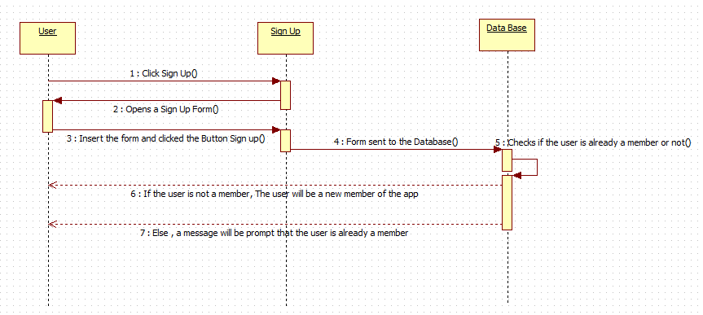

Log In Sequence Diagram: :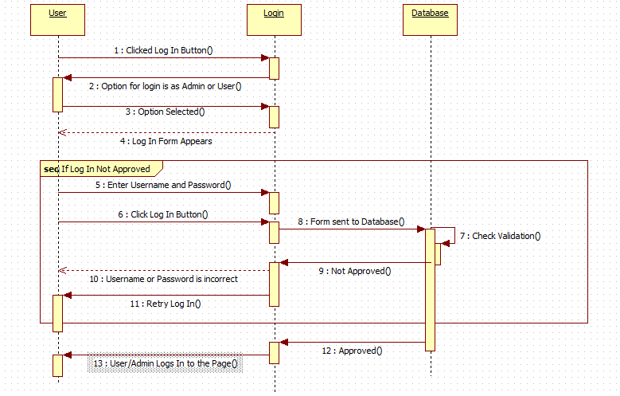

Food Edit Sequence Diagram: :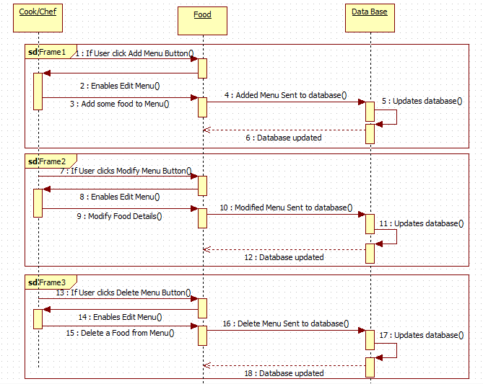

Order Food Sequence Diagram: :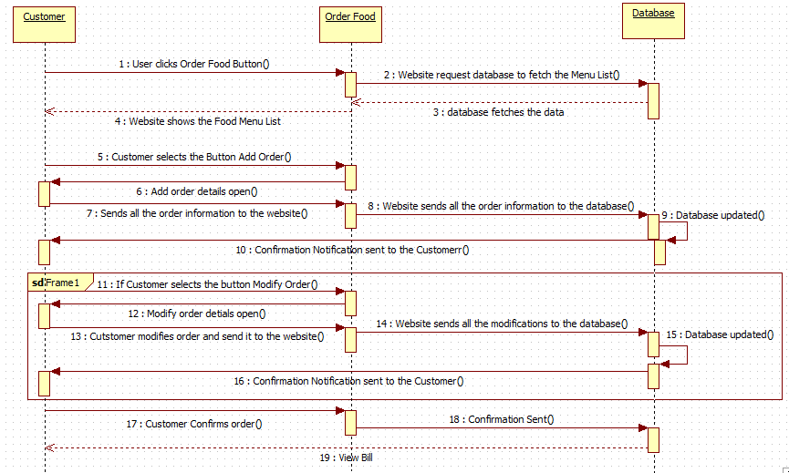

Billing Sequence Diagram :
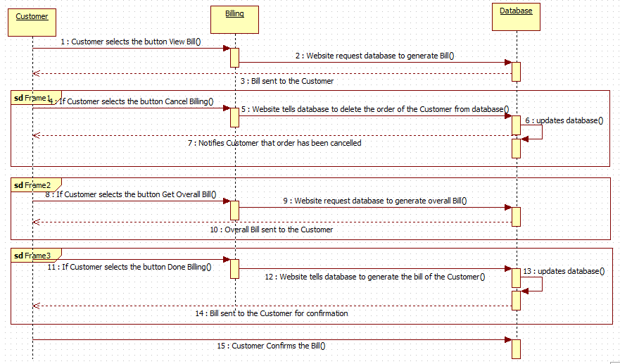

Log Out Sequence Diagram :
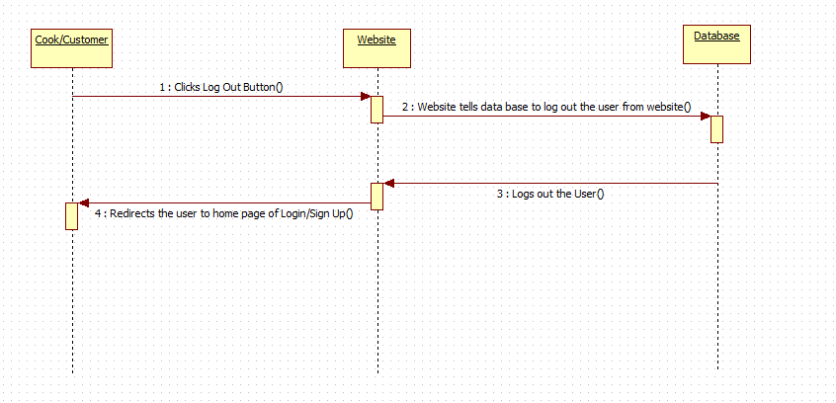

4.3 Collaboration Diagrams
Sign Up Collaboration Diagram :
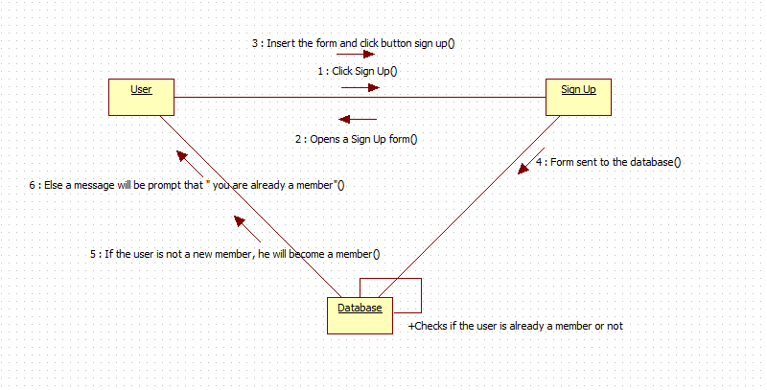

Log In Collaboration Diagram :
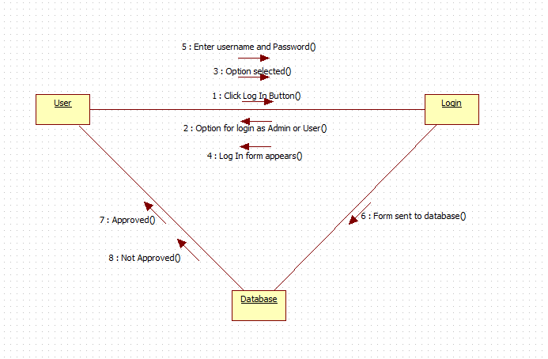

Edit Food Collaboration Diagram :
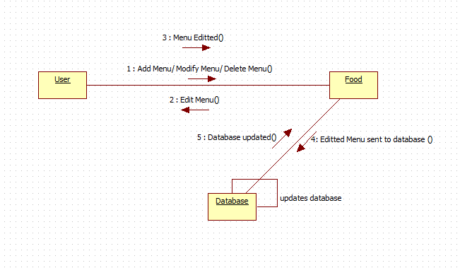

Order Food Collaboration Diagram :
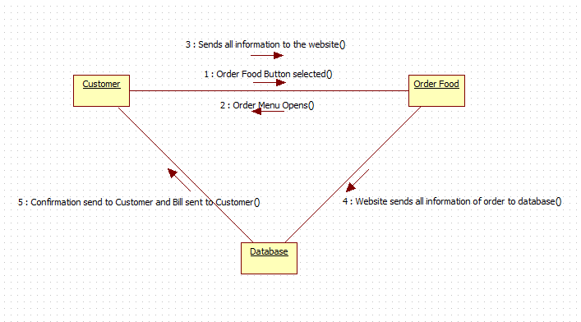

Billing Collaboration Diagram :
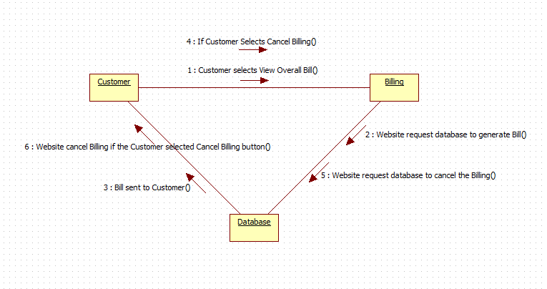

Log Out Collaboration Diagram :
