NATIONAL COMMON OPERATING PICTURE
A Unified Geospatial Situational-Awareness Platform
for the National Disaster Management Authority of Pakistan
Prepared for
National Emergency Operations Centre (NEOC)
National Disaster Management Authority (NDMA)
Table of Contents

1. Preamble — Why NCOP Was Created 3
2. Methodology 4
2.1. Approach in Layman's Terms 4
2.2. System-Level Flow Diagram 5
2.3. User Interaction Flow 5
2.4. Data Ingestion Pipeline 6
3. Current Status & Operational Capabilities 6
3.1. What Is Operational Today 6
3.2. Capability Matrix 7
4. The Product, in Plain Language 7
5. Closing Notes 8

1. Preamble — Why NCOP Was Created

Pakistan sits at the intersection of nearly every category of natural hazard a country can face. Monsoon floods cycle through the Indus plains every season; heatwaves push southern Punjab and interior Sindh past dangerous thermal thresholds; cyclones spin out of the Arabian Sea; the northern belt records regular earthquakes and glacial-lake outburst events; and an already-fragile air-quality picture in the urban centres compounds every meteorological event into a public-health problem. Each of these hazards has a designated authority, a designated dataset, a designated dashboard, and a designated set of pager notifications. What had been missing — and what NCOP was built to deliver — is a single unified picture.
Before NCOP, an operator at the National Emergency Operations Centre tracking a developing monsoon event would routinely have six to ten browser tabs open: the Pakistan Meteorological Department station feed, the Flood Forecasting Division's level reports, the Meteoblue precipitation forecasts, the Global Flood Awareness System (GloFAS) raster outputs, the WAQI air-quality network, the GDACS event tracker, the USGS earthquake feed, and a handful of internal GIS layers served from GeoServer. Each tab had its own coordinate system, its own time-zone handling, its own login, its own refresh cycle and its own interpretation challenges. Cross-referencing one against another — say, matching a heavy-rain forecast against the districts most exposed to flooding — required mental gymnastics no operator should have to perform under pressure.
NCOP was created to consolidate every authoritative feed onto one map, with one time control, one set of theming rules, and one set of click-through behaviours. It is not a replacement for the underlying authorities: PMD remains the authoritative source for weather, USGS for seismology, NDMA for incident declarations. It is, instead, the layer above them — the briefing-quality synthesis that a director can use to brief the prime minister, that a regional commander can use to plan deployments, and that a field analyst can use to answer a single concrete question: 'right now, what is the operating posture?'
The four problems NCOP was built to solve, in order of importance:
- Fragmentation — too many tabs, too many logins, too many maps.
- Latency — by the time an operator had stitched a picture together manually, the data underneath had already moved.
- Inconsistency — the same place could appear under different names, different boundary versions, different coordinate systems across providers.
- Inaccessibility — the existing tools assumed a GIS background. Most operators and almost all decision-makers do not have one.
NCOP exists to make the picture immediate, consistent, and usable by someone who has never opened a GIS tool in their life. Everything else in the platform is a consequence of those four goals.

2. Methodology

2.1 Approach in Layman's Terms
Think of NCOP as a translator standing between the user and a dozen different data providers, each of whom speaks a different dialect. The user opens one screen and says, in effect, 'show me what's happening with rainfall today'. NCOP turns that single request into a quiet flurry of background work: it fetches the latest PMD station readings, downloads the Meteoblue rainfall forecast for the next 168 hours, pulls the river-discharge points from the Flood Forecasting Division, and brings down the district and provincial boundary layers from the in-house GeoServer.
Once all of that data is on the map, the translator does a second pass. It applies sensible defaults — the right colours for rainfall, the right symbol for a weather station, the right opacity for a forecast overlay. It places every layer in a sensible stacking order so that user-toggleable layers always sit above background overlays. It hooks up a time slider so the user can scrub forwards or backwards through the forecast horizon. And it generates a side panel — the Weather Report — that summarises, district by district, what the active layer is actually saying.
Nothing in the platform asks the user to know what a vector tile is, or what EPSG:3857 means, or how a GeoJSON is structured. The translator handles all of that. The user sees a clean dark-themed map with a clear sidebar and a single time slider, and the picture updates as they explore.
2.2 System-Level Flow Diagram
The diagram below describes the high-level path data takes from an external provider into a Mapbox layer on the user's screen. The flow runs top-to-bottom with each cluster (Providers, Backend, Browser Modules) laid out horizontally inside its own box — keeping the chart compact enough to fit comfortably on a portrait A4 page when rendered via mermaid.live.

Figure 1 — End-to-end data flow from external provider to user screen.
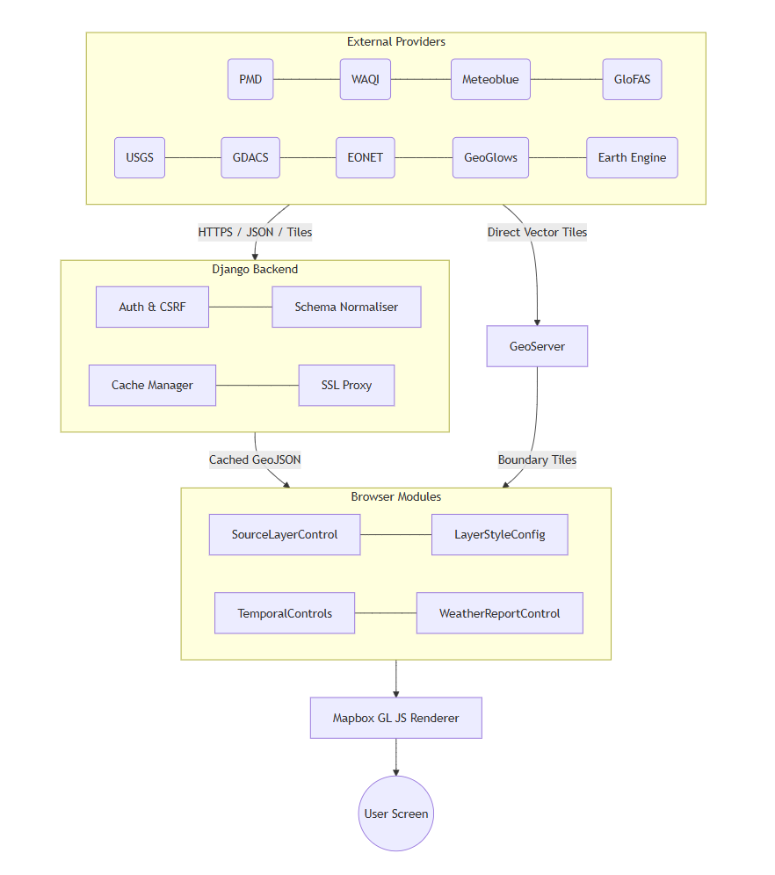
2.3 User Interaction Flow
When the user toggles a layer, switches the basemap, or drags the temporal slider, the platform follows a deterministic sequence. The diagram below captures the four most common interactions in a single top-down flow.

Figure 2 — User-driven interaction sequence.
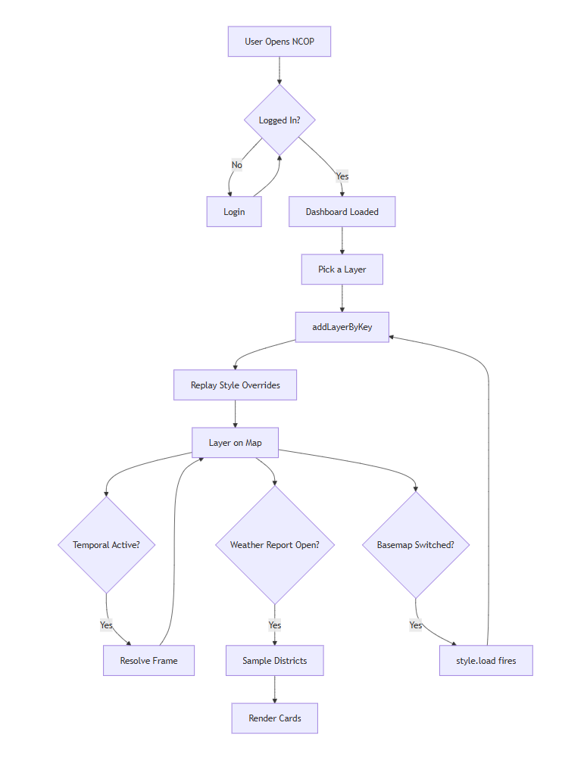
2.4 Data Ingestion Pipeline
For every live-data feed that NCOP consumes, Django acts as a thin caching proxy. The sequence diagram below applies to the PMD weather-station merger, the WAQI feed, the heatwave-monitoring cities, the GDACS event list, the USGS earthquake stream, and the NASA EONET feed — Mermaid sequence diagrams render vertically by default, which already suits the portrait layout.
Figure 3 — Caching proxy sequence for a live-data feed.

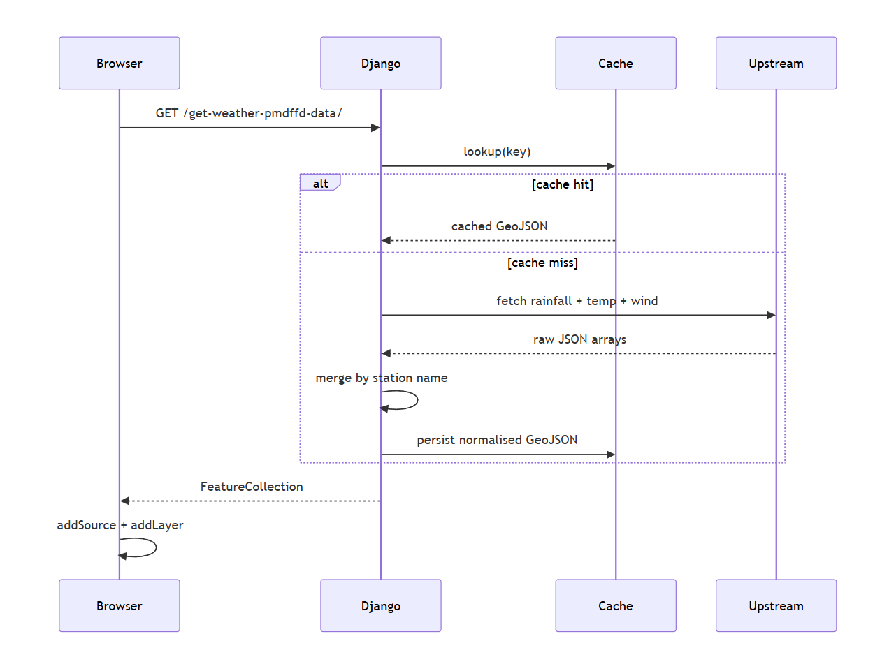
3. Current Status & Operational Capabilities

3.1 What Is Operational Today
NCOP is in production use at NEOC. The platform supports authenticated access with the standard sign-in, password-reset and session-management flows. The dashboard itself is fully styled in a dark, briefing-quality theme with a day-mode toggle for outdoor lighting conditions. The right-side rail hosts ten functional panels — geocoder search, layer order management, layer styling, layer information, projection toggle (Globe / Mercator), basemap picker, wind-and-ocean particle animation, weather report, guided tour and the story builder.
On the data side, more than forty distinct thematic layers are wired into the sidebar across six top-level categories: GIS Layers, Weather Systems, Flood Monitoring, Air Quality, Ocean & Coastal, and Disaster Early Warning. Every vector layer can be recoloured, restyled and labelled in-app via the Layer Style panel, and those user preferences now persist correctly across basemap switches — a recent fix that closed a long-standing irritation for power users.
The Weather Report panel — the analytical core of the platform — is fully operational. When a temporal layer is active it samples every visible district at the centroid, groups the readings by province, computes kind-aware aggregates (mean for most metrics, max for CAPE and storm helicity), and surfaces a hotspot card plus per-province cards with click-to-fly behaviour. Research-based thresholds drawn from the WHO 2021 Air Quality Guidelines, the US EPA AQI breakpoints, and the IMD / PMD rainfall classifications drive the red-alert flagging.
3.2 Capability Matrix
Capability Area | Status | Notes
Live Map Rendering | Operational | Mapbox GL JS, dark theme, multi-basemap.
Vector Boundaries | Operational | National / Provincial / District / Tehsil via GeoServer TMS.
Temporal Forecast Layers | Operational | Hourly / daily / weekly with global time slider.
Station Networks | Operational | PMD weather, WAQI air quality, heatwave monitoring.
Per-District Reporting | Operational | Weather Report panel with hotspot + click-to-fly.
Layer Style Editor | Operational | Polygon / line / point / label, persistent across basemaps.
Disaster Early Warning | Operational | GDACS, USGS, NASA EONET, Meteoblue early warnings.
Air Quality (CAMS) | Operational | AQI, dust, AOD, NO2, SO2, CO.
Earth Engine Catalogue | Operational | Dynamic + temporal layer instantiation.
Documentation Portal | Operational | In-app /docs/ route with full reference.
Story Builder | Operational | Chapter-based narrative tours.
Mobile Responsive UI | Partial | Tablet-class works; phone-class scoped for future iteration.
Real-Time Radar (RainViewer) | Held | Implementation present; held pending rate-limit tuning.

4. The Product, in Plain Language

If you have never seen NCOP, here is what it does. You open a web page. The page is a map of Pakistan — by default, a clean satellite view with the provincial and district lines drawn on top. The country's logo sits in the top-left corner, and a slim vertical rail of buttons runs down the right side. Most of the screen is the map.
On the left, a sidebar slides open when you click the small hamburger button. Inside it are categories — Weather, Flood, Air Quality, Ocean, and so on. Each category contains layers. A 'layer' is just a particular kind of information you can add to the map: where the rain is forecast to fall, where the active weather stations are, where the GDACS thinks a cyclone is forming, and so on. You tick a layer; it appears on the map. You untick it; it disappears. You can have several layers on at once.
Some layers are static — they show the same thing all the time, like the district boundaries. Other layers are temporal: they cover a period in time. When you turn one of these on, a horizontal time slider appears below the map. Dragging the slider forwards moves you into the future, and the colours on the map shift to show what is being forecast at that moment. The play button on the slider animates the whole sequence. This is the easiest way to see whether a storm is moving towards a particular city or away from it.
On the right rail, the most important button is the Weather Report. Clicking it slides out a panel that reads the currently-active layer and tells you, district by district, what the numbers actually mean. Districts that are over a research-based alert threshold — say, rainfall above 100 millimetres in a week — turn red. The very worst district appears at the top as the 'hotspot'. Provinces are summarised with their average reading and a count of how many districts inside them are flagged. Click any district card and the map flies to that district. Click a province header and the map flies to the whole province.
There is a search box for jumping to a specific place. There is a styling panel that lets you recolour any layer to taste — useful when you need to tune the map for a presentation or for a colour-blind audience. There is a layer-order panel so you can decide which layer sits on top of which. The basemap can be switched to streets, light, dark, navigation, or several third-party tile providers, and the projection can be flipped between a flat Mercator view and a 3D Globe. Every choice you make persists for the session.
That is the whole product. A map, a sidebar of layers, a time slider, a right-side report panel, and a handful of utility buttons. Nothing on the screen requires GIS experience — anyone who can use Google Maps can drive NCOP within a few minutes.

5. Closing Notes

NCOP is the product of a deliberate choice not to build yet another niche GIS console for specialists. The platform was scoped from day one as a briefing tool for decision-makers, and every architectural decision — the dark theme, the single time slider, the unified Weather Report, the in-app styling editor, the click-to-fly navigation — flows from that scope.
The platform is operational, in production, and used during live events. The data pipeline is resilient: aggressive caching shields free-tier upstream APIs from rate-limit pressure, the Django proxy layer normalises every feed's schema before it reaches the browser, and the GeoServer-served boundary tiles bypass Django entirely so tile latency stays low. The frontend is deliberately built as plain ES modules — no framework lock-in — which keeps the bundle small and the maintenance ceiling low.
Future iterations will extend the platform towards phone-class viewports, richer narrative storytelling through the Story Builder, deeper Earth Engine integration for satellite-derived analyses, and integration with NDMA's own incident-management database so that operational decisions made on top of NCOP can be written back to the institutional record. The architecture as it stands today comfortably accommodates each of those directions; none of them require a redesign.
NCOP is, in the end, an attempt to give the country's emergency operations community a single screen that tells the truth about the day. It is small in scope by design, sharp in execution by intent, and built to survive the very specific stress of a live event briefing. We expect it to continue to evolve, but the foundation laid in this first version is intentionally stable enough to carry that evolution forward.
— End of Document —

