Global Common Operating Picture

(GCOP)

An Overview of the updates during the last two years:
Table 1: Key Tasks and Achievements of years 2023 to 2024
Month | Key Tasks & Achievements
Nov 2023 | Initialization of the concept of NCOP (later named as GCOP)
Dec 2023 | Selection of data to be represented within GCOP EMHVRAS hazards, database design, Mapbox 3D & MVT, disaster risk layers
Jan 2024 | USGS Earthquake API, NEOS updates, docker work.
Feb 2024 | Distance/Area tools, projections DB, VM/server setup, MetEye design
Mar 2024 | GCOP production, Metrology forecast, animations, NEOC Forecasts
Apr 2024 | Sidebar redesign, legends, precipitation forecast, alerts planning
May 2024 | GCOP Alerts Model, Central Geodatabase, global layers optimization
Jun 2024 | GCOP production setup, ECMWF/JAXA, health/faultline updates, tourism portal
Jul 2024 | Radar layers, FFD API, Incident Reporter tool, Global portals updates
Aug 2024 | AQ DATA, incident redesign, NGINX deployment
Sep 2024 | Alerts & Threat Module.
Oct 2024 | ARC Vulnerability, Exposure API, projections updates, GDACS integration
Nov 2024 | 6MP projections, NASA EONET updates, DB cleaning, raster/vector fixes

Table 1 covers most of the tasks performed regarding the development of GCOP during the years 2023 and 2024. In General, these years represent the early development phases of GCOP, where it was referred to as NCOP and had limited features and a restricted User Interface (UI). Figure 1 represents the initial UI of GCOP with a limited tool set and features- for the case of this report, this will be hereafter referred as GCOP 1.0.
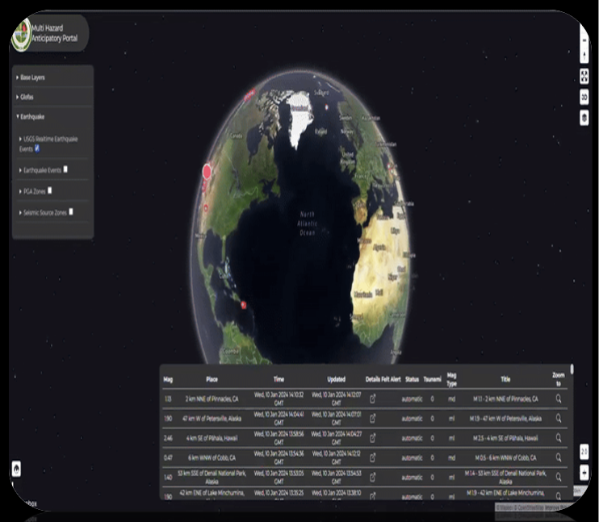
Figure 1: GCOP Version 1.0
The initial version of GCOP (v1.0) primarily monitored natural hazards and weather phenomena, providing users with a global perspective on emerging events. However, the early system had several limitations, including the absence of essential tools such as feature filtering, projection shifting, and feature selection. Furthermore, it lacked support for geotagged hazard alerts, relied on a limited dataset for hazard monitoring, and the UI was not particularly user-friendly.

Creation of GCOP Version 2.0

Taking into account the limitations of previous version of GCOP, the entire UI was redesigned to accommodate user needs and create a more intuitive and user-friendly experience. The second iteration of GCOP was re-imagined to introduce forecasting and real-time monitoring capabilities, shifting the platform from a basic hazard viewer to a more dynamic analytical environment. Supported by newly added projection and forecasting modules, this version provided a national-level perspective on weather phenomena and associated hazards. It also introduced essential operational features such as alerts, incident reporting, and the geotagging of natural hazards which significantly enhanced situational awareness. Additionally, Disaster Early Warning (DEW) was also integrated into the system; however, the version still lacked an intuitive design in several areas and did not fully showcase important analytical outputs such as exposure calculations generated by DEW. This highlighted the need for further refinement in both functionality and visual presentation.

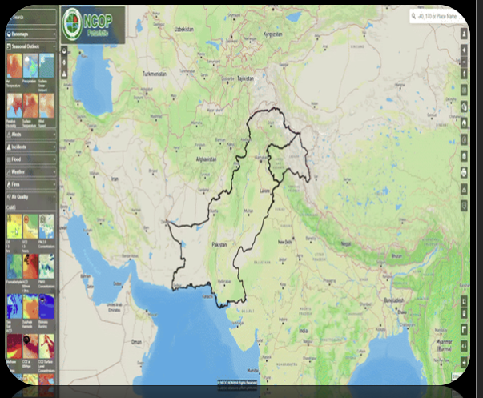
Figure 2: GCOP Version 2.0

Creation of GCOP Version 3.0

Following the foundational progress achieved through GCOP Versions 1.0 and 2.0, the release of GCOP Version 3.0 marked a significant milestone in the system’s transformation from a basic hazard viewer into a comprehensive, analytical, and operational geospatial platform. Building upon the limitations and lessons of earlier iterations, Version 3.0 focused heavily on enhancing usability, improving analytical depth, and broadening the system’s national and global monitoring capabilities.
Version 3.0 introduced a fully redesigned, intuitive user interface aimed at addressing the remaining usability challenges of the previous versions. While Version 2.0 expanded functionality substantially, several analytical tools and visual modules were either difficult to navigate or did not present outputs with the clarity required for operational decision-making. The enhanced UI of Version 3.0 resolved these issues by providing a cleaner and structured layout with improved interactivity while offering users a seamless experience across analytical, forecasting, and monitoring components.
Another major advancement in this version was the system’s enhanced dual-perspective monitoring framework, which enabled users to simultaneously observe both national-level dynamics and global-scale weather and hazard activity. This capability strengthened situational awareness by integrating diverse datasets, allowing stakeholders to transition fluidly between localized risk assessments and broader international hazard trends.

Projections and forecasting capabilities also underwent substantial improvement. Version 3.0 introduced an advanced, custom-built time-slider, enabling users to visualize temporal variations in hazards and weather with a far greater precision. The forecasting modules were expanded with additional meteorological and geospatial resources, offering deeper insights and more accurate predictive modeling than the previous iterations.
Operational tools such as alerts, incident reporting, and hazard geotagging were also refined and strengthened in Version 3.0. These enhancements included a more robust alert management system, improved incident visualization, and more accurate geotagging workflows. A major improvement was the integration of DEW and exposure monitoring directly into the platform which enabled real-time assessment of vulnerable populations and assets. This integration addressed key gaps in Version 2.0, where DEW outputs existed but were not fully represented in the UI or analytical modules.
One of the most transformative upgrades introduced in Version 3.0 was the inclusion of graphical and map-based analytical dashboards. These tools provided dynamic data visualization, chart-based analysis, and spatial representation of hazards and weather indicators—turning GCOP into an advanced analytical environment rather than a mere viewer of natural events. Users were able to explore the exposure metrics, hazard intensities, temporal variations, and comparative risk analyses through interactive charts and spatial layers, offering a more comprehensive understanding of evolving conditions.
In summary, GCOP Version 3.0 represented a mature, feature-rich evolution of the platform. It resolved many longstanding limitations, enhanced operational workflows, and introduced sophisticated analytical capabilities that significantly improved hazard awareness, forecasting accuracy, and decision support. This version sets a new standard for the GCOP ecosystem by combining intuitive design with advanced geospatial intelligence while ensuring that the platform was both efficient for daily operations and powerful enough for the national-level disaster risk management.
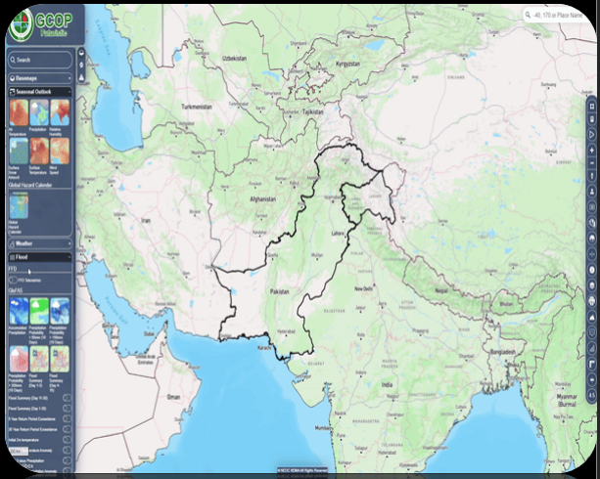
Figure 3: GCOP Version 3.0

Summary of Major Systems and Technical Advancements (2023–2025)

Between 2023 and 2025, the GCOP ecosystem underwent significant expansion, transitioning from early-stage concept development to a mature, feature-rich operational platform. These years marked the consolidation of multi-hazard monitoring capabilities, introduction of advanced analytical tools, and evolution of the system’s infrastructure to support national and global situational awareness. Several major systems were designed, deployed, and continuously refined, forming the foundation for the GCOP Version 3.0.

Global Command & Operations Platform (GCOP)
Formerly introduced as NCOP, GCOP became the central operational environment for multi-hazard monitoring and decision support. During 2023–2025, the platform was expanded to include the following:
- Multi-hazard monitoring and real-time forecasting
- National and global alert and incident management workflows
- 6-month and 12-month meteorological projections
- Advanced visualization layers, thematic maps, and analysis modules
- Dual dark/light theme support for improved usability
- Integrated AI-driven chatbot assistant for platform guidance
These improvements transformed GCOP into a comprehensive analytical and operational system capable of delivering timely insights and supporting situational awareness across multiple sectors.

Assessment & Response Calculator (ARC), later named as DEW (Disaster Early Warning)
The ARC module evolved into a fully automated assessment engine supporting disaster risk analysis. Its key capabilities include:
- Automated exposure calculations for population and infrastructure
- Structural vulnerability and impact assessment workflows
- Multi-hazard threat mapping
- Evacuation planning (implemented in Version 1 and Version 2)
- Integration of Global Climate Change (GCC) indicators.
This system significantly enhanced GCOP’s analytical capacity and enabled field-ready decision-making.

Climate Projection Systems

A major component of the 2024–2025 development cycle was the expansion of long-range forecasting. The climate projection suite included:
- 6-Month projections: air temperature, precipitation, humidity, snowfall, and wind
- 12-Month projections: extended into 2026
- CMIP6 global climate model scenarios
- CORDEX-CORE regional downscaled models
- Probable Futures datasets
- Seasonal forecasting layers
These tools strengthened GCOP’s long-term risk assessment capabilities and supported planning for climate-sensitive sectors.

Alert & Incident Management Framework
The alerting ecosystem was extensively upgraded, enabling end-to-end management of hazard notifications and field incidents. Key features included:
- Automated alert generation for floods, earthquakes, landslides, droughts, GLOF events, heatwaves, and wildfires
- Media-supported incident reporting
- Shapefile-based alert creation
- SIMEX (simulation exercise) integration
- Role-based access control
- Alert-to-incident conversion workflows
This framework enabled rapid communication and incident tracking across multiple departments.

Global Monitoring & Data Integration
To support GCOP’s global perspective, numerous international datasets and APIs were integrated, covering:
- Earthquakes (USGS, PMD, shakemaps)
- Weather (MeteoBlue premium, DWD radar, GDPS, rain radar systems)
- Air quality (CAMS, OpenWeather AQI, dust models)
- Flood forecasting (GeoGLOWS, GLOFAS)
- Health (WHO datasets)
- Economics (World Bank)
- Conflict and crisis monitoring (HDX, ReliefWeb, GDACS, GDELT)
- Real-time news and social media feeds

These integrations ensured GCOP’s ability to visualize and analyze global-scale hazards continuously.

Infrastructure & Exposure Analysis Tools
Comprehensive infrastructure mapping and exposure modelling were deployed to support national risk analysis. Included systems:
- Health and education facilities
- Communication towers
- Transportation networks (roads, rail, airport, seaport)
- Dams and reservoirs
- Hydropower stations
- Agricultural impact assessment
- Population exposure modelling
These analytical components strengthened GCOP’s readiness for nationwide disaster response.

Technical Infrastructure Evolution

Backend Development
- Django-based REST architecture
- PostgreSQL 14 + PostGIS for spatial operations
- Nginx and Waitress for production deployment
- Docker experimentation (adapted due to Windows Server limitations)
- Git with formal branching strategy and protection rules

Frontend Technologies
- Vite.js bundling for improved performance
- Mapbox GL & OpenLayers for geospatial rendering
- ES6 modules and optimized async patterns
- Responsive UI with dark/light theming
- Chart.js and Recharts for dashboards and analytical charts
- Custom AI assistant integrated with CORS support

Geospatial Stack
- Geoserver for MVT vector tiles and raster processing
- SLD styling for consistent symbolization
- GeoJSON, Shapefile, NetCDF, and GRIB2 support
- Multi-projection capability for local and global datasets

External API Integrations
- Meteorological APIs (MeteoBlue, Open-Meteo, DWD, GDPS, Geomet)
- Satellite data (FIRMS, MODIS, Planet)
- Disaster data (USGS, GDACS, EONET, ReliefWeb)
- Climate services (ECMWF CAMS, IPCC datasets)
- Global institutions (WHO, World Bank, HDX, flight tracking APIs)

2025 Highlights

Major Innovations
Introduction of GCOP’s first AI Chatbot Assistant
- Theme system with professional-grade dark/light UI
- Launch of 12-month climate projections
- Real-time disaster news + social media integration
- Global Hazard Calendar for historical trend analysis
- Comprehensive documentation, deployment guides, and templates
- Performance Enhancements
- Large-scale codebase refactoring
- Layer caching and loading optimization
- Faster database queries and API responses
- Reduced frontend bundle size
- User Experience Improvements
- Enhanced legends and control wrappers
- Improved mobile responsiveness
- Redesigned popups and modular workflows
Table 3: Major Milestones
Period | Milestone
Nov 2023 | Project inception & team formation
Q4 2023 | Foundation systems (FMS, EMHVRAS and Anticip)
Q1 2024 | NCOP launch with core platform features
Q2 2024 | Advanced tools: MetEye, calculators and flood portals
Q3 2024 | Alerts system, ARC module and global data portals
Q4 2024 | Production optimization and 6-month projections
Q1 2025 | 12-month projections and climate scenarios
Q2 2025 | Data expansion (WHO, World Bank) and GCOP branding finalized
Q3 2025 | UI overhaul (themes, chatbot, and news integration)
Q4 2025 | Refinements, 2026 projections and performance optimization

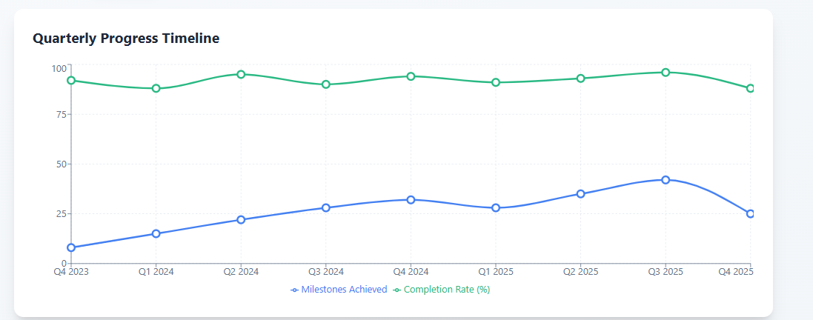
Figure 4: Time line of completion

Infographic Detail
The following is a representation of all the previous details in graphical formats
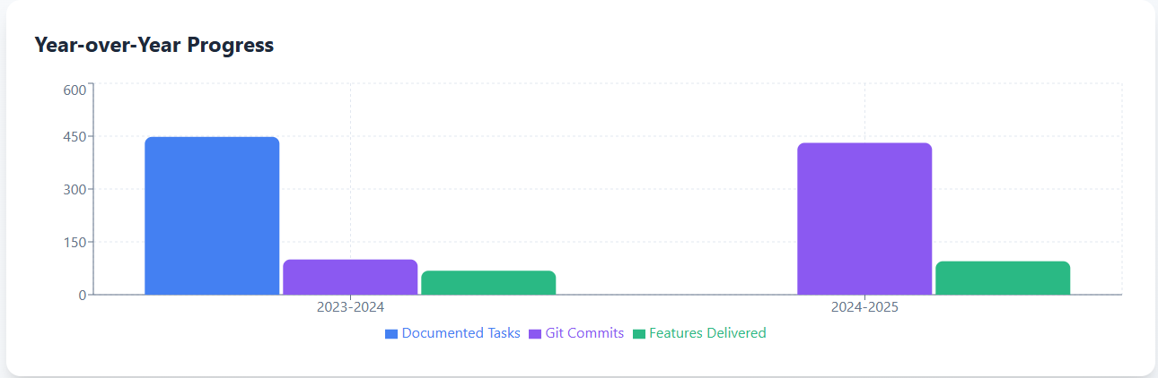
Figure 5: Yearly Progress
Figure 4 represents the yearly progress of the workflow of GCOP regarding feature creation and etc. Whereas Figure 5 gives information regarding the monthly tasks and features delivered. The entire distribution of feature development is illustrated in Figure 6.
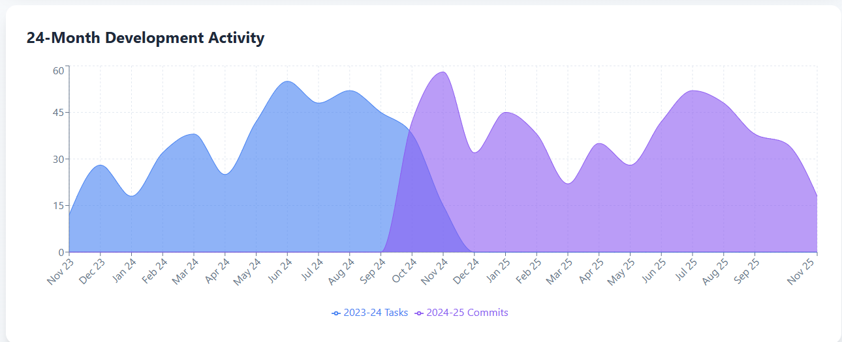
Figure 6: Monthly Development Activity

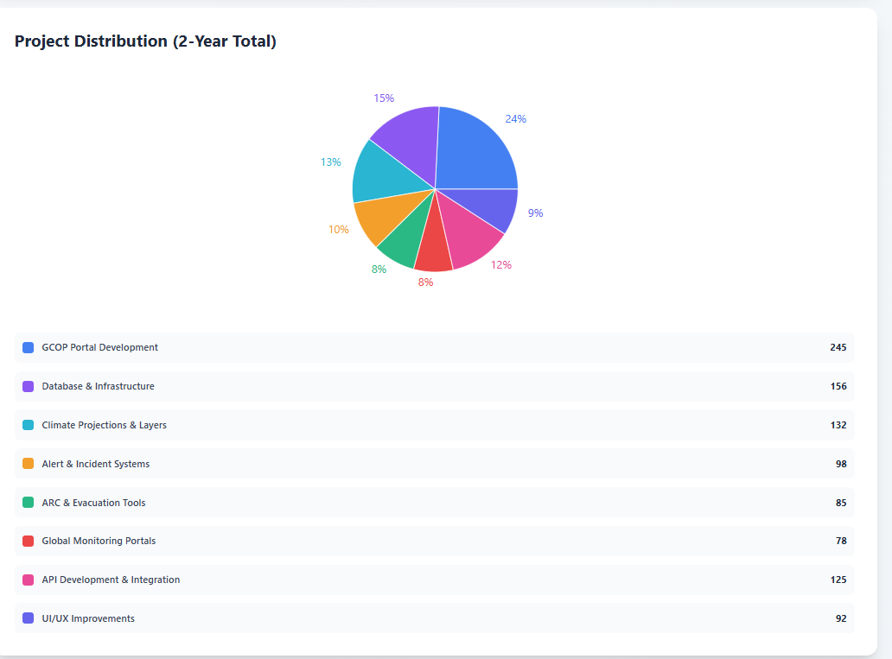
[Grab your reader’s attention with a great quote from the document or use this space to emphasize a key point. To place this text box anywhere on the page, just drag it.]e
Figure 7: Distribution

The Current GCOP version 3.0

The Current GCOP formally NCOP is a is a fully modernized, multi-hazard and operational monitoring system designed to support national disaster management. It integrates real-time data from meteorological, hydrological, and seismic sources, enabling automated alerts, incident management, and visualization of affected areas. GCOP provides both short-term and long-term forecasting, drawing from global datasets and local ground stations, and presents the information through a highly interactive GIS interface with multiple layers and custom visualizations. The platform tracks development progress and project milestones, providing comprehensive dashboards that display tasks, Git commits, and key achievements over multiple years. Its user interface has been redesigned for usability and responsiveness, featuring dark/light modes, advanced legends, and customizable views. GCOP’s robust reporting, visualization, and data integration capabilities make it a center.
The use of AI tool for decision-making, operational coordination, and strategic planning ensures efficient management of disaster response and national-level risk monitoring.

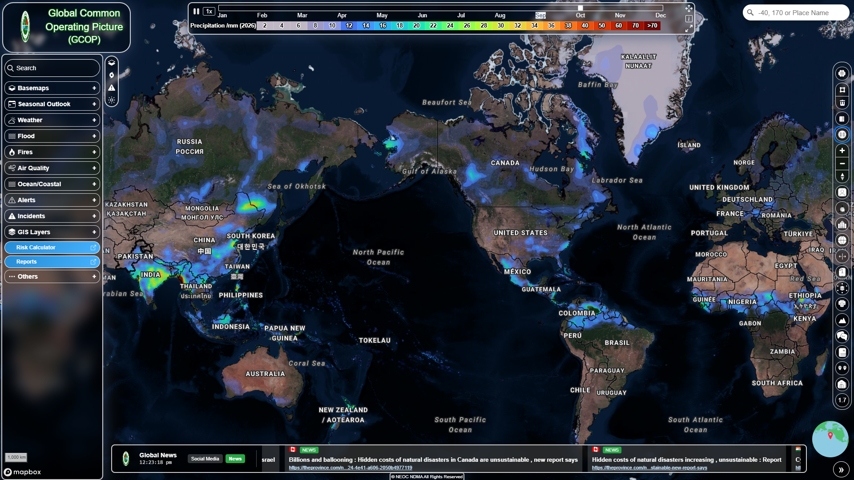
Figure 8: Current GCOP Version

