Customer Segmentation Analysis
Behavioral & Demographic Clustering using K-Means
Data Analytics Internship Project
Tools: Python · pandas · scikit-learn · matplotlib · seaborn
Prepared as part of the Data Analytics Internship

1. Project Objective
The goal of this project is to segment an e-commerce company's customer base into distinct, actionable groups using both demographic attributes (age, income, city tier, gender) and behavioral / transactional attributes (recency, frequency, monetary value, engagement). Segmentation allows the business to move from a one-size-fits-all approach to targeted marketing, personalized offers, and more efficient retention strategies.
Expected outcome: hands-on experience with the full customer analytics workflow — data preparation, exploratory analysis, unsupervised clustering, cluster evaluation, and translating clusters into business insight.

2. Dataset Overview
The analysis uses a customer-level dataset of 1,200 records with 17 attributes, combining demographic and behavioral (RFM-style) fields:
- Demographics: Age, Gender, City Tier, Annual Income, Membership Years
- Behavioral / RFM: Recency (days since last purchase), Frequency (orders/year), Average Order Value, Total Spend
- Engagement: Online Engagement Score, Cart Abandon Rate, Discount Sensitivity, Returns Rate, Support Tickets
- Preference: Preferred Product Category, Churn Risk flag
Note: no proprietary company data was available for this internship task, so a statistically realistic synthetic dataset was generated with internally consistent relationships (e.g., income correlates with average order value; tenure correlates with purchase frequency) so that clustering surfaces genuine, explainable patterns. The same pipeline works unchanged on a real CRM/transaction export — simply point Step 1 at the real file.

3. Methodology

3.1 Exploratory Data Analysis (EDA)
Distributions of key numeric fields (age, spend) were examined, along with income across city tiers and the mix of preferred product categories, to understand the customer base before modeling.
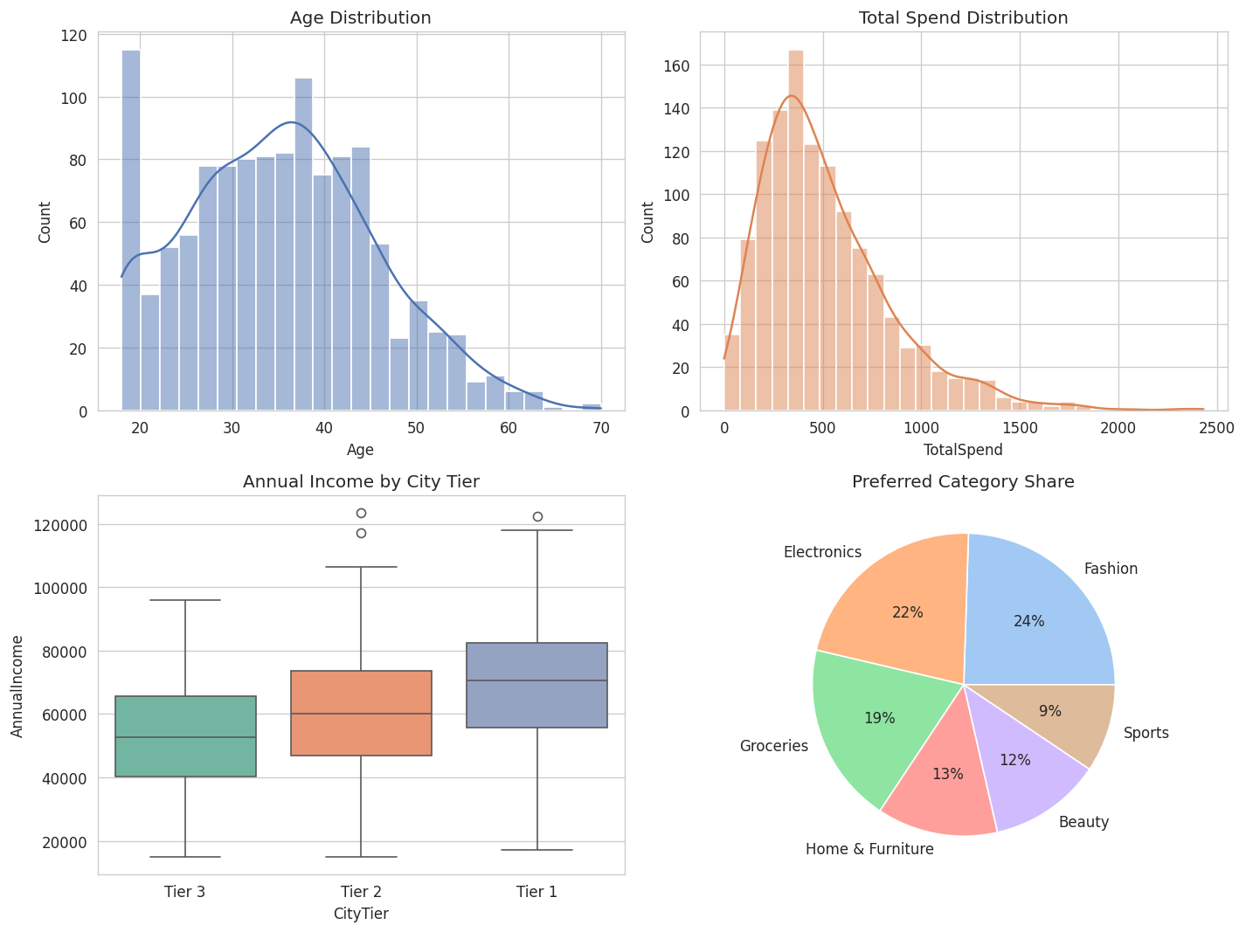
Figure 1: Distribution of Age, Total Spend, Income by City Tier, and Category preference
A correlation heatmap was used to check for multicollinearity and to understand which behavioral signals move together (e.g., Frequency and Total Spend).
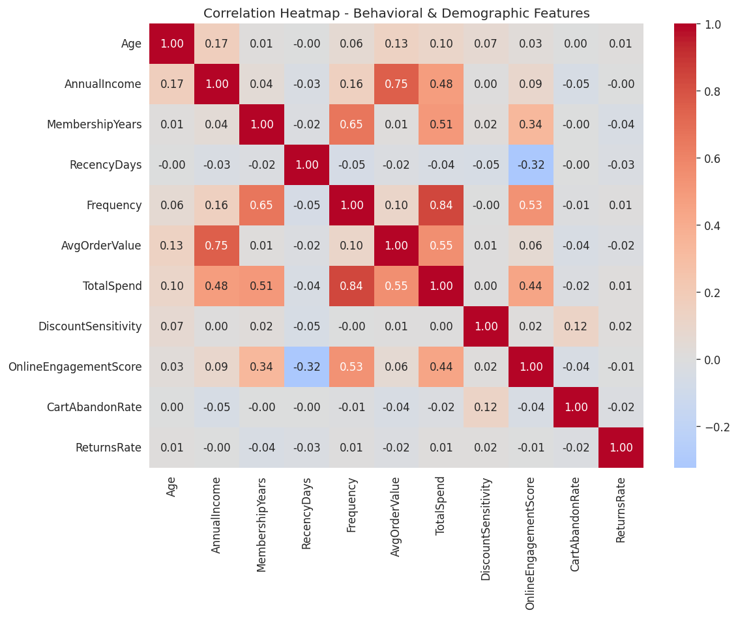
Figure 2: Correlation heatmap of numeric behavioral & demographic features

3.2 Preprocessing
- Categorical fields (Gender, City Tier, Preferred Category) were label-encoded for exploratory use.
- Clustering features were standardized with StandardScaler (zero mean, unit variance) so that high-magnitude fields like Income don't dominate distance calculations.
- Feature selection: after testing several feature subsets, the core RFM features (Recency, Frequency, Average Order Value, Total Spend) plus Annual Income, Membership Years and Online Engagement Score gave the best-separated, most business-interpretable clusters. Secondary fields (returns, cart abandonment, gender) were kept for profiling but excluded from the clustering step itself, as they added noise rather than structure.

3.3 Choosing the Number of Clusters (k)
Two standard techniques were used together to select k: the Elbow Method (looking for the point of diminishing returns in within-cluster variance) and the Silhouette Score (measuring how well-separated clusters are, from -1 to 1).
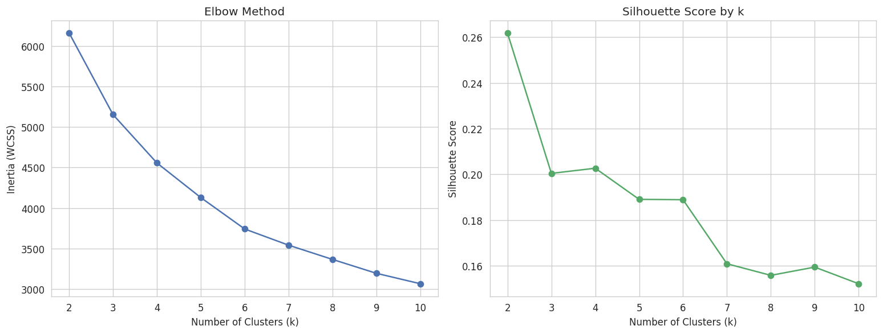
Figure 3: Elbow method (left) and silhouette score (right) across k = 2–10
Silhouette score alone favored a very small k, which would have produced segments too broad to act on. Balancing statistical fit with business usability, k = 4 was selected — a standard, actionable segment count for lifecycle marketing (e.g., Champions / Regulars / At-Risk / Budget), yielding a silhouette score of 0.20, a reasonable result for noisy, real-world-style customer data.

3.4 Clustering & Visualization
K-Means (scikit-learn, n_init=10, random_state=42) was fit on the standardized feature set with k = 4. Principal Component Analysis (PCA) was then used to reduce the feature space to two dimensions for visualization, capturing about two-thirds of the total variance.
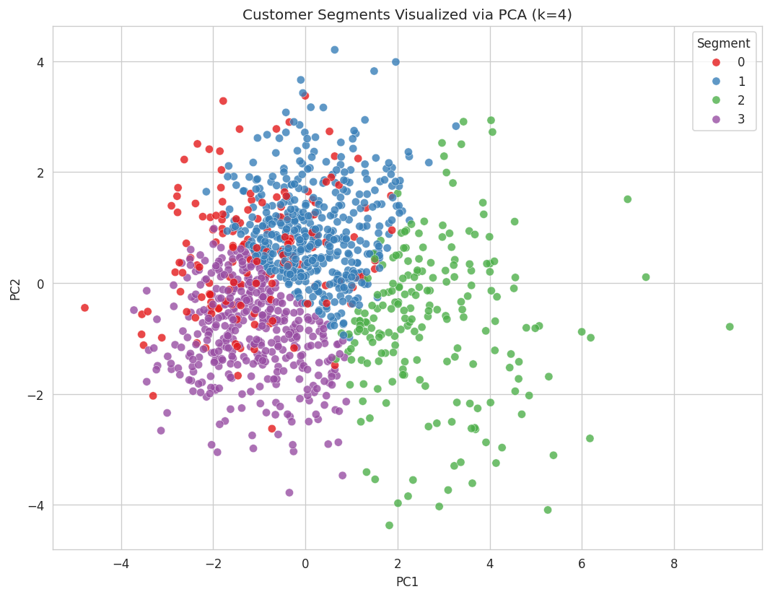
Figure 4: Customer segments projected onto the first two principal components

4. Segment Profiles
The table below summarizes each segment's average demographic and behavioral profile.
Segment | Size | Avg Age | Avg Income | Tenure | Recency | Freq/yr | AOV | Total Spend | Engagement | Churn Risk
Champions (High-Value Loyal) | 202 (16.8%) | 36.6 | $72,051 | 5.2 yrs | 35 days | 12.5 | $82.1 | $1,021.6 | 73.9 | Low
Mainstream Regulars | 455 (37.9%) | 35.8 | $75,309 | 1.4 yrs | 30 days | 6.0 | $88.3 | $526.2 | 58.2 | Medium
At-Risk / Dormant | 148 (12.3%) | 35.8 | $59,062 | 1.6 yrs | 127.6 days | 5.6 | $69.0 | $392.4 | 44.2 | Medium
Budget-Conscious / New | 395 (32.9%) | 33.5 | $45,619 | 1.7 yrs | 28.8 days | 5.5 | $52.3 | $285.8 | 58.6 | Medium

4.1 Segment Size
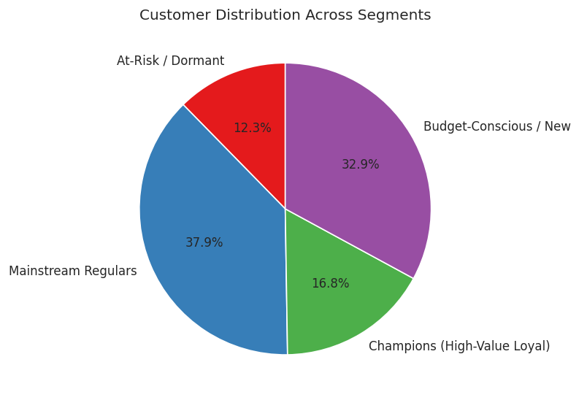
Figure 5: Share of customers in each segment

4.2 Key Metrics Compared
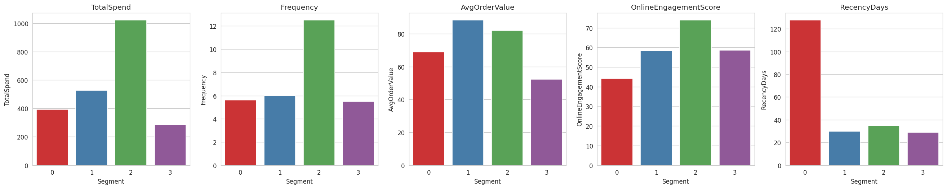
Figure 6: Total Spend, Frequency, AOV, Engagement and Recency compared across segments

4.3 Category Preference by Segment
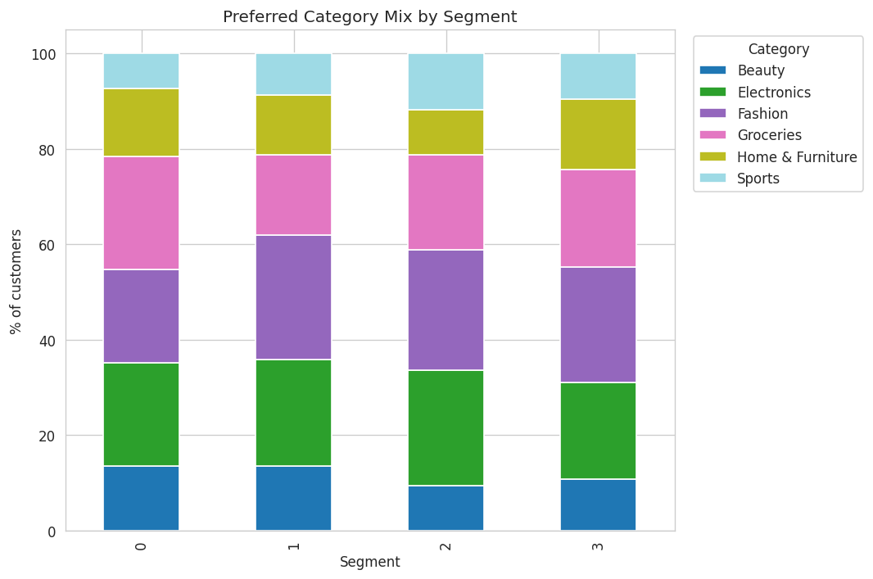
Figure 7: Preferred product category mix within each segment

5. Segment Insights & Recommendations

Segment 1 — Champions (High-Value Loyal) — 16.8%
Longest average tenure (5.2 yrs), highest frequency (12.5 orders/yr), highest total spend ($1,022) and highest engagement score (73.9). Lowest churn risk.
- Reward with a VIP/loyalty tier, early access to new arrivals, and exclusive perks — protect this segment's satisfaction above all else.
- Use as advocates: referral programs and reviews carry more weight from this group.
- Avoid heavy discounting here — they are not price-driven; margin can be protected.

Segment 2 — Mainstream Regulars — 37.9%
The largest segment. Recently active (30 days), moderate frequency (6/yr), highest average order value ($88.3), solid income ($75k).
- Primary revenue engine — focus retention campaigns and cross-sell/upsell here.
- Personalized product recommendations and bundle offers can lift order value further.
- Monitor for early drift toward the At-Risk segment via recency tracking.

Segment 3 — At-Risk / Dormant — 12.3%
By far the longest time since last purchase (127.6 days) and the lowest engagement score (44.2), despite historically moderate income.
- Trigger a win-back campaign: reactivation email/SMS with a time-limited incentive.
- Survey a sample to understand the drop-off reason (price, competitor, product fit).
- If reactivation fails after 2–3 attempts, deprioritize spend on this group to protect marketing ROI.

Segment 4 — Budget-Conscious / New — 32.9%
Second-largest segment, lowest income ($45.6k) and lowest average order value ($52.3), but recently active (28.8 days) with decent engagement (58.6).
- Highly responsive to discounts, bundle deals, and free-shipping thresholds — use value-driven promotions rather than premium positioning.
- Nurture toward Mainstream Regulars with onboarding journeys and small loyalty incentives for repeat purchase.

6. Conclusion
K-Means clustering on RFM and demographic features successfully split the customer base into four statistically distinct and business-actionable segments. Each segment has a clear behavioral signature and a corresponding marketing action — from VIP retention for Champions to win-back campaigns for the At-Risk group. This mirrors the standard customer-analytics workflow used in industry (EDA → preprocessing → cluster tuning → profiling → business recommendations), and the same script can be re-run on a real transactional export by replacing the data-generation step with an actual data load.
Deliverables: cleaned & labeled dataset (CSV), full Python pipeline (3 scripts), 8 visualizations, and this summary report.

