|  |
| --- |
| Esajee Procurement |
| UI and Functional Design |
| V0.2 |

1. Overview

This document covers the first phase of the procurement module of the Esajee ERP Suite. The resulting module should not be considered commercial off the shelf ready to sell product. Since this module has to integrate with the existing Esajee systems, this document does not cover the user management and access control list. Moreover, Saas is not a consideration at this point.

1. Existing Business Process

* Purchase requests are handled by staff and added to the purchase list
* The items are periodically sent via
  + Email
  + Microsoft Excel
  + Communicated via Phone
* Vendors receive orders and fulfillment process starts
* Invoice is sent for clearance
* 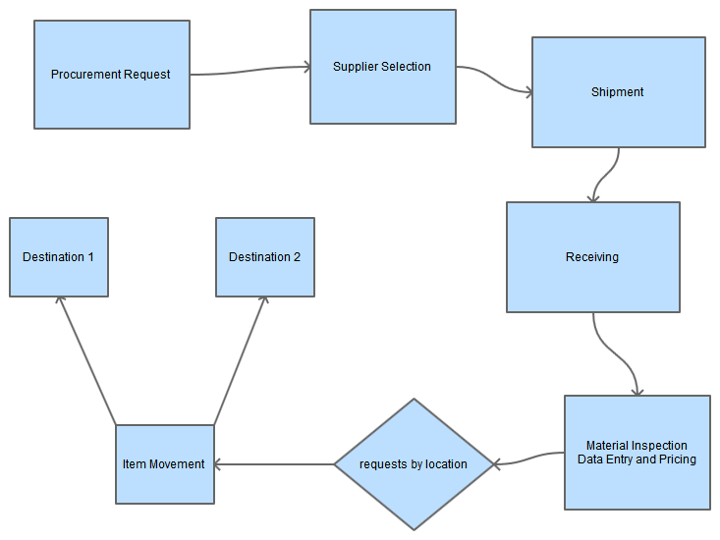Invoice is added to the system after material inspection

1. Limitations

* Supplier Comparison is often not available
* Barcodes aren’t always listed in the supplier invoice
* Multiple data entry points and no history may result is duplicate or incorrect orders
* No deadlines and incorrect fulfillment may result in losses
* Customer’s orders that are not tracked properly may result in losses
* Multiple data entry steps result in delayed shelving or incorrect pricing

1. Solution Overview

Esajee Procurement is intended automate the business process and document all entry points at a single place that could be used as reference in future. Moreover, it will help

* make critical business decisions
* reduce product losses
* streamline data entry and pricing mechanism

1. Features
   1. Access Control List

Existing users of the system will have the ability to login to the application.

* 1. System Settings
* Will only be reserved for Admin group
* Settings will override the existing settings of Esajee Systems including Date, Time, Currency
  1. ***Purchase Indent***
  2. ***Bulk Indent***
  3. ***Supplier Selection***
     1. ***Quotations***
     2. ***Approval***
  4. ***Purchase Orders***
  5. ***Goods Arrival (Shipment)***
  6. ***Material Inspection***
  7. ***Receiving (Stock Updates)***

1. 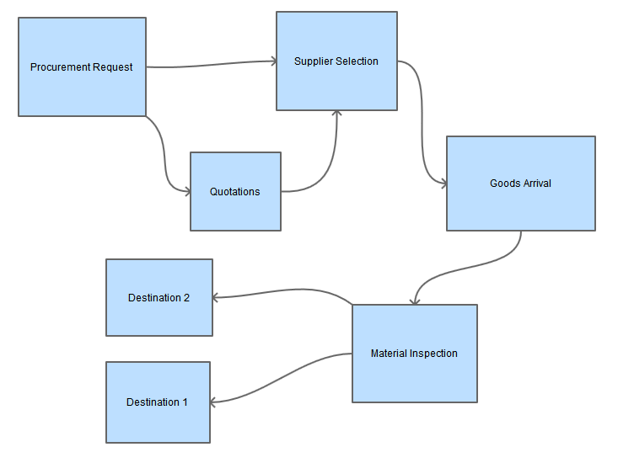**Process Flow**

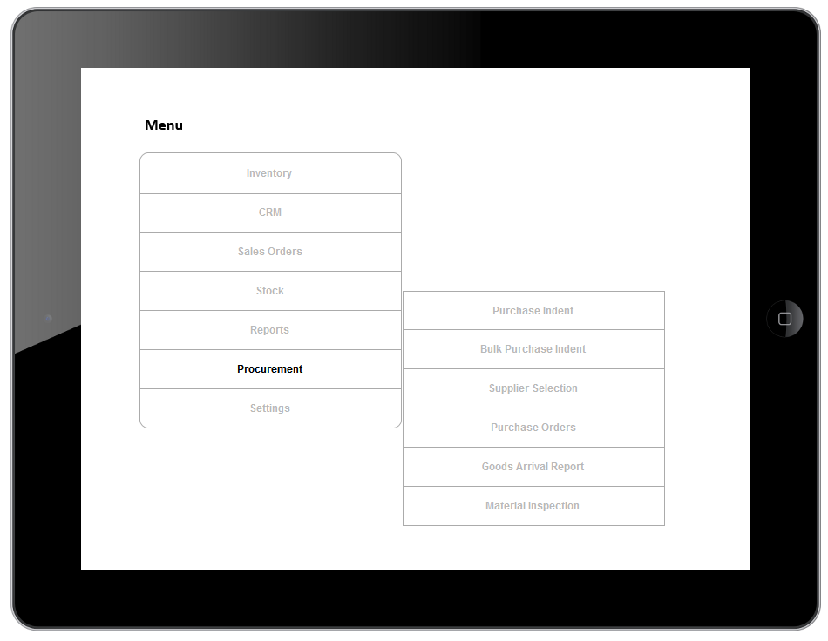**New Menu**

**Following sections were added to new menu:**

1. **Inventory**
2. **CRM**
3. **Sales Orders**
4. **Stock**
5. **Reports**
6. **Settings**

**All settings were moved to “Settings” menu**

* 1. 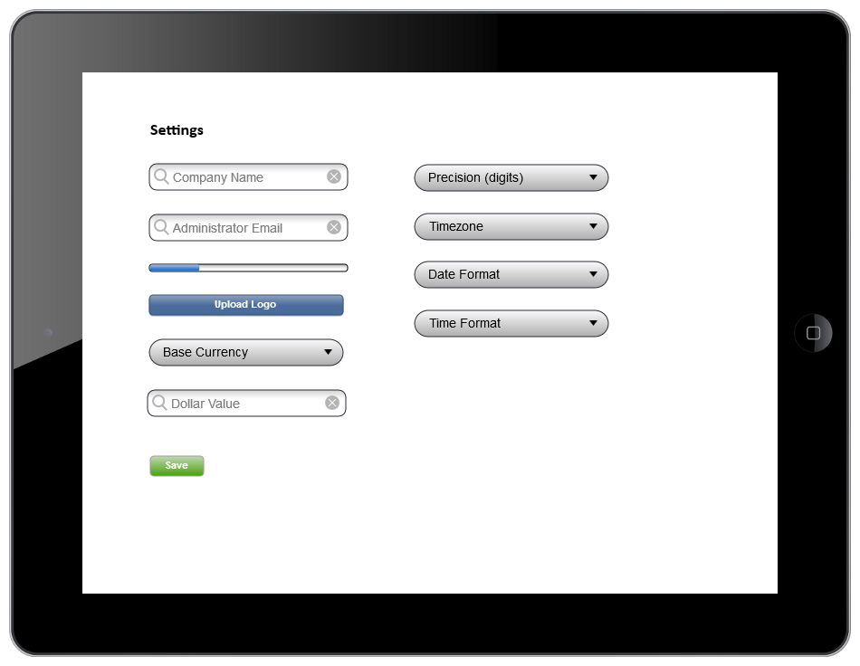***System Settings (Admin Only)***

*A new version of Settings page has been created and will replace the existing page, see below:*

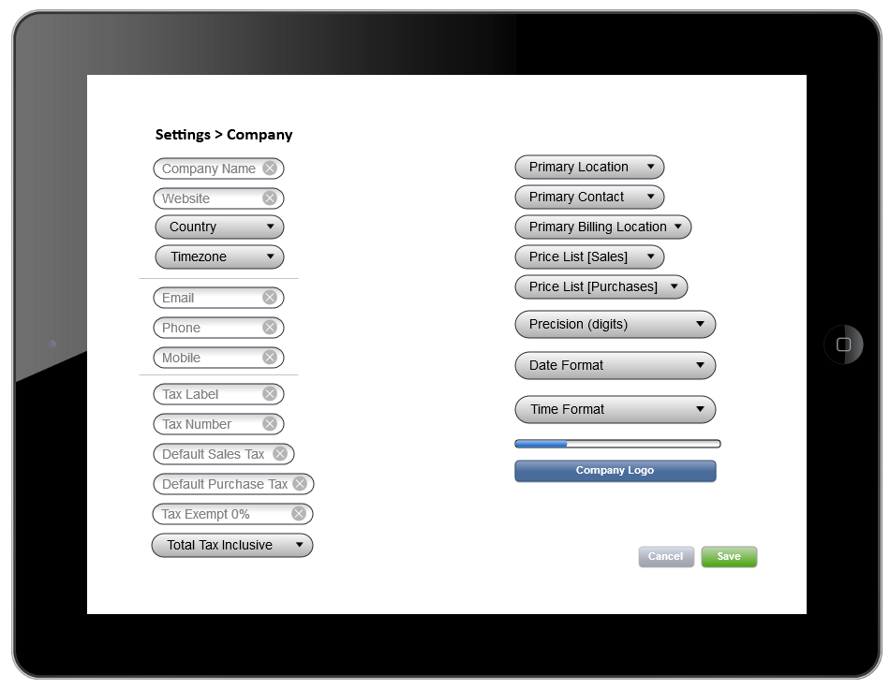

*Following changes were made to this page:*

1. *Currencies were moved to a separate section “Currencies”*
2. *New fields were added*
   1. *Website*
   2. *Country*
   3. *Phone*
   4. *Mobile*
3. *Global Taxes section was added (it applies on company level). For more than one company, two separate accounts should be managed.*
   1. *Tax Label*
   2. *Tax Number*
   3. *Default Sales Tax*
   4. *Default Purchase Tax*
   5. *Tax Exempt*
   6. *Total Tax*
      1. *Inclusive(applied on items and is part of total amount)*
      2. *Exclusive(is applied on subtotal and not included in the individual item’s price)*
   7. *Primary Location*
      1. *Warehouse*
      2. *Kohsar*
      3. *Gulberg*
      4. *DHA*
   8. *Primary Contact*
      1. *Administrator*
      2. *Owners*
   9. *Primary Billing Location*
      1. *Kohsar*
      2. *DHA*
   10. *Price List (sales)*
       1. *Wholesale Price*
       2. *Retail Price*
       3. *Purchase Price*
       4. *Trade Price*
   11. *Price List (Purchases)*
       1. *Wholesale Price*
       2. *Trade Price*
   12. ***Purchase Indent***

***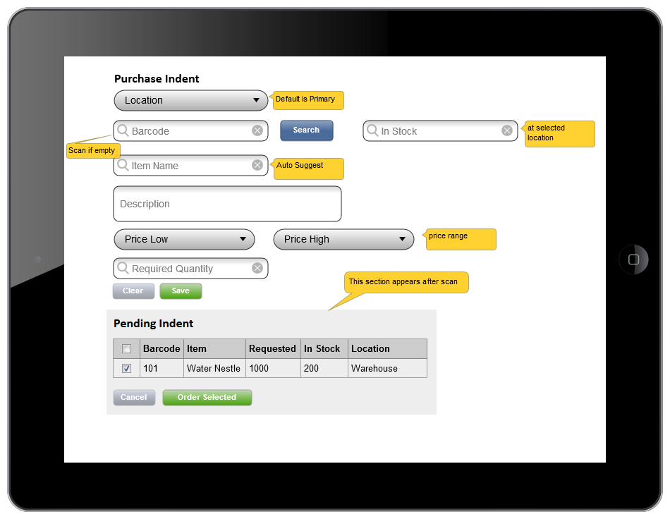****The purchase indent screen has been modified and a new screen with a few modifications has been added:*

Following features have been added to the screen:

1. Location has been added
2. In stock will now show existing units of the selected location of procurement.
3. Price range selection options have been added, this will fetch existing “Low” and “High” range from the selected location.
4. “Existing Indent” has been changed to “Pending Indent” and will not account for the “Purchase”, “In Transit”, “Fulfilled” units.
5. “Order Selected” should display the item in the form above it and only the order quantity should be added to process the indent.
   1. 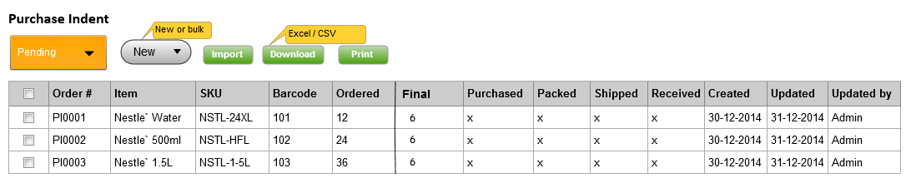**Purchase Indent (Management View)**

Initially, the status of indent is “Pending”. With each step of the procurement process, the status of item is updated at this screen. The “Final”, “Purchased”, “Packed”, “Shipped”, and “Received” are linked to the detailed information about these actions. Import process is explained on the next page.

Note: Item column will contain following information:

1. Item Name
2. Description

If value in “Final”, “Purchased”, “Packed”, “Shipped”, “Received” is less than “Ordered” column, the order will be considered partially processed.

This screen will have 2 more views according to user types:

1. 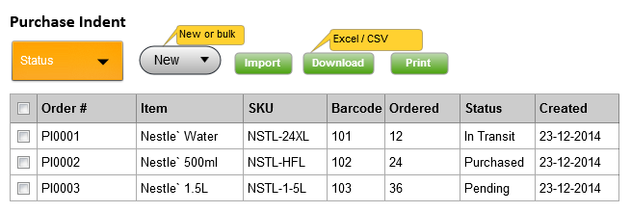Data Entry (who requested item)
2. 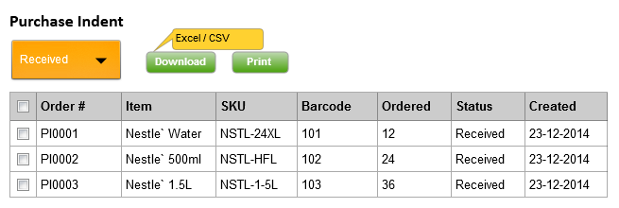Data Entry (who received item)
3. ***Import***

Excel or CSV file could be uploaded to import new items to the existing indent. A review screen will be opened up where user could perform following operations:

1. Select desired items for upload
2. Change quantity

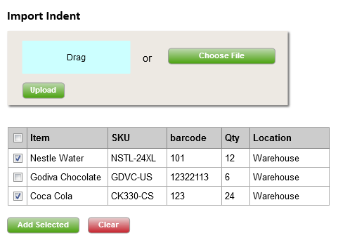

*Location is displayed from the user’s active location defined in user management section.

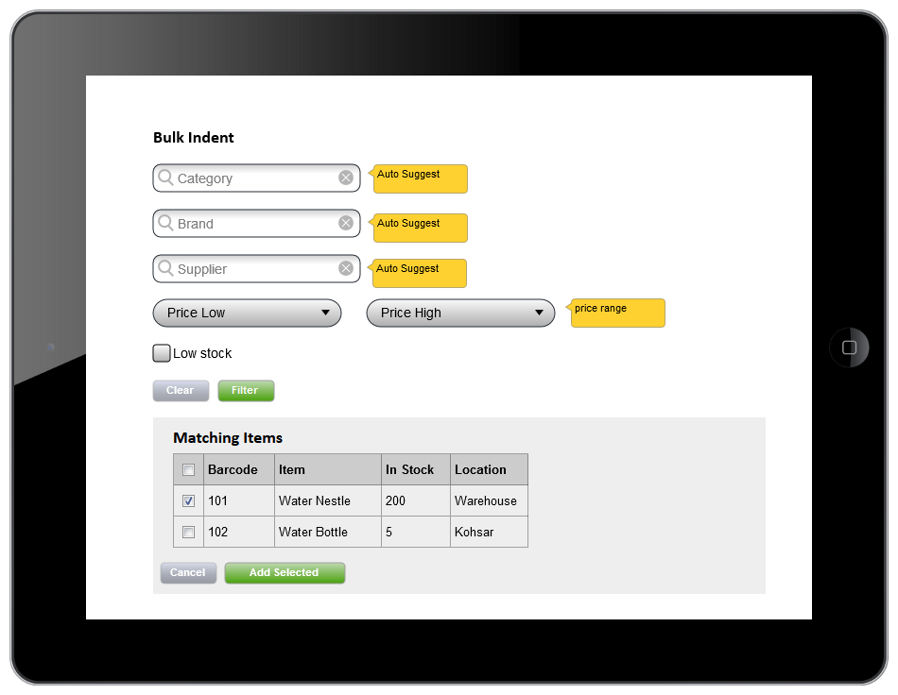

1. ***Bulk Indent***

This screen will be used to add bulk (more than one) items to the purchase indent. The filters will help user find the desired items from existing stock. After finding the right items, user could add them to the purchase indent. Location has been added to help search and add items from all available locations.

1. ***Supplier Selection***

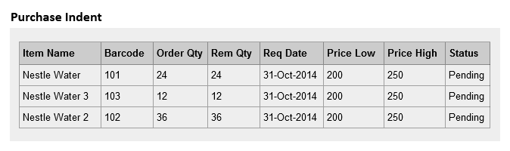This screen will display all purchase indent items that are either Pending or partially processed.

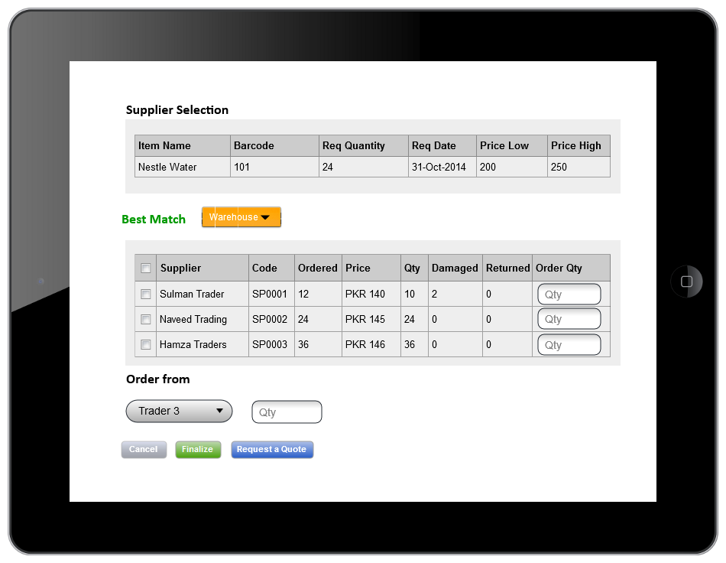When any of the items from this list is selected, it will display following interface for further processing.

1. Selected items could be ordered from the best match or from the list of available suppliers.
2. Supplier Comparison is displayed on the basis location. This report gives useful insight to the past purchases and helps in supplier selection process. If user has access to other locations, the filter is provided to view other locations data.
3. On pressing the “Finalize” button, selected item will be moved to the “Pending” purchase order of the selected supplier.
4. “Request a Quote” will move the item to active quotations of selected supplier.
5. Both 3 & 4 will not appear in Supplier’s Panel (discussed later in this document under “Supplier Panel” head) until the process is finalized by the requesting person.
6. ***Request for Quotation (new quotation)***

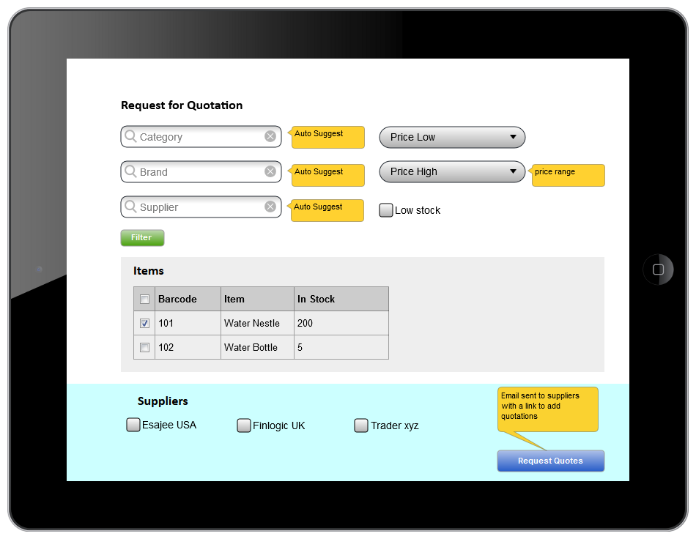This screen will be used to create new quotations in bulk. The mechanism will be very similar to Bulk Indent.

***\* Change:*** *Emails will be sent after quotes are finalized and not on the “Request Quotes” action.*

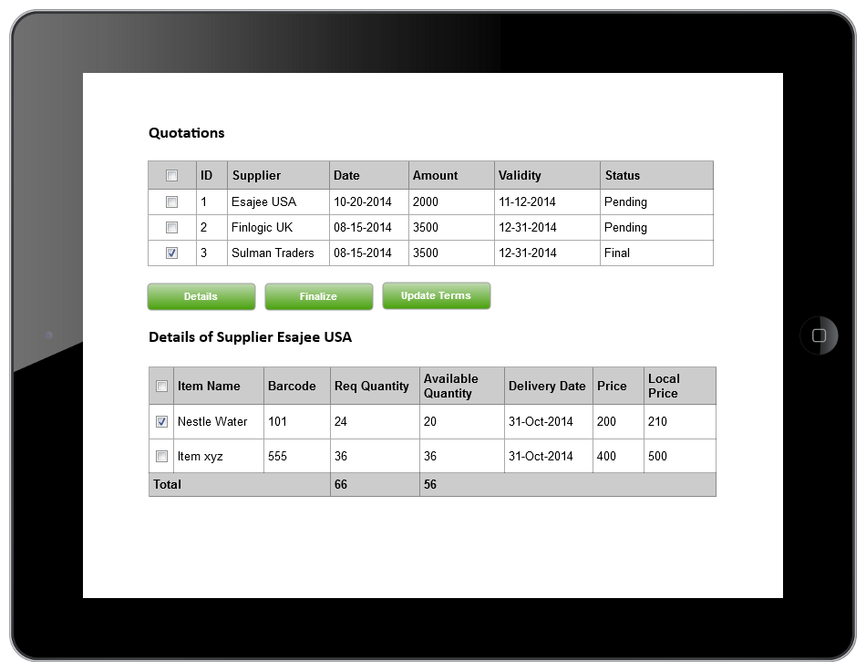Quotations could be processed and finalized from this screen. Once processed, email will be sent to the supplier with details.

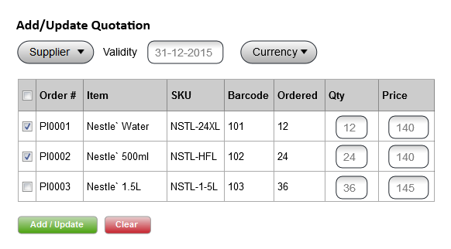After receiving response from the supplier, a user could select the desired quotation and update supplier rates and quantity by using “Update Terms” from the Add/Update Quotations screen.

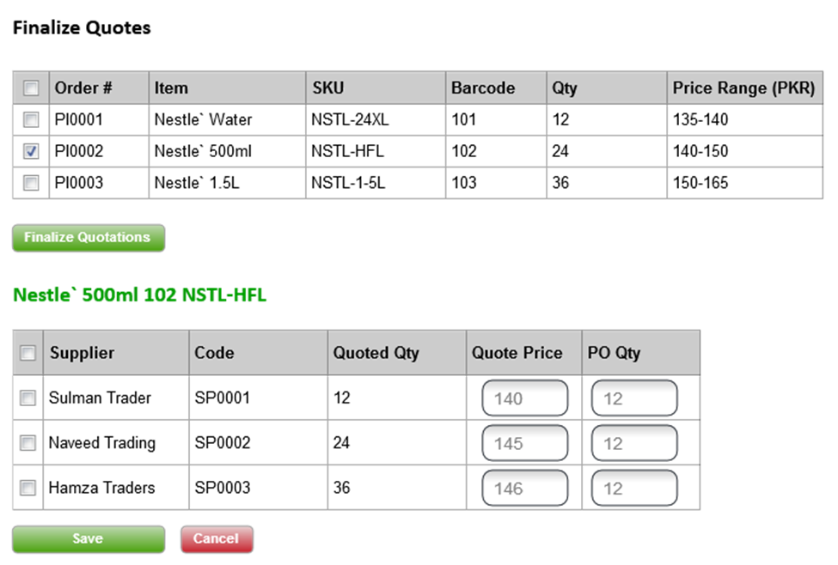

Finalize Quotes, is to make final changes and update quotes to Purchase Orders. Both “Quote Price” and “PO Qty” could be negotiated and changed after consultation with selected suppliers. After save operation, following processes will be performed:

1. A purchase order (with status Finalized) will be created for the selected supplier(s)
2. PO quantity will be updated in the PO
3. Validity, Quote Price and Currency will be taken from Quote
4. 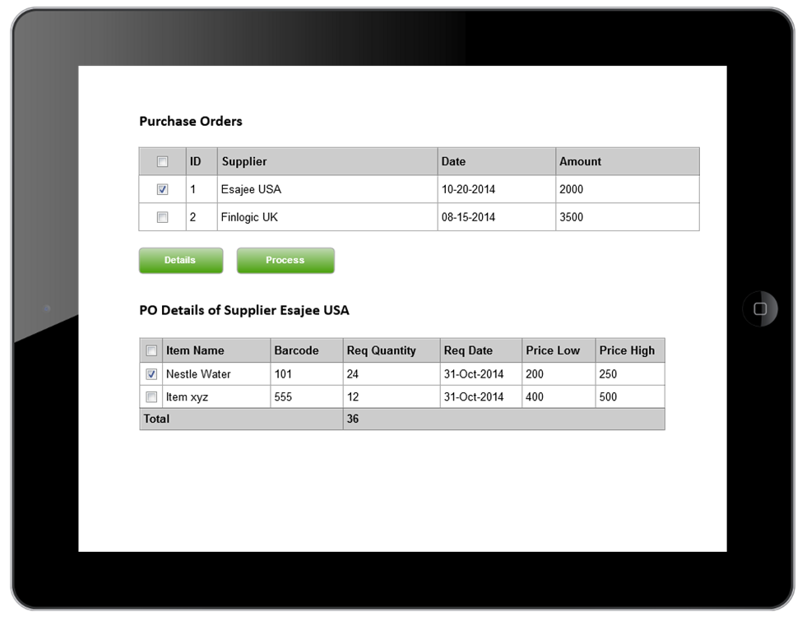***Purchase Orders***

This screen will be used to view detailed of final purchase orders and to make a requisition request.

1. 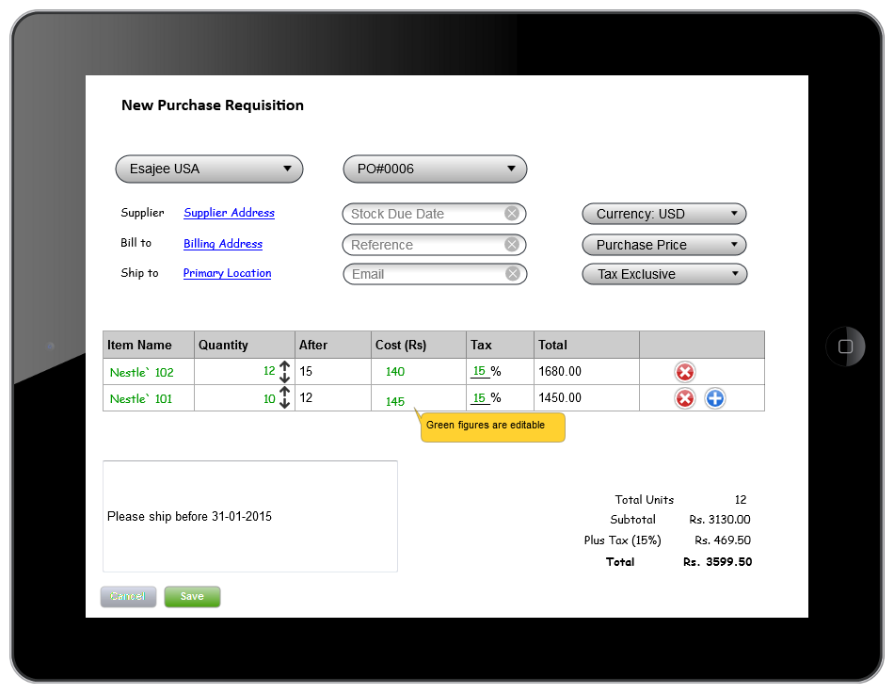**Add Purchase Requisition**

This screen is used to add a new purchase request (with or without indent)

* + 1. Select Supplier and fields like “supplier address”, “supplier email” will be auto filled
    2. Select Valid PO and remaining items will be auto filled. Otherwise add/remove items from +/- buttons
    3. Bill to and Ship to should be selected from available locations
    4. Notes for supplier could be added to the text area.
    5. Upon saving the requisition, an email will be sent to supplier with details and it will also appear in **Supplier Panel**.

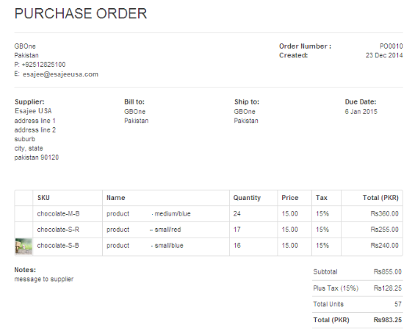Purchase Requisition Preview of Email/Print

1. 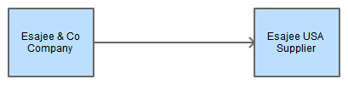**Supplier Panel**

In order to understand the relationship between “Company” making a procurement request and the “Supplier” please see the diagram below:

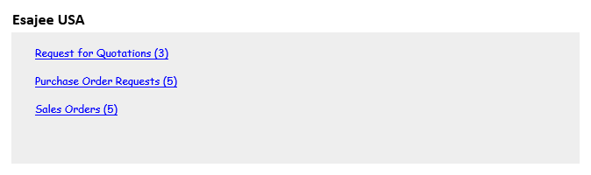Here Esajee & Co as a company has been making all the transaction like adding purchase indent, making quotations and sending to different suppliers. Esajee USA as one of the suppliers could login to an application and view all requests for quotations, purchase orders and sales orders. This panel will be available to all suppliers of the system however it will not be compulsory to process orders. A simple view of the panel is displayed below:

1. **Request for Quotations**

This section will display approved quotations for supplier feedback and will be very similar to the add quotations screen discussed earlier and mentioned below:



1. **Purchase Order Requests**

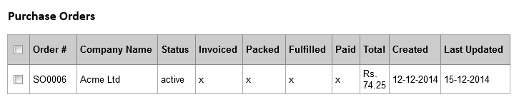This is the section that will display “**New Purchase Requisition**” for this supplier. The shopping list could be printed from the same.

1. **Sales Orders**

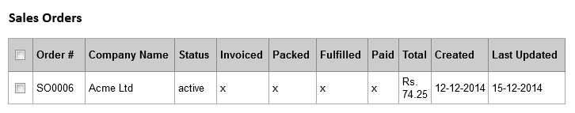Esajee USA (as a supplier) will deliver items to Esajee & Co and in order to do so will process “Purchase Requisition” by creating sales orders. The sales order is the “Fulfillment” side of the supplier and will contain different steps to handle the requisition cycle. This process will involve following steps:

1. 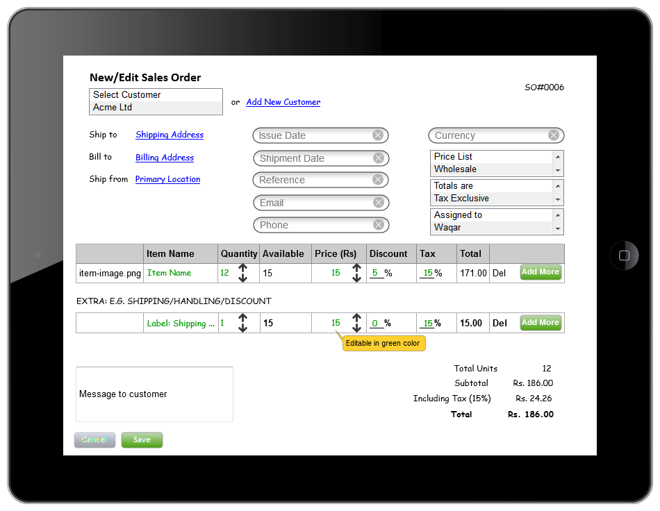**Add Sales Order**

A “Sales Order” will pick items from the “Purchase Requisition” that is sent to the supplier. The customer will be the “Company” requesting the items. Similarly, shipping and billing location could be selected. Line items like “shipping and handling” could be added. Once, this process is complete and sales order is saved, it will generate a “Goods Arrival Report” for the company.

Items in sales order could be packed from the same screen.

Sales Order could be packed in the following way:

1. 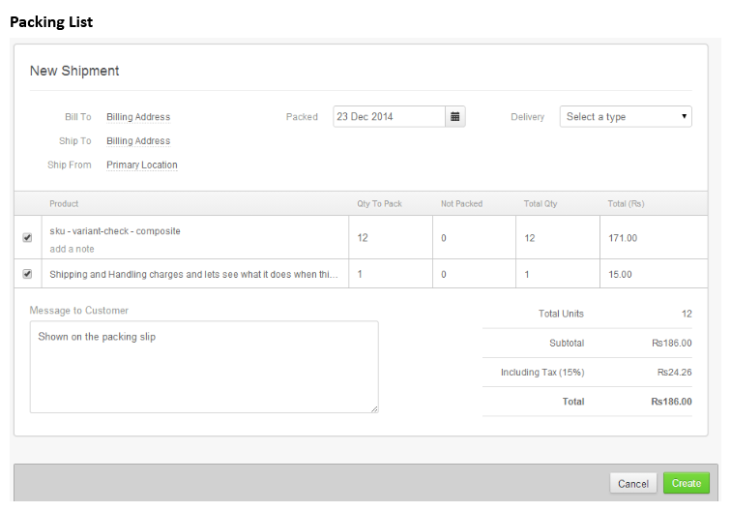**Generate Packing List**

When sales order is packed and a shipper/delivery type is saved, the status of the original purchase requisition and corresponding items will become in transit.

1. 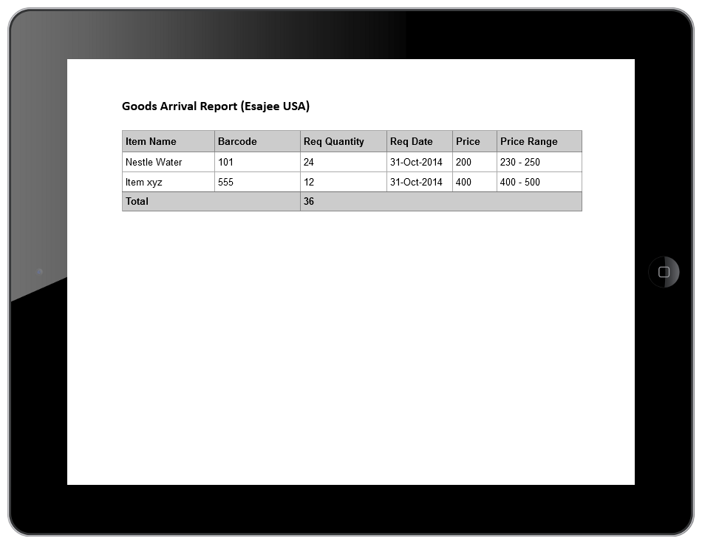***Goods Arrival Report***

This report will be available to the receiving department of the company requesting items.

1. 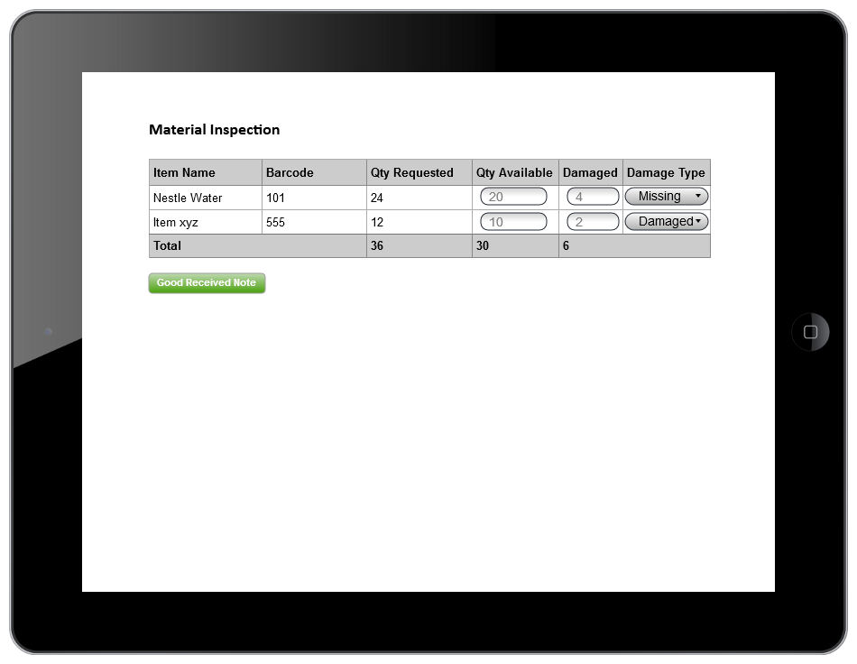***Material Inspection***
   1. *This step could be performed at the destination/receiving location*
2. ***Goods Received Note***

Goods received noted is a report that confirms that goods sent by the supplier have been received at the destination. This confirms the items sent by the supplier vs the items ordered via Purchase Order. (INVOICE that goes to accounts with reference to supplier PO)

***Implementation at Esajee***

In case of Esajee, following steps are applicable:

1. Purchase Indent and Finalization (by Esajee & Co)
2. Purchase Requisition (by Esajee & Co)
3. Sales Order (by Esajee USA)
4. Receiving (Esajee & Co)

**Additional Settings**

1. **Locations**
2. **Payment Terms**
3. **Price Lists**
4. **Currencies**
5. **Taxes**
6. **Users**
7. **Reports**

These settings are explained the upcoming sections.

1. 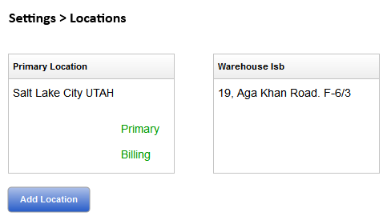Locations

**Add Location:**

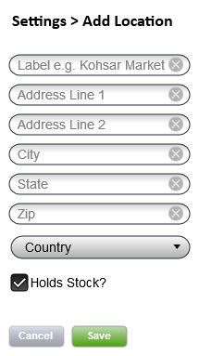

**Holds Stock?**

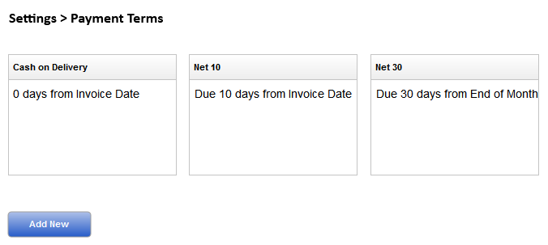If unchecked, the location cannot receive physical stock. E-Commerce sites can be one such example. One location must be marked as Primary/Billing for accounting transactions.

1. **Payment Terms**

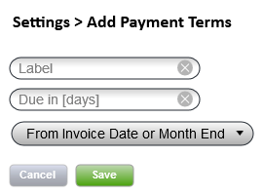**Add Payment Terms**

1. 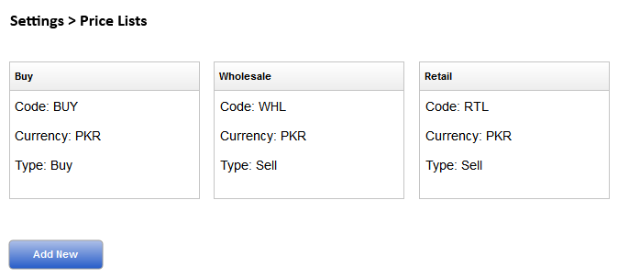**Price Lists**

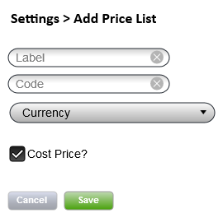**Add Price List**

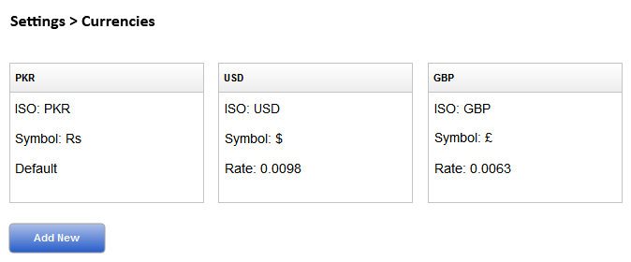

1. **Currencies**

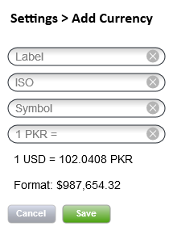**Add Currency**

1. 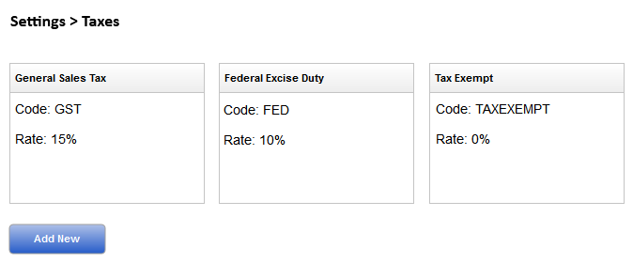**Taxes**

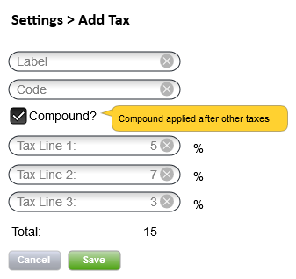**Add Taxes**

1. 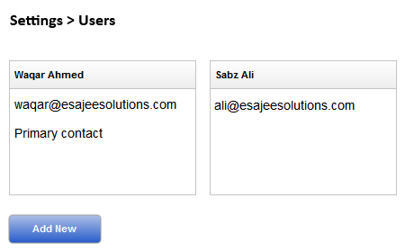**Users**

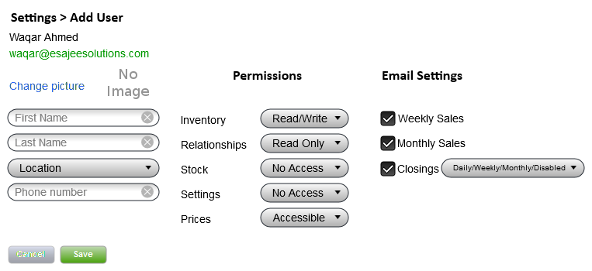**Add User**

1. **Reports**

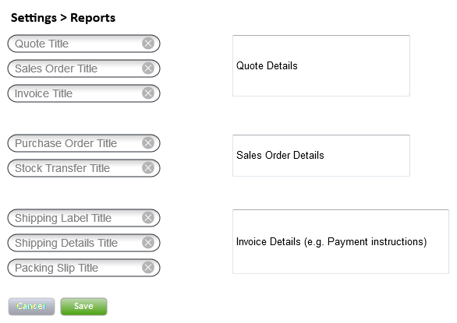

***To do:***

1. ***Shipping Costs (taxes are inclusive)***
   1. ***Freight***
   2. ***Clearing***
   3. ***Commission***
   4. ***(manage international expenses in settings)***
   5. ***Distribute Expense percentage among items (just like in start of the stock)***
2. ***Expiries***

***\*\*The supplier is not Esajee USA instead payment goes to Esajee USA, in this case catering Suppliers / Vendors***

***\*\*\* Accounts posting mechanism for suppliers***