The results when the train/test split is set to the default 67/33 cut:

1. Random Forest Classifier

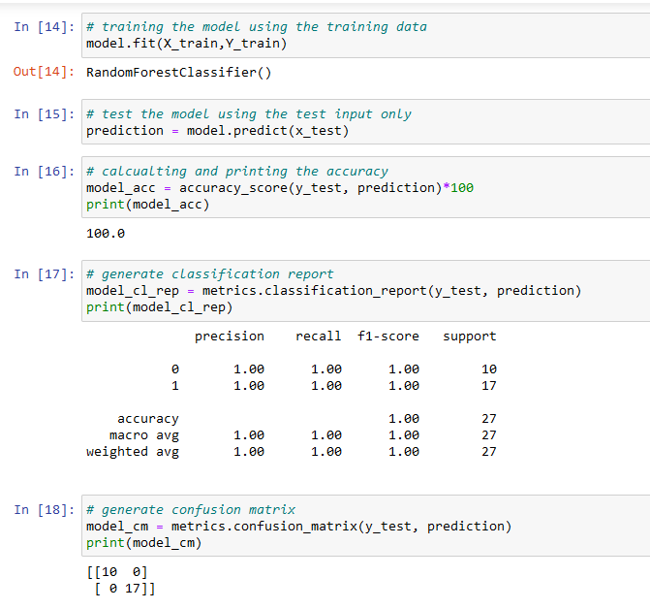

1. Support Vector Machines

1. Multilayer Perceptron Classifier

The results when the train/test split is set to 80/20 cut:

1. Random Forest Classifier

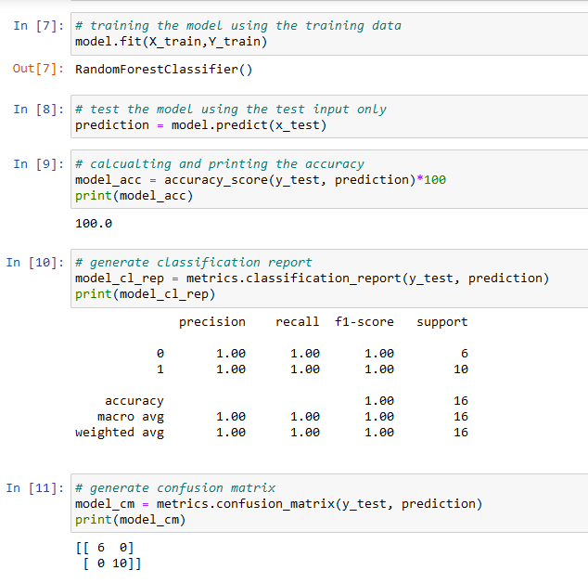

1. Support Vector Machines

1. Multilayer Perceptron Classifier

