Problem: Players get stuck.

Fix: integrated player object inside

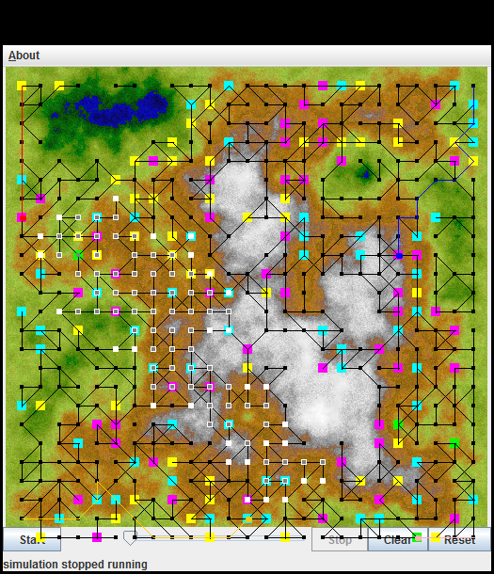

Ï ----jGRASP exec: java ArslanianGiang282P3  
ÏÏ§Ï  
ÏÏ§ÏCreating the tables.  
ÏÏ§ÏTables have been successfully created.  
ÏÏ§ÏOpened database successfully  
ÏÏ§ÏPlayer 1 Gold (20.0, 20.0), $ 92, 2000 $ 1000  
ÏÏ§ÏPlayer 2 Gold (460.0, 500.0), $ 79, 1957 $ 1000  
ÏÏ§ÏPlayer 4 City (500.0, 40.0), $ 70, 2050 $ 1000  
ÏÏ§ÏPlayer 4 City (500.0, 60.0), $ 79, 2108 $ 1000  
ÏÏ§ÏPlayer 3 City (60.0, 480.0), $ 96, 2054 $ 1000  
ÏÏ§ÏPlayer 1 City (20.0, 120.0), $ 84, 1955 $ 1000  
ÏÏ§ÏPlayer 4 Gold (480.0, 80.0), $ 73, 2078 $ 1000  
ÏÏ§ÏPlayer 4 Gold (500.0, 100.0), $ 76, 2050 $ 1000  
ÏÏ§ÏPlayer 3 City (100.0, 460.0), $ 54, 2054 $ 1000  
ÏÏ§ÏPlayer 1 Map (20.0, 160.0) Treasure (80,200) 1890 $ 1000  
ÏÏ§ÏPlayer 1 Map (20.0, 160.0) Treasure (80,200) 1890 $ 1000  
ÏÏ§ÏPlayer 1 Map (20.0, 160.0) Treasure (80,200) 1890 $ 1000  
ÏÏ§ÏPlayer 3 City (120.0, 460.0), $ 98, 2101 $ 1000  
ÏÏ§ÏPlayer 4 Map (420.0, 200.0) Treasure (320,80) 1846 $ 1000  
ÏÏ§ÏPlayer 1 Map (20.0, 160.0) Treasure (80,200) 1890 $ 1000  
ÏÏ§ÏPlayer 1 Map (20.0, 160.0) Treasure (80,200) 1890 $ 1000  
ÏÏ§ÏPlayer 4 Map (420.0, 200.0) Treasure (320,80) 1846 $ 1000  
ÏÏ§ÏPlayer 1 Map (20.0, 160.0) Treasure (80,200) 1890 $ 1000  
ÏÏ§ÏPlayer 1 Map (20.0, 160.0) Treasure (80,200) 1890 $ 1000  
ÏÏ§ÏPlayer 1 Map (20.0, 160.0) Treasure (80,200) 1890 $ 1000  
ÏÏ§ÏPlayer 3 Gold (220.0, 500.0), $ 54, 1957 $ 1000  
ÏÏ§ÏPlayer 1 Map (20.0, 160.0) Treasure (80,200) 1890 $ 1000  
ÏÏ§ÏPlayer 1 Map (20.0, 160.0) Treasure (80,200) 1890 $ 1000  
ÏÏ§ÏPlayer 4 Map (420.0, 200.0) Treasure (320,80) 1846 $ 1000  
ÏÏ§ÏPlayer 4 Map (420.0, 200.0) Treasure (320,80) 1846 $ 1000  
ÏÏ§ÏPlayer 1 Map (20.0, 160.0) Treasure (80,200) 1890 $ 1000  
ÏÏ§ÏPlayer 1 Map (20.0, 160.0) Treasure (80,200) 1890 $ 1000  
ÏÏ§ÏPlayer 4 Map (420.0, 200.0) Treasure (320,80) 1846 $ 1000  
ÏÏ§ÏPlayer 1 Map (20.0, 160.0) Treasure (80,200) 1890 $ 1000  
ÏÏ§ÏPlayer 1 Map (20.0, 160.0) Treasure (80,200) 1890 $ 1000  
ÏÏ§ÏPlayer 4 Map (420.0, 200.0) Treasure (320,80) 1846 $ 1000  
ÏÏ§ÏPlayer 4 Map (420.0, 200.0) Treasure (320,80) 1846 $ 1000  
ÏÏ§ÏPlayer 3 City (260.0, 480.0), $ 87, 1986 $ 1000  
ÏÏ§ÏPlayer 4 Map (420.0, 200.0) Treasure (320,80) 1846 $ 1000  
ÏÏ§ÏPlayer 4 Map (420.0, 200.0) Treasure (320,80) 1846 $ 1000  
ÏÏ§ÏPlayer 4 Map (420.0, 200.0) Treasure (320,80) 1846 $ 1000  
ÏÏ§ÏPlayer 1 Map (20.0, 160.0) Treasure (80,200) 1890 $ 1000  
¼¼ÏÏ