# **Overview**

Our team is consisting of 3 three people:

* **Arsen Ishan TS-2002.**
* **Alhakim Saiken TS-2002.**
* **Arina Shalgynbayeva TS-2001.**

Having learned the information that we are in a team, the first thing we did was creating a group on a social network. Our subsequent discussions about the project and interactions took place on the discord platform. Since the essence of the project was not to create something individual but had a clear indication that it is the site about football, we assigned responsibilities and helped each other during the entire project.

Rehearsing and repeating the topics we went through, as well as getting good grades were the leading motivation for completing the project. Since, unfortunately, there will be no continuation of this course.

The project consisted in the fact that we are creating two sites about football. One of which was supposed to display information about the participants of both teams, as well as the score, at the end of which the winner with possible options for goals was revealed. Another site simply provides information about our three-person team. A script was used to count the goals. Moreover, another task was to build a server for displaying a general photo of the team and the provided video from YouTube.

# **Project goals and team interests**

Project goals

* Make the correct head count
* Consolidate knowledge of HTML, CSS, and Java script
* Learn how to attach a video on a specific server using express.js

Team interests

• Review HTML and CSS to create a soccer website.

• Get a clearer idea of how to bind objects with html with java script

• Learn to bind video to the server so that it works without problems

# **Phases**

* Phase 1 – Creation of site skeletons, that is, HTML and its work with CSS
* Phase 2 – Connecting sites to each other, as well as Java scripts with inputs from the site
* Phase 3 – Server building
* Phase 4 – Upload on GitHub

# **Content structure**

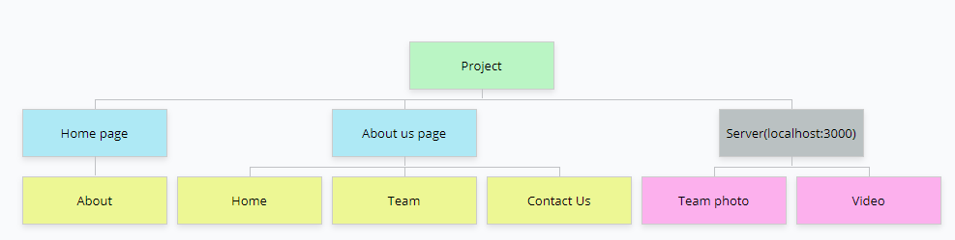**Site map**

**Content types**  
Keeping scores of goals in football.

**Design**

* Image files:
  + - <file:///C:/Users/user/AppData/Local/Temp/Rar$EXa11332.32804/final%20project/aboutteam/Sakura.png>
    - <file:///C:/Users/user/AppData/Local/Temp/Rar$EXa11332.32804/final%20project/aboutteam/Sasuke.png>
    - <file:///C:/Users/user/AppData/Local/Temp/Rar$EXa11332.32804/final%20project/aboutteam/Naruto.png>
    - <file:///C:/Users/user/AppData/Local/Temp/Rar$EXa11332.28048/final%20project/home/Astana_IT_University.png>
    - <https://images.alphacoders.com/116/1168055.jpg>
* Colors:
  + - rgba(244,168,200,1), rgba(0,109,246,1)(for background, Home page)
    - black and white(for text)
    - rgba(131, 8, 8, 0.87)(for shadow, About us page)
    - midnight blue(for footer background)
* Typography rules:
  + - 'Roboto', sans-serif (for navbar, home page)
    - Monospace (Home page text)  
      Verdana, Geneva, Tahoma, sans-serif (for description, About us page)
    - Georgia, 'Times New Roman', Times, serif (for heading, About us page)

**Functionality**

The functionality of our site is that it calculates which team won and how many points they received. And from the server side, we made a transition to the about and home page with a link to the video and photo. Another functionality of our site includes the output of text with the results.

**Hosting**

First, we created a repository by naming it. Then we downloaded all the necessary templates such as HTML, CSS, app.js and package.json file. Then we copied the repository link by clicking on the settings in the upper right corner.

**Accessibility**

The site is easy to read, and the design is minimalistic, which does not hurt the eyes. Two boxes for two groups where it will be easy to enter the names of the participants, and two boxes are provided for keeping score. In addition, the fonts are not so small which makes them convenient to read.

**Deadlines**

* Phase 1 – November 14, 23:59
* Phase 2 – November 18, 23:59
* Phase 3 – November 20, 23:59
* Phase 4 – November 21, 23:59

# **Summary**

In this project, we used all our knowledge that was gained during these 10 weeks. Of course, this is not a level to work as a web programmer, but it is a good start to become one. We learned how to work as a team, saw misunderstandings during development and various conflicts, but this is also an experience.