Main program

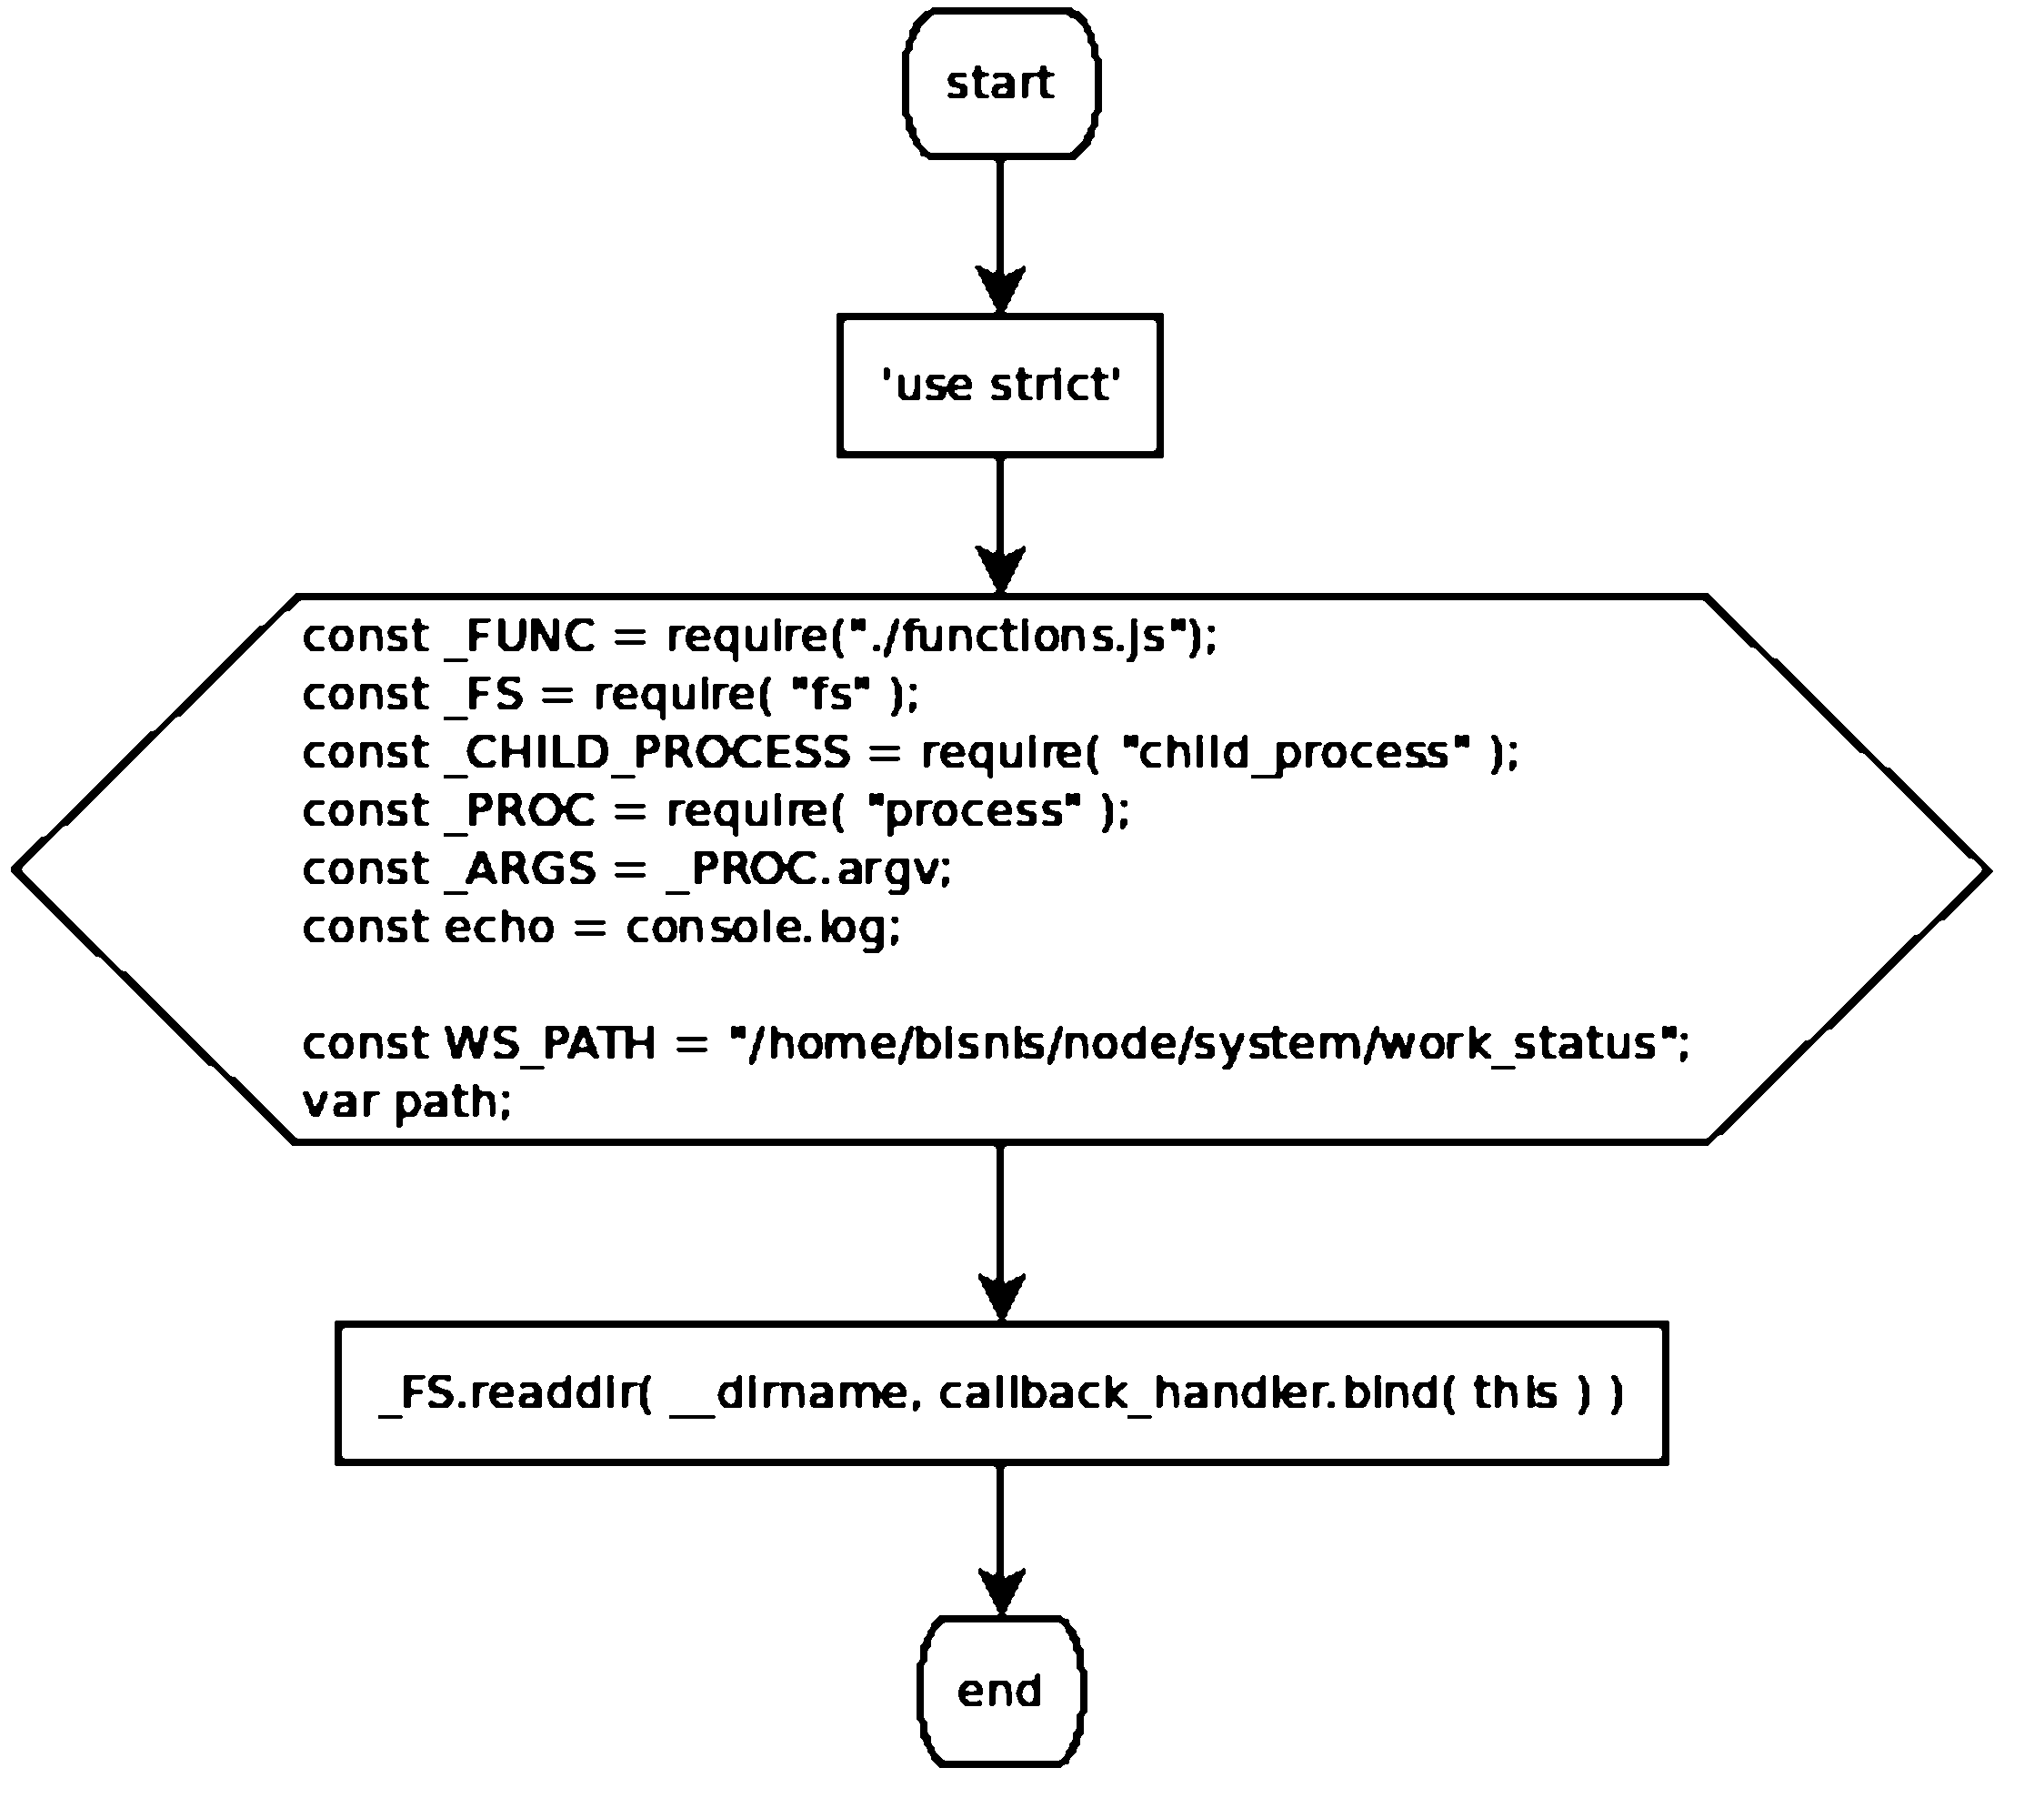

Refers to:
- callback_handler

async function callback_handler( err, items )

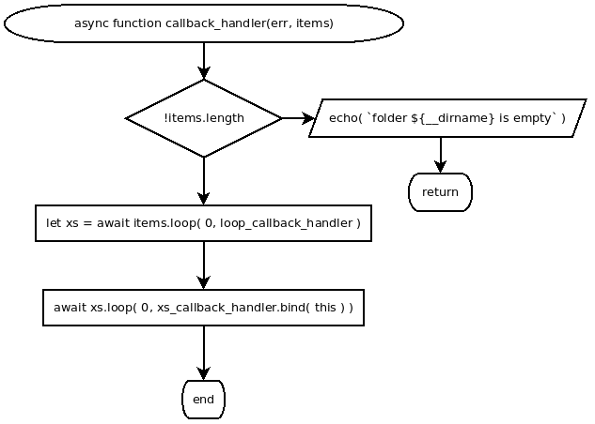

Refers to
- loop_callback_handler
- xs_callback_handler

async function loop_callback_handler(i, item)

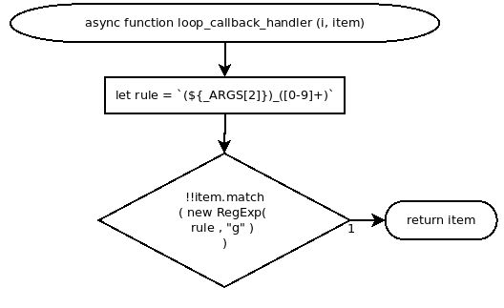

async function xs_callback_handler( item )

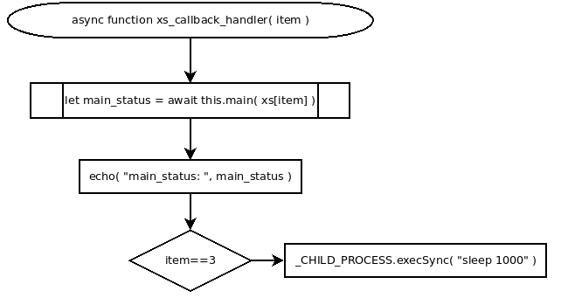

Refers to:
- this.main( source_path )

this.main = async function( source_path )

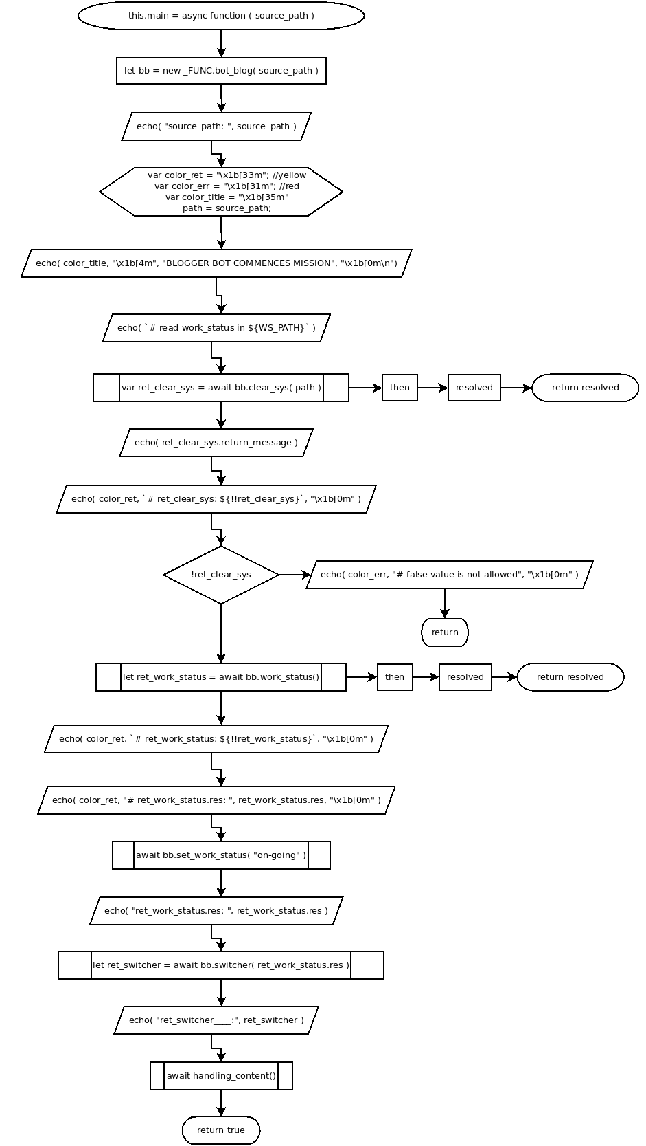

Refers to:
- set_work_status()
- switcher()
- handling_content()

async function handling_content()

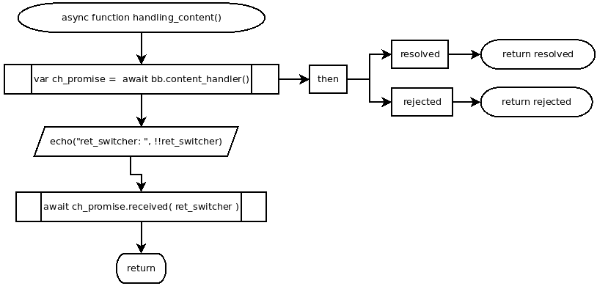

Refers to:
- content_handler()

async function set_work_status( status )

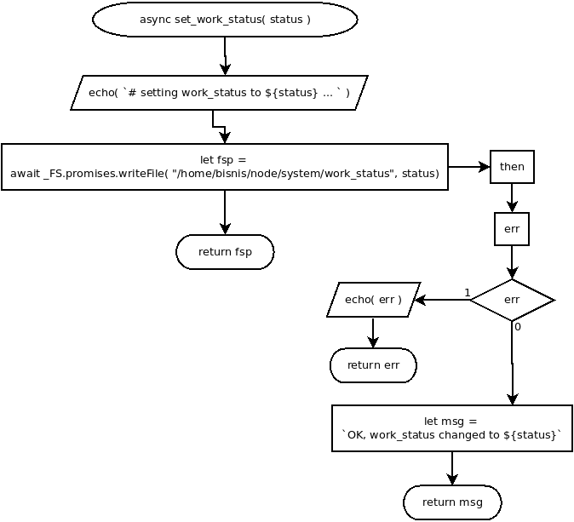

async function switcher( data )

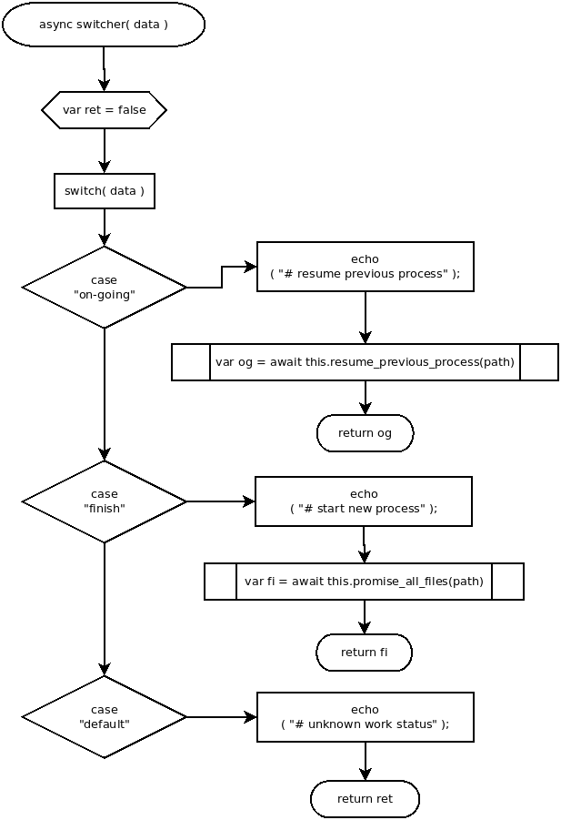

Refers to:
- resume_previous_process( path )
- promise_all_files( path )

async function resume_previous_process( path )

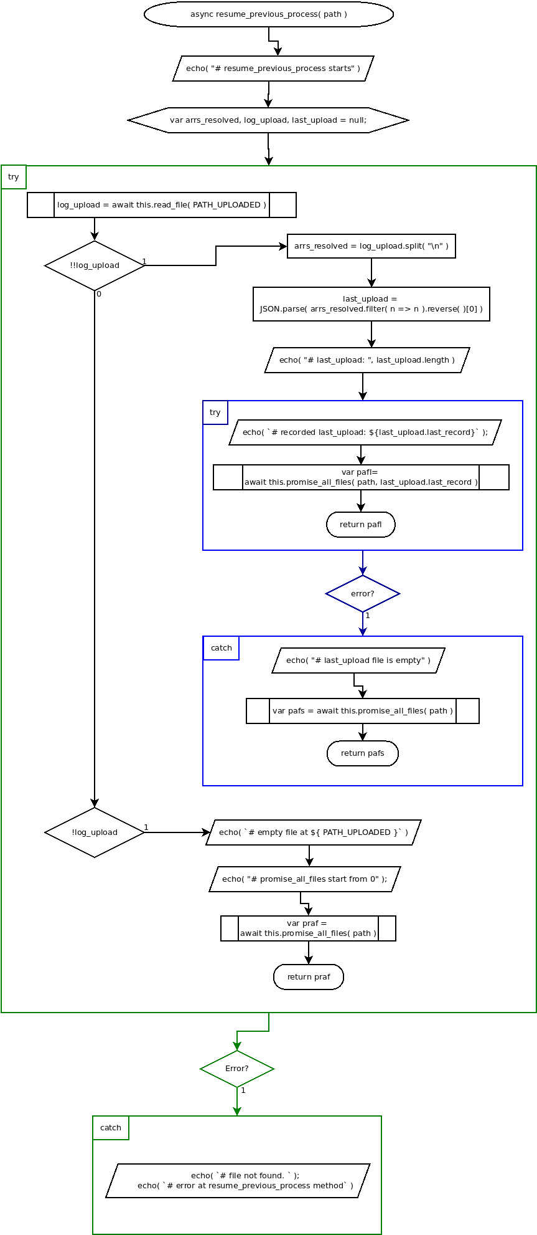

Refers to:
- read_file()
- promise_all_files()

async function read_file( filepath )

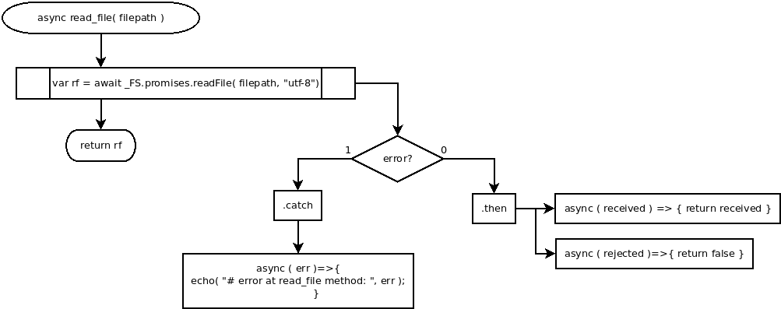

async function promise_all_files( path, recorded_last_upload = 0 )

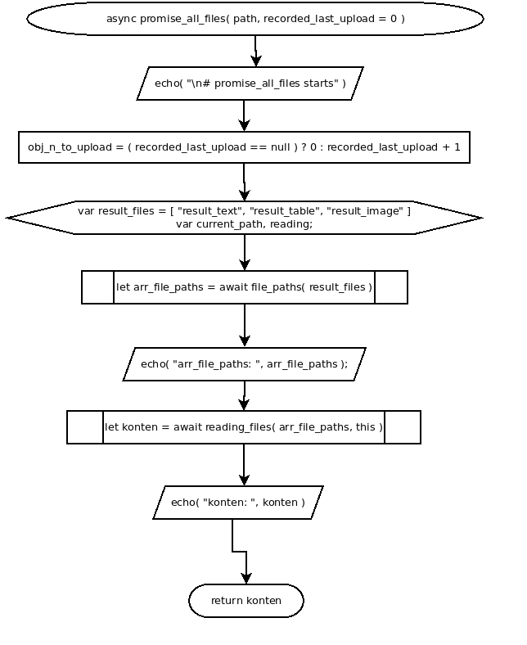

Refers to:
- file_paths()
- reading_files()

async function reading_files( arr_file_paths, _this )

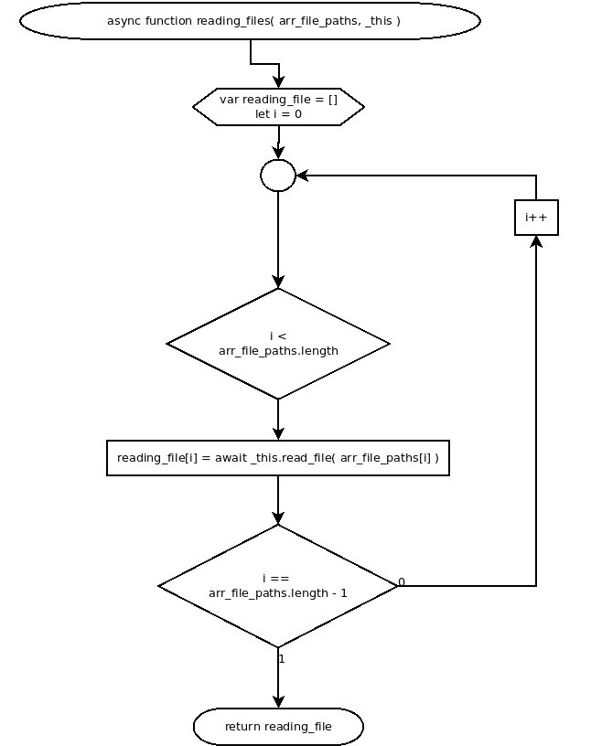

async function file_paths( result_files )

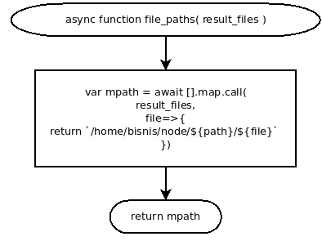

async function content_handler()

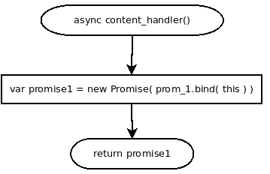

Refers to:
- prom_1()

async function prom_1( resolve, reject )

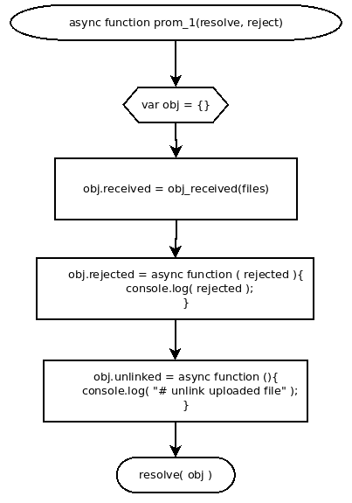

Refers to:
- obj_received( files )

async function obj_received( files )

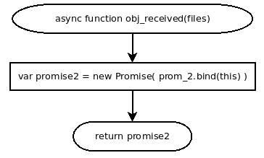

Refers to:
- prom_2()

async function prom_2( receive, reject )

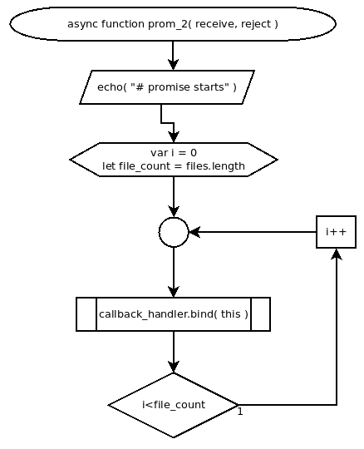

Refers to:
- callback_handler()

async function callback_handler( i, file )

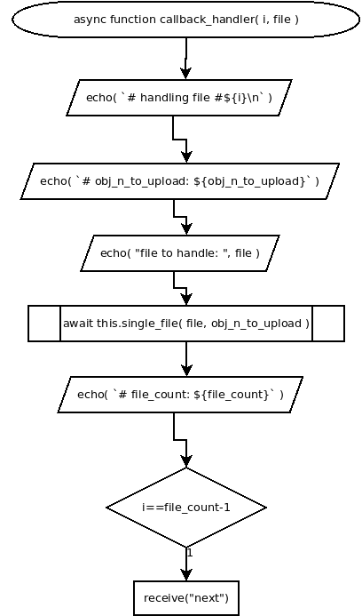

Refers to:
- single_file( file, obj_n_to_upload )

async single_file( file, obj_n_to_upload )

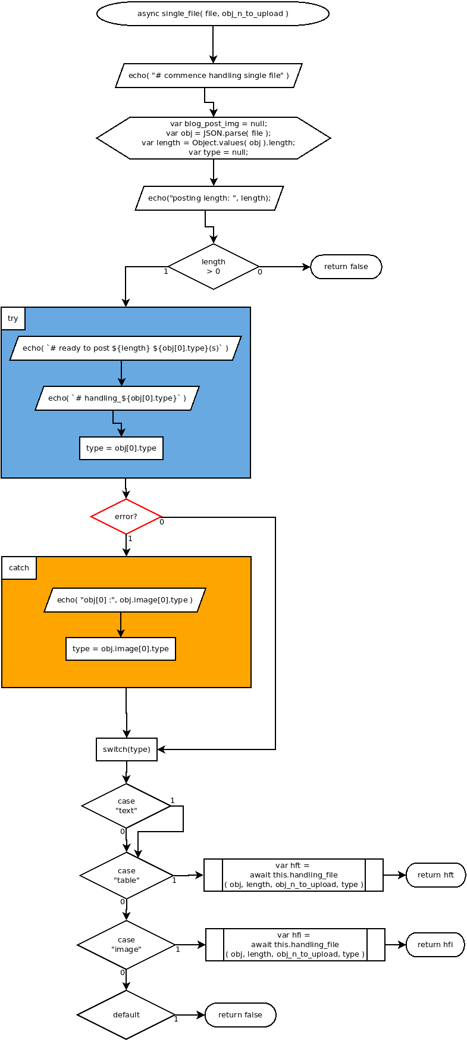

Refers to:
- handling_file()

async handling_file( obj, length, obj_n_to_upload, type )

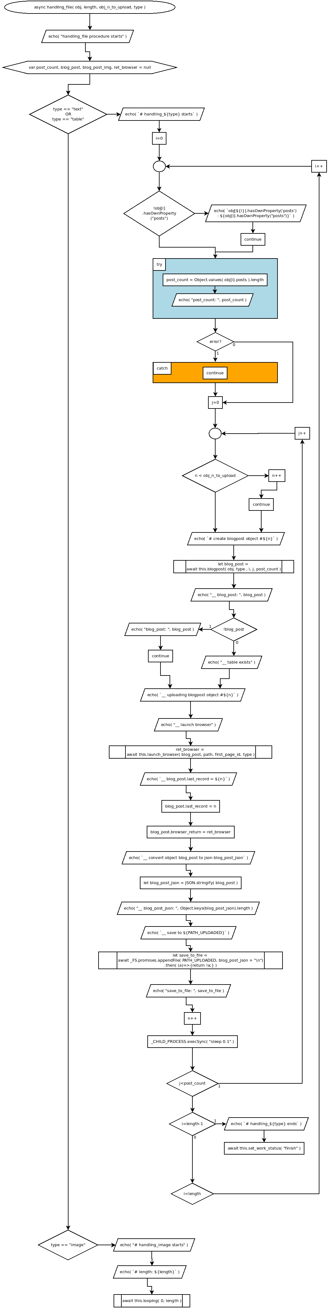

Refers to:
- blogpost()
- launch_browser()
- looping()

this.looping = async function( idx=0, length )

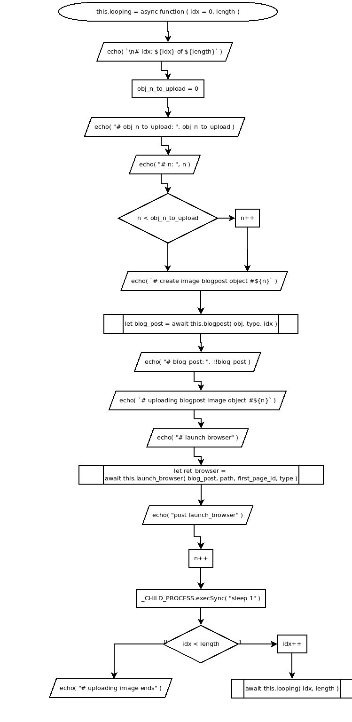

Refers to:
- blogpost
- launch_browser()

