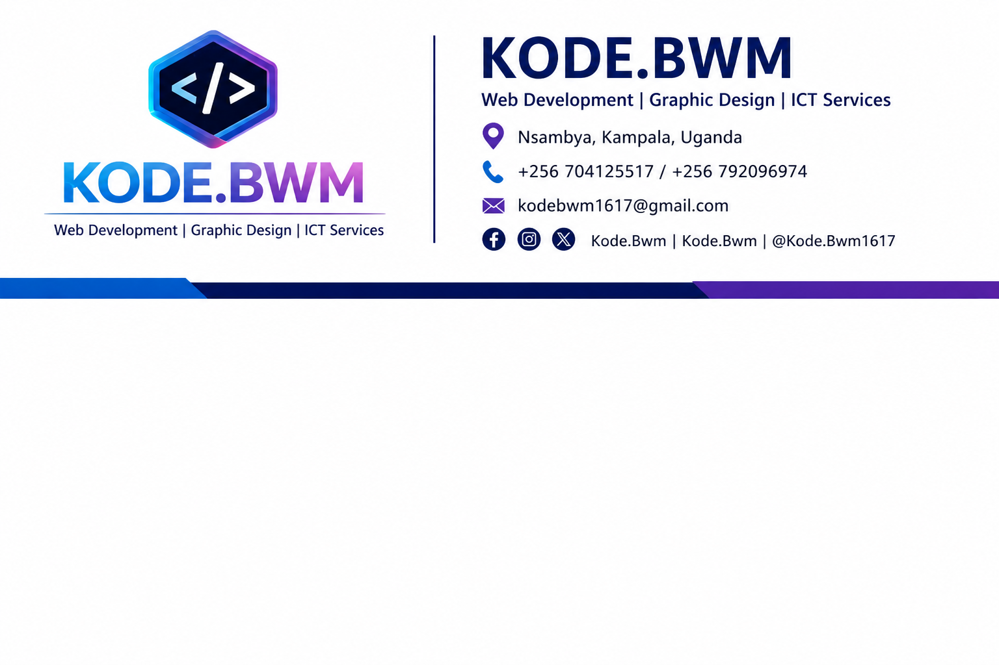

Date: 03/May/2026
To: Mr.ALI KAMBERE
Organization: Private

SUBJECT: REQUEST FOR BUSINESS EQUIPMENT SUPPORT
Dear Sir,
I hope this letter finds you well.
My name is Arsene Kahunga, the Founder and CEO of KODE.BWM, a growing digital solutions company committed to providing professional services in web development, graphic design, ICT support, and digital office solutions.
Our Mission
To empower businesses, organizations, and individuals through innovative, affordable, and professional digital solutions that promote growth and efficiency.
Our Vision
To become one of Uganda’s most trusted and innovative digital service providers, transforming ideas into impactful digital realities across Africa and beyond.
KODE.BWM has been serving clients by offering quality digital solutions including website development, software installation, branding materials, and technical ICT support. As our client base continues to grow, we are currently in need of essential equipment to improve service delivery and sustain our operations.
We are kindly requesting your support toward acquiring the following business equipment:
- Lenovo Desktop Computer – UGX 950,000
- Epson Printer – UGX 300,000
These tools are vital for enhancing productivity, delivering quality work on time, and expanding our service capacity.
Your support, whether financial or material, will significantly contribute to the growth and sustainability of KODE.BWM. We remain committed to accountability and excellence, and we shall ensure that every contribution is utilized effectively for the intended purpose.
We would greatly appreciate your partnership in helping us strengthen this vision.
Thank you for your time, consideration, and support.
Yours faithfully,
ARSENE KAHUNGA
Founder & CEO
KODE.BWM

