1. Объектная модель

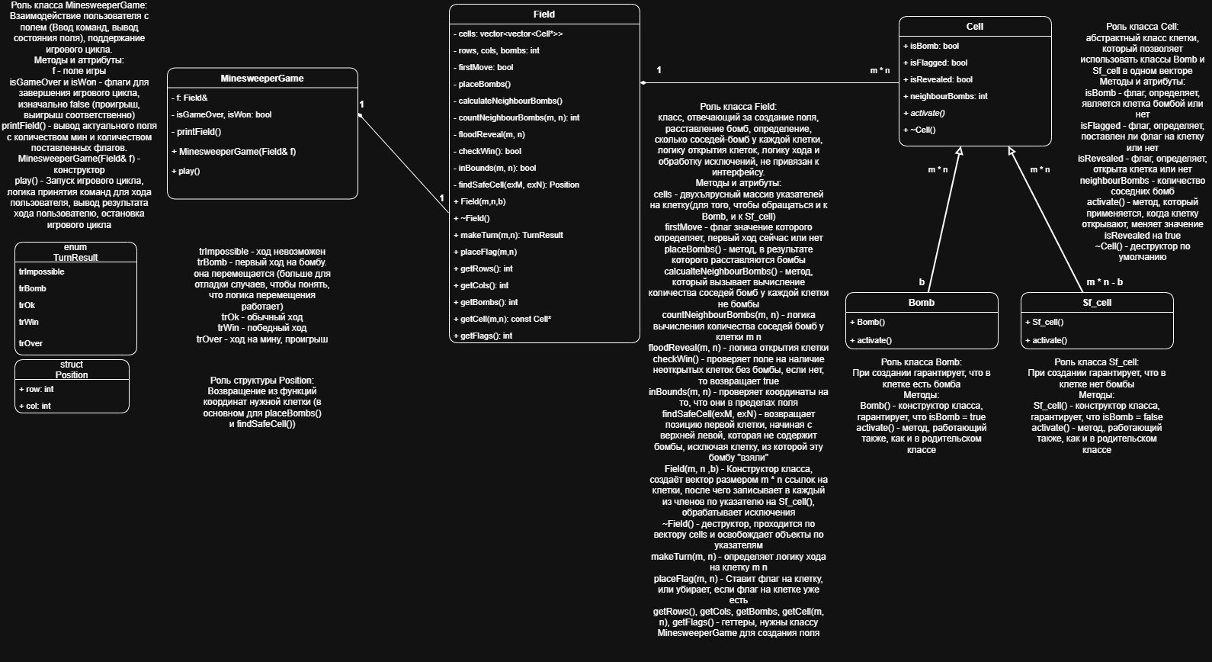

2. Функциональная схема

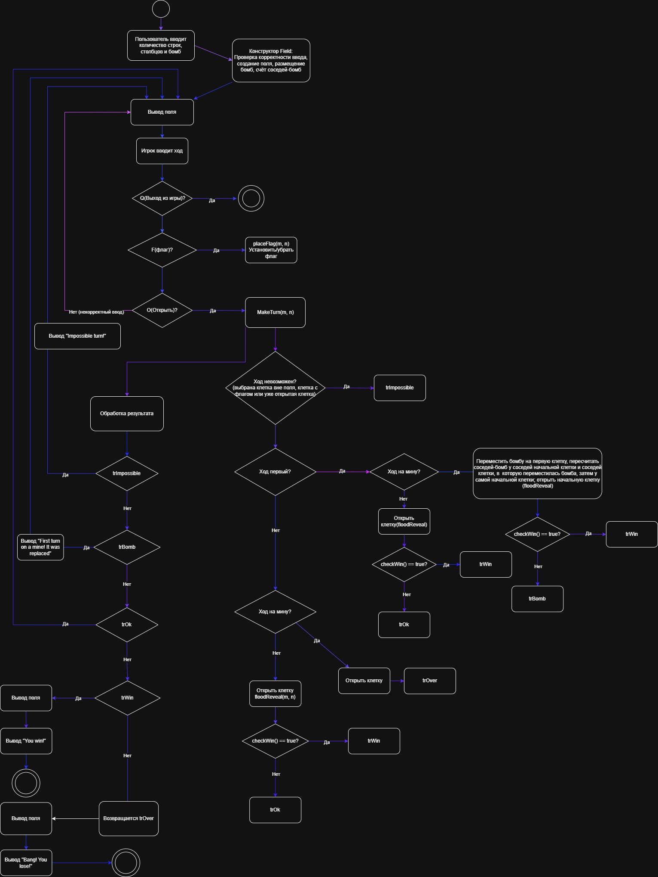

3. Исходный код

3.1 Minesweeper.h
#pragma once
#include <vector>
enum TurnResult {
trImpossible, // Ход невозможен
trBomb, // Первый ход на мину
trOk, // Обычный ход
trWin, // Победа
trOver // Проигрыш
};
struct Position {
int row, col;
};
class Cell {
public:
bool isBomb = false;
bool isFlagged = false;
bool isRevealed = false;
int neighbourBombs = 0;

virtual void activate() { isRevealed = true; }
virtual ~Cell() = default;
};

class Bomb : public Cell {
public:
Bomb(){ isBomb = true; }
void activate() override { isRevealed = true; }
};

class Sf_cell : public Cell {
public:
Sf_cell() { isBomb = false; }
void activate() override { isRevealed = true; }
};

class Field {
std::vector <std::vector<Cell*>> cells;
int rows, cols, bombs;
int flags = 0;
bool firstMove = true;

void placeBombs();
void calculateNeighbourBombs();
int countNeighbourBombs(int m, int n) const;
void floodReveal(int m, int n) const;
bool checkWin() const;
bool inBounds(int m, int n) const;
Position findSafeCell(int exM, int exN) const;

public:
Field(int m, int n, int b);
~Field();

TurnResult makeTurn(int m, int n);
void placeFlag(int m, int n);

int getRows() const { return rows; }
int getCols() const { return cols; }
int getBombs() const { return bombs; }
int getFlags() const { return flags; }

const Cell* getCell(int m, int n) const;

};

class MinesweeperGame {
Field& f;
bool isGameOver = false;
bool isWon = false;
void printField() const;
public:
MinesweeperGame(Field& f);
void play();
};

3.2 Field.cpp
#include "Minesweeper.h"
#include <random>
#include <algorithm>
#include <stdexcept>

Field::Field(int m, int n, int b) : rows(m), cols(n), bombs(b) {
if (m <= 0 || n <= 0)
throw std::invalid_argument("Field size should be positive");
if (b <= 0 || b >= m * n)
throw std::invalid_argument("Impossible bomb count");

cells.resize(rows, std::vector<Cell*>(cols, nullptr));
for (int i = 0; i < rows; i++)
for (int j = 0; j < cols; j++)
cells[i][j] = new Sf_cell();

placeBombs();
}

Field::~Field() {
for (int i = 0; i < rows; i++)
for (int j = 0; j < cols; j++)
delete cells[i][j];
}

bool Field::inBounds(int m, int n) const {
return (m >= 0 && m < rows && n < cols && n >= 0);
}

void Field::placeBombs() {
std::vector<Position> positions;

positions.reserve(rows * cols);
for (int i = 0; i < rows; i++)
for (int j = 0; j < cols; j++)
positions.push_back({ i, j });

std::mt19937 rng(std::random_device{}());
std::shuffle(positions.begin(), positions.end(), rng);

for (int i = 0; i < bombs; i++) {
int r = positions[i].row;
int c = positions[i].col;
delete cells[r][c];
cells[r][c] = new Bomb();
}
calculateNeighbourBombs();
}

void Field::calculateNeighbourBombs() {
for (int i = 0; i < rows; i++)
for (int j = 0; j < cols; j++)
if (!cells[i][j]->isBomb)
cells[i][j]->neighbourBombs = countNeighbourBombs(i, j);
}

int Field::countNeighbourBombs(int m, int n) const {
const int dr[] = { -1, -1, -1, 0, 0, 1, 1, 1 };
const int dc[] = { -1, 0, 1, -1, 1, -1, 0, 1 };
int count = 0;
for (int d = 0; d < 8; d++) {
int nr = m + dr[d], nc = n + dc[d];
if (inBounds(nr, nc) && cells[nr][nc]->isBomb)
count++;
}
return count;
}

void Field::floodReveal(int m, int n) const {
if (!inBounds(m, n) || cells[m][n]->isRevealed || cells[m][n]->isBomb)
return;
cells[m][n]->activate();
if (cells[m][n]->neighbourBombs == 0) {
const int dr[] = { -1, -1, -1, 0, 0, 1, 1, 1 };
const int dc[] = { -1, 0, 1, -1, 1, -1, 0, 1 };
for (int d = 0; d < 8; d++)
floodReveal(m + dr[d], n + dc[d]);
}
}

bool Field::checkWin() const {
for (int i = 0; i < rows; i++)
for (int j = 0; j < cols; j++)
if (!cells[i][j]->isBomb && !cells[i][j]->isRevealed)
return false;
return true;
}

Position Field::findSafeCell(int exM, int exN) const {
for (int i = 0; i < rows; ++i)
for (int j = 0; j < cols; ++j)
if (!cells[i][j]->isBomb && (i != exM || j != exN))
return { i, j };
throw std::logic_error("No safe cells, field is incorrect");
}

TurnResult Field::makeTurn(int m, int n) {
if (!inBounds(m, n))
return trImpossible;
if (cells[m][n]->isRevealed)
return trImpossible;
if (cells[m][n]->isFlagged)
return trImpossible;

if (firstMove) {
firstMove = false;
if (cells[m][n]->isBomb) {
const int dr[] = { -1,-1,-1, 0, 0, 1, 1, 1 };
const int dc[] = { -1, 0, 1,-1, 1,-1, 0, 1 };
delete cells[m][n];
cells[m][n] = new Sf_cell();

for (int d = 0; d < 8; ++d) {
int nr = m + dr[d], nc = n + dc[d];
if (inBounds(nr, nc))
cells[nr][nc]->neighbourBombs--;
}
Position pos = findSafeCell(m, n);
delete cells[pos.row][pos.col];
cells[pos.row][pos.col] = new Bomb();

for (int d = 0; d < 8; ++d) {
int nr = pos.row + dr[d], nc = pos.col + dc[d];
if (inBounds(nr, nc))
cells[nr][nc]->neighbourBombs++;
}
cells[m][n]->neighbourBombs = countNeighbourBombs(m, n);
floodReveal(m, n);
return checkWin() ? trWin : trBomb;
}
floodReveal(m, n);
return checkWin() ? trWin : trOk;
}

if (cells[m][n]->isBomb) {
cells[m][n]->activate();
return trOver;
}
floodReveal(m, n);
return checkWin() ? trWin : trOk;
}

void Field::placeFlag(int m, int n) {
if (!inBounds(m, n) || cells[m][n]->isRevealed)
return;
if (!cells[m][n]->isFlagged) {
cells[m][n]->isFlagged = true;
flags++;
}
else {
cells[m][n]->isFlagged = false;
flags--;
}
}

const Cell* Field::getCell(int m, int n) const {
if (!inBounds(m, n))
return nullptr;
return cells[m][n];
}

3.3 MinesweeperGame.cpp
#include "Minesweeper.h"
#include <iostream>
using namespace std;

MinesweeperGame::MinesweeperGame(Field& f) : f(f) {}

void MinesweeperGame::printField() const {
cout << "\n ";
for (int i = 0; i < f.getCols(); i++)
cout << (i % 10) << " ";
cout << "\n";

for (int i = 0; i < f.getRows(); i++) {
cout << (i < 10 ? " " : "") << i << " ";
for (int j = 0; j < f.getCols(); j++) {
const Cell* cell = f.getCell(i, j);
if (!cell->isRevealed) {
cout << (cell->isFlagged ? "F " : ". ");
}
else if (cell->isBomb) {
cout << "* ";
}
else {
int n = cell->neighbourBombs;
if (n == 0)
cout << " ";
else
cout << n << " ";
}
}
cout << "\n";
}
cout << "Bombs: " << f.getBombs() << " Flags: " << f.getFlags() << "\n" << endl;
}

void MinesweeperGame::play() {
cout << "===== Minesweeper ===== \n";
cout << "Commands: O|row|col - open, F|row|col - flag, Q - exit\n" << endl;

while (!isGameOver && !isWon) {
printField();

char command;
int m, n;
cout << "Turn: ";
cin >> command;

if (command == 'Q' || command == 'q')
break;

cin >> m >> n;

if (command == 'F' || command == 'f') {
f.placeFlag(m, n);
continue;
}

if (command != 'O' && command != 'o') {
cout << "Unknown command" << endl;
continue;
}
switch (f.makeTurn(m, n)) {
case trImpossible:
cout << "Impossible turn!" << endl;
break;
case trBomb:
cout << "First turn on a mine! it was replaced" << endl;
break;
case trOk:
break;
case trWin:
printField();
cout << "You win!" << endl;
isWon = true;
break;
case trOver:
printField();
cout << "Bang! You lose!" << endl;
isGameOver = true;
break;
}
}
}

3.4 Minesweeper_main.cpp
#include <iostream>
#include "Minesweeper.h"
using namespace std;
int main()
{
int m, n, b;

cout << "===== Minesweeper =====" << endl;
cout << "Enter number of rows, columns and bombs: ";
cin >> m >>n >> b;

try {
Field field(m, n, b);
MinesweeperGame game(field);
game.play();
}
catch (const exception& e) {
cerr << "Error: " << e.what() << endl;
return 1;
}
return 0;
}

