**PILIPENKO ARSENY**

|  |  |
| --- | --- |
| Email: | arsen.pilipenko2014@gmail.com |
| Mobile phone: | +380966920144 |
| Skype: | - |
| Linkedin: |  |

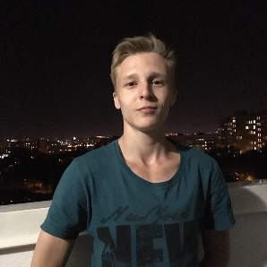

**WORK EXPERIENCE**

2018.06.03 - NDA – Freelance

Frontend developer

Landing page, website template

**SUMMARY**:

**Frontend development:**

* Markup development and css \ js animation

**Skills:**

|  |  |  |  |
| --- | --- | --- | --- |
| Programming languages | | | Experience, years |
| HTML + CSS | | | 2 |
| SASS + SCSS + LESS | | | 1 |
| C++ |  |  | 1 |
| Tools | | | Experience, years |
| Photoshop | | | 2 |
| СorelDRAW | | | 2 |
| Illustator | | | 2 |
| Sublime | | | 2 |
| Brackets | | | 1 |

**PORTFOLIO**:

**NDA**

**(on construction !)**

**Goal :**

**Frontend :** HTML5, CSS3, CSS Flex,

**Time** :

**Languages:**

English - Intermediate

**Education:**

### 2007 – 2016 - Elementary School School № 126

**2016 – 2020 – ХКТК НТУ “ХПІ”** ct-college. Software development

**Additional:**