**INDEPENDENT STUDY WEEK 2 REPORT**

**Top 6 feature detection from Decision Tree (Max Depth =3)**

|  |  |
| --- | --- |
| Features | Weightage |
| ImageBase | 0.774 |
| SubSystem | 0.096 |
| Checksum | 0.054 |
| Major OperatingSystemVersion | 0.033 |
| AddressOfEntryPoint | 0.030 |
| ResourceMaxSize | 0.010 |

**Decision Tree for Malware Detection using Gini Index**

**Top 10 feature detection from Decision Tree (Max Depth =4)**

|  |  |
| --- | --- |
| **Feature** | **Weightage** |
| ImageBase | 0.753 |
| Subsystem | 0.093 |
| CheckSum | 0.053 |
| MajorOperatingSystemVersion | 0.032 |
| AddressOfEntrypoint | 0.030 |
| SectionsNb | 0.011 |
| ResourceMaxSize | 0.010 |
| MajorImageVersion | 0.006 |
| SizeOfHeaders | 0.002 |

**Note : Please refer to DecisionTreeDepth4.png image attached here.**

**Neural Network Model for Malware Classification**

1. **Model 1 (Complex Model)**

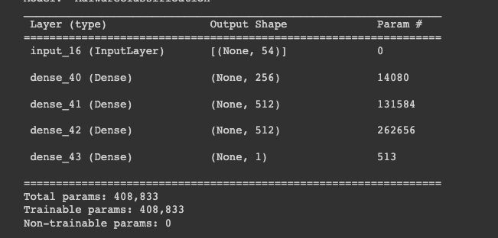

Optimizer Used: Adam Optimizer

Loss function used: Binary Cross entropy

Model: 54 $×$ 256 $× 512 × 512 × 1$

Training Time: 2minutes 10 seconds

Total trainable parameter: 408, 833

**Accuracy on test data set: 92.2%**

1. **Model 2 (Simple Model)**

Optimizer Used: Adam Optimizer

Loss function used: Binary Cross entropy

Model: 54 $×$ 128 $× 128× 1$

Training Time: 44 seconds

Total trainable parameter: 23,681

**Accuracy on test data set: 90.28%**

**Now, we again run the model with different hyperparameters and test the accuracy.**

1. **Mini batch Gradient Descent**

|  |  |  |  |  |
| --- | --- | --- | --- | --- |
| **Model** | **[Learning Rate ($α)$** | **Num of Epochs** | **Num of batches** | **Test Accuracy** |
| 54 $×$ 256 $× 512 × 512 × 1$ | 1e-4 | 10 | 128 | 92.73 |
| 54 $×$ 256 $× 512 × 512 × 1$ | 1e-3 | 10 | 128 | 92.23 |
| 54 $×$ 256 $× 512 × 512 × 1$ | 1e-2 | 10 | 128 | 83.4% |
| 54 $×$ 256 $× 512 × 512 × 1$ | 1e-4 | 20 | 128 | 91.84% |
| 54 $×$ 128 $× 128× 1$ | 1e-4 | 20 | 64 | 89.88% |
| 54 $×$ 128 $× 128× 1$ | 1e-3 | 20 | 64 | 91.07 |

1. **Stochastic Gradient Descent**

|  |  |  |  |  |
| --- | --- | --- | --- | --- |
| **Model** | **Learning Rate** ( $α)$ | **Num of Epochs** | **Num of batches** | **Test Accuracy** |
| 54 $×$ 128 $× 128× 1$ | 1e-3 | 2 | 1 | 84.3% |
| 54 $×$ 128 $× 128× 1$ | 1e-4 | 2 | 1 | 86.2% |
| 54 $×$ 128 $× 128× 1$ | 1e-2 | 2 | 1 | 83.2% |