Multiple linear models workshop

2023-04-06

For this workshop, make sure you have the R 4.2.1 OR newer version!

These are the packages that we will be using today. If any of these are not in your R studio, make sure to use install.packages(“name of package”) to install before loading.

#Setting up

library(tidyverse) #Contains dplyr, tibble, readr, all help organize our code  
library(broom) #Allows us to simplify model outputs  
library(knitr) #Makes nice tables and allows us to insert graphics  
library(kableExtra) # Also used to customize tables  
library(tidyr) #simplifies multiple simultaneous models  
library(trend) #Allows us to explore trends

#Understanding the workflow

#Inserting image for demonstration 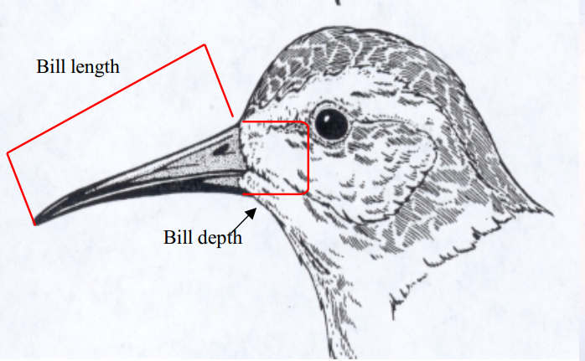

#Nested data frames, multiple models