**Homework 5**

Remember that your programs must read the data from the text files exactly as they appear. You may not edit the text files to make them more convenient for SAS. Turn in the code, log file and output. If any of these 3 items is missing then you will not be graded for that question. Use the snipping tool instead of screen shots and make sure the font is large enough for me to read.

1. Refer to CATS datasets. Write a SAS program that reads in three separate SAS datasets from CATS1, CATS2, and CATS3 data. Make two new variables which represent the GFR at week 0 for the treated kidney and the GFR at week 0 for the untreated kidney. Print only the cats’ names and the two new variables, identified as “treated” or “untreated” (not “left or “right”).

The output looks like this:

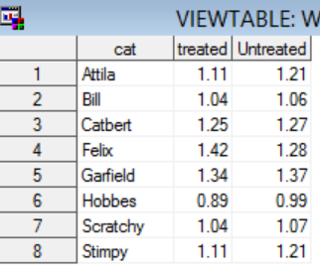

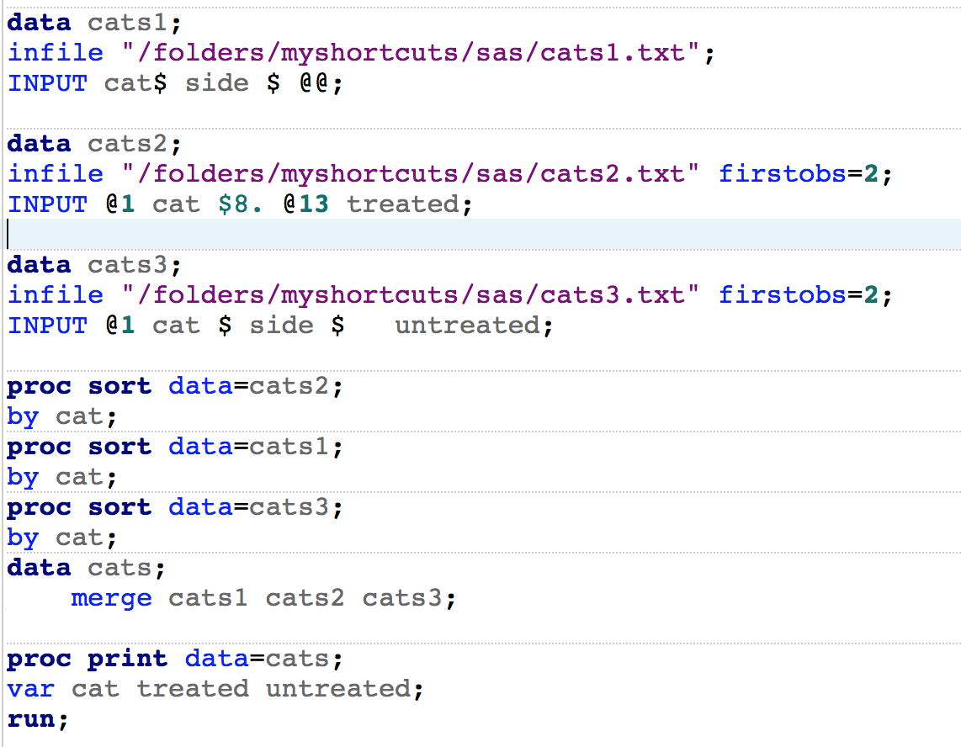

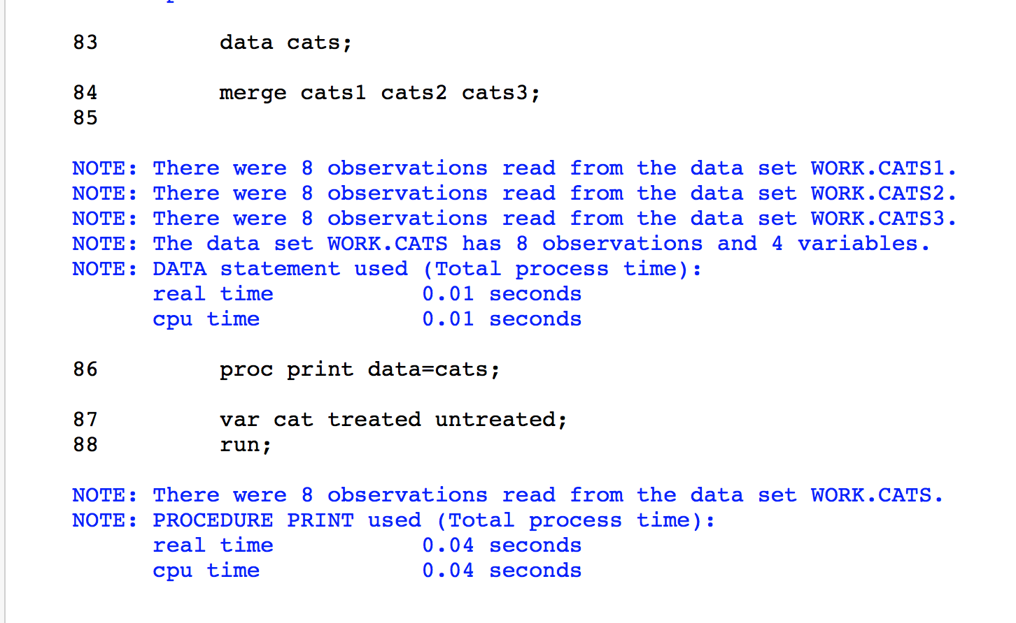

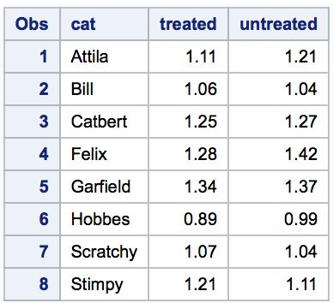

1. Refer to SOCCER dataset. Suppose that the team plans to go to Europe for some exhibition matches, and you need to send their hosts some information about the players. Use a SAS program to convert the players’ heights to meters, then print the players’ first and last names, jersey numbers, and heights in meters. For this question, list only 3 significant digits for the heights (example: 5 feet, 8 inches is equivalent to 1.73 meters).

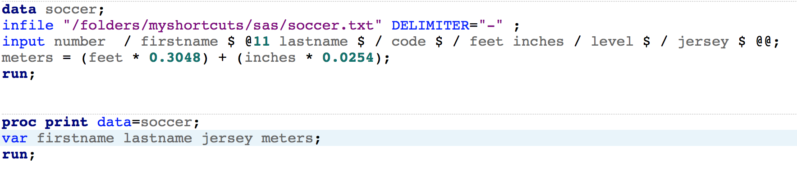

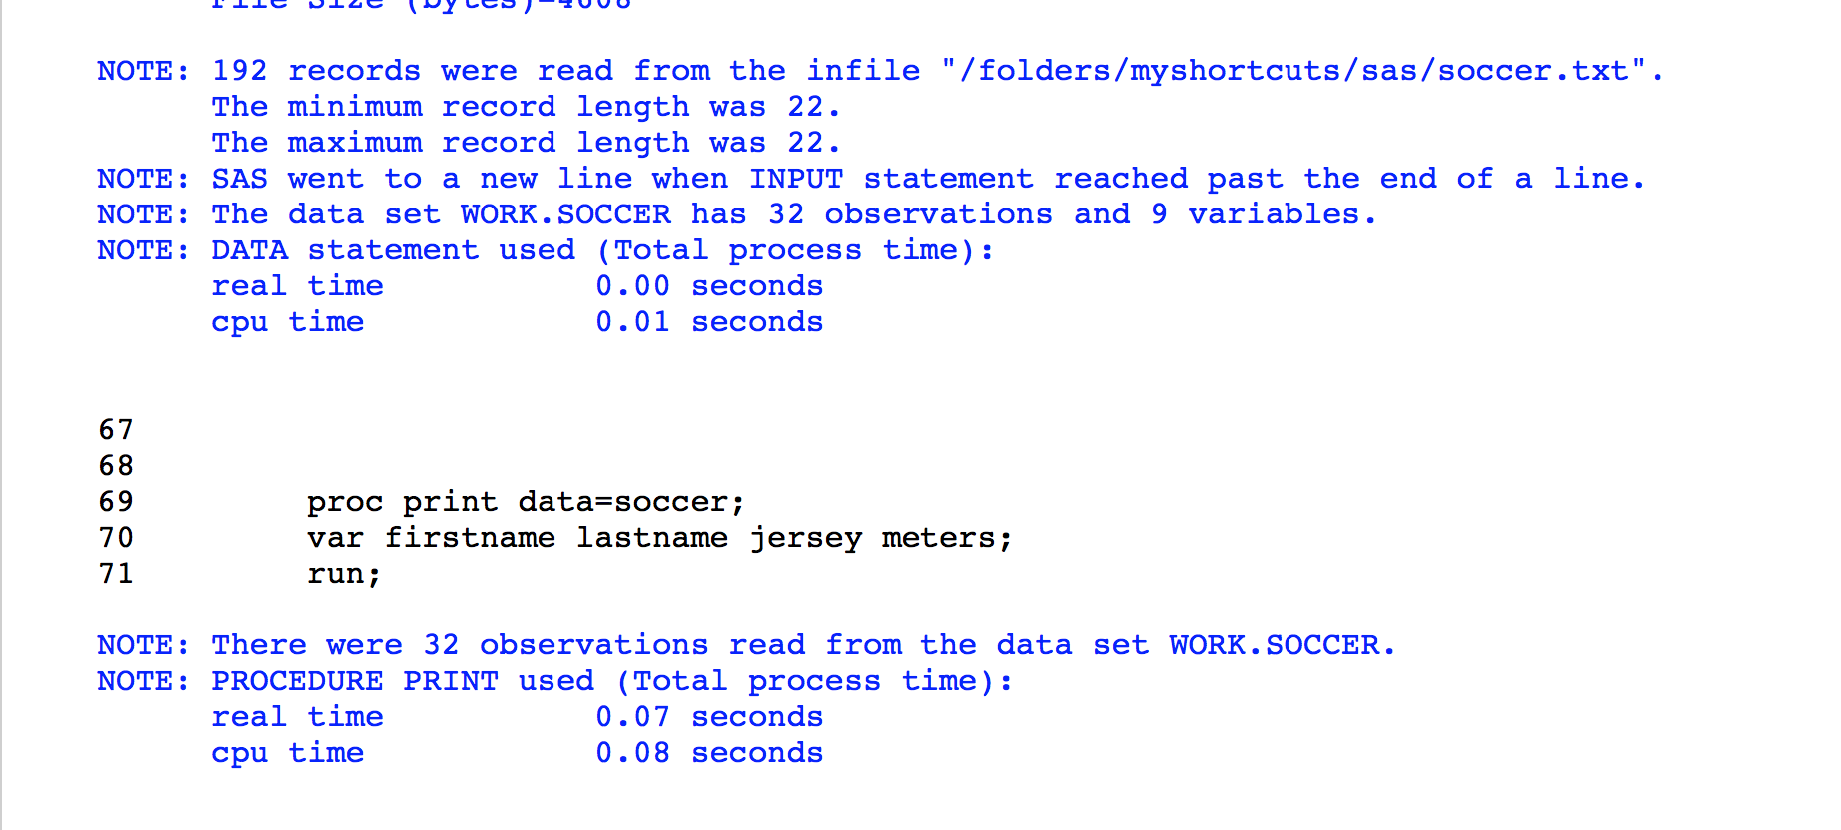

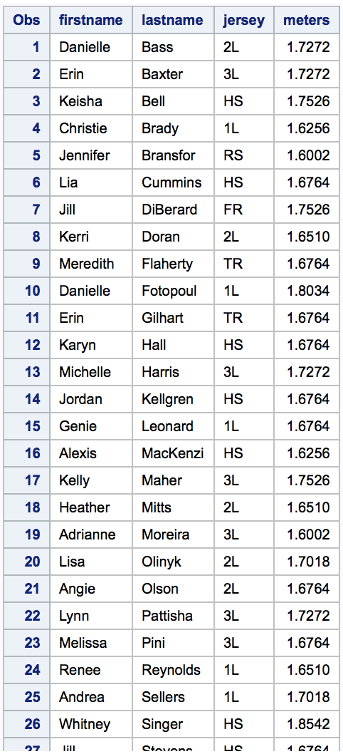

1. Refer to the BREAD dataset. Suppose that you need to create a reference list of bread recipes that do not use eggs (for dietary requirements or preferences, or perhaps you forgot to buy eggs). Create and print a permanent SAS dataset, using LIBNAME and associated commands, which contains only the recipes which use no eggs.

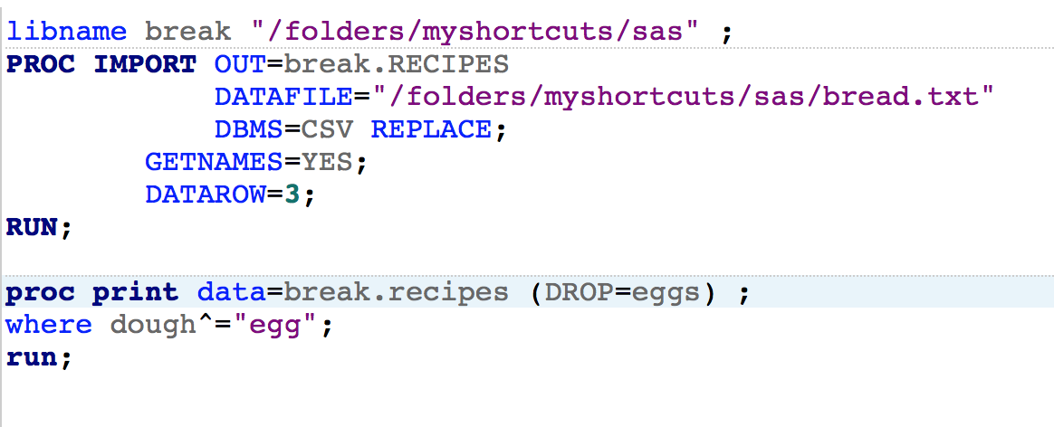

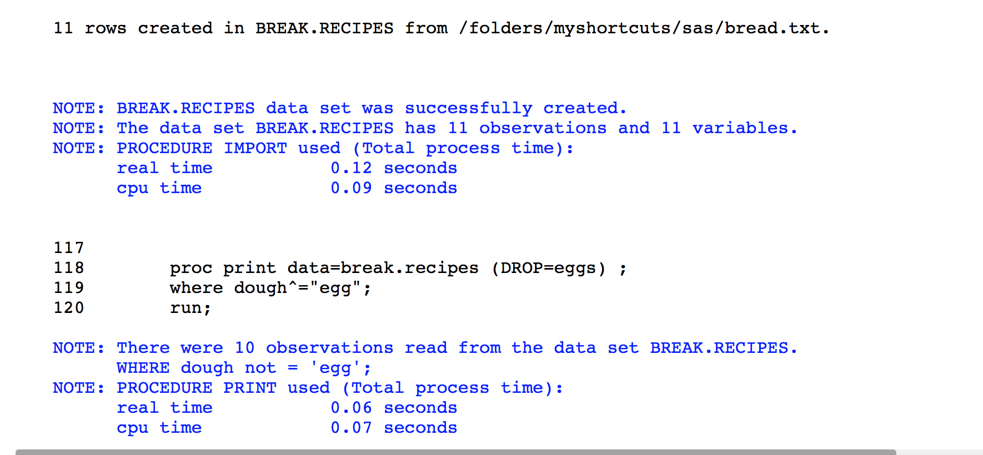

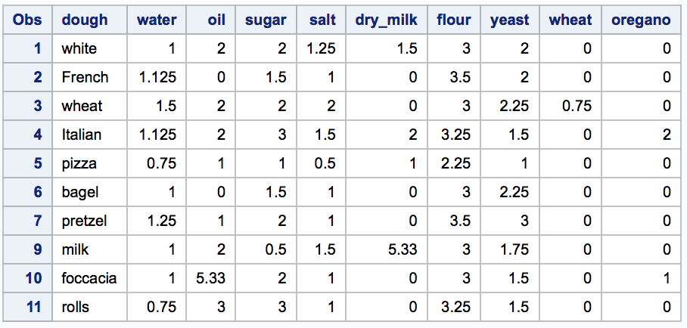

1. Refer to the CLINTON dataset. Gallup has conducted more polls to assess President Clinton’s job approval rating since the CLINTON dataset was created. The data are shown below:

Date Approve Disapprove No opinion

8-18-98 66 29 5

8-20-98 61 34 5

8-21-98 62 35 3

9-1-98 62 33 5

9-10-98 60 37 3

9-11-98 63 34 3

Create two datasets in SAS. One dataset should consist of the numbers in the file CLINTON.TXT and the second dataset should contain the numbers listed above. Combine the two datasets into a larger dataset with the appropriate commands, sort the observations in that dataset in descending order by date (so that September 11, 1998 appears first), and print the larger dataset. Use an appropriate format to print the date variable.

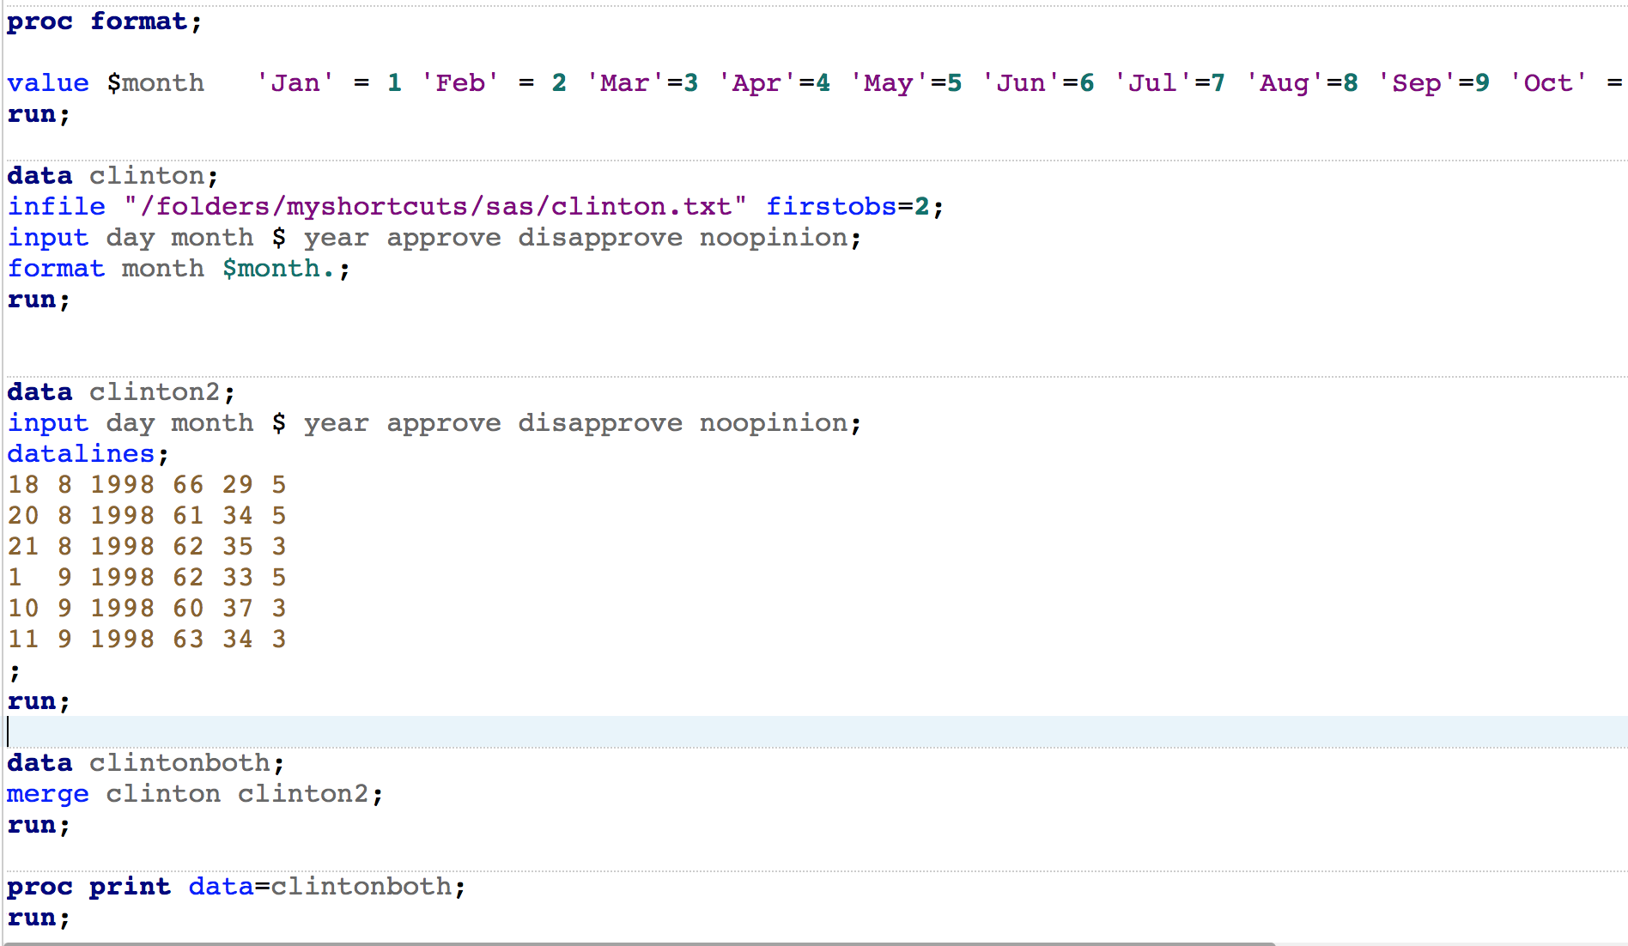

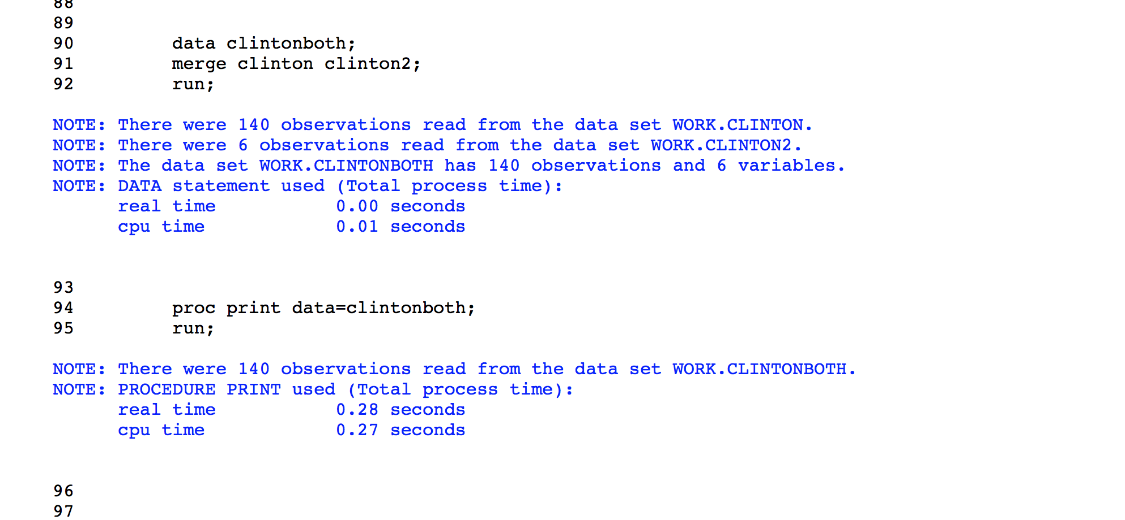

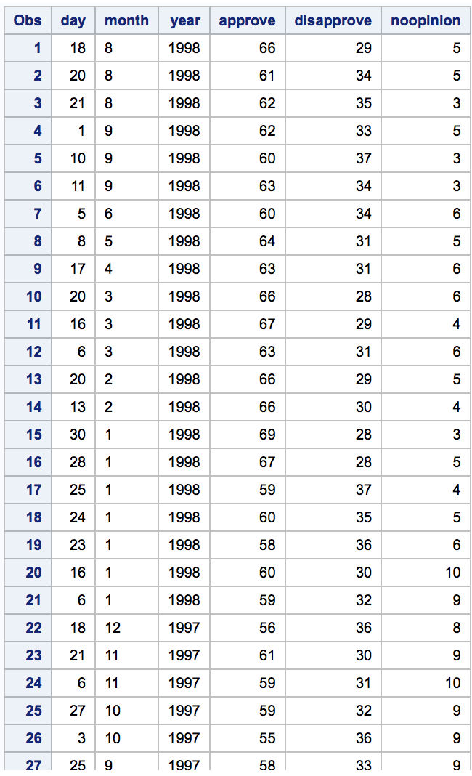

1. Using the SAS data set Blood, create two temporary SAS data sets called Subset_A and Subset_B. Include in both of these data sets a variable called Combined equal to 0.001 times WBC plus RBC. Subset_A should consist of observations from Blood where Gender is equal to Female and BloodType is equal to AB. Subset_B should consist of all observations from Blood where Gender is equal to **Female**, BloodType is equal to **AB**, and Combined is greater than or equal to **14**.

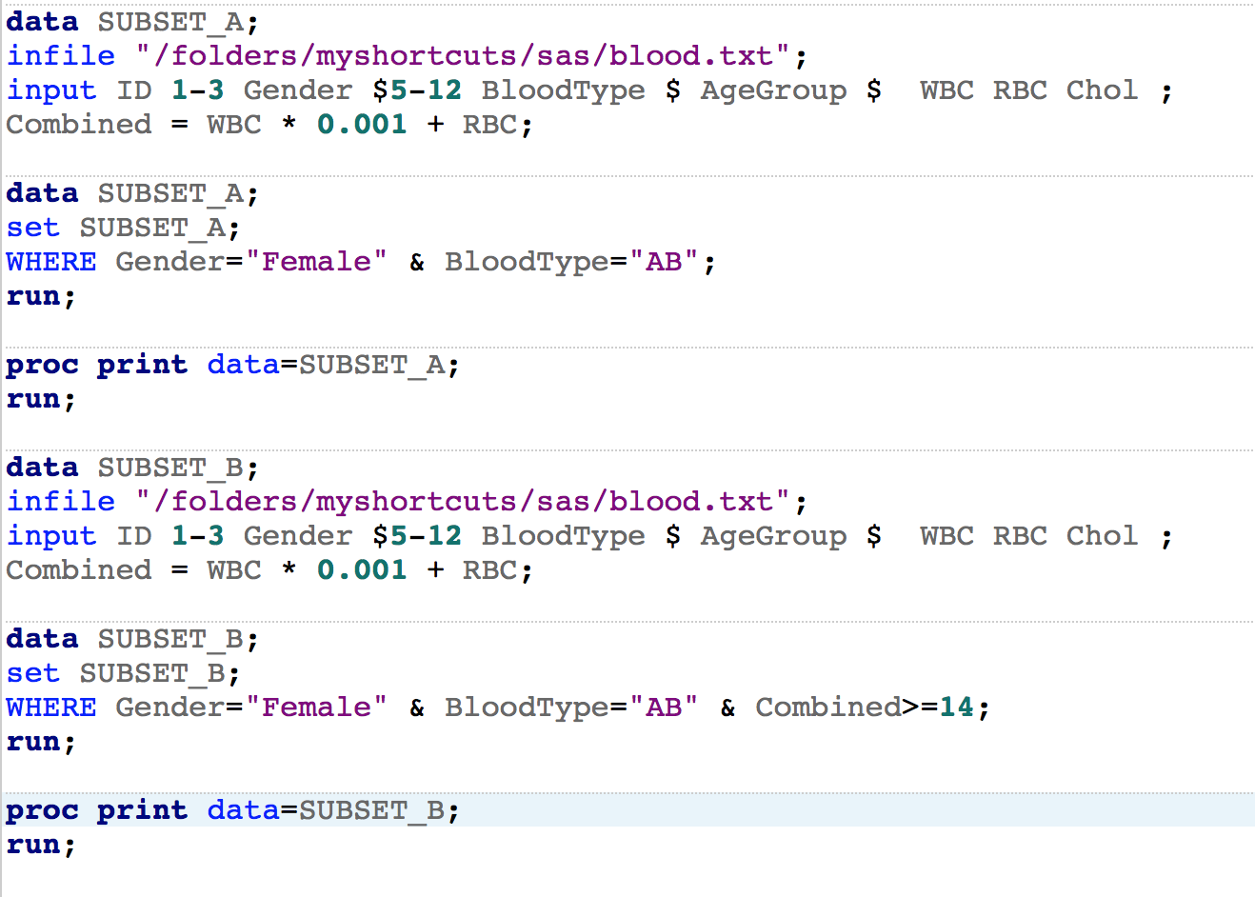

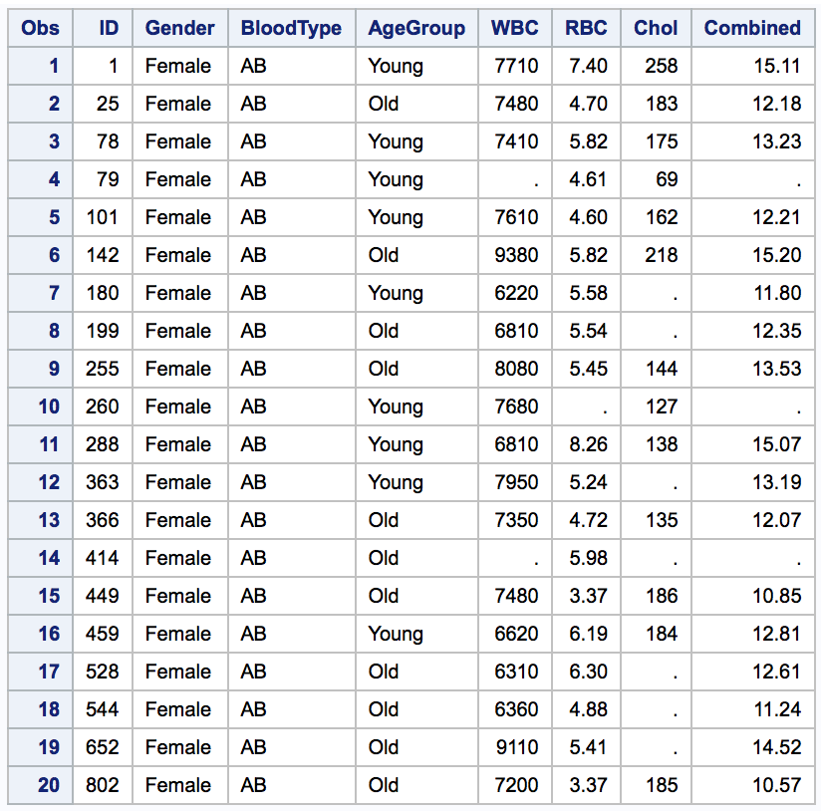

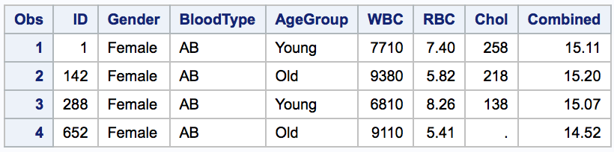

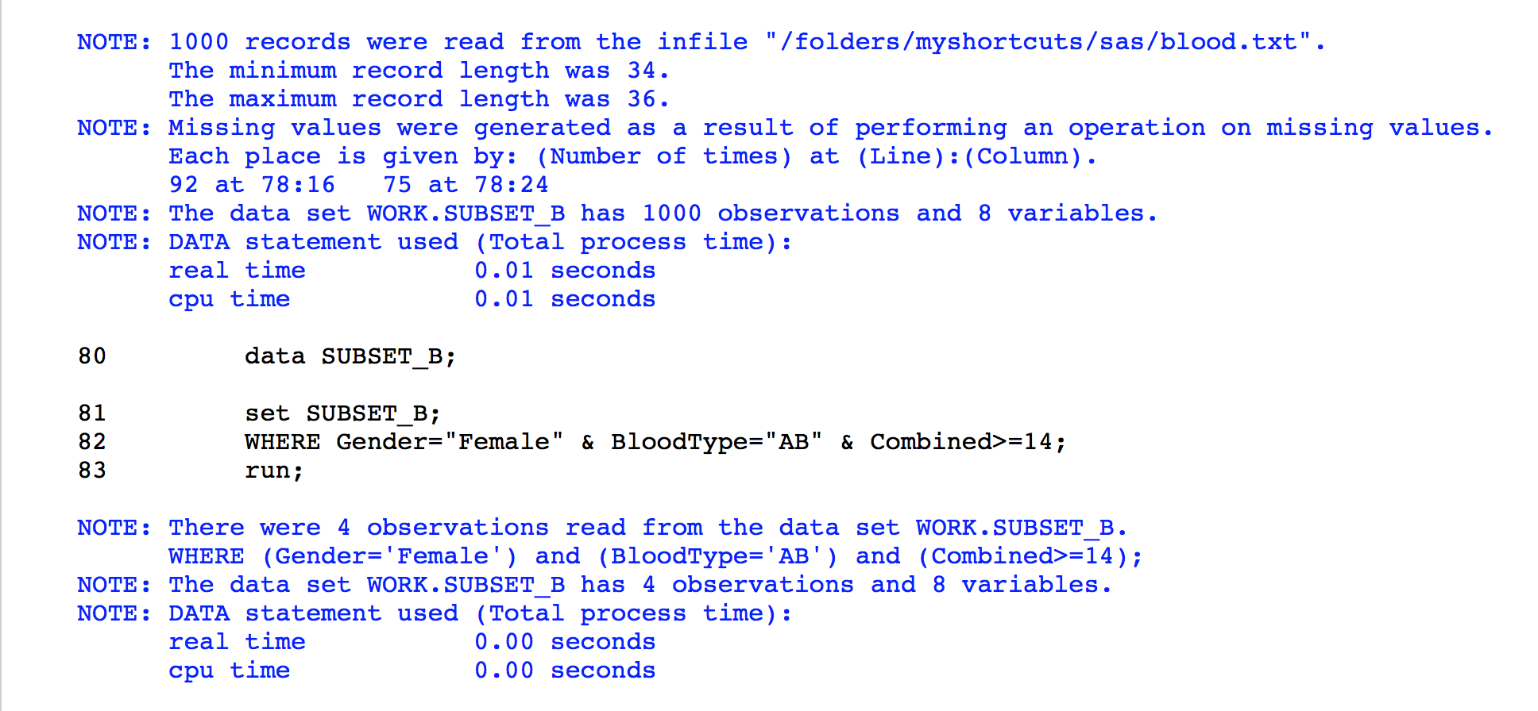

1. Using the SAS data set Blood, create two temporary SAS data sets by selecting all subjects with cholesterol levels (Chol) below 100. Place the male subjects in Lowmale and the female subjects in Lowfemale. Do this using a single DATA step.

Note: Values for Gender are Make and Female.

Careful, some of the cholesterol values are missing. Print the resulting data sets.

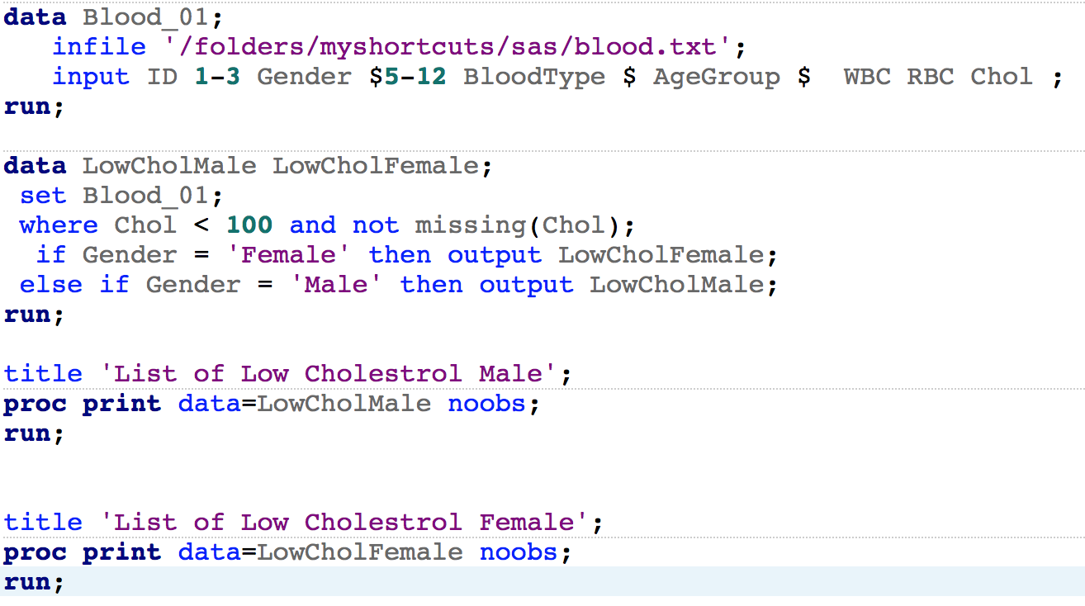

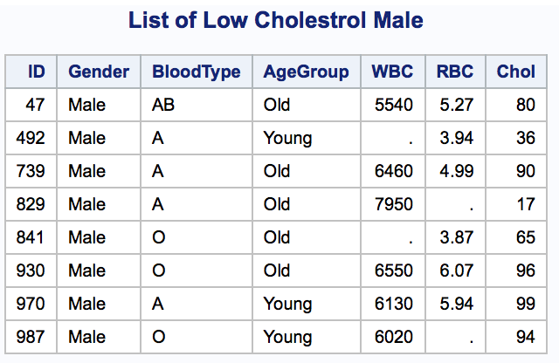

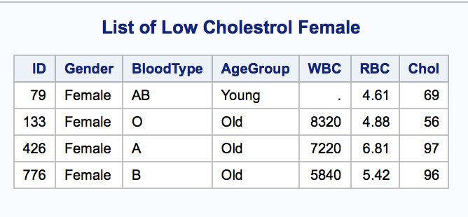

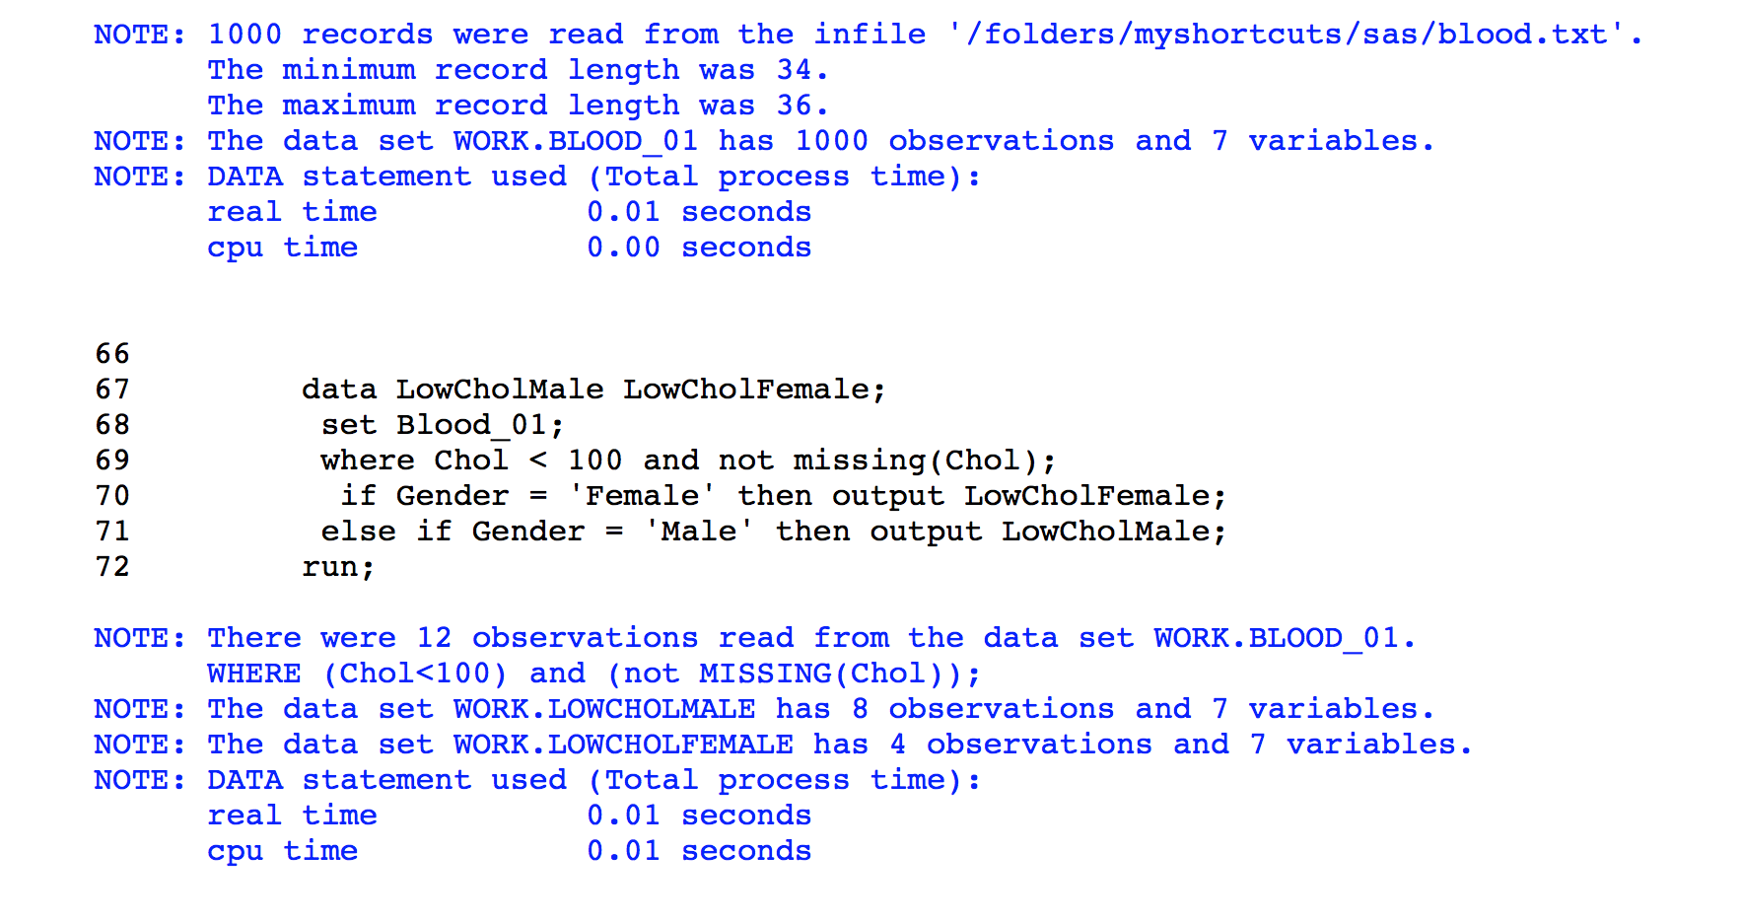

1. Using the SAS data sets Bicycles, create two temporary SAS data sets as follows: Mountain_USA consists of all observations from Bicycles where Country is **USA** and Model is **Mountain Bike**. Road_France consists of all observations from Bicycles where Country is **France** and Model is **Road Bike**. Print these two data sets.

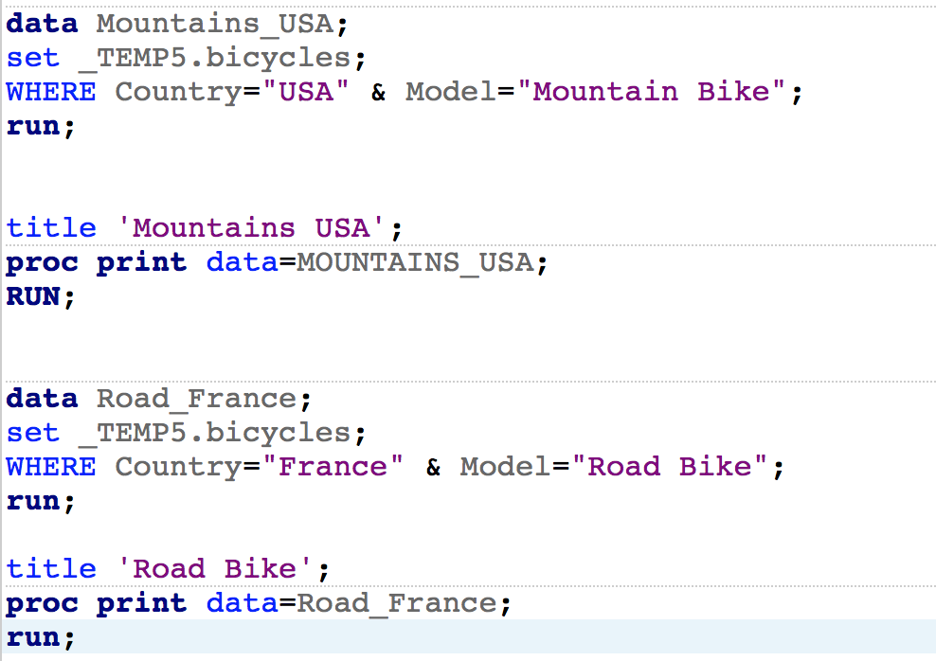

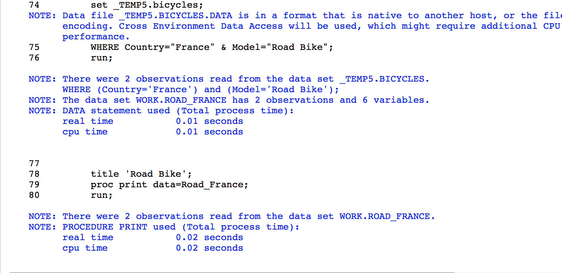

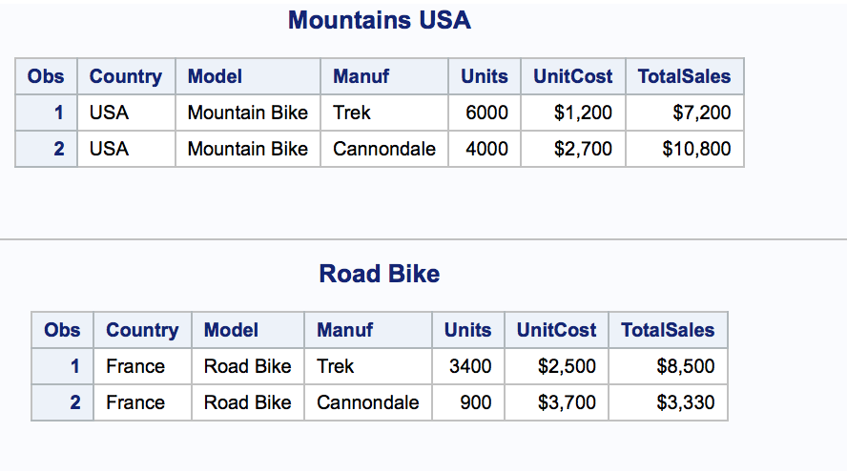

1. Print out the observations in the two data sets Inventory and NewProducts. Next, create a new temporary SAS data set (Updated) containing all the observations in Inventory followed by all the observations in NewProducts. Sort the resulting data set by model and print out the observations.

