**RESULT**

**Formula for contrast stretching:**

Pnew = (P - Pmin)/(Pmax - Pmin)*255

**Sample_1 image:**

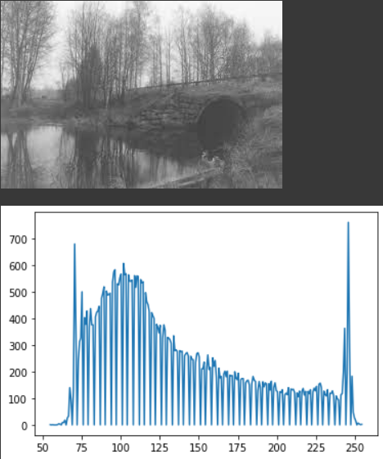



Pmax = 255, Pmin = 55

Image before contrast stretching with its histogram

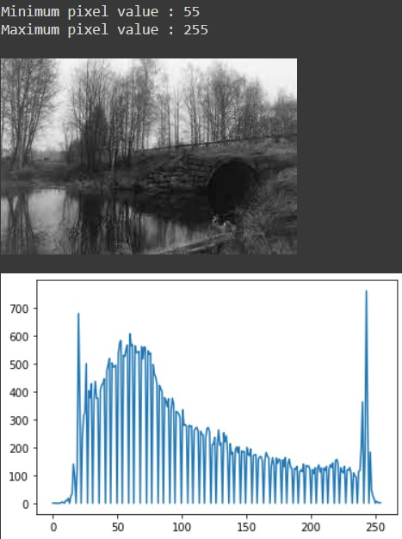

Image after contrast stretching with its histogram

Pmin i.e, 55 is stretched to the possible minimum intensity value 0 and Pmax i.e, 255 is stretched to the possible maximum intensity value 255.

(Similar output for other sample images)