BITS PILANI, DUBAI CAMPUS

DUBAI INTERNATIONAL ACADEMIC CITY, DUBAI

**FIRST SEMESTER 2021 – 2022**

**COURSE:** F213 (Object Oriented Programming)

**COMPONENT:** Practical Sheet 1 **DATE:** 6-9th September 2021

* 1. Write a Java program to find GCD of two numbers

**Solution:**

import java.util.Scanner; public class GCD

{

public static void main(String[] args)

{

int a, b;

Scanner sc = new Scanner(System.in); System.out.print("Enter the First Number: "); a = sc.nextInt();

System.out.print("Enter the Second Number: "); b = sc.nextInt();

System.out.println("GCD of " + a +" and " + b + " is " + findGCD(a, b));

}

static int findGCD(int a, int b)

{

if (b == 0)

return a;

return findGCD(b, a % b);

}

}

**Output:**

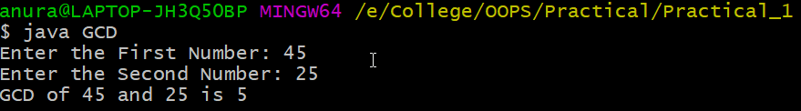

* 1. Write a program in Java to generate a random number and display if it is odd or even

**Solution:**

import java.util.Random; import java.util.Scanner; class GenerateRandom {

public static void main( String args[] ) {

Random rand = new Random(); //instance of random class int upperbound;

Scanner sc = new Scanner(System.in);

System.out.print("Enter the upper bound of the random number: "); upperbound = sc.nextInt();

int int_random = rand.nextInt(upperbound);

System.out.println("Random integer value from 0 to" + (upperbound- 1) + " : "+ int_random);

if (int_random % 2 == 0 ) System.out.println("Random number is even");

else

System.out.println("Random number is odd");

}

}

**Output:**

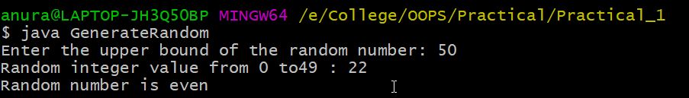

Q3. Write a program in Java to check if a number is a perfect square.

**Solution:**

import java.util.Scanner; public class Square

{

static boolean checkPerfectSquare(double number)

{

double sqrt=Math.sqrt(number);

return ((sqrt - Math.floor(sqrt)) == 0);

}

public static void main(String[] args)

{

System.out.print("Enter any number: "); Scanner sc=new Scanner(System.in); double number=sc.nextDouble();

if (checkPerfectSquare(number))

System.out.print("Yes, the given number is perfect square."); else

System.out.print("No, the given number is not perfect square.");

}

}

**Output:**

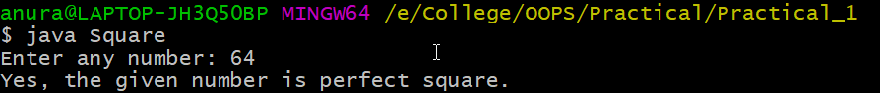

Q4. Write a Java program to read three numbers and get the smallest number using a ternary operator.

**Solution:**

import java.util.Scanner; public class Smallest

{

public static void main(String[] args)

{

int a, b, c, smallest;

Scanner sc = new Scanner(System.in); System.out.println("Enter the first number:"); a = sc.nextInt();

System.out.println("Enter the second number:"); b = sc.nextInt();

System.out.println("Enter the third number:"); c = sc.nextInt();

smallest = c < (a < b ? a : b) ? c : ((a < b) ? a : b); System.out.println("The smallest number is: "+smallest);

}

}

**Output:**

