BITS PILANI, DUBAI CAMPUS

DUBAI INTERNATIONAL ACADEMIC CITY, DUBAI

**FIRST SEMESTER 2021 – 2022**

**COURSE:** F213 (Object Oriented Programming)

**COMPONENT:** Practical Sheet 1 **DATE:** 6-9th September 2021

* 1. Write a Java program to compute average and percentage of 5 subjects and print grade using if else ladder

Grade = A if percentage>70 Grade = B if percentage>60 Grade = C if percentage>50 Grade = D if percentage>40

Grade =E if percentage>30

**Solution:**

import java.util.Scanner;

public class GradeCalc

{

public static void main(String[] args)

{

char grade;

Scanner s = new Scanner(System.in); float total = 0F;

for(int i = 1; i<=5; i++)

{

System.out.printf("Enter your test score for Subject %d: ",i); total += s.nextFloat();

}

System.out.println("Your total is " + total);

System.out.println("Your average is " + total/5); System.out.println("Your percentage is " + total*100/500 +"%"); total /= 5;

if (total >= 90)

{

grade = 'A';

}

else if (total >= 80)

{

grade = 'B';

}

else if (total >= 70)

{

grade = 'C';

}

else if (total >= 60)

{

grade = 'D';

}

else

{

grade = 'F';

}

System.out.println("Your grade is " + grade); s.close();

}

}

**Output:**

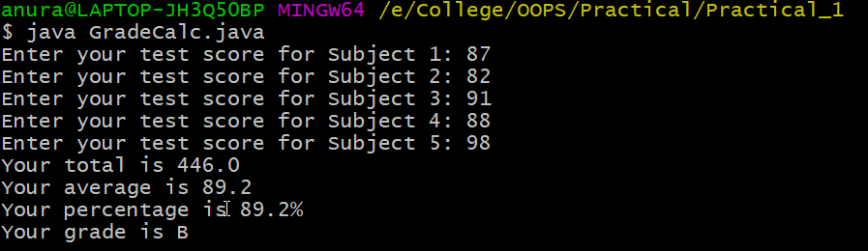

* 1. Write a program in Java to print quotient and remainder when user provides divisor and dividend at run time.

**Solution:**

import java.util.Scanner;

public class QuotientRemainder {

public static void main(String[] args) { Scanner s = new Scanner(System.in);

System.out.print("Please enter the dividend: "); int dividend = s.nextInt();

System.out.print("Please enter the divisor: "); int divisor = s.nextInt();

int quotient = dividend / divisor; int remainder = dividend % divisor;

System.out.println("Quotient = " + quotient); System.out.println("Remainder = " + remainder); s.close();

}

}

**Output:**

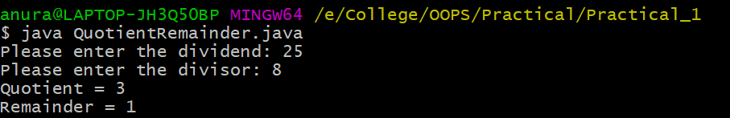

Q3. Write a program in Java to print simple interest.

**Solution:**

import java.util.Scanner; public class SimpleInterest

{

public static void main(String args[])

{

float p, r, t, sinterest;

Scanner scan = new Scanner(System.in); System.out.print("Enter the Principal : "); p = scan.nextFloat();

System.out.print("Enter the Rate of interest : "); r = scan.nextFloat();

System.out.print("Enter the Time period : "); t = scan.nextFloat();

scan.close();

sinterest = (p * r * t) / 100; System.out.print("Simple Interest is: " +sinterest);

}

}

**Output:**

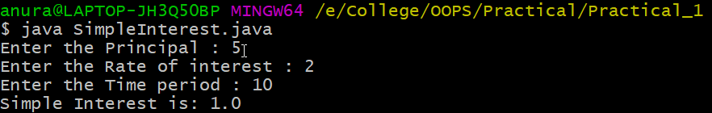

Q4. Write a Java program to reverse a number using while loop.

**Solution:**

import java.util.Scanner; class Reverse {

public static void main(String[] args) {

Scanner s = new Scanner(System.in); System.out.print("Please enter the number: "); int num = s.nextInt();

int reversed = 0; while(num != 0)

{

int digit = num % 10;

reversed = reversed * 10 + digit; num /= 10;

}

s.close();

System.out.println("Reversed Number: " + reversed);

}

}

**Output:**

