AIDL Teams App
Screen-by-Screen Data Flow Plan
Reviewed design files: teams-admin-cards.html (Admin side) and teams-cards.html (Learner side)

1. What This Document Is
Two design files were added to the project: teams-admin-cards.html (what the Admin should see) and teams-cards.html (what the Learner / user should see). Both files are working HTML mock-ups — they look and behave like the final screens, but none of the data on them is real yet; it is all sample text typed directly into the file.
This document goes through both files screen by screen and explains, in plain English: what is shown on each screen, what data it needs, where that data should come from in the backend, which parts already work in the real AIDL codebase today, and which parts still need to be built.
Read this as a plan, not a status report of finished work — most of the Admin Home screen already works exactly like this; most of the Cards catalogue screen does not exist in the backend yet. Each screen says clearly which one it is.

2. How Microsoft Teams Actually Shows These Screens
There are two completely different technologies at play here, and mixing them up is the easiest way to plan something that cannot actually be built the way it looks in the mock-up. It is worth understanding both before reading the screen-by-screen plan.
- Website Tab — runs a normal webpage inside Teams (an iframe). It can use any HTML, CSS and JavaScript — buttons, pop-up modals, drag-and-drop, live data fetching, anything a website can do.
- Adaptive Card — a fixed JSON layout that Teams itself draws natively, either as a chat message or inside a tab. It looks clean and native, but it cannot run custom JavaScript, cannot show a pop-up modal, cannot show social-share icons, and cannot do drag-and-drop file upload.
The two mock-up files use rich custom HTML — pop-up modals, drag-and-drop, share buttons, like/dislike counters. None of that is possible inside a plain Adaptive Card. That means both files are best built as Website Tabs (the same technique already used for the working Admin Home tab today), not as Adaptive Cards. The one exception is: two learner screens (the welcome message and the licence-issued message) should also be pushed as an actual chat message the moment something happens — that part has to be a real Adaptive Card, sent by the bot, because only a bot message can pop into someone's chat by itself; a tab only shows up when the user opens it.
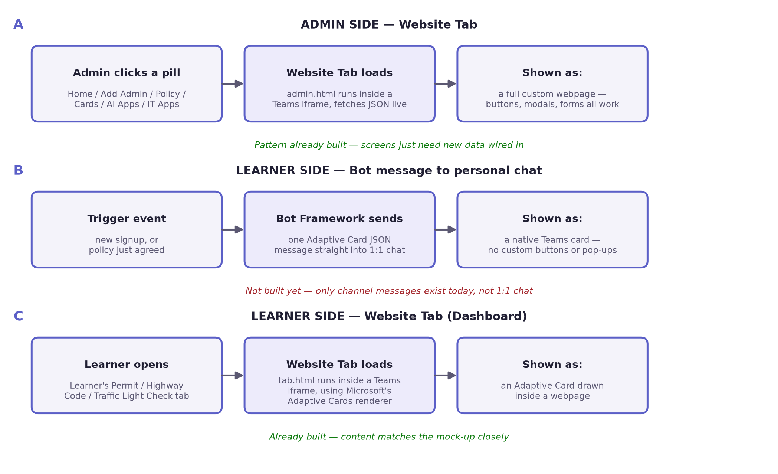
Figure 1 — the three different ways a screen can reach a user in Microsoft Teams.

3. How Every Screen Gets Its Data
Whether it is a Website Tab or a card, the pattern for fetching real data is the same four-step loop. This is already built and working for the existing Admin Home tab, and the same pattern should be reused for every new screen described in this document.
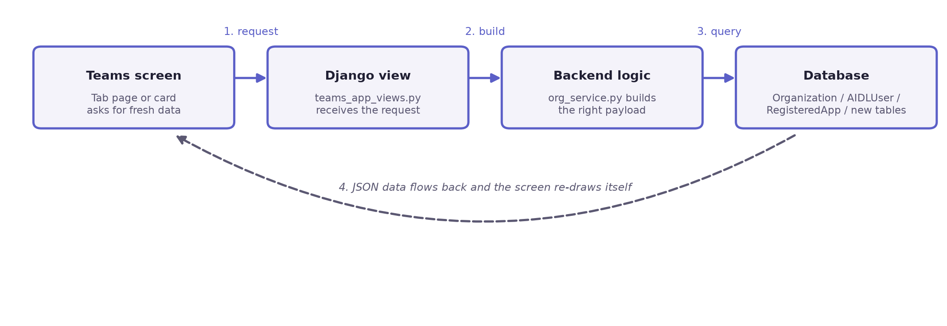
Figure 2 — the request/response loop every screen repeats each time it opens or refreshes.
- The screen (tab page or card) asks the backend for fresh data.
- A Django view (in teams_app_views.py) receives that request.
- A backend function (in org_service.py, or a new file for new features) works out exactly what to show.
- That function reads the real numbers from the database (MongoDB, through Django's models).
- The result travels back as JSON, and the screen redraws itself with real data.

4. Admin Side — Screen by Screen
From teams-admin-cards.html. Six screens, shown as tabs (pills) inside the "aidl dashboard" channel — exactly the same tab bar already built for the working Admin Center today.

4.1. Home
Already built and working today — matches this mock-up almost exactly.
What's on screen | AIDL logo and org name; a welcome heading with the admin's first name; 3 stat tiles (Seats Purchased + renewal date, Licences Issued + % of enrolled, AUP Unsigned, shown in red as a warning); a 4-tile Governance Snapshot (Total Admins, Total Approved apps, AI Applications, IT Applications); an Export Coverage CSV button; a rollout-progress line; a "Next step" link.
Data needed | seats_purchased, seats_renews_on, licences issued count, enrolled count, AUP-unsigned count, admin count and seat limit, approved/total app counts, AI app count, IT app count, rollout steps done/total.
Comes from | Organization model (seats, renewal date, admin seat limit, rollout steps) + AIDLUser model (counted per organisation: role, licence_issued, aup_signed) + RegisteredApp model (counted per organisation: status, app_type).
API endpoint | GET /api/teams/admin/home/ → build_admin_dashboard_from_db() in org_service.py
Displayed in Teams as | A Website Tab (admin.html) inside the "aidl dashboard" channel.

4.2. Add Admin
New work needed — the permission-chip feature does not exist in the backend yet.
What's on screen | Three permission chips (Approve Apps, Access Cards, Create Card) that can be switched on or off for the person being invited; a "Send Admin Invite" button; a footer line showing "X of Y admin seats used".
Data needed | Which permissions are turned on for this invite; current admin seat usage.
Comes from | Today, AIDLUser only stores one simple role: admin or learner. There is no field yet for fine-grained permissions like "can approve apps" or "can send cards".
API endpoint | POST /api/teams/admin/invite-user/ (adds a brand-new user, always as Learner) and POST /api/teams/admin/invite/ (promotes an existing user to Admin) both exist today, but neither accepts a list of permissions, and the real Admin screen has no permission-chip UI at all yet.
New work needed | (1) add a permissions field to AIDLUser, or a small separate permissions table; (2) add the permission-chip UI to the real screen; (3) update the invite endpoint to save the chosen permissions.
Displayed in Teams as | Same Website Tab technique, extra section on the existing Add Admin tab.

4.3. Policy (Acceptable Use Policy)
Partly built — signed/unsigned counts work today; file upload and version history do not exist yet.
What's on screen | A "Current Live Policy" box showing the file name, version number, effective date and who uploaded it, with a "Live" badge; a drag-and-drop zone to upload a new PDF; "Publish New Version" and "View Current Policy" buttons; a footer showing signed/unsigned counts.
Data needed | Policy file name, version number, effective date, uploader's name, signed count, unsigned count, and the list of people who have not signed.
Comes from | Organization model today only has policy_title and a single policy_url — no file name, version number, effective date or uploaded-by field exists yet. AIDLUser.aup_signed already tracks who has signed.
API endpoint | GET /api/teams/admin/policy/ already returns signed/unsigned counts and the current policy_url. There is no upload endpoint yet.
New work needed | A PolicyVersion table (organisation, file, version, effective date, uploaded by, is this the live one) to keep a history, plus a file-upload endpoint and a "Publish New Version" action.
Displayed in Teams as | Same Website Tab technique as the Policy tab today.

4.4. Cards (Send Cards catalogue)
Biggest gap — almost none of this exists in the backend yet. See the dedicated section below.
What's on screen | A catalogue of 10 ready-made reference cards (Acceptable Use, Traffic Light Check, Approved Apps Registry, Data Ethics Gate, Mistake Museum, Data Classification Cheat Sheet, Redaction Before Submission, Customer Data in Prompts, The Verification Pass, Reporting an AI Mistake). Each has a price, a star rating, a "View" button (opens the full text), a "Request Card" button, a "Send Card" button with a Send Now / Schedule for Later choice; a monthly quota bar ("X of 10 cards requested this month"); a "Request a New Card" custom form.
Data needed | Card name, category, price, rating, review count, full body text, icon; how much of this organisation's monthly quota is used; the send state of each card (not sent / requested / sent / scheduled) and its scheduled date/time; any custom card requests submitted.
Comes from | None of this exists today. The real Cards tab currently returns two fixed lines of text ("Admin Center Home" and "Learner welcome") from build_admin_tab_payload('cards') in org_service.py — a completely different, much simpler design.
API endpoint | None of the mock-up's actions (View, Request, Send, Schedule, Request a New Card) are wired to any backend endpoint today.
New work needed | Entirely new feature — new database tables, new endpoints, and a way to actually deliver a card into Teams. Full plan in Section 6.
Displayed in Teams as | Same Website Tab technique — the catalogue, quota bar and pop-up modals all need real custom HTML, which only a Website Tab can do.

4.5. AI Apps
Partly built — the list and Approved/Prohibited badge already work; category, data-allowed level and the Add Application form do not exist yet.
What's on screen | A list of AI tools; each row shows the name, category, data-allowed level and a coloured Approved / Prohibited pill; clicking a row opens a short usage-guidance note; an "Add AI Application" button opens a form (Name, Category dropdown, Data Allowed dropdown, Status).
Data needed | App name, category (from a fixed list, e.g. "Coding Assistant", "Writing & Content"...), a data-allowed classification (Public only / Internal / Internal + Confidential / None), status, and a short usage-guidance paragraph.
Comes from | RegisteredApp model already stores name, app_type, status and a general description — it has no category field and no data-allowed field yet.
API endpoint | GET /api/teams/admin/ai-apps/ already returns name, status and description.
New work needed | Add category and data_allowed fields to RegisteredApp, and build a POST endpoint so the "Add Application" form actually saves — today it only updates the page in the browser and is lost on refresh.
Displayed in Teams as | Same Website Tab technique as the AI Apps tab today.

4.6. IT Apps
Same situation as AI Apps — same fix applies, just filtered to IT-type apps.
What's on screen | Identical layout to AI Apps, filtered to IT tools (Okta SSO, Google Workspace, Slack, Jira + Confluence, Snowflake, Personal cloud drives, etc.).
Data needed | Same fields as AI Apps.
Comes from | Same RegisteredApp model, filtered by app_type = IT.
API endpoint | GET /api/teams/admin/it-apps/ already exists.
New work needed | Same as AI Apps — category, data_allowed fields, and a working Add Application endpoint.
Displayed in Teams as | Same Website Tab technique as the IT Apps tab today.

5. Learner (User) Side — Screen by Screen
From teams-cards.html. Four screens. Two of them (Home, Learner's Permit) are meant to reach the learner as a message the moment something happens (signup, policy agreed); the other two (Highway Code, Traffic Light Check) live in a personal dashboard tab the learner can open any time.

5.1. Home (Welcome + Policy)
Mostly built for the tab version — the personal-chat delivery and the in-card "I Agree" action still need to be built.
What's on screen | A welcome message with the learner's first name and org name; a "Read full policy" button; opens the full Acceptable Use Policy with checklist points and an "I Agree" button; after agreeing, shows "You agreed to Acceptable Use v3.1 on [date]".
Data needed | Learner's first name, org name, the full policy text, and the exact date/time they agreed.
Comes from | The policy text should come from the same PolicyVersion data the admin uploads on the Policy screen (Section 4.3), so both sides always show the same live policy. AIDLUser.aup_signed and aup_signed_at already store the "agreed" state.
API endpoint | The card itself is already built by build_home_card() in teams_cards.py. Signing already works through POST /api/teams/admin/aup/sign/ — but that endpoint needs a normal login session (a JWT token), which a bot conversation does not have.
New work needed | (1) push this card as a real message into the learner's personal 1:1 chat right after signup — only channel messages exist today, not personal chat messages; (2) wire the "I Agree" click inside a bot conversation to an Action.Submit handler that can record the signature without a browser session.
Displayed in Teams as | A bot-sent Adaptive Card in personal chat (new) and/or the existing Home tab (already built).

5.2. Learner's Permit (Licence Card)
New work needed — the licence card today uses made-up data, not real per-person data.
What's on screen | A Learner / Full class toggle; a licence-card graphic showing name, class, issued date, expiry date, status, licence number, and the organisation's own logo as a seal; a "Download Licence" button; social-share buttons (X, LinkedIn, Facebook, WhatsApp).
Data needed | Licence class, licence number, issued date, expiry date, status, the learner's full name, and the organisation's logo image.
Comes from | AIDLUser.licence_issued already exists as a yes/no flag, but there are no fields yet for licence number, class, issued date or expiry date. Organization has no logo field yet either — every card today shows the one shared AIDL logo, not the org's own.
API endpoint | build_learners_permit_card() in teams_cards.py exists, but it currently makes up a licence number from the person's name and always shows "Learner" — none of it is real per-user data yet. There is no download or share feature at all today.
New work needed | Add licence_number, licence_class, issued_at and expires_at to AIDLUser, filled in automatically when an admin issues a licence (POST /api/teams/admin/licence/issue/ already exists and just needs to set these new fields); add a logo_url field to Organization; build a licence image/PDF download endpoint. Share buttons need no backend, just a shareable link.
Displayed in Teams as | A bot-sent Adaptive Card after policy is agreed, and/or a personal dashboard tab.

5.3. Highway Code
Already built — the rule titles and wording already match this mock-up almost word for word.
What's on screen | Five fixed safety-rule cards (Keep Private Things Private, Check Before You Trust, You're Still the Driver, Better Prompt Better Answer, Mind What You Share), each with a road-sign icon; an "Open full Highway Code" button opens the expanded text.
Data needed | This content is the same for every organisation — it is training material, not company-specific data.
Comes from | Already fully built as fixed text inside build_highway_code_card() in teams_cards.py.
API endpoint | GET /api/teams/cards/highway-code/
New work needed | None, unless the business later wants each organisation to customise the wording.
Displayed in Teams as | A Website Tab (tab.html) that renders this Adaptive Card inside the learner's personal dashboard.

5.4. Traffic Light Check
Mostly built — the three coloured sections already exist; the like/dislike counter does not.
What's on screen | Three coloured sections (Green / Amber / Red) with example situations and an action line each; a thumbs-up / thumbs-down "Was this card useful?" widget with running counts.
Data needed | The three sections' text (fixed content, same as Highway Code); like/dislike counts for this card.
Comes from | The three sections are already built in build_traffic_light_check_card() in teams_cards.py. The like/dislike counter does not exist anywhere in the backend today.
API endpoint | GET /api/teams/cards/traffic-light-check/ for the card content; no endpoint exists yet for ratings.
New work needed | A small CardFeedback table to store like/dislike counts per card, plus an endpoint to record a vote and return the updated counts.
Displayed in Teams as | Same Website Tab / dashboard technique as Highway Code.

6. Deep Dive — the Cards Catalogue Flow
This is the single biggest new feature in either mock-up, so it gets its own detailed plan. Everything below is new work — nothing here exists in the backend today.
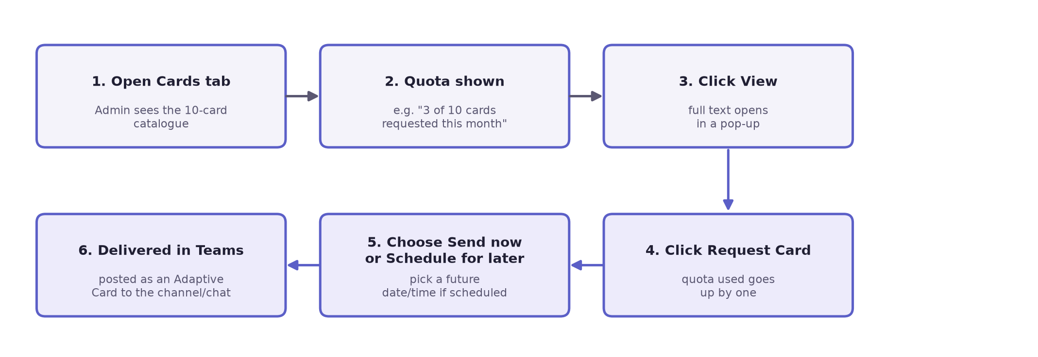
Figure 3 — an admin's journey through the Cards catalogue, from opening the tab to the card actually reaching Teams.

New database tables needed
- CardCatalog — id, name, category/kicker, price, rating, review count, icon, full body text, is_active.
- CardRequest — organisation, card, status (requested / sent / scheduled), requested_by, requested_at, scheduled_at, sent_at.
- A monthly quota rule — count CardRequest rows made this calendar month per organisation, compared against a limit (similar to the existing admin_seat_limit idea on Organization).

New endpoints needed
- GET /api/teams/admin/cards/ → catalogue list plus quota used/limit.
- GET /api/teams/admin/cards/<id>/ → full detail for the pop-up modal.
- POST /api/teams/admin/cards/<id>/request/ → marks the card as requested, quota +1.
- POST /api/teams/admin/cards/<id>/send/ → delivers now, or saves a scheduled date/time.
- POST /api/teams/admin/cards/request-new/ → saves a custom card request for review.

One thing to plan for
"Send now" can reuse the channel-message function that already exists (send_channel_adaptive_card() in teams_messaging.py). "Schedule for later" cannot — Django on its own does not run anything at a future time by itself. That part needs a background job runner (for example Celery with a periodic beat schedule, or a simple scheduled task) that checks every few minutes for any card whose scheduled time has arrived and sends it then.

7. Summary — All 10 Screens at a Glance
Screen | Side | Status | Main new work needed
Home | Admin | Done | None — already matches the mock-up.
Add Admin | Admin | New | Permission field on AIDLUser + permission-chip UI + endpoint update.
Policy | Admin | Partial | PolicyVersion table, file upload, "Publish New Version" action.
Cards (catalogue) | Admin | New | CardCatalog + CardRequest tables, quota logic, 5 new endpoints, scheduler.
AI Apps | Admin | Partial | category + data_allowed fields on RegisteredApp, working Add Application endpoint.
IT Apps | Admin | Partial | Same as AI Apps, filtered to IT.
Home (Welcome + Policy) | Learner | Partial | Personal-chat bot message sending + Action.Submit for "I Agree".
Learner's Permit | Learner | New | Licence number/class/issued/expiry fields, org logo field, download endpoint.
Highway Code | Learner | Done | None — already matches the mock-up.
Traffic Light Check | Learner | Partial | CardFeedback table + like/dislike endpoint.

Done = works today exactly like the mock-up. Partial = part of it works, part is missing. New = nothing exists yet.

8. Suggested Build Order
A practical order to build this in, so each step can be tested before the next one depends on it.
1. Extend the data models first
Add every new field/table identified above (Organization logo + policy version, AIDLUser licence fields, RegisteredApp category/data-allowed, CardCatalog/CardRequest/CardFeedback). Nothing visible changes yet, but every later step depends on this being in place.
2. Wire up the two screens that are almost done
Home (Admin) and Highway Code (Learner) already have close to all the data they need — connecting them to the new HTML designs is quick and gives an early visible win.
3. Build the Policy upload and versioning flow
The Home (Learner) screen's policy text will reuse this, so it is worth finishing before the learner side.
4. Add the Licence fields and issue flow
Powers the Learner's Permit screen, plus the download and share features.
5. Build the Cards Catalogue
The biggest and most independent new feature — catalogue, quota, request/send/schedule.
6. Add the Admin permission chips
Smaller in size, but depends on first deciding the exact list of permissions the business wants.
7. Extend AI/IT Apps
Add category and data-allowed fields, and make the "Add Application" form actually save.
8. Build personal 1:1 bot messaging
So the Welcome/Policy and Licence-Issued cards can be pushed straight into a learner's chat, not just shown in a tab. Saved for last because it is the only piece that needs new Bot Framework plumbing, not just new database fields and endpoints.

9. API Reference — Screen by Screen
This section shows the exact backend API call behind every screen — a plain REST call (fetch() in the browser talking to a Django endpoint), not an AI/GPT model. No AI or language model is involved anywhere in this app; "the data is fetched through an API" is the correct way to describe it.
The pattern is always the same: the screen calls fetch() on a URL, Django returns JSON, and the screen's JavaScript turns that JSON into what you see on screen. Read-only screens use one GET call. Screens with a button (Invite, Sign, Send, Rate) use a second POST call that saves the change, and then the screen re-runs its GET call to refresh what it shows.

Admin side

9.1 Home
Request:
GET /api/teams/admin/home/?email=priya@northwind.com

Response:
{
"tab": "home",
"dashboard": {
"first_name": "Priya",
"org_name": "Northwind Logistics",
"stats": [
{"label": "SEATS PURCHASED", "value": "50", "sub": "renews 01 Mar"},
{"label": "LICENCES ISSUED", "value": "18", "sub": "56% of enrolled"},
{"label": "AUP UNSIGNED", "value": "6", "sub": "blocks ethics gate", "alert": true}
],
"governance": [
{"label": "TOTAL ADMINS", "value": "2", "sub": "of 3 seats"},
{"label": "AI APPLICATIONS", "value": "6", "sub": "in registry"}
]
}
}
buildHomeHtml(data.dashboard) turns this straight into the stat tiles and the governance grid. Already working today, exactly like this.

9.2 Add Admin
Request:
GET /api/teams/admin/add-admin/?email=priya@northwind.com

Response:
{
"tab": "add-admin",
"placeholder": {
"items": [{"name": "Priya Raman", "email": "priya@...", "role": "admin"}],
"admin_count": 2,
"admin_seat_limit": 3,
"can_add": true
}
}

To save a change (button click):
POST /api/teams/admin/invite-user/
Header: Authorization: Bearer <JWT>
Body: {"email": "new@northwind.com", "full_name": "New User"}

{"ok": true, "email_sent": true}
After a successful invite, the screen calls GET /admin/add-admin/ again to refresh the list. The permission chips (Approve Apps / Access Cards / Create Card) are not in this response yet — that field has to be added to the backend first.

9.3 Policy
Request:
GET /api/teams/admin/policy/?email=priya@northwind.com

Response:
{
"tab": "policy",
"placeholder": {
"policy_url": "https://.../aup.pdf",
"signed_count": 26,
"unsigned_count": 6,
"items": [{"name": "Jordan Ellis", "email": "jordan@...", "aup_signed": false}]
}
}
File name, version number, effective date and uploaded-by are not in this response yet — they will come from the new PolicyVersion table once it exists.
To save a change (button click):
POST /api/teams/admin/policy/upload/ (multipart file — new endpoint, not built yet)

9.4 Cards (catalogue) — target shape, not built yet
Request:
GET /api/teams/admin/cards/?email=priya@northwind.com

Response:
{
"quota": {"used": 3, "max": 10},
"catalog": [
{"id": "traffic", "name": "Traffic Light Check", "price": "$49",
"rating": 4.8, "status": "not_sent"}
]
}
This whole endpoint is new work — the real Cards tab today only returns two fixed lines of text ("Admin Center Home" and "Learner welcome").
To save a change (button click):
POST /api/teams/admin/cards/traffic/request/ -> quota goes up by one
POST /api/teams/admin/cards/traffic/send/
Body: {"when": "now"}
or: {"when": "later", "at": "2026-09-20T10:00"}

9.5 AI Apps (IT Apps is identical, just /it-apps/)
Request:
GET /api/teams/admin/ai-apps/?email=priya@northwind.com

Response:
{
"tab": "ai-apps",
"placeholder": {
"items": [{"name": "Claude Enterprise", "status": "approved",
"description": "Assistant · Internal"}]
}
}

To save a change (button click):
POST /api/teams/admin/ai-apps/add/ (new endpoint, not built yet)
Body: {"name": "New App", "category": "Assistant",
"data_allowed": "Internal", "status": "Approved"}

Today the mock-up's "Add Application" button only updates the page in the browser — nothing is actually saved. This POST endpoint needs to be built.

Learner side

9.6 Home (Welcome + Policy)
Request:
GET /api/teams/cards/home/?full_name=Jordan Ellis&org_name=Northwind

Response:
{
"tab": "home",
"card": {
"type": "AdaptiveCard",
"body": [
{"type": "TextBlock", "text": "Welcome to AIDL, Jordan!"},
{"type": "ActionSet", "actions": [
{"type": "Action.OpenUrl", "title": "Read full policy", "url": "..."}
]}
]
}
}
The response is a full Adaptive Card JSON, not a simple object — Microsoft's AdaptiveCards.js library (loaded in tab.html) draws it on screen.
To save a change (button click):
POST /api/teams/admin/aup/sign/ Header: Authorization: Bearer <JWT>

There is no Action.Submit button wired to this yet, and there is no endpoint at all for pushing this card into a learner's personal 1:1 chat — both are new work.

9.7 Learner's Permit
Request:
GET /api/teams/cards/learners-permit/?full_name=Jordan Ellis&org_name=Northwind

Response:
{
"name": "JORDAN ELLIS",
"class": "Learner's Permit",
"issued": "Today",
"expires": "1 year from issue"
}
These values are made up on the fly from the person's name — they are not real database fields yet. The target shape, once built, should look like:
{"licence_number": "AIDL-L-04552210", "licence_class": "Learner",
"issued_at": "2026-02-14", "expires_at": "2027-02-14"}
To save a change (button click):
GET /api/teams/cards/learners-permit/download/ (new endpoint, not built yet — returns a PDF or image file)

9.8 Highway Code
Request:
GET /api/teams/cards/highway-code/

Response:
{ "tab": "highway-code", "card": { "type": "AdaptiveCard", "body": [ /* 5 fixed rule cards */ ] } }
Fixed content, already fully working — no new work needed.

9.9 Traffic Light Check
Request:
GET /api/teams/cards/traffic-light-check/

Response:
{ "tab": "traffic-light-check", "card": { "type": "AdaptiveCard", "body": [ /* Green/Amber/Red sections */ ] } }
The three sections are already working. The like/dislike widget is new.
To save a change (button click):
POST /api/teams/cards/traffic-light-check/rate/ (new endpoint, not built yet)
Body: {"vote": "like"}

{"likes": 129, "dislikes": 6}

Quick summary
Already returns real data today | API call needs to be built
Home (Admin), Highway Code, Traffic Light Check content | Cards catalogue, permission chips, real licence fields + download, like/dislike, policy upload, Add Application save, personal-chat bot push

