Question 1: SaafHawa Model Decision
Assignment Beta, Agentic AI (AI4015), Student ID 23k-0078

Parameters
Parameter | Formula | Working | Value
R | Last two digits of the roll number | 23k-0078 | 78
D | Sum of digits, mod 10 | (2 + 3 + 0 + 0 + 7 + 8) mod 10 = 20 mod 10 | 0
Normal daily queries, Q | 1,500 + 25 × R | 1,500 + 25 × 78 | 3,450
LLM calls per query, N | 5 + (R mod 4) | 5 + 2 | 7
Tool-call failure probability, p | 0.04 + 0.01 × D | 0.04 + 0.01 × 0 | 0.04
Heatwave days per month, H | 4 + (R mod 4) | 4 + 2 | 6
Monthly inference budget, B | 1,200 + 10 × R | 1,200 + 10 × 78 | $1,980
Latency target, T | 10 − (R mod 3) | 10 − 0 | 10 s

The answer for the technical lead
Do not self-host now. Use a paid API, and redesign the agent loop so it makes two LLM calls instead of seven. The best fit is DeepSeek V4.1 Flash 1017 with reasoning off, an open-weight model served through a public API, which also keeps a route to self-hosting later.
- Speed: on the seven-call loop no model meets the 10 s target; the fastest takes 29.1 s. On the two-call design DeepSeek takes 9.19 s.
- Cost: that design costs $72.86 per month at the lowest listed price and $272.11 at DeepSeek's own price, against a budget of $1,980. One always-on GPU costs $784.80 per month.
- Self-hosting: in the primary case it never breaks even, because each GPU serves only about 5,582 queries per day. Self-hosted Qwen3.8 27B would also take about 33 s per query at its measured public speed, well over T.
- Before launch: no public benchmark I found tests Urdu or Roman Urdu, so a pilot with real SaafHawa questions is still needed. See the risks section.

Section 1: Model comparison
All figures were accessed on 4 November 2026; codes in the last column refer to the source key below. Prices are per million tokens as input / cached input / output. Each model runs in its lowest measured reasoning setting.
Model | Parameters | Context / max output | Price | Rate limits (new paid tier) | Speed | Benchmarks | Features | Licence | Src
Claude Haiku 5.5 (Anthropic; low effort) | not disclosed | 1,000,000 / 128,000 | 0.1 / 0.01 / 0.5 | 4,000 RPM; 2,000,000 input + 400,000 output TPM (Start tier) | TTFT 7.92 s; first answer 7.92 s; 218.5 tok/s | AutomationBench-AA: 0.229; HLE: 0.270; non-hallucination: 0.595 | Tools: Yes; JSON: Yes; reasoning: low, medium, high, xhigh, max | Proprietary; self-host: No (weights not released) | S1 S2 S3 S4
Claude Sonnet 5.5 (Anthropic; low effort) | not disclosed | 1,000,000 / 128,000 | 2 / 0.1 / 10 | 4,000 RPM; 2,000,000 input + 400,000 output TPM (Start tier) | TTFT 2.88 s; first answer 2.88 s; 139.1 tok/s | AutomationBench-AA: 0.494; HLE: 0.362; non-hallucination: 0.523 | Tools: Yes; JSON: Yes; reasoning: low, medium, high, xhigh, max | Proprietary; self-host: No (weights not released) | S1 S2 S3 S4
GPT-6 Luna (OpenAI; reasoning none) | not disclosed | 1,050,000 / 128,000 | 0.1 / 0.01 / 0.5 | 5,000 RPM; 2,000,000 TPM (Build tier) | TTFT 1.13 s; first answer 1.13 s; 92.6 tok/s | AutomationBench-AA: 0.091; HLE: 0.086; non-hallucination: 0.200 | Tools: Yes; JSON: Yes; reasoning: none, low, medium, high, xhigh, max | Proprietary; self-host: No (weights not released) | S1 S2 S5 S6
GPT-6.1 Terra (OpenAI; reasoning none) | not disclosed | 1,050,000 / 128,000 | 1 / 0.05 / 5 | 5,000 RPM; 1,000,000 TPM (Build tier) | TTFT 1.55 s; first answer 1.55 s; 71.5 tok/s | AutomationBench-AA: 0.510; HLE: 0.211; non-hallucination: 0.229 | Tools: Yes; JSON: Yes; reasoning: none, low, medium, high, xhigh, max | Proprietary; self-host: No (weights not released) | S1 S2 S5 S7
Gemini 3.5 Flash-Lite (Google; default (lowest measured)) | not disclosed | 1,048,576 / 65,536 | 0.3 / 0.03 / 2.5 | not verified RPM; not verified TPM (Tier 1 (limits shown only in AI Studio)) | TTFT 5.11 s; first answer 5.11 s; 317.2 tok/s | AutomationBench-AA: 0.250; HLE: 0.188; non-hallucination: 0.733 | Tools: Yes; JSON: Yes; reasoning: supported; levels not verified | Proprietary; self-host: No (weights not released) | S1 S2 S8 S9
Nova 2 Lite (Amazon; reasoning off) | not disclosed | 1,000,000 / 65,535 | 0.3 / – / 2.5 | 2,000 (cross-region) RPM; 8,000,000 (cross-region) TPM (Default us-east-1 quota) | TTFT 1.64 s; first answer 1.64 s; 114.9 tok/s | tau2-bench: 0.620; HLE: 0.029 | Tools: Yes; JSON: Not listed; reasoning: off, low, medium, high | Proprietary; self-host: No (weights not released) | S1 S2 S10
Grok 4.7 (xAI; low effort) | not disclosed | 500,000 / 450,000 | 2 / 0.5 / 6 | 9,000 (150 per second) RPM; 50,000,000 TPM (General limit; entry tier not stated) | TTFT 9.23 s; first answer 9.23 s; 71.7 tok/s | AutomationBench-AA: 0.567; HLE: 0.392; non-hallucination: 0.662 | Tools: Yes; JSON: Yes; reasoning: low, medium, high, xhigh | Proprietary; self-host: No (weights not released) | S1 S2 S11 S12
DeepSeek V4.1 Flash 1017 (DeepSeek; reasoning off) | 552B total, 16B active (Hugging Face safetensors total: 763B) | 1,048,576 / 131,072 | 0.025 / 0.0015 / 0.25 (Particle AI) | not published RPM; not published TPM (DeepSeek first party: 2,500 concurrent requests) | TTFT 1.28 s; first answer 1.28 s; 151.8 tok/s | AutomationBench-AA: 0.488; HLE: 0.115; non-hallucination: 0.747 | Tools: Yes; JSON: Yes; reasoning: off, high, max | MIT; self-host: Yes | S1 S13 S14 S15 S16
Qwen3.8 27B (Alibaba; reasoning off) | 27.8B (full model, no experts) | 262,144 / 65,536 | 0.039 / 0.0039 / 1.25 (Chutes) | not published RPM; not published TPM (Not listed by endpoint) | TTFT 5.51 s; first answer 5.51 s; 44.2 tok/s | AutomationBench-AA: 0.124; HLE: 0.121; non-hallucination: 0.820 | Tools: Yes; JSON: Yes; reasoning: off, low, medium, default | Apache 2.0; self-host: Yes | S1 S13 S14
Mistral Small 4 (Mistral; reasoning off) | 119B total, 6.5B active | 262,144 / 209,715 | 0.15 / 0.015 / 0.6 (Mistral) | not published RPM; not published TPM (Not listed by endpoint) | TTFT 1.76 s; first answer 1.76 s; 136.1 tok/s | tau2-bench: 0.184; HLE: 0.038 | Tools: Yes; JSON: Yes; reasoning: off, default | Apache 2.0; self-host: Yes | S1 S13 S14 S16
Nemotron 3.5 Lightning (NVIDIA; default (only variant measured)) | 30B total, 3B active | 262,144 / 32,768 | 0.025 / 0.0125 / 0.12 (Darkbloom) | not published RPM; not published TPM (Not listed by endpoint) | TTFT 0.95 s; first answer 15.18 s; 247.5 tok/s | AutomationBench-AA: 0.008; HLE: 0.106; non-hallucination: 0.643 | Tools: Yes; JSON: Yes; reasoning: default measured; others not verified | OpenMDW 1.1; self-host: Yes | S1 S13 S14
GLM-5.3 (Z AI; low effort) | 753B total, 40B active | 1,048,576 / 943,718 | 0.0699 / 0.0689 / 1.4 (Wafer) | not published RPM; not published TPM (Not listed by endpoint) | TTFT 3.03 s; first answer 7.90 s; 60.5 tok/s | AutomationBench-AA: 0.520; HLE: 0.366; non-hallucination: 0.368 | Tools: Yes; JSON: Yes; reasoning: low, default (max) | GLM-5.3 License; self-host: Yes, with restrictions | S1 S13 S14 S16
Beam 1.0 (Reflection; default (only variant measured)) | 501B total, 23B active | 1,048,576 / 131,072 | 0.25 / 0.05 / 1 (Nebius) | not published RPM; not published TPM (Not listed by endpoint) | TTFT 0.82 s; first answer 6.93 s; 281.3 tok/s | AutomationBench-AA: 0.485; HLE: 0.347; non-hallucination: 0.590 | Tools: Yes; JSON: Yes; reasoning: default measured; others not verified | Apache 2.0; self-host: Yes | S1 S13 S14

Source key. S1 artificialanalysis.ai/leaderboards/models (performance, benchmarks; snapshot saved as artificial_analysis_snapshot_2026-11-04.csv), with definitions at /evaluations/automationbench-aa and /evaluations/tau2-bench. S2 openrouter.ai/api/v1/models (limits, features; snapshot saved). S3 platform.claude.com/docs/en/about-claude/pricing and /build-with-claude/prompt-caching. S4 platform.claude.com/docs/en/api/rate-limits. S5 developers.openai.com/api/docs/pricing and /guides/prompt-caching. S6 developers.openai.com/api/docs/models/gpt-6-luna. S7 developers.openai.com/api/docs/models/gpt-6.1-terra. S8 aistudio.google.com/docs/pricing and /caching. S9 aistudio.google.com/docs/rate-limits. S10 docs.aws.eu/bedrock/latest/userguide/model-card-amazon-nova-2-lite.html. S11 docs.x.ai/docs/models. S12 docs.x.ai/docs/models/grok-4.7. S13 openrouter.ai/api/v1/models/<model>/endpoints. S14 huggingface.co model pages and API. S15 api-docs.deepseek.com/quick_start/rate_limit and /guides/kv_cache. S16 artificialanalysis.ai/models/<model> (active parameters, licence).
Notes. The tool-use benchmark is AutomationBench-AA, which scores task completion through REST API tools. tau2-bench is used where no AutomationBench score exists, so the two are not directly comparable. HLE is Humanity's Last Exam. For open-weight models, the provider named is the one with the lowest total cost for SaafHawa's token mix among those listing tool support. Published speed figures are for the model across endpoints, so a low-priced host may be slower.

Two values I could not verify
First, the hidden reasoning tokens in low settings. Anthropic does not publish an average for Claude Haiku 5.5 at low effort, and its first token and first answer token times are identical. My estimate of 1,342 tokens per call comes from timing, using benchmark tasks that are harder than SaafHawa's steps. That one estimate moves Haiku from about $669 per month (its price with no reasoning, the same as GPT-6 Luna) to $1,574, and it decides whether Haiku fits its output rate limit at peak. Second, the prompt length behind published time-to-first-token figures. Artificial Analysis's methodology page does not state it, so I assumed the figure applies at the loop's mean input of 4,400 tokens. If it instead applies to 2,000 tokens, DeepSeek's two-call latency rises from 9.19 s to 12.30 s and misses T; at 6,800 tokens it falls to 8.28 s. The recommendation therefore needs a direct measurement before launch. Other gaps are marked in the table: Gemini's limits appear only inside AI Studio, public endpoint listings give no rate limits for open-weight models, and DeepSeek's 552B total differs from the 763B Hugging Face safetensors count.

Section 2: Calculations

1. Token volume
Input for call k is 2,000 + 800(k − 1). Each of calls 1 to 6 retries with p = 0.04, using the same input and another 350 output tokens.
Call k | Input | Output | Expected retry input | Expected retry output
1 | 2,000 | 350 | 80 | 14
2 | 2,800 | 350 | 112 | 14
3 | 3,600 | 350 | 144 | 14
4 | 4,400 | 350 | 176 | 14
5 | 5,200 | 350 | 208 | 14
6 | 6,000 | 350 | 240 | 14
7 | 6,800 | 600 | 0 | 0
Total | 30,800 | 2,700 | 960 | 84

Expected input per query = 30,800 + 960 = 31,760 tokens
Expected output per query = 2,700 + 84 = 2,784 tokens
Expected LLM calls per query = 7 + 6 × 0.04 = 7.24
Monthly queries = (30 − 6) × 3,450 + 6 × (5 × 3,450) = 82,800 + 103,500 = 186,300
Monthly input = 186,300 × 31,760 = 5,916,888,000 tokens
Monthly output = 186,300 × 2,784 = 518,659,200 tokens

2. Monthly API cost
Without caching: Cost = Queries × (Input × input price + Output × output price) / 1,000,000. Reasoning tokens are added to output.
With caching: cached tokens per query = 1,500 × 7.24 = 10,860, leaving 20,900 uncached. Cache entries are assumed to go cold hourly, a cautious figure, so 720 writes of 1,500 tokens are charged monthly at the write price where one exists.
Example, GPT-6 Luna without caching: 186,300 × (31,760 × $0.10 + 2,784 × $0.50) / 1,000,000 = $851.02
Example, GPT-6 Luna with caching: $669.05
Model | Reasoning tokens per query | No cache | With cache | Within $1,980: no cache / cache
DeepSeek V4.1 Flash 1017 | 0 | $277.59 | $230.04 | Yes / Yes
GPT-6 Luna | 0 | $851.02 | $669.05 | Yes / Yes
Nemotron 3.5 Lightning | 25,510 | $780.45 | $755.16 | Yes / Yes
Qwen3.8 27B | 0 | $879.08 | $808.07 | Yes / Yes
Mistral Small 4 | 0 | $1,198.73 | $925.59 | Yes / Yes
Claude Haiku 5.5 | 9,720 | $1,756.40 | $1,574.44 | Yes / Yes
GLM-5.3 | 2,132 | $1,695.72 | $1,693.70 | Yes / Yes
Nova 2 Lite | 0 | $3,071.71 | Not applied | No / No
Beam 1.0 | 12,451 | $4,317.43 | $3,912.79 | No / No
GPT-6.1 Terra | 0 | $8,510.18 | $6,589.42 | No / No
Gemini 3.5 Flash-Lite | 7,669 | $6,643.35 | Not applied | No / No
Claude Sonnet 5.5 | 1,114 | $19,095.57 | $15,254.04 | No / No
Grok 4.7 | 3,871 | $19,273.17 | $16,238.34 | No / No

Reasoning tokens are estimated as (first answer − first token) × speed per call. Where the two times are equal, the median first-token time of current non-reasoning models (1.77 s) replaces the first token.
Cache terms by provider:
Provider | Minimum prefix (tokens) | Lifetime | Write premium | Caching applied
Anthropic | 512 | 5 min (or 1 h) | 1.25× input | Yes
OpenAI | 1,024 | 30 min (or 12 h) | 1.25× input | Yes
Google | not stated (other Gemini 3 models: 4,096) | not stated | storage $1.00 per 1M per hour | No
Amazon | no price found | not found | not found | No
xAI | not stated | not stated | none listed | Yes
Open-weight hosts | not published by endpoint | not published (DeepSeek first party: hours to days) | none listed | Yes, at listed price

Where a minimum is unknown and no usable cache price exists, I assumed no caching, which is the cautious choice. For open-weight hosts the listed cached price is used, and whether a 1,500-token prefix qualifies should be confirmed with the chosen host.

3. Peak load and rate limits
Heatwave day = 5 × 3,450 = 17,250 queries
12:00 to 14:00 window = 0.35 × 17,250 = 6,037.5 queries over 120 minutes
Peak = 6,037.5 / 120 = 50.31 queries per minute (0.8385 per second)
Peak LLM requests = 50.31 × 7.24 = 364.3 per minute
Peak tokens per minute = 1,597,925 input + 140,070 output = 1,737,995
Model | Requests (used / limit) | Tokens per minute | Fits?
Claude Haiku 5.5 | 364 / 4,000 | uncached input 1,051,531 of 2,000,000; output 629,088 of 400,000 | No
Claude Sonnet 5.5 | 364 / 4,000 | uncached input 1,051,531 of 2,000,000; output 196,113 of 400,000 | Yes
GPT-6 Luna | 364 / 5,000 | 1,737,995 of 2,000,000 TPM | Yes
GPT-6.1 Terra | 364 / 5,000 | 1,737,995 of 1,000,000 TPM | No
Nova 2 Lite | 364 / 2,000 | 1,737,995 of 8,000,000 TPM | Yes
Grok 4.7 | 364 / 9,000 | 1,932,774 of 50,000,000 TPM | Yes

Anthropic's Start tier also has a $500 monthly spend cap and its Build tier a $1,000 cap, so Claude Haiku on the seven-call loop would need a tier increase despite being within B.

4. Self-hosting memory
Model: Qwen3.8 27B, because it is Apache 2.0 and small enough for one GPU. Its config.json lists 16 full-attention and 48 linear-attention layers, so the formula must be adapted. Applying the standard formula to every layer would overstate memory.
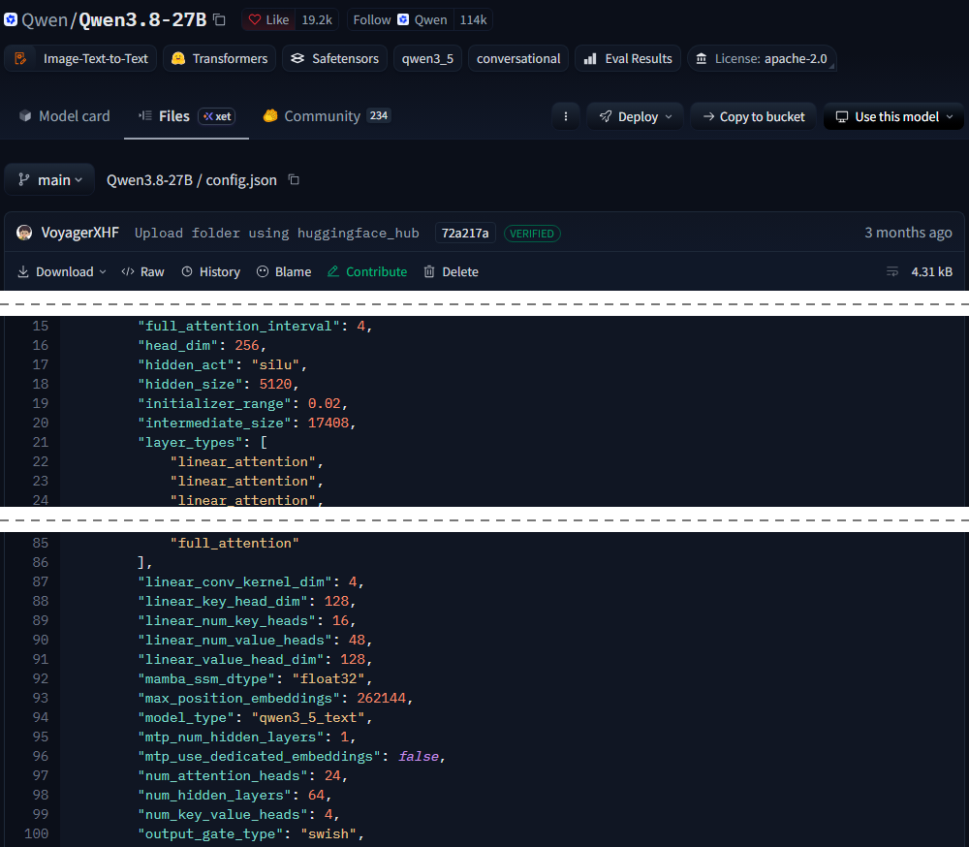
Screenshot of huggingface.co/Qwen/Qwen3.8-27B/blob/main/config.json, taken 5 November 2026. Dashed lines mark where unrelated lines were cropped out; the layer_types list (lines 22 to 85) repeats three linear_attention layers followed by one full_attention layer.
From config.json: layers = 64, KV heads = 4, head_dim = 256, hidden_size = 5120, attention heads = 24
(1) Weight memory, from the Hugging Face total of 27,781,427,952 parameters:
FP16: 2 bytes each = 55.56 GB; 8-bit: 1 byte each = 27.78 GB; 4-bit: 0.5 byte each = 13.89 GB
(2) Cache per sequence, at the longest context of 6,800 input + 600 output = 7,400 tokens:
Full-attention layers: 2 × 16 × 4 × 256 × 7,400 × 2 = 484,966,400 bytes = 0.4850 GB
Justification for the change: a linear-attention layer stores no per-token keys and values. It keeps a fixed recurrent state and a small convolution state, so its memory does not grow with sequence length. The shapes come from the Hugging Face Transformers source (modeling_qwen3_5.py), and the config sets this state to float32, so it uses 4 bytes per value.
Linear-attention layers: 48 × (40,960 + 786,432) values × 4 bytes = 0.1589 GB, fixed
Total per sequence = 0.4850 + 0.1589 = 0.6438 GB
For comparison, the standard formula on all 64 layers = 1.9399 GB (upper bound)
(3) Maximum concurrent sequences on an NVIDIA L40S 48 GB, RunPod Secure Cloud at $1.09/hour (runpod.io/gpu-cloud/pricing, accessed 4 November 2026):
Free memory = 48 − 4.8 (10% reserve) − 13.89 (4-bit weights) = 29.31 GB
Sequences = floor(29.31 / 0.6438) = 45 (standard formula: 15)
(4) GPUs required. Item 3 gives an arrival rate, not concurrent sessions, so I use Little's law: concurrent sessions = arrival rate × time in system. I assume a session holds its memory for the whole query.
Qwen query latency at its measured speed: 33.17 s on the two-call plan; 104.24 s on the original loop
Two-call plan: 0.8385 × 33.17 = 27.8 sessions, so ceil(27.8 / 45) = 1 GPU
Original loop: 0.8385 × 104.24 = 87.4 sessions, so 2 GPUs
This counts memory only. At peak, the two-call plan needs about 808 output tokens per second from Qwen. I found no verified figure for that on an L40S, so the real GPU count could be higher, which would make self-hosting less attractive still.

5. Break-even analysis
One GPU = $1.09 × 720 hours = $784.80 per month
GPUs(Q) = ceil((5 × 0.35 × Q / 7,200) × W / 45); self-hosting cost = GPUs(Q) × $784.80
API cost(Q) = 54 × Q × cost per query, since monthly queries = (30 + 4H) × Q
Primary case. The cheaper candidate meeting T is DeepSeek V4.1 Flash at the lowest listed price: $0.000391 per query, or $72.86 per month at Q = 3,450. Self-hosting costs $784.80 at that volume. With W = 33.17 s each GPU serves up to 5,582 queries per day, so self-hosting adds about $0.1406 per month for each extra daily query, against $0.0211 on the API. The lines never cross, so Q* does not exist in this case (tested to 400,000 queries per day).
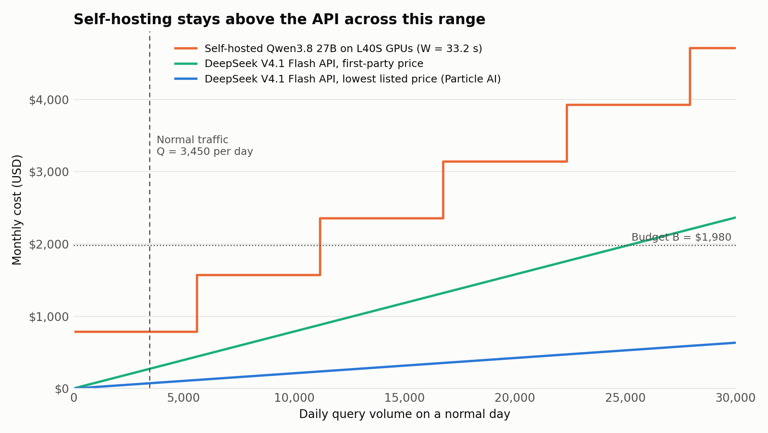
Because that result depends on an unusually low host price and on Qwen's public speed, I tested other cases:
API price | Design | W | API at Q = 3,450 | First Q* | Cheaper for good from
Lowest listed (Particle AI) | Two-call plan | 33.2 s | $72.86 | No crossing | –
Lowest listed (Particle AI) | Two-call plan | 10.0 s | $72.86 | No crossing | –
Lowest listed (Particle AI) | Original 7-call loop | 104.2 s | $230.04 | No crossing | –
Lowest listed (Particle AI) | Original 7-call loop | 10.0 s | $230.04 | 11,800 | 23,550
DeepSeek first party | Two-call plan | 33.2 s | $272.11 | No crossing | –
DeepSeek first party | Two-call plan | 10.0 s | $272.11 | 10,000 | 19,950
DeepSeek first party | Original 7-call loop | 104.2 s | $901.32 | No crossing | –
DeepSeek first party | Original 7-call loop | 10.0 s | $901.32 | 3,050 | 3,050
AA median | Two-call plan | 33.2 s | $544.21 | 5,000 | 44,800
AA median | Two-call plan | 10.0 s | $544.21 | 5,000 | 5,000
AA median | Original 7-call loop | 104.2 s | $1,802.63 | 1,550 | 9,050
AA median | Original 7-call loop | 10.0 s | $1,802.63 | 1,550 | 1,550

The step function explains why a first crossing can be followed by a stretch where the API is cheaper again. Is Q* realistic? The most useful comparison is DeepSeek's own price on the two-call plan with W = T, where Q* = 10,000 queries per normal day, about 2.9 times current traffic. That assumes Qwen could reach T, which its measured speed does not support. It also leaves out staff time for running GPUs, monitoring and security, which would push the real figure higher. For a company at this stage, Q* is not a realistic near-term target. Self-hosting becomes worth reviewing if traffic grows several-fold, API prices rise, or data rules require it.

6. Latency budget
Measured tool delay. I called OpenAQ and Open-Meteo 50 times each and timed the heat index and knowledge-base lookup locally, on these days: 2026-11-04, 2026-11-05. Raw timings are in tool_latency_log.csv.
Tool | Successful calls | Median (ms) | Min (ms) | Max (ms)
Air quality, OpenAQ | 50 | 880.297 | 739.162 | 2075.265
Heat index, local | 50 | 0.012 | 0.004 | 0.070
Knowledge base lookup, local | 50 | 0.158 | 0.046 | 0.783
Modelled PM10, Open-Meteo (not pooled) | 50 | 717.732 | 519.826 | 2170.966
Weather, Open-Meteo | 50 | 697.640 | 509.726 | 2662.705

The pooled median is d = 255.25 ms, as the assignment specifies. The pool has two clusters, with the middle timings at 0.783 ms and 509.726 ms, so this median falls between them and matches no real tool. I use it as instructed and also show the slowest API's median of 880 ms as a check.
Model. Call k takes TTFA × input_k / 4,400 + output_k / speed, because each call has a longer input than the last. Reasoning time is already inside TTFA. Retries add 0.04 × (TTFA_k + 350 / speed) for calls 1 to 6, and the six tool calls add 6 × d.
Candidate | LLM calls | Retries | Tools | Total | Meets 10 s?
DeepSeek V4.1 Flash 1017 | 26.76 s | 0.83 s | 1.53 s | 29.12 s | No
Claude Haiku 5.5 | 67.78 s | 2.11 s | 1.53 s | 71.42 s | No

How the candidates were chosen. I required a monthly cost within B, a tool score of at least 0.2 to exclude models near the bottom of the benchmark, then took the fastest on each side. All models and their latencies are in the notebook. GPT-6 Luna is cheaper than Haiku but scores 0.091 on tool use and 0.200 on non-hallucination in this setting, which is too weak when errors reach municipal officers.
Architectural change: merge the tool loop into one parallel step. Air quality, weather and the knowledge base are independent, so they can run together. The heat index only needs the weather result, so plain code computes it with no LLM step. This leaves two LLM calls: (2,000 input, 350 output) to understand the question and request tools, and (6,800 input, 600 output) to answer. Streaming would not help, because WhatsApp delivers a finished message.
New expected tokens per query: input 8,880, output 964, calls 2.04
DeepSeek: (1.282 × 2,000 / 4,400 + 350 / 151.8) + (1.282 × 6,800 / 4,400 + 600 / 151.8) = 8.82 s
DeepSeek total = 8.82 + 0.12 (retry) + 0.26 (tools) = 9.19 s
Candidate | Before | After | Meets 10 s? | With slowest tool | Monthly cost after
DeepSeek V4.1 Flash 1017 | 29.12 s | 9.19 s | Yes | 9.82 s | $72.86
Claude Haiku 5.5 | 71.42 s | 20.65 s | No | 21.27 s | $459.16

DeepSeek meets T with little margin, and Haiku does not because its first answer takes about 8 s even at low effort. The change also cuts cost by about 68%.

Risks to check before launch
- Language: no benchmark used here tests Urdu or Roman Urdu. Test each candidate on real questions, including the two samples in the brief, in both scripts.
- Host reliability: the lowest listed price comes from a small provider. I would budget using DeepSeek's own price, which still fits well within B, and compare data-handling terms for health-related questions.
- PM10 data: in my 4 November 2026 query of OpenAQ within 25 km of central Karachi, every location active in the previous 30 days reported PM2.5 only. The system therefore uses modelled PM10 from Open-Meteo, which must be labelled as modelled.
- Morning summary for officers: figures should come straight from tool outputs in code, not be retyped by the LLM, and a named person should review the summary before it is sent.
- Measure, don't assume: run the two-call design against the chosen host to confirm the real latency, since the margin against T is small.

Declaration of AI tools used
Claude Code (Anthropic): used to help collect and organise published model data, write the latency logger, knowledge base and calculation notebook, and draft this report.

