ARSH

23K-0078
BAI-3C

LAB 6

Task 1
Declare marks = 67, 84, 92, 75, 88. Display the first element, last element and element at index 2, show LENGTHOF and SIZEOF, then change index 1 to 90 and display the updated array.

Code
INCLUDE Irvine32.inc

.data
marks BYTE 67, 84, 92, 75, 88

msgFirst BYTE "First element [marks + 0] = ", 0
msgLast BYTE "Last element marks[ESI=4] = ", 0
msgIdx2 BYTE "Index 2 [marks + 2] = ", 0
msgLen BYTE "LENGTHOF marks = ", 0
msgSize BYTE "SIZEOF marks = ", 0
msgBytes BYTE " bytes", 0
msgOrig BYTE "Original array : ", 0
msgUpd BYTE "Updated array : ", 0
msgSpace BYTE " ", 0

.code
main PROC
mov edx, OFFSET msgOrig
call WriteString
call ShowMarks
call Crlf

; ---------- first element (direct-offset) ----------
mov edx, OFFSET msgFirst
call WriteString
movzx eax, [marks + 0] ; 67
call WriteDec
call Crlf

; ---------- last element (indexed, using LENGTHOF) ----------
mov edx, OFFSET msgLast
call WriteString
mov esi, LENGTHOF marks - 1 ; last index = 4
movzx eax, marks[esi] ; 88
call WriteDec
call Crlf

; ---------- element at index 2 ----------
mov edx, OFFSET msgIdx2
call WriteString
movzx eax, [marks + 2] ; 92
call WriteDec
call Crlf
call Crlf

; ---------- number of elements and size ----------
mov edx, OFFSET msgLen
call WriteString
mov eax, LENGTHOF marks ; 5
call WriteDec
call Crlf

mov edx, OFFSET msgSize
call WriteString
mov eax, SIZEOF marks ; 5
call WriteDec
mov edx, OFFSET msgBytes
call WriteString
call Crlf
call Crlf

; ---------- change index 1 to 90 ----------
mov [marks + 1], 90 ; size known from marks (BYTE)

mov edx, OFFSET msgUpd
call WriteString
call ShowMarks

exit
main ENDP

;------------------------------------------------------------
; ShowMarks
; Displays every element of marks on one line.
;------------------------------------------------------------
ShowMarks PROC
mov esi, 0 ; index
mov ecx, LENGTHOF marks
L1:
movzx eax, marks[esi]
call WriteDec
mov edx, OFFSET msgSpace
call WriteString
inc esi ; TYPE marks = 1
loop L1
call Crlf
ret
ShowMarks ENDP
END main

Output
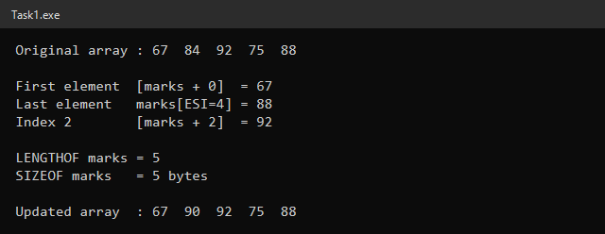

Results
Item | Operand / Operator | Result
First element | [marks + 0] | 67
Last element | marks[ESI], ESI = LENGTHOF marks − 1 = 4 | 88
Element at index 2 | [marks + 2] | 92
Number of elements | LENGTHOF marks | 5
Total size | SIZEOF marks (5 × TYPE 1) | 5 bytes
Index 1 after update | MOV [marks + 1], 90 | 84 → 90

Expected checks: the updated second element is 90, LENGTHOF is 5 and SIZEOF is 5 bytes — all match the output. Because each element is a BYTE, the index and the byte offset are the same number, and LENGTHOF − 1 gives the index of the last element without hard-coding it.

Task 2
Traverse scores = 12, 25, 18, 30, 15, 20 with LOOP and an index register, display every element, and calculate the total and the integer average.

Code
INCLUDE Irvine32.inc

.data
scores DWORD 12, 25, 18, 30, 15, 20

msgScores BYTE "Scores : ", 0
msgTotal BYTE "Total = ", 0
msgAvg BYTE "Average = ", 0
msgSpace BYTE " ", 0

.code
main PROC
mov edx, OFFSET msgScores
call WriteString

mov ecx, LENGTHOF scores ; loop counter = 6
mov esi, 0 ; index register
mov ebx, 0 ; running total (not the loop counter)
L1:
mov eax, scores[esi * TYPE scores] ; byte offset = index * 4
call WriteDec
mov edx, OFFSET msgSpace
call WriteString
add ebx, eax ; total += element
inc esi ; next index
loop L1
call Crlf

; ---------- display total ----------
mov edx, OFFSET msgTotal
call WriteString
mov eax, ebx ; 120
call WriteDec
call Crlf

; ---------- integer average = total / count ----------
mov eax, ebx ; dividend = total
mov edx, 0 ; clear upper half of EDX:EAX
mov ecx, LENGTHOF scores ; divisor = 6
div ecx ; EAX = quotient (20), EDX = remainder

mov edx, OFFSET msgAvg
call WriteString
call WriteDec
call Crlf

exit
main ENDP
END main

Output
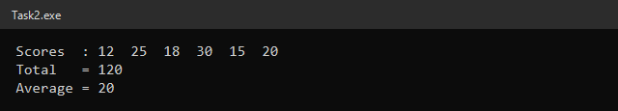

Loop Trace
Iteration | ESI (index) | Byte offset = ESI × TYPE scores | Element | EBX (running total) | ECX after LOOP
1 | 0 | 0 | 12 | 12 | 5
2 | 1 | 4 | 25 | 37 | 4
3 | 2 | 8 | 18 | 55 | 3
4 | 3 | 12 | 30 | 85 | 2
5 | 4 | 16 | 15 | 100 | 1
6 | 5 | 20 | 20 | 120 | 0 (loop ends)

- ECX is set from LENGTHOF scores (6) and is used only as the loop counter.
- EBX holds the running total, so the LOOP counter is never disturbed.
- scores[ESI * TYPE scores] scales the index by 4 because each DWORD occupies 4 bytes.
- Average: EDX is cleared, EAX = 120, then DIV ECX (ECX = 6) gives quotient EAX = 20 and remainder EDX = 0.
Total = 120 and Average = 20, matching the expected values.

Task 3
Fill an uninitialized DWORD array of 10 elements with the multiples of 7 using a pointer in ESI, display it with a second loop, then display it in memory with DumpMem.

Code
INCLUDE Irvine32.inc

.data
multiples DWORD 10 DUP(?)

msgArr BYTE "Multiples of 7 : ", 0
msgDump BYTE "DumpMem of multiples:", 0
msgSpace BYTE " ", 0

.code
main PROC
; ---------- loop 1 : fill the array through ESI ----------
mov esi, OFFSET multiples ; pointer to first element
mov ecx, LENGTHOF multiples ; 10 iterations
mov eax, 7 ; first multiple
Fill:
mov [esi], eax ; store current multiple
add eax, 7 ; next multiple of 7
add esi, TYPE multiples ; next element (+4 bytes)
loop Fill

; ---------- loop 2 : display the array ----------
mov edx, OFFSET msgArr
call WriteString
mov esi, OFFSET multiples
mov ecx, LENGTHOF multiples
Show:
mov eax, [esi]
call WriteDec
mov edx, OFFSET msgSpace
call WriteString
add esi, TYPE multiples
loop Show
call Crlf
call Crlf

; ---------- memory dump ----------
mov edx, OFFSET msgDump
call WriteString
mov esi, OFFSET multiples ; starting address
mov ecx, LENGTHOF multiples ; number of units
mov ebx, TYPE multiples ; unit size (4 = doubleword)
call DumpMem

exit
main ENDP
END main

Output
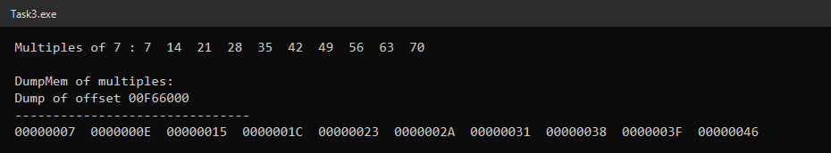

DumpMem Values
DumpMem prints each doubleword in hexadecimal. The address after "Dump of offset" changes from run to run.
Element | Decimal | Hex in DumpMem | Address offset
multiples[0] | 7 | 00000007 | +0
multiples[1] | 14 | 0000000E | +4
multiples[2] | 21 | 00000015 | +8
multiples[3] | 28 | 0000001C | +12
multiples[4] | 35 | 00000023 | +16
multiples[5] | 42 | 0000002A | +20
multiples[6] | 49 | 00000031 | +24
multiples[7] | 56 | 00000038 | +28
multiples[8] | 63 | 0000003F | +32
multiples[9] | 70 | 00000046 | +36

The array is filled by a single loop: [ESI] receives the current multiple, EAX is increased by 7, and ESI is advanced by TYPE multiples (4 bytes). No separate MOV instruction is written for each element. DumpMem receives ESI = OFFSET multiples, ECX = LENGTHOF multiples (10) and EBX = TYPE multiples (4).

Task 4
Print a 5-row number triangle with nested LOOP instructions, saving the outer ECX in a memory variable before the inner loop and restoring it afterwards.

Code
INCLUDE Irvine32.inc

ROWS = 5

.data
outerCount DWORD ? ; saved outer-loop counter
rowNum DWORD 1 ; numbers to print in current row
msgSpace BYTE " ", 0

.code
main PROC
mov ecx, ROWS ; outer loop: 5 rows
Outer:
mov outerCount, ecx ; save outer ECX
mov ecx, rowNum ; inner loop runs rowNum times
mov eax, 1 ; first number of every row
Inner:
call WriteDec
mov edx, OFFSET msgSpace
call WriteString
inc eax ; next number
loop Inner

call Crlf ; end of row
inc rowNum ; next row prints one more number
mov ecx, outerCount ; restore outer ECX
loop Outer

exit
main ENDP
END main

Output
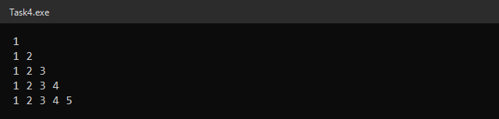

Nested Loop Trace
Row | Outer ECX saved in outerCount | Inner ECX (rowNum) | Printed
1 | 5 | 1 | 1
2 | 4 | 2 | 1 2
3 | 3 | 3 | 1 2 3
4 | 2 | 4 | 1 2 3 4
5 | 1 | 5 | 1 2 3 4 5

Why ECX Must Be Saved and Restored
Both loops use the LOOP instruction, and LOOP always decrements ECX. The inner loop finishes with ECX = 0. If the outer value were not restored from outerCount, the outer LOOP would decrement 0 to FFFFFFFFh and keep looping about 4 billion times. Saving ECX in outerCount before loading the inner count, and reloading it after the inner loop, keeps the outer loop at exactly 5 rows.

Task 5
Generate 12 dice rolls (1–6) with Randomize and RandomRange, display them, count the rolls of 4 or greater and calculate their sum. Ask with MsgBoxAsk before showing the results.

Code
INCLUDE Irvine32.inc

.data
rolls DWORD 12 DUP(?)
highCount DWORD ? ; rolls that are 4 or greater
rollSum DWORD ? ; sum of all rolls

msgRolls BYTE "Dice rolls : ", 0
msgCount BYTE "Rolls of 4 or greater = ", 0
msgSum BYTE "Sum of all rolls = ", 0
msgCancel BYTE "Results cancelled by the user.", 0
msgSpace BYTE " ", 0
caption BYTE "Dice Analysis", 0
question BYTE "Do you want to view the results?", 0

.code
main PROC
call Randomize ; seed the generator once

; ---------- fill the array with 1..6 ----------
mov esi, OFFSET rolls
mov ecx, LENGTHOF rolls ; 12 rolls
Fill:
mov eax, 6
call RandomRange ; EAX = 0..5
inc eax ; EAX = 1..6
mov [esi], eax
add esi, TYPE rolls
loop Fill

; ---------- display rolls, count >= 4 and sum ----------
mov edx, OFFSET msgRolls
call WriteString
mov esi, OFFSET rolls
mov ecx, LENGTHOF rolls
mov ebx, 0 ; count of rolls >= 4
mov edi, 0 ; sum
Scan:
mov eax, [esi]
call WriteDec
mov edx, OFFSET msgSpace
call WriteString
add edi, eax ; sum += roll
cmp eax, 4
jb NotHigh ; skip if roll < 4
inc ebx ; roll >= 4
NotHigh:
add esi, TYPE rolls
loop Scan
call Crlf

mov highCount, ebx ; save results (EBX is needed for MsgBoxAsk)
mov rollSum, edi

; ---------- ask the user ----------
mov edx, OFFSET question
mov ebx, OFFSET caption
call MsgBoxAsk ; EAX = IDYES (6) or IDNO (7)
cmp eax, IDYES
je ShowResults
jmp Cancelled

ShowResults:
mov edx, OFFSET msgCount
call WriteString
mov eax, highCount
call WriteDec
call Crlf
mov edx, OFFSET msgSum
call WriteString
mov eax, rollSum
call WriteDec
call Crlf
jmp Done

Cancelled:
mov edx, OFFSET msgCancel
call WriteString
call Crlf

Done:
exit
main ENDP
END main

Output
The MsgBoxAsk dialog shown by the program:
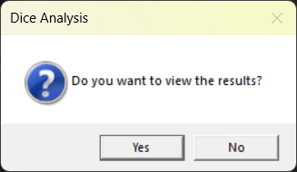
Run 1 — user clicked Yes (EAX = 6):
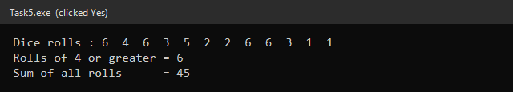
Run 2 — user clicked No (EAX = 7):
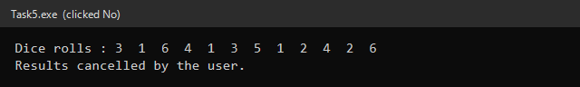

Checking Run 1
Rolls | Rolls ≥ 4 | Count | Sum
6 4 6 3 5 2 2 6 6 3 1 1 | 6, 4, 6, 5, 6, 6 | 6 | 6+4+6+3+5+2+2+6+6+3+1+1 = 45

Explanation
- Randomize is called once to seed the generator from the clock, so every run produces different rolls.
- RandomRange with EAX = 6 returns 0 to 5; INC EAX turns this into 1 to 6.
- Fill and scan loops use ESI as the pointer, ECX = LENGTHOF rolls (12) and ADD ESI, TYPE rolls (4).
- Counting: CMP EAX, 4 followed by JB skips the INC EBX for rolls below 4; EDI keeps the sum.
- MsgBoxAsk needs EDX = OFFSET question and EBX = OFFSET caption, so the count and sum are first saved in highCount and rollSum. The returned EAX is compared with IDYES (6): JE jumps to the results, otherwise JMP goes to the cancellation message (IDNO = 7).

