ARSH

23K-0078
BAI-3C

LAB 5

Task 1
Read selected elements of arrayB and arrayW with direct-offset operands, zero-extend them and display them with WriteHex.

Code
INCLUDE Irvine32.inc

.data
arrayB BYTE 12h, 24h, 36h, 48h, 5Ah
arrayW WORD 1111h, 2222h, 3333h, 4444h

msgTitle BYTE "Task 1 - Direct-Offset Operands", 0
msgB1 BYTE "arrayB first [arrayB + 0] = ", 0
msgB3 BYTE "arrayB third [arrayB + 2] = ", 0
msgB5 BYTE "arrayB last [arrayB + 4] = ", 0
msgW2 BYTE "arrayW second [arrayW + 2] = ", 0
msgW4 BYTE "arrayW fourth [arrayW + 6] = ", 0
msgHex BYTE "h", 0

.code
main PROC
mov edx, OFFSET msgTitle
call WriteString
call Crlf
call Crlf

; ---------- arrayB : 1 byte per element ----------
mov edx, OFFSET msgB1
call WriteString
movzx eax, [arrayB + 0] ; first element, zero-extended to 32 bits
call WriteHex
mov edx, OFFSET msgHex
call WriteString
call Crlf

mov edx, OFFSET msgB3
call WriteString
movzx eax, [arrayB + 2] ; third element (index 2 * 1 byte)
call WriteHex
mov edx, OFFSET msgHex
call WriteString
call Crlf

mov edx, OFFSET msgB5
call WriteString
movzx eax, [arrayB + 4] ; last element (index 4 * 1 byte)
call WriteHex
mov edx, OFFSET msgHex
call WriteString
call Crlf

; ---------- arrayW : 2 bytes per element ----------
mov edx, OFFSET msgW2
call WriteString
movzx eax, [arrayW + 2] ; second element (index 1 * 2 bytes)
call WriteHex
mov edx, OFFSET msgHex
call WriteString
call Crlf

mov edx, OFFSET msgW4
call WriteString
movzx eax, [arrayW + 6] ; fourth element (index 3 * 2 bytes)
call WriteHex
mov edx, OFFSET msgHex
call WriteString
call Crlf

exit
main ENDP
END main

Output
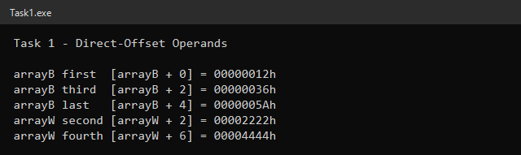

Selected Elements
Element | Operand | Displacement (index × TYPE) | Value
arrayB first | [arrayB + 0] | 0 × 1 = 0 | 12h
arrayB third | [arrayB + 2] | 2 × 1 = 2 | 36h
arrayB last | [arrayB + 4] | 4 × 1 = 4 | 5Ah
arrayW second | [arrayW + 2] | 1 × 2 = 2 | 2222h
arrayW fourth | [arrayW + 6] | 3 × 2 = 6 | 4444h

A direct-offset operand adds a constant byte displacement to the array's address. Because each WORD takes 2 bytes, the displacement for arrayW is index × 2, not index × 1. WriteHex always prints all of EAX, so each BYTE/WORD is loaded with MOVZX to clear the upper bits of EAX; otherwise leftover data in EAX would appear in the output.

Task 2
Load the address of each array with OFFSET, display it, and display TYPE, LENGTHOF and SIZEOF for every array, verifying SIZEOF = TYPE × LENGTHOF.

Code
INCLUDE Irvine32.inc

.data
numbers BYTE 10, 20, 30, 40, 50, 60
marks WORD 1000h, 2000h, 3000h
values DWORD 11111111h, 22222222h

msgAddr BYTE "--- Array addresses (OFFSET) ---", 0
msgAddrN BYTE "OFFSET numbers (ESI) = ", 0
msgAddrM BYTE "OFFSET marks (EDI) = ", 0
msgAddrV BYTE "OFFSET values (EBX) = ", 0
msgNum BYTE "numbers : ", 0
msgMarks BYTE "marks : ", 0
msgVals BYTE "values : ", 0
msgType BYTE "TYPE = ", 0
msgLen BYTE " LENGTHOF = ", 0
msgSize BYTE " SIZEOF = ", 0
msgCheck BYTE " TYPE x LENGTHOF = ", 0
msgOK BYTE " = SIZEOF (verified)", 0
msgBad BYTE " <> SIZEOF (mismatch)", 0
msgHex BYTE "h", 0

.code
main PROC
; ---------- load the three addresses ----------
mov esi, OFFSET numbers
mov edi, OFFSET marks
mov ebx, OFFSET values

mov edx, OFFSET msgAddr
call WriteString
call Crlf

mov edx, OFFSET msgAddrN
call WriteString
mov eax, esi
call WriteHex
mov edx, OFFSET msgHex
call WriteString
call Crlf

mov edx, OFFSET msgAddrM
call WriteString
mov eax, edi
call WriteHex
mov edx, OFFSET msgHex
call WriteString
call Crlf

mov edx, OFFSET msgAddrV
call WriteString
mov eax, ebx
call WriteHex
mov edx, OFFSET msgHex
call WriteString
call Crlf
call Crlf

; ---------- operators for each array ----------
mov edx, OFFSET msgNum
call WriteString
mov eax, TYPE numbers ; 1
mov ebx, LENGTHOF numbers ; 6
mov ecx, SIZEOF numbers ; 6
call ShowSizes

mov edx, OFFSET msgMarks
call WriteString
mov eax, TYPE marks ; 2
mov ebx, LENGTHOF marks ; 3
mov ecx, SIZEOF marks ; 6
call ShowSizes

mov edx, OFFSET msgVals
call WriteString
mov eax, TYPE values ; 4
mov ebx, LENGTHOF values ; 2
mov ecx, SIZEOF values ; 8
call ShowSizes

exit
main ENDP

;------------------------------------------------------------
; ShowSizes
; Displays TYPE, LENGTHOF and SIZEOF and checks SIZEOF = TYPE x LENGTHOF.
; Receives: EAX = TYPE, EBX = LENGTHOF, ECX = SIZEOF
;------------------------------------------------------------
ShowSizes PROC
push eax ; keep TYPE for the multiplication

mov edx, OFFSET msgType
call WriteString
call WriteDec ; TYPE

mov edx, OFFSET msgLen
call WriteString
mov eax, ebx
call WriteDec ; LENGTHOF

mov edx, OFFSET msgSize
call WriteString
mov eax, ecx
call WriteDec ; SIZEOF
call Crlf

pop eax
imul eax, ebx ; EAX = TYPE x LENGTHOF
mov edx, OFFSET msgCheck
call WriteString
call WriteDec

cmp eax, ecx ; compare with SIZEOF
mov edx, OFFSET msgOK
je L1
mov edx, OFFSET msgBad
L1:
call WriteString
call Crlf
ret
ShowSizes ENDP
END main

Output
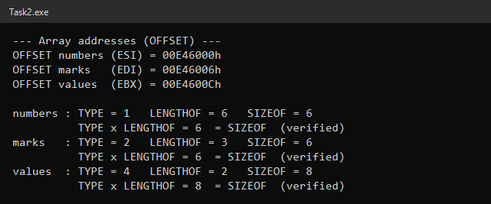

Results
Array | Register | Address (this run) | TYPE | LENGTHOF | SIZEOF | TYPE × LENGTHOF
numbers | ESI | 00E46000h | 1 | 6 | 6 | 1 × 6 = 6 ✓
marks | EDI | 00E46006h | 2 | 3 | 6 | 2 × 3 = 6 ✓
values | EBX | 00E4600Ch | 4 | 2 | 8 | 4 × 2 = 8 ✓

- TYPE is the size of one element in bytes (BYTE = 1, WORD = 2, DWORD = 4).
- LENGTHOF is the number of elements in the declaration.
- SIZEOF is the total number of bytes, which always equals TYPE × LENGTHOF.
The exact addresses change from run to run (Windows loads the program at a different base address), but the gaps between them do not: marks starts 6 bytes after numbers (SIZEOF numbers) and values starts 6 bytes after marks (SIZEOF marks), because the arrays are stored one after another in the .data segment.

Task 3
Use WORD PTR, BYTE PTR and DWORD PTR to read parts of dataVal and wordList, and explain the values using little-endian order.

Code
INCLUDE Irvine32.inc

.data
dataVal DWORD 89ABCDEFh
wordList WORD 1357h, 2468h

; Little-endian: the LOWEST byte is stored at the LOWEST address.
; dataVal in memory : EF CD AB 89 (dataVal+0 .. dataVal+3)
; wordList in memory : 57 13 68 24 (1357h then 2468h)

msgTitle BYTE "Task 3 - PTR and Little-Endian", 0
msgLow BYTE "Low word : AX = WORD PTR dataVal = ", 0
msgHigh BYTE "High word : BX = WORD PTR [dataVal + 2] = ", 0
msgByte BYTE "Low byte : CL = BYTE PTR dataVal = ", 0
msgDword BYTE "DWORD : ESI = DWORD PTR wordList = ", 0
msgHex BYTE "h", 0

.code
main PROC
mov edx, OFFSET msgTitle
call WriteString
call Crlf

xor eax, eax ; clear registers so DumpRegs is easy to read
xor ebx, ebx
xor ecx, ecx

; bytes at dataVal+0, +1 are EF CD -> read as a word = CDEFh
mov ax, WORD PTR dataVal

; bytes at dataVal+2, +3 are AB 89 -> read as a word = 89ABh
mov bx, WORD PTR [dataVal + 2]

; byte at dataVal+0 is EF -> lowest byte = EFh
mov cl, BYTE PTR dataVal

; bytes 57 13 68 24 read as one DWORD -> 24681357h
; (the second word 2468h becomes the HIGH half because it is at the higher address)
mov esi, DWORD PTR wordList

call DumpRegs

; ---------- display the four values ----------
mov edx, OFFSET msgLow
call WriteString
movzx eax, ax ; AX = CDEFh
call WriteHex
mov edx, OFFSET msgHex
call WriteString
call Crlf

mov edx, OFFSET msgHigh
call WriteString
movzx eax, bx ; BX = 89ABh
call WriteHex
mov edx, OFFSET msgHex
call WriteString
call Crlf

mov edx, OFFSET msgByte
call WriteString
movzx eax, cl ; CL = EFh
call WriteHex
mov edx, OFFSET msgHex
call WriteString
call Crlf

mov edx, OFFSET msgDword
call WriteString
mov eax, esi ; ESI = 24681357h
call WriteHex
mov edx, OFFSET msgHex
call WriteString
call Crlf

exit
main ENDP
END main

Output
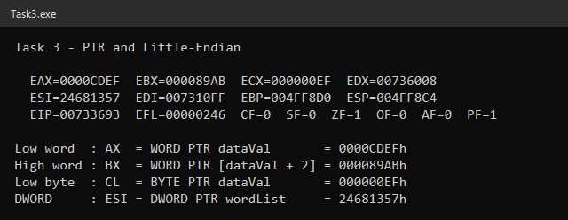

Memory Layout (Little-Endian)
Variable | +0 | +1 | +2 | +3
dataVal (89ABCDEFh) | EF | CD | AB | 89
wordList (1357h, 2468h) | 57 | 13 | 68 | 24

Values Read
Instruction | Bytes read | Register | Value
MOV AX, WORD PTR dataVal | EF CD | AX | CDEFh
MOV BX, WORD PTR [dataVal + 2] | AB 89 | BX | 89ABh
MOV CL, BYTE PTR dataVal | EF | CL | EFh
MOV ESI, DWORD PTR wordList | 57 13 68 24 | ESI | 24681357h

Explanation
x86 stores multi-byte values in little-endian order: the lowest (least significant) byte is placed at the lowest address. When the CPU reads several bytes, the byte at the lowest address again becomes the least significant byte of the register.
- The low word of dataVal is at dataVal+0 and +1 (EF CD), so it reads as CDEFh; the high word is at +2 and +3 (AB 89), so it reads as 89ABh.
- The lowest byte of dataVal is the first byte in memory, EFh.
- Reading wordList as a DWORD takes the bytes 57 13 68 24. The first word (1357h) is at the lower address so it becomes the low half, and the second word (2468h) becomes the high half: 24681357h.
PTR is needed because the declared type of each variable does not match the size being read (for example, reading 2 bytes of a DWORD).

Task 4
Access buffer only through ESI: read the first element, replace the second with 66h and increment the fifth, then display the array before and after.

Code
INCLUDE Irvine32.inc

.data
buffer BYTE 15h, 25h, 35h, 45h, 55h

msgBefore BYTE "Original buffer : ", 0
msgFirst BYTE "First element read with [ESI] = ", 0
msgAfter BYTE "Modified buffer : ", 0
msgHex BYTE "h", 0
msgSpace BYTE "h ", 0

.code
main PROC
mov edx, OFFSET msgBefore
call WriteString
call ShowBuffer

mov esi, OFFSET buffer ; ESI points to buffer[0]

; ---- read the first element ----
mov al, [esi] ; AL = 15h (size known from AL)
mov edx, OFFSET msgFirst
call WriteString
movzx eax, al
mov ebx, 1
call WriteHexB
mov edx, OFFSET msgHex
call WriteString
call Crlf

; ---- replace the second element with 66h ----
mov BYTE PTR [esi + 1], 66h ; PTR needed: an immediate has no size

; ---- increment the fifth element ----
inc BYTE PTR [esi + 4] ; PTR needed: INC has only one operand (55h -> 56h)

mov edx, OFFSET msgAfter
call WriteString
call ShowBuffer

exit
main ENDP

;------------------------------------------------------------
; ShowBuffer
; Displays every byte of buffer in hexadecimal on one line.
;------------------------------------------------------------
ShowBuffer PROC
push esi
mov esi, OFFSET buffer
mov ecx, LENGTHOF buffer
mov ebx, TYPE buffer ; WriteHexB: display 1 byte
L1:
movzx eax, BYTE PTR [esi]
call WriteHexB
mov edx, OFFSET msgSpace
call WriteString
add esi, TYPE buffer
loop L1
call Crlf
pop esi
ret
ShowBuffer ENDP
END main

Output
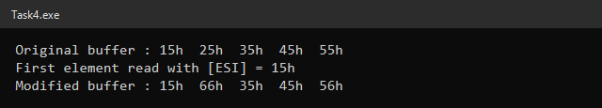

Changes
Element | Operand | Instruction | Before | After
1st | [ESI] | MOV AL, [ESI] (read) | 15h | 15h
2nd | [ESI + 1] | MOV BYTE PTR [ESI + 1], 66h | 25h | 66h
3rd | [ESI + 2] | — | 35h | 35h
4th | [ESI + 3] | — | 45h | 45h
5th | [ESI + 4] | INC BYTE PTR [ESI + 4] | 55h | 56h

Why PTR Is Needed
ESI only holds an address, so [ESI] by itself does not tell the assembler whether to access a byte, word or doubleword.
- MOV AL, [ESI] needs no PTR because AL tells the assembler the size is 1 byte.
- MOV BYTE PTR [ESI + 1], 66h needs PTR because neither operand has a size: an immediate value can be any size (without PTR, MASM gives error A2070 "invalid instruction operands").
- INC BYTE PTR [ESI + 4] needs PTR because INC has only one operand; without it MASM gives error A2023 "instruction operand must have size".

Task 5
Traverse arrayB, arrayW and arrayD in separate loops using indirect addressing, advancing ESI by TYPE and using LENGTHOF as the loop count.

Code
INCLUDE Irvine32.inc

.data
arrayB BYTE 5, 10, 15, 20, 25
arrayW WORD 100h, 200h, 300h, 400h, 500h
arrayD DWORD 1000h, 2000h, 3000h, 4000h, 5000h

msgB BYTE "arrayB (decimal) : ", 0
msgW BYTE "arrayW (hex) : ", 0
msgD BYTE "arrayD (hex) : ", 0
msgWrong BYTE "arrayW if ESI += 1 (wrong) : ", 0
msgSep BYTE " ", 0
msgSepH BYTE "h ", 0

.code
main PROC
; ---------- arrayB ----------
mov edx, OFFSET msgB
call WriteString
mov esi, OFFSET arrayB ; ESI -> first element
mov ecx, LENGTHOF arrayB ; 5 iterations
L1:
movzx eax, BYTE PTR [esi]
call WriteDec
mov edx, OFFSET msgSep
call WriteString
add esi, TYPE arrayB ; next element (+1)
loop L1
call Crlf

; ---------- arrayW ----------
mov edx, OFFSET msgW
call WriteString
mov esi, OFFSET arrayW
mov ecx, LENGTHOF arrayW
mov ebx, TYPE arrayW ; WriteHexB: display 2 bytes
L2:
movzx eax, WORD PTR [esi]
call WriteHexB
mov edx, OFFSET msgSepH
call WriteString
add esi, TYPE arrayW ; next element (+2)
loop L2
call Crlf

; ---------- arrayD ----------
mov edx, OFFSET msgD
call WriteString
mov esi, OFFSET arrayD
mov ecx, LENGTHOF arrayD
L3:
mov eax, [esi] ; size known from EAX
call WriteHex
mov edx, OFFSET msgSepH
call WriteString
add esi, TYPE arrayD ; next element (+4)
loop L3
call Crlf
call Crlf

; ---------- demonstration: wrong increment for a WORD array ----------
mov edx, OFFSET msgWrong
call WriteString
mov esi, OFFSET arrayW
mov ecx, LENGTHOF arrayW
mov ebx, TYPE arrayW
L4:
movzx eax, WORD PTR [esi]
call WriteHexB
mov edx, OFFSET msgSepH
call WriteString
inc esi ; WRONG: only 1 byte instead of TYPE arrayW
loop L4
call Crlf

exit
main ENDP
END main

Output
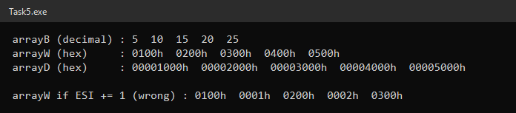

Loop Summary
Array | ESI starts at | ECX (LENGTHOF) | ESI step (TYPE) | Elements displayed
arrayB | OFFSET arrayB | 5 | 1 | 5, 10, 15, 20, 25
arrayW | OFFSET arrayW | 5 | 2 | 0100h … 0500h
arrayD | OFFSET arrayD | 5 | 4 | 00001000h … 00005000h

What Goes Wrong if ESI Is Advanced by 1 Byte
The last line of the output runs the arrayW loop with INC ESI instead of ADD ESI, TYPE arrayW. arrayW is stored in memory as the bytes 00 01 00 02 00 03 00 04 00 05. Moving ESI by only one byte makes every second read start in the middle of an element:
Read | ESI offset | Bytes read | Value shown | Correct?
1 | 0 | 00 01 | 0100h | Yes
2 | 1 | 01 00 | 0001h | No (overlaps two elements)
3 | 2 | 00 02 | 0200h | Yes, but it should have been read 2nd
4 | 3 | 02 00 | 0002h | No
5 | 4 | 00 03 | 0300h | Should have been read 3rd

So the loop prints wrong, mixed-up values and, because it still stops after LENGTHOF = 5 iterations, it never reaches 0400h and 0500h. For arrayD the problem is worse: reading 4 bytes from offset 1 gives 00000010h instead of 2000h. Advancing by TYPE keeps ESI on the start of each element no matter what size the elements are.

Task 6
Use indexed operands (arrayB[ESI] / [arrayB + ESI]) with displacements calculated from TYPE and LENGTHOF, find the valid displacement range of each array and show an out-of-range access.

Code
INCLUDE Irvine32.inc

.data
arrayB BYTE 11, 22, 33, 44, 55, 66
arrayW WORD 1000h, 2000h, 3000h, 4000h, 5000h, 6000h
arrayD DWORD 11111111h, 22222222h, 33333333h, 44444444h

msgB BYTE "--- arrayB (TYPE 1) ---", 0
msgW BYTE "--- arrayW (TYPE 2) : elements 1, 3, 5 ---", 0
msgD BYTE "--- arrayD (TYPE 4) : second and fourth ---", 0
msgIdx BYTE " index ", 0
msgDisp BYTE " displacement = ", 0
msgVal BYTE " value = ", 0
msgDec BYTE "h (", 0
msgClose BYTE ")", 0
msgHex BYTE "h", 0
msgRange BYTE " valid displacements: 0 to ", 0
msgOut BYTE "--- Out-of-range access ---", 0
msgOutB BYTE " arrayB[6] (displacement 6) assembled and read = ", 0
msgOutNote BYTE " -> this is NOT part of arrayB; it is the low byte of arrayW[0] (1000h)", 0

.code
main PROC
; ================= arrayB =================
mov edx, OFFSET msgB
call WriteString
call Crlf

mov esi, 0 * TYPE arrayB ; index 0
movzx eax, arrayB[esi]
mov ebx, 0
mov ecx, TYPE arrayB
call PrintEntry

mov esi, 2 * TYPE arrayB ; index 2
movzx eax, arrayB[esi]
mov ebx, 2
mov ecx, TYPE arrayB
call PrintEntry

mov esi, (LENGTHOF arrayB - 1) * TYPE arrayB ; last index 5
movzx eax, [arrayB + esi] ; same as arrayB[esi]
mov ebx, LENGTHOF arrayB - 1
mov ecx, TYPE arrayB
call PrintEntry

mov eax, (LENGTHOF arrayB - 1) * TYPE arrayB
call PrintRange

; ================= arrayW =================
mov edx, OFFSET msgW
call WriteString
call Crlf

mov esi, 1 * TYPE arrayW ; displacement 2
movzx eax, arrayW[esi]
mov ebx, 1
mov ecx, TYPE arrayW
call PrintEntry

mov esi, 3 * TYPE arrayW ; displacement 6
movzx eax, arrayW[esi]
mov ebx, 3
mov ecx, TYPE arrayW
call PrintEntry

mov esi, 5 * TYPE arrayW ; displacement 10
movzx eax, arrayW[esi]
mov ebx, 5
mov ecx, TYPE arrayW
call PrintEntry

mov eax, (LENGTHOF arrayW - 1) * TYPE arrayW
call PrintRange

; ================= arrayD =================
mov edx, OFFSET msgD
call WriteString
call Crlf

mov esi, 1 * TYPE arrayD ; second element, displacement 4
mov eax, arrayD[esi]
mov ebx, 1
mov ecx, TYPE arrayD
call PrintEntry

mov esi, 3 * TYPE arrayD ; fourth element, displacement 12
mov eax, arrayD[esi]
mov ebx, 3
mov ecx, TYPE arrayD
call PrintEntry

mov eax, (LENGTHOF arrayD - 1) * TYPE arrayD
call PrintRange

; ================= out of range =================
mov edx, OFFSET msgOut
call WriteString
call Crlf
mov esi, LENGTHOF arrayB * TYPE arrayB ; displacement 6 = one past the end
movzx eax, arrayB[esi] ; assembles fine, no range check
mov edx, OFFSET msgOutB
call WriteString
mov ebx, TYPE arrayB
call WriteHexB
mov edx, OFFSET msgHex
call WriteString
call Crlf
mov edx, OFFSET msgOutNote
call WriteString
call Crlf

exit
main ENDP

;------------------------------------------------------------
; PrintEntry
; Displays one element as: index, displacement, value (hex and decimal).
; Receives: EAX = value, EBX = index, ECX = TYPE of the array,
; ESI = byte displacement
;------------------------------------------------------------
PrintEntry PROC
push eax

mov edx, OFFSET msgIdx
call WriteString
mov eax, ebx
call WriteDec ; index

mov edx, OFFSET msgDisp
call WriteString
mov eax, esi
call WriteDec ; displacement

mov edx, OFFSET msgVal
call WriteString
pop eax
mov ebx, ecx ; WriteHexB size = TYPE
call WriteHexB ; value in hex
mov edx, OFFSET msgDec
call WriteString
call WriteDec ; value in decimal
mov edx, OFFSET msgClose
call WriteString
call Crlf
ret
PrintEntry ENDP

;------------------------------------------------------------
; PrintRange
; Displays the valid displacement range 0 .. EAX.
; Receives: EAX = largest valid displacement
;------------------------------------------------------------
PrintRange PROC
mov edx, OFFSET msgRange
call WriteString
call WriteDec
call Crlf
call Crlf
ret
PrintRange ENDP
END main

Output
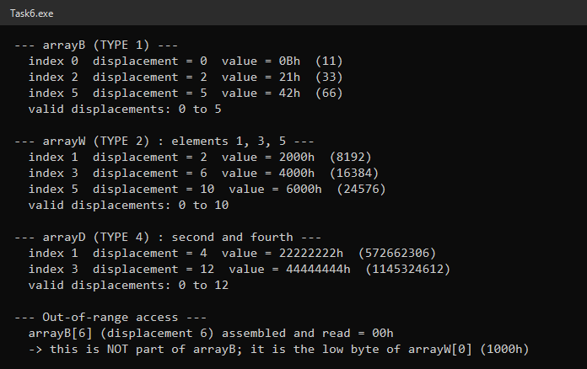

Requested Elements
Element numbers are treated as 0-based indexes, so displacement = index × TYPE.
Array | Index | Displacement | Operand | Value
arrayB | 0 | 0 × 1 = 0 | arrayB[ESI] | 0Bh (11)
arrayB | 2 | 2 × 1 = 2 | arrayB[ESI] | 21h (33)
arrayB | 5 | 5 × 1 = 5 | [arrayB + ESI] | 42h (66)
arrayW | 1 | 1 × 2 = 2 | arrayW[ESI] | 2000h
arrayW | 3 | 3 × 2 = 6 | arrayW[ESI] | 4000h
arrayW | 5 | 5 × 2 = 10 | arrayW[ESI] | 6000h
arrayD | 1 (second) | 1 × 4 = 4 | arrayD[ESI] | 22222222h
arrayD | 3 (fourth) | 3 × 4 = 12 | arrayD[ESI] | 44444444h

Valid Displacement Ranges
Array | TYPE | LENGTHOF | Valid displacements = 0 … (LENGTHOF − 1) × TYPE
arrayB | 1 | 6 | 0 to 5
arrayW | 2 | 6 | 0 to 10 (even values only)
arrayD | 4 | 4 | 0 to 12 (multiples of 4)

Valid vs Out-of-Range Access
An indexed operand is just "array address + ESI". The assembler only knows the starting address of the array; it does not store or check the array's size, and the value in ESI is only known when the program runs. The CPU does not check bounds either. So an instruction like MOVZX EAX, arrayB[ESI] with ESI = 6 assembles and runs without any error.
The output shows this: arrayB[6] returned 00h, which is not part of arrayB at all. It is the first byte of arrayW (1000h is stored as 00 10), because arrayW is placed right after arrayB in memory. Reading out of range gives wrong data, and writing out of range would silently overwrite a neighbouring variable, so the programmer must keep the displacement within the valid range.

Comparison of Addressing Modes
Mode | Example | How the address is formed | Typical use
Direct-offset | MOV AL, [arrayB + 2] | Array address + a constant fixed at assemble time | A specific element that is known in advance
Indirect | MOV AL, [ESI] | The whole address is held in a register | Walking through an array with a pointer (ADD ESI, TYPE)
Indexed | MOV AL, arrayB[ESI] | Array address (constant) + displacement in a register | Selecting an element by a computed index while keeping the array name visible

