ARSH
23K-0078
BAI-3C
LAB 4

Task 1
Declare num1 = 1500h and num2 = 2500h, copy them through EAX/EBX/ECX, swap EBX and ECX with XCHG, store the results in memory and display the registers with DumpRegs.

Code

INCLUDE Irvine32.inc

.data
num1 DWORD 1500h
num2 DWORD 2500h
finalEBX DWORD ?
finalECX DWORD ?

msgTitle BYTE "Task 1 - MOV and XCHG", 0
msgEBX BYTE "finalEBX (memory) = ", 0
msgECX BYTE "finalECX (memory) = ", 0
msgHex BYTE "h", 0

.code
main PROC
mov edx, OFFSET msgTitle
call WriteString
call Crlf

mov eax, num1 ; EAX = 00001500h
mov ebx, eax ; EBX = 00001500h
mov ecx, num2 ; ECX = 00002500h

xchg ebx, ecx ; EBX = 00002500h, ECX = 00001500h

mov finalEBX, ebx ; store final EBX in memory
mov finalECX, ecx ; store final ECX in memory

call DumpRegs ; show EAX, EBX, ECX

; display both memory variables
mov edx, OFFSET msgEBX
call WriteString
mov eax, finalEBX
call WriteHex
mov edx, OFFSET msgHex
call WriteString
call Crlf

mov edx, OFFSET msgECX
call WriteString
mov eax, finalECX
call WriteHex
mov edx, OFFSET msgHex
call WriteString
call Crlf

exit
main ENDP
END main

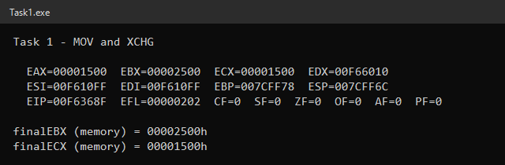

Task 2
Perform ADD, DEC and NEG on 8-bit registers and record the flags immediately after each instruction (DumpRegs is called right after each operation).

Code

INCLUDE Irvine32.inc

.data
resAL BYTE ?
resBL BYTE ?
resCL BYTE ?

msgAdd BYTE "1) MOV AL,7Fh ADD AL,01h", 0
msgDec BYTE "2) MOV BL,00h DEC BL", 0
msgNeg BYTE "3) MOV CL,05h NEG CL", 0
msgFinal BYTE "Final 8-bit register values:", 0
msgAL BYTE "AL = ", 0
msgBL BYTE "BL = ", 0
msgCL BYTE "CL = ", 0
msgHex BYTE "h", 0

.code
main PROC
xor eax, eax ; clear registers so DumpRegs is easy to read
xor ebx, ebx
xor ecx, ecx

; ---------- Operation 1 : ADD ----------
mov edx, OFFSET msgAdd
call WriteString
mov al, 7Fh ; AL = 7Fh (+127)
add al, 01h ; AL = 80h -> CF=0 ZF=0 SF=1 OF=1
call DumpRegs ; flags recorded immediately after ADD
mov resAL, al

; ---------- Operation 2 : DEC ----------
mov edx, OFFSET msgDec
call WriteString
mov bl, 00h ; BL = 00h
clc ; DEC does not touch CF, so start it from a known 0
dec bl ; BL = FFh -> CF=0 (unchanged) ZF=0 SF=1
call DumpRegs ; flags recorded immediately after DEC
mov resBL, bl

; ---------- Operation 3 : NEG ----------
mov edx, OFFSET msgNeg
call WriteString
mov cl, 05h ; CL = 05h
neg cl ; CL = FBh (-5) -> CF=1 ZF=0 SF=1 OF=0
call DumpRegs ; flags recorded immediately after NEG
mov resCL, cl

; ---------- Final register values ----------
mov edx, OFFSET msgFinal
call WriteString
call Crlf

mov ebx, 1 ; WriteHexB: display 1 byte

mov edx, OFFSET msgAL
call WriteString
movzx eax, resAL
call WriteHexB
mov edx, OFFSET msgHex
call WriteString
call Crlf

mov edx, OFFSET msgBL
call WriteString
movzx eax, resBL
call WriteHexB
mov edx, OFFSET msgHex
call WriteString
call Crlf

mov edx, OFFSET msgCL
call WriteString
movzx eax, resCL
call WriteHexB
mov edx, OFFSET msgHex
call WriteString
call Crlf

exit
main ENDP
END main

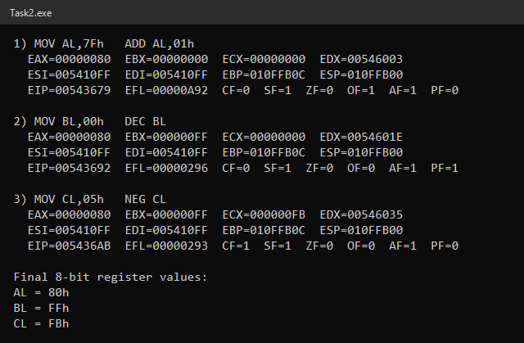

Flag Table 1: MOV AL, 7Fh / ADD AL, 01h → AL = 80h
Flag | Value | Why
CF | 0 | 7Fh + 01h = 80h fits in 8 bits, no carry out of bit 7
ZF | 0 | Result 80h is not zero
SF | 1 | Bit 7 of 80h (1000 0000b) is 1
OF | 1 | +127 + 1 = +128 is outside the signed byte range (−128 to +127); two positives gave a "negative" result

Flag Table 2: MOV BL, 00h / DEC BL → BL = FFh
Flag | Value | Why
CF | 0 | DEC never changes CF; it keeps its previous value (cleared with CLC before DEC)
ZF | 0 | Result FFh is not zero
SF | 1 | Bit 7 of FFh is 1 (FFh = −1 signed)

Flag Table 3: MOV CL, 05h / NEG CL → CL = FBh
Flag | Value | Why
CF | 1 | NEG sets CF = 1 whenever the operand is not zero (0 − 5 needs a borrow)
ZF | 0 | Result FBh is not zero
SF | 1 | FBh = 1111 1011b, bit 7 is 1 (−5 in two's complement)
OF | 0 | OF is set by NEG only when the operand is −128 (80h)

Final Register Values
Register | Hex | Unsigned | Signed
AL | 80h | 128 | −128
BL | FFh | 255 | −1
CL | FBh | 251 | −5

Task 3
Use MOVZX and MOVSX on uVal = 9Bh, sVal = −101 and CL = 9Bh, store the extended values in DWORD variables and display them.

Code

INCLUDE Irvine32.inc

.data
uVal BYTE 9Bh ; unsigned byte
sVal SBYTE -101 ; signed byte (stored as 9Bh)
zxResult DWORD ? ; zero-extended CL
sxResult DWORD ? ; sign-extended CL

msgTitle BYTE "Task 3 - MOVZX / MOVSX", 0
msgEAX BYTE "EAX = MOVZX uVal : ", 0
msgEBX BYTE "EBX = MOVSX sVal : ", 0
msgZX BYTE "zxResult (MOVZX CL): ", 0
msgSX BYTE "sxResult (MOVSX CL): ", 0
msgHex BYTE "h decimal = ", 0

.code
main PROC
mov edx, OFFSET msgTitle
call WriteString
call Crlf

movzx eax, uVal ; EAX = 0000009Bh = 155
movsx ebx, sVal ; EBX = FFFFFF9Bh = -101

xor ecx, ecx ; clear ECX so CL is easy to see
mov cl, 9Bh ; same bit pattern 1001 1011
movzx edx, cl ; EDX = 0000009Bh (zero extension)
movsx esi, cl ; ESI = FFFFFF9Bh (sign extension)

mov zxResult, edx
mov sxResult, esi

call DumpRegs

; ---- display every converted value in hex and decimal ----
mov edx, OFFSET msgEAX
call WriteString
call WriteHex ; EAX already holds MOVZX uVal
mov edx, OFFSET msgHex
call WriteString
call WriteDec ; unsigned decimal
call Crlf

mov edx, OFFSET msgEBX
call WriteString
mov eax, ebx
call WriteHex
mov edx, OFFSET msgHex
call WriteString
call WriteInt ; signed decimal
call Crlf

mov edx, OFFSET msgZX
call WriteString
mov eax, zxResult
call WriteHex
mov edx, OFFSET msgHex
call WriteString
call WriteDec
call Crlf

mov edx, OFFSET msgSX
call WriteString
mov eax, sxResult
call WriteHex
mov edx, OFFSET msgHex
call WriteString
call WriteInt
call Crlf

exit
main ENDP
END main

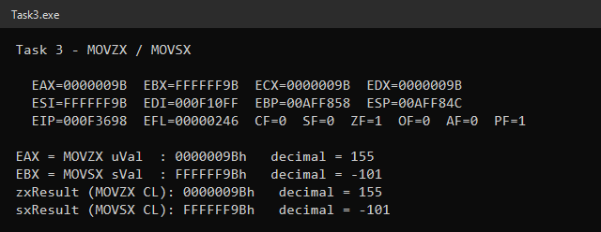

Converted Values
Instruction | Destination | Hex | Decimal
MOVZX EAX, uVal | EAX | 0000009Bh | 155
MOVSX EBX, sVal | EBX | FFFFFF9Bh | −101
MOVZX EDX, CL | EDX → zxResult | 0000009Bh | 155
MOVSX ESI, CL | ESI → sxResult | FFFFFF9Bh | −101

Explanation
uVal, sVal and CL all hold exactly the same 8 bits: 9Bh = 1001 1011b. The CPU does not know whether a byte is signed or unsigned; the instruction decides how it is interpreted.
- Unsigned: 1001 1011b = 128 + 16 + 8 + 2 + 1 = 155.
- Signed (two's complement): bit 7 is the sign bit, so the value is 155 − 256 = −101.
- MOVZX fills the upper 24 bits with 0, so the number stays 155 (0000009Bh).
- MOVSX copies the sign bit (1) into the upper 24 bits, so the number stays −101 (FFFFFF9Bh).
So the same bit pattern represents 155 when treated as unsigned and −101 when treated as signed.

Task 4
Use ROWS, COLS and TOTAL to define the values array, find its size with LENGTHOF/SIZEOF, access elements by offset, swap the first and last elements and sum the first four.

Code

INCLUDE Irvine32.inc

ROWS = 3
COLS = 4
TOTAL EQU ROWS * COLS

.data
values WORD TOTAL DUP(5)
result DWORD ?
buffer BYTE 16 DUP(?)

msgTotal BYTE "TOTAL (ROWS*COLS) = ", 0
msgLen BYTE "LENGTHOF values = ", 0
msgSize BYTE "SIZEOF values (bytes) = ", 0
msgType BYTE "TYPE values (bytes) = ", 0
msgBefore BYTE "--- Before XCHG ---", 0
msgAfter BYTE "--- After XCHG (first <-> last) ---", 0
msgFirst BYTE "values[0] (offset 0) = ", 0
msgFourth BYTE "values[3] (offset 6) = ", 0
msgFifth BYTE "values[4] (offset 8) = ", 0
msgLast BYTE "values[11] (offset 22) = ", 0
msgSum BYTE "Sum of first four elements (result) = ", 0

.code
main PROC
; ---- array dimensions ----
mov edx, OFFSET msgTotal
call WriteString
mov eax, TOTAL ; 12
call WriteDec
call Crlf

mov edx, OFFSET msgLen
call WriteString
mov eax, LENGTHOF values ; 12 elements
call WriteDec
call Crlf

mov edx, OFFSET msgSize
call WriteString
mov eax, SIZEOF values ; 12 * 2 = 24 bytes
call WriteDec
call Crlf

mov edx, OFFSET msgType
call WriteString
mov eax, TYPE values ; 2 bytes per element
call WriteDec
call Crlf
call Crlf

; ---- selected elements before the exchange ----
mov edx, OFFSET msgBefore
call WriteString
call Crlf
call ShowElements

; ---- exchange first and last element ----
mov ax, values ; AX = first element
xchg ax, [values + SIZEOF values - TYPE values] ; AX <-> last element
mov values, ax ; old last -> first

mov edx, OFFSET msgAfter
call WriteString
call Crlf
call ShowElements

; ---- sum of the first four elements ----
movzx eax, values ; values[0]
movzx ebx, [values + 2] ; values[1]
add eax, ebx
movzx ebx, [values + 4] ; values[2]
add eax, ebx
movzx ebx, [values + 6] ; values[3]
add eax, ebx
mov result, eax ; result = 20

mov edx, OFFSET msgSum
call WriteString
mov eax, result
call WriteDec
call Crlf

exit
main ENDP

;------------------------------------------------------------
; ShowElements
; Displays the first, fourth, fifth and last elements of values.
;------------------------------------------------------------
ShowElements PROC
mov edx, OFFSET msgFirst
call WriteString
movzx eax, values ; offset 0
call WriteDec
call Crlf

mov edx, OFFSET msgFourth
call WriteString
movzx eax, [values + 3 * TYPE values] ; offset 6
call WriteDec
call Crlf

mov edx, OFFSET msgFifth
call WriteString
movzx eax, [values + 4 * TYPE values] ; offset 8
call WriteDec
call Crlf

mov edx, OFFSET msgLast
call WriteString
movzx eax, [values + SIZEOF values - TYPE values] ; offset 22
call WriteDec
call Crlf
call Crlf
ret
ShowElements ENDP
END main

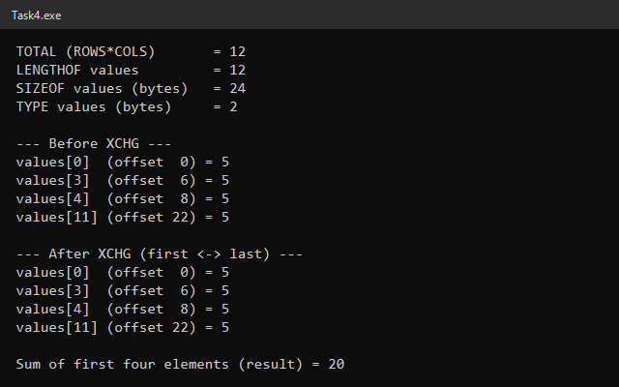

Calculations
Item | Calculation | Result
Total elements (TOTAL / LENGTHOF) | ROWS × COLS = 3 × 4 | 12
Size of one element (TYPE) | WORD | 2 bytes
Total bytes (SIZEOF) | 12 × 2 | 24 bytes
result | 5 + 5 + 5 + 5 | 20

Element Offsets
Element | Index | Offset | Operand used | Before XCHG | After XCHG
First | 0 | 0 | [values] | 5 | 5
Fourth | 3 | 6 | [values + 3*TYPE values] | 5 | 5
Fifth | 4 | 8 | [values + 4*TYPE values] | 5 | 5
Last | 11 | 22 | [values + SIZEOF values − TYPE values] | 5 | 5

The exchange is done with AX as the intermediate register (MOV AX, first → XCHG AX, last → MOV first, AX). Because the array is declared as TOTAL DUP(5), every element is 5, so the first and last elements still show 5 after the swap even though the exchange did execute.

= versus EQU
- = creates an integer symbolic constant that can be redefined later in the program (e.g. ROWS = 5 further down is allowed).
- EQU creates a symbol that cannot be redefined, and it can also stand for text, not only integers.

Why values reserves memory but TOTAL does not
TOTAL is an assemble-time constant: the assembler simply replaces the name TOTAL with 12 wherever it appears, so it never exists in the program's memory. values is a data definition in the .data segment, so the assembler allocates 12 WORDs (24 bytes) of real storage for it that the program can read and write at run time.

Task 5
Evaluate R = −(2X − Y) + (Z − 3W) using signed 32-bit variables X = 120, Y = 75, Z = 40, W = 30, without modifying the original variables.

Code

INCLUDE Irvine32.inc

.data
X SDWORD 120
Y SDWORD 75
Z SDWORD 40
W SDWORD 30
R SDWORD ?

msgT1 BYTE "Term 1 : EAX = -(2X - Y)", 0
msgT2 BYTE "Term 2 : ECX = (Z - 3W)", 0
msgFinal BYTE "Final : EAX = EAX + ECX (flags after final ADD)", 0
msgRHex BYTE "R (hexadecimal) = ", 0
msgRDec BYTE "R (signed decimal) = ", 0
msgVerify BYTE "Verify: ESI = R = ", 0
msgUns BYTE "Same bits read unsigned = ", 0
msgHex BYTE "h", 0

.code
main PROC
xor ebx, ebx ; clear registers so DumpRegs is easy to read
xor ecx, ecx
xor esi, esi

; ---------- Term 1 : -(2X - Y) ----------
mov edx, OFFSET msgT1
call WriteString
mov eax, X ; EAX = 120
add eax, X ; EAX = 2X = 240
sub eax, Y ; EAX = 2X - Y = 165
neg eax ; EAX = -165 (FFFFFF5Bh)
call DumpRegs ; flags after NEG

; ---------- Term 2 : (Z - 3W) ----------
mov edx, OFFSET msgT2
call WriteString
mov ebx, W ; EBX = 30
add ebx, W ; EBX = 60
add ebx, W ; EBX = 3W = 90
mov ecx, Z ; ECX = 40
sub ecx, ebx ; ECX = Z - 3W = -50 (FFFFFFCEh)
call DumpRegs ; flags after SUB

; ---------- Combine ----------
mov edx, OFFSET msgFinal
call WriteString
add eax, ecx ; EAX = -165 + (-50) = -215 (FFFFFF29h)
call DumpRegs ; flags immediately after the final ADD
mov R, eax ; store final answer

; ---------- Display R ----------
mov edx, OFFSET msgRHex
call WriteString
mov eax, R
call WriteHex
mov edx, OFFSET msgHex
call WriteString
call Crlf

mov edx, OFFSET msgRDec
call WriteString
mov eax, R
call WriteInt
call Crlf

; ---------- Verify by loading R into another register ----------
mov esi, R ; ESI = FFFFFF29h
mov edx, OFFSET msgVerify
call WriteString
mov eax, esi
call WriteInt ; signed view : -215
call Crlf

mov edx, OFFSET msgUns
call WriteString
mov eax, esi
call WriteDec ; unsigned view : 4294967081
call Crlf

exit
main ENDP
END main

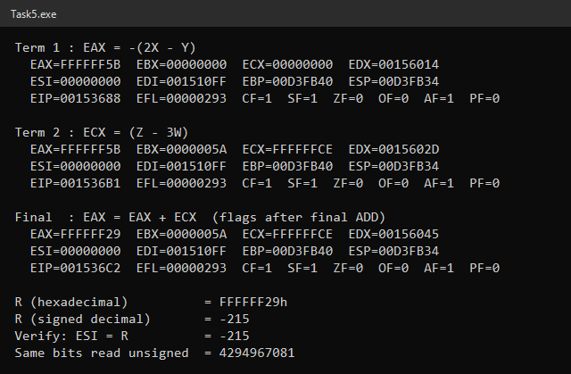

Intermediate Register Values
Step | Instruction(s) | Register | Hex | Decimal
2X | MOV EAX, X / ADD EAX, X | EAX | 000000F0h | 240
2X − Y | SUB EAX, Y | EAX | 000000A5h | 165
−(2X − Y) | NEG EAX | EAX | FFFFFF5Bh | −165
3W | MOV EBX, W / ADD EBX, W (×2) | EBX | 0000005Ah | 90
Z − 3W | MOV ECX, Z / SUB ECX, EBX | ECX | FFFFFFCEh | −50
R | ADD EAX, ECX / MOV R, EAX | EAX → R | FFFFFF29h | −215

Check: −(2·120 − 75) + (40 − 3·30) = −165 + (−50) = −215.

Flags After the Final ADD (EAX = EAX + ECX)
Flag | Value | Explanation
CF | 1 | As unsigned numbers FFFFFF5Bh + FFFFFFCEh = 1FFFFFF29h, which carries out of bit 31. CF only matters for unsigned math, so it is ignored for this signed result.
ZF | 0 | The result FFFFFF29h is not zero.
SF | 1 | Bit 31 of the result is 1, so the signed result is negative.
OF | 0 | Two negative numbers were added and the result is also negative; −215 fits in a signed 32-bit integer, so there is no signed overflow.

Why R Is a Signed Integer
R is declared as SDWORD and the expression contains negation and subtraction, so the answer can be negative. FFFFFF29h has its most significant bit set, which in two's complement means a negative number: −(100000000h − FFFFFF29h) = −D7h = −215.
To verify, R is loaded into ESI (MOV ESI, R). Printing ESI with WriteInt (signed) gives −215, which matches the hand calculation. Printing the same bits with WriteDec (unsigned) gives 4,294,967,081, which is meaningless for this expression; this shows R must be interpreted as signed.

