ARSH

23K-0078
BAI-3C

LAB 7

Task 1
Set EAX = 11, EBX = 22, ECX = 33, push them in that order, then pop into EDX, ESI and EDI. Record ESP after every PUSH and POP and display the registers with DumpRegs.

Prediction (before running)
The stack is Last-In-First-Out, so the last value pushed (ECX = 33) is popped first. Predicted: EDX = 33, ESI = 22, EDI = 11.

Code
INCLUDE Irvine32.inc

.data
esp0 DWORD ? ; ESP before any PUSH
esp1 DWORD ? ; after PUSH EAX
esp2 DWORD ? ; after PUSH EBX
esp3 DWORD ? ; after PUSH ECX
esp4 DWORD ? ; after POP EDX
esp5 DWORD ? ; after POP ESI
esp6 DWORD ? ; after POP EDI

msgRegs BYTE "Registers after the three POPs:", 0
msgTitle BYTE "ESP trace (change is relative to the starting ESP):", 0
msgS0 BYTE "Start ESP = ", 0
msgS1 BYTE "After PUSH EAX ESP = ", 0
msgS2 BYTE "After PUSH EBX ESP = ", 0
msgS3 BYTE "After PUSH ECX ESP = ", 0
msgS4 BYTE "After POP EDX ESP = ", 0
msgS5 BYTE "After POP ESI ESP = ", 0
msgS6 BYTE "After POP EDI ESP = ", 0
msgChange BYTE "h change = ", 0

.code
main PROC
mov edx, OFFSET msgRegs ; label printed first so EDX is free later
call WriteString

mov eax, 11
mov ebx, 22
mov ecx, 33
xor edx, edx ; clear destination registers
xor esi, esi
xor edi, edi

mov esp0, esp
push eax ; stack: 11
mov esp1, esp
push ebx ; stack: 22, 11
mov esp2, esp
push ecx ; stack: 33, 22, 11 (33 on top)
mov esp3, esp

pop edx ; EDX = 33 (top of stack)
mov esp4, esp
pop esi ; ESI = 22
mov esp5, esp
pop edi ; EDI = 11
mov esp6, esp

call DumpRegs ; EDX = 33, ESI = 22, EDI = 11

; ---------- ESP trace ----------
mov edx, OFFSET msgTitle
call WriteString
call Crlf

mov edx, OFFSET msgS0
mov eax, esp0
call ShowStep
mov edx, OFFSET msgS1
mov eax, esp1
call ShowStep
mov edx, OFFSET msgS2
mov eax, esp2
call ShowStep
mov edx, OFFSET msgS3
mov eax, esp3
call ShowStep
mov edx, OFFSET msgS4
mov eax, esp4
call ShowStep
mov edx, OFFSET msgS5
mov eax, esp5
call ShowStep
mov edx, OFFSET msgS6
mov eax, esp6
call ShowStep

exit
main ENDP

;------------------------------------------------------------
; ShowStep
; Prints a label, an ESP value and its change from the start.
; Receives: EDX = OFFSET label, EAX = recorded ESP value
;------------------------------------------------------------
ShowStep PROC
call WriteString
call WriteHex
mov edx, OFFSET msgChange
call WriteString
sub eax, esp0 ; change in bytes
call WriteInt
call Crlf
ret
ShowStep ENDP
END main

Output
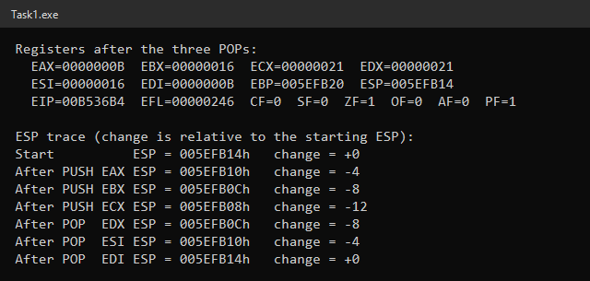
Result: EDX = 00000021h (33), ESI = 00000016h (22), EDI = 0000000Bh (11), exactly as predicted.

ESP After Each Operation
Instruction | ESP (relative) | Top of stack | Stack contents (top first)
Start | X | — | empty
PUSH EAX | X − 4 | 11 | 11
PUSH EBX | X − 8 | 22 | 22, 11
PUSH ECX | X − 12 | 33 | 33, 22, 11
POP EDX | X − 8 | 22 | 22, 11 (EDX = 33)
POP ESI | X − 4 | 11 | 11 (ESI = 22)
POP EDI | X | — | empty (EDI = 11)

Why the Order Is Reversed
PUSH decrements ESP by 4 and then stores the value, so each new value sits on top of the previous one. POP always removes the value at the top (the one ESP points to) and then adds 4 to ESP. Because the stack is LIFO, the values come back in the reverse order: 33, 22, 11. ESP returns to its starting value after the three POPs, so the stack is balanced.

Task 2
Save EAX = 12345678h and EBX = 0ABCDEF0h on the stack, overwrite them, restore them by popping in reverse order, and check that ESP returns to its original value.

Code
INCLUDE Irvine32.inc

.data
espBefore DWORD ?
espAfter DWORD ?

msgOrig BYTE "1) Original values (before PUSH):", 0
msgOver BYTE "2) After PUSH and overwriting EAX/EBX:", 0
msgRest BYTE "3) After POP EBX, POP EAX (restored):", 0
msgB BYTE "ESP before the two PUSHes = ", 0
msgA BYTE "ESP after the two POPs = ", 0
msgOK BYTE "Stack pointer is back to its original value.", 0
msgHex BYTE "h", 0

.code
main PROC
mov edx, OFFSET msgOrig
call WriteString
mov eax, 12345678h
mov ebx, 0ABCDEF0h
call DumpRegs

mov edx, OFFSET msgOver
call WriteString

mov espBefore, esp
push eax ; save EAX
push ebx ; save EBX (now on top)

mov eax, 11111111h ; overwrite both registers
mov ebx, 22222222h
call DumpRegs ; ESP is 8 bytes lower here

mov edx, OFFSET msgRest
call WriteString
pop ebx ; reverse order: last pushed, first popped
pop eax
mov espAfter, esp
call DumpRegs ; EAX = 12345678h, EBX = 0ABCDEF0h

; ---------- show stack balance ----------
mov edx, OFFSET msgB
call WriteString
mov eax, espBefore
call WriteHex
mov edx, OFFSET msgHex
call WriteString
call Crlf

mov edx, OFFSET msgA
call WriteString
mov eax, espAfter
call WriteHex
mov edx, OFFSET msgHex
call WriteString
call Crlf

mov eax, espAfter
cmp eax, espBefore
jne Done
mov edx, OFFSET msgOK
call WriteString
call Crlf
Done:
exit
main ENDP
END main

Output
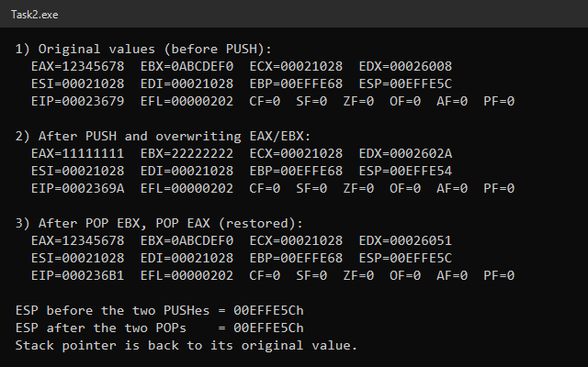

Results
Step | EAX | EBX | ESP
1) Original | 12345678h | 0ABCDEF0h | X
2) After PUSH EAX, PUSH EBX and overwrite | 11111111h | 22222222h | X − 8
3) After POP EBX, POP EAX | 12345678h | 0ABCDEF0h | X

EBX was pushed last, so it is on top of the stack and must be popped first (POP EBX, then POP EAX). Popping in the same order as the pushes would swap the two values. The DumpRegs output confirms both registers are restored, and the program confirms ESP after the two POPs equals ESP before the two PUSHes.

Task 3
Create a known flag state, save EFLAGS with PUSHFD, change the flags with other instructions, then restore them with POPFD and inspect the results with DumpRegs.

Code
INCLUDE Irvine32.inc

.data
msgKnown BYTE "1) Known state: MOV EAX,5 / CMP EAX,5 (ZF should be 1)", 0
msgChanged BYTE "2) After PUSHFD and flag-changing instructions", 0
msgRestored BYTE "3) After POPFD (flags restored, registers NOT restored)", 0

.code
main PROC
xor ebx, ebx ; clear registers so DumpRegs is easy to read
xor ecx, ecx

mov edx, OFFSET msgKnown
call WriteString

mov eax, 5
cmp eax, 5 ; 5 - 5 = 0 -> ZF=1, CF=0, SF=0
call DumpRegs

pushfd ; save EFLAGS (ZF=1) on the stack

mov edx, OFFSET msgChanged
call WriteString

mov ebx, 10
add ebx, 1 ; EBX = 11, result non-zero -> ZF=0
sub eax, 3 ; EAX = 2
mov ecx, 1
sub ecx, 2 ; ECX = FFFFFFFFh -> CF=1, SF=1, ZF=0
call DumpRegs

mov edx, OFFSET msgRestored
call WriteString

popfd ; restore EFLAGS saved by PUSHFD
call DumpRegs ; ZF=1 again, but EAX/EBX/ECX keep new values

exit
main ENDP
END main

Output
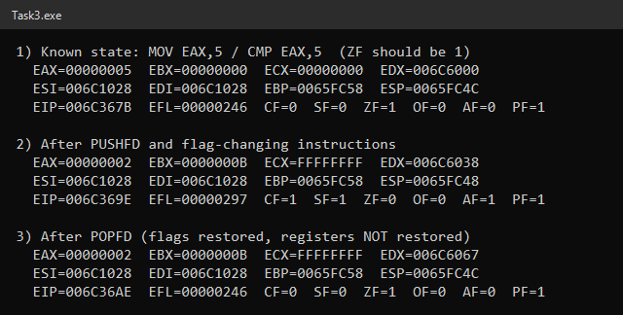

Flag and Register States
Point | EAX | EBX | ECX | CF | SF | ZF
1) After CMP EAX, 5 | 5 | 0 | 0 | 0 | 0 | 1
2) After the changing instructions | 2 | 0Bh | FFFFFFFFh | 1 | 1 | 0
3) After POPFD | 2 | 0Bh | FFFFFFFFh | 0 | 0 | 1

- ZF before saving: CMP EAX, 5 subtracts 5 − 5 internally. The result is 0, so ZF = 1 (and CF = 0, SF = 0). PUSHFD then saves this EFLAGS value on the stack.
- Changing the flags: ADD EBX, 1 gives a non-zero result (ZF = 0), and SUB ECX, 2 with ECX = 1 needs a borrow, so CF = 1 and SF = 1.
- After POPFD: the flags are exactly the saved ones again (ZF = 1, CF = 0, SF = 0, EFL = 00000246h), but EAX, EBX and ECX keep their new values. POPFD only restores EFLAGS, not general-purpose registers.
There is exactly one PUSHFD and one POPFD, so the stack is balanced (ESP in step 3 equals ESP in step 1).

Task 4
Create a procedure DisplayStudentInfo that prints a student's name, registration number and course title, and call it three times from main with different information.

Code
INCLUDE Irvine32.inc

.data
; ----- student 1 -----
name1 BYTE "Ali Ahmed", 0
reg1 BYTE "24K-0512", 0
course1 BYTE "Computer Organization and Assembly Language", 0
; ----- student 2 -----
name2 BYTE "Sara Khan", 0
reg2 BYTE "24K-0738", 0
course2 BYTE "Data Structures", 0
; ----- student 3 -----
name3 BYTE "Usman Raza", 0
reg3 BYTE "24K-0941", 0
course3 BYTE "Digital Logic Design", 0

msgName BYTE "Student Name : ", 0
msgReg BYTE "Registration No : ", 0
msgCourse BYTE "Course Title : ", 0

.code
main PROC
mov esi, OFFSET name1 ; pass the three strings in registers
mov edi, OFFSET reg1
mov ebx, OFFSET course1
call DisplayStudentInfo ; returns to the next instruction

mov esi, OFFSET name2
mov edi, OFFSET reg2
mov ebx, OFFSET course2
call DisplayStudentInfo

mov esi, OFFSET name3
mov edi, OFFSET reg3
mov ebx, OFFSET course3
call DisplayStudentInfo

exit
main ENDP

;------------------------------------------------------------
; DisplayStudentInfo
; Prints a student's name, registration number and course
; title on separate lines, followed by a blank line.
; Receives: ESI = OFFSET name, EDI = OFFSET reg. no,
; EBX = OFFSET course title
; Returns: nothing (EDX is preserved)
;------------------------------------------------------------
DisplayStudentInfo PROC
push edx ; WriteString needs EDX

mov edx, OFFSET msgName
call WriteString
mov edx, esi
call WriteString
call Crlf

mov edx, OFFSET msgReg
call WriteString
mov edx, edi
call WriteString
call Crlf

mov edx, OFFSET msgCourse
call WriteString
mov edx, ebx
call WriteString
call Crlf
call Crlf

pop edx
ret ; return address is on top of the stack
DisplayStudentInfo ENDP
END main

Output
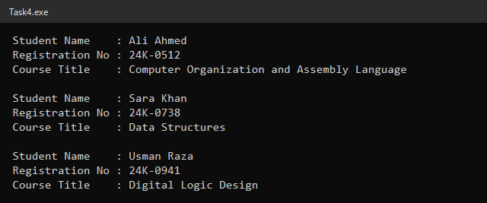

Explanation
- Passing data: before each CALL, main loads ESI, EDI and EBX with the OFFSETs of that student's name, registration number and course title.
- CALL pushes the address of the next instruction onto the stack and jumps to the procedure.
- RET pops that address back into EIP, so execution continues with the instruction after each CALL.
- No duplication: the output instructions are written once inside the procedure. EDX is pushed and popped inside it so the caller's EDX is not changed.

Task 5
Create a procedure CalculateResult that receives two unsigned integers in EAX and EBX and returns their sum, difference and product in registers. Test with several input pairs.

Code
INCLUDE Irvine32.inc

.data
firstVals DWORD 25, 120, 8 ; test inputs (first number)
secondVals DWORD 7, 45, 20 ; test inputs (second number)
sumR DWORD ?
diffR DWORD ?
prodR DWORD ?

msgCase BYTE "Test ", 0
msgA BYTE ": A = ", 0
msgB BYTE ", B = ", 0
msgSum BYTE " Sum (A + B) = ", 0
msgDiff BYTE " Difference (A - B) = ", 0
msgSigned BYTE " (signed view: ", 0
msgClose BYTE ")", 0
msgProd BYTE " Product (A * B) = ", 0

.code
main PROC
mov esi, 0 ; test index
mov ecx, LENGTHOF firstVals ; number of tests
NextTest:
; ---- show the inputs ----
mov edx, OFFSET msgCase
call WriteString
mov eax, esi
inc eax
call WriteDec
mov edx, OFFSET msgA
call WriteString
mov eax, firstVals[esi * TYPE firstVals]
call WriteDec
mov edx, OFFSET msgB
call WriteString
mov eax, secondVals[esi * TYPE secondVals]
call WriteDec
call Crlf

; ---- call the procedure ----
mov eax, firstVals[esi * TYPE firstVals] ; input 1
mov ebx, secondVals[esi * TYPE secondVals] ; input 2
call CalculateResult
call ShowResults

inc esi ; ECX and ESI were preserved by the procedures
loop NextTest

exit
main ENDP

;------------------------------------------------------------
; ShowResults
; Displays the three results returned by CalculateResult.
; Receives: EDI = sum, EDX = difference, EAX = product
;------------------------------------------------------------
ShowResults PROC
mov sumR, edi
mov diffR, edx
mov prodR, eax

mov edx, OFFSET msgSum
call WriteString
mov eax, sumR
call WriteDec
call Crlf

mov edx, OFFSET msgDiff
call WriteString
mov eax, diffR
call WriteDec ; unsigned result
mov edx, OFFSET msgSigned
call WriteString
call WriteInt ; same bits as signed
mov edx, OFFSET msgClose
call WriteString
call Crlf

mov edx, OFFSET msgProd
call WriteString
mov eax, prodR
call WriteDec
call Crlf
call Crlf
ret
ShowResults ENDP

;------------------------------------------------------------
; CalculateResult
; Calculates the sum, difference and product of two
; unsigned integers.
; Receives: EAX = first number (A), EBX = second number (B)
; Returns: EDI = A + B
; EDX = A - B
; EAX = A * B (low 32 bits)
; Preserves: EBX, ECX, ESI
;------------------------------------------------------------
CalculateResult PROC
mov edi, eax
add edi, ebx ; EDI = sum

push eax ; save A (MUL overwrites EAX and EDX)
mul ebx ; EDX:EAX = A * B
pop edx ; EDX = A
sub edx, ebx ; EDX = A - B
ret
CalculateResult ENDP
END main

Output
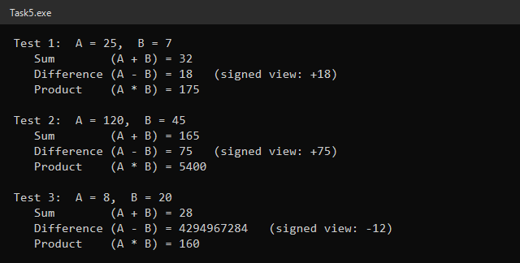

Register Usage
Register | Direction | Meaning
EAX | Input | First number (A)
EBX | Input | Second number (B) — preserved
EDI | Output | Sum A + B
EDX | Output | Difference A − B
EAX | Output | Product A × B (low 32 bits)
ECX, ESI | Preserved | Not modified, so main can use them as the loop counter and index

Test Results
A | B | Sum | Difference | Product
25 | 7 | 32 | 18 | 175
120 | 45 | 165 | 75 | 5400
8 | 20 | 28 | 4294967284 (−12 signed) | 160

MUL stores its result in EDX:EAX, which would destroy A. So A is pushed before MUL and popped into EDX afterwards to calculate A − B. In test 3 the first number is smaller than the second. The unsigned result wraps around to 4294967284, which is −12 when the same bits are read as a signed number.

Task 6
Write a procedure AddStackNumbers that receives two 32-bit arguments pushed by the caller, returns their sum in EAX, and leaves the stack balanced so that RET uses the correct return address.

Code
INCLUDE Irvine32.inc

.data
argA SDWORD 150, -40, 1000 ; first argument of each test
argB SDWORD 275, 90, -2500 ; second argument of each test
retAddr DWORD ? ; return address saved by the procedure
argTemp DWORD ? ; first argument removed from the stack
espBefore DWORD ?
espAfter DWORD ?

msgPlus BYTE " + ", 0
msgEq BYTE " = ", 0
msgBefore BYTE " ESP before PUSH = ", 0
msgAfter BYTE "h ESP after return = ", 0
msgBal BYTE "h (balanced)", 0
msgUnbal BYTE "h (NOT balanced)", 0

.code
main PROC
mov esi, 0 ; test index
mov ecx, LENGTHOF argA ; 3 tests
NextTest:
mov espBefore, esp

push argA[esi * TYPE argA] ; first argument
push argB[esi * TYPE argB] ; second argument
call AddStackNumbers ; pushes the return address
mov espAfter, esp ; EAX = sum
call ShowTest

inc esi
loop NextTest

exit
main ENDP

;------------------------------------------------------------
; ShowTest
; Displays "a + b = sum" and the ESP values for one test.
; Receives: EAX = sum, ESI = test index
;------------------------------------------------------------
ShowTest PROC
; ---- display "a + b = sum" ----
mov ebx, eax ; keep the sum
mov eax, argA[esi * TYPE argA]
call WriteInt
mov edx, OFFSET msgPlus
call WriteString
mov eax, argB[esi * TYPE argB]
call WriteInt
mov edx, OFFSET msgEq
call WriteString
mov eax, ebx
call WriteInt
call Crlf

; ---- display stack balance ----
mov edx, OFFSET msgBefore
call WriteString
mov eax, espBefore
call WriteHex
mov edx, OFFSET msgAfter
call WriteString
mov eax, espAfter
call WriteHex
mov edx, OFFSET msgBal
cmp eax, espBefore
je ShowBal
mov edx, OFFSET msgUnbal
ShowBal:
call WriteString
call Crlf
call Crlf
ret
ShowTest ENDP

;------------------------------------------------------------
; AddStackNumbers
; Adds two 32-bit integers that the caller pushed on the stack.
; Stack on entry: [ESP] = return address
; [ESP+4] = second argument
; [ESP+8] = first argument
; Returns: EAX = first + second. Both arguments are removed,
; so the stack is balanced when control returns.
;------------------------------------------------------------
AddStackNumbers PROC
pop retAddr ; save the return address
pop eax ; EAX = second argument
pop argTemp ; first argument
add eax, argTemp ; EAX = sum
push retAddr ; put the return address back on top
ret ; RET pops the correct return address
AddStackNumbers ENDP
END main

Output
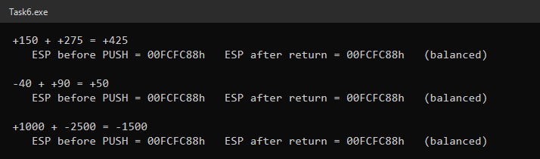

Stack Layout
Moment | Stack (top first) | ESP
Before PUSH | … | X
After PUSH first, PUSH second | second, first | X − 8
After CALL (procedure entry) | return address, second, first | X − 12
After POP retAddr, POP EAX, POP argTemp | (empty) | X
After PUSH retAddr | return address | X − 4
After RET (back in main) | (empty) | X

- Return address on top: right after CALL, the return address is at [ESP] and the arguments are below it. The procedure first pops the return address into the variable retAddr so it can reach the arguments.
- Arguments: the second argument was pushed last, so it is popped first into EAX; the first argument is popped into argTemp and added to EAX.
- Correct RET: the return address is pushed back so it is on top again. RET then pops the real return address, not an argument, into EIP.
- Balanced stack: the procedure removes both arguments, so ESP after returning equals ESP before the two PUSHes in all three tests.
First | Second | EAX (WriteInt)
150 | 275 | +425
−40 | 90 | +50
1000 | −2500 | −1500

Task 7
Create AnalyzeValues, which receives two values in EAX and EBX, calculates their sum, performs another flag-changing operation, returns the sum in EAX and preserves the caller's EFLAGS with PUSHFD/POPFD.

Code
INCLUDE Irvine32.inc

.data
msgCase1 BYTE "===== Case 1: CMP 7,7 (ZF=1) then AnalyzeValues(20, 30) =====", 0
msgCase2 BYTE "===== Case 2: CMP 1,2 (ZF=0, CF=1) then AnalyzeValues(45, -45) =====", 0
msgBefore BYTE "Main, before CALL:", 0
msgInside BYTE "Inside AnalyzeValues, after arithmetic (flags changed):", 0
msgAfter BYTE "Main, after RET (caller flags restored, EAX = sum):", 0

.code
main PROC
xor ecx, ecx ; clear registers so DumpRegs is easy to read
xor esi, esi
xor edi, edi

; ======================= Case 1 =======================
mov edx, OFFSET msgCase1
call WriteString
call Crlf
mov edx, OFFSET msgBefore
call WriteString

mov eax, 7
cmp eax, 7 ; recognizable state: ZF=1, CF=0, SF=0
mov eax, 20 ; MOV does not change flags
mov ebx, 30
call DumpRegs

call AnalyzeValues ; EAX = 50

pushfd ; keep the restored flags while printing
mov edx, OFFSET msgAfter
call WriteString
popfd
call DumpRegs ; EAX = 00000032h, ZF=1 (caller's flag)
call Crlf

; ======================= Case 2 =======================
mov edx, OFFSET msgCase2
call WriteString
call Crlf
mov edx, OFFSET msgBefore
call WriteString

mov eax, 1
cmp eax, 2 ; recognizable state: ZF=0, CF=1, SF=1
mov eax, 45
mov ebx, -45
call DumpRegs

call AnalyzeValues ; EAX = 0

pushfd
mov edx, OFFSET msgAfter
call WriteString
popfd
call DumpRegs ; EAX = 0 but ZF=0 (caller's flag)

exit
main ENDP

;------------------------------------------------------------
; AnalyzeValues
; Adds two values and also computes their difference, which
; changes the status flags. The caller's EFLAGS are preserved.
; Receives: EAX = first value, EBX = second value
; Returns: EAX = EAX + EBX
; Preserves: EFLAGS, EBX, ECX, EDX
;------------------------------------------------------------
AnalyzeValues PROC
pushfd ; save the caller's flags first
push ecx
push edx

mov edx, OFFSET msgInside
call WriteString

mov ecx, eax
sub ecx, ebx ; ECX = first - second (changes flags)
add eax, ebx ; EAX = sum (changes flags again)
call DumpRegs ; shows the procedure's own flags

pop edx
pop ecx
popfd ; restore caller's flags just before RET
ret ; EAX keeps the sum: POPFD restores flags only
AnalyzeValues ENDP
END main

Output
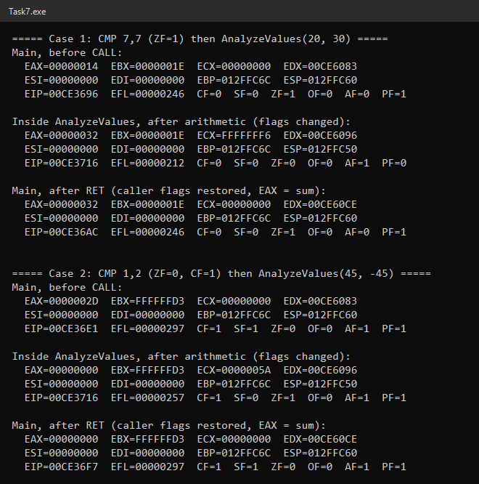

Expected vs Actual
Case | Caller flags before CALL | Flags inside procedure | EAX after RET | ZF after RET
1: CMP 7,7 then (20, 30) | ZF=1, CF=0, SF=0 | ZF=0, CF=0 (50 ≠ 0) | 00000032h (50) | 1 (caller's)
2: CMP 1,2 then (45, −45) | ZF=0, CF=1, SF=1 | ZF=1, CF=1 (sum = 0) | 00000000h (0) | 0 (caller's)

- Saving the flags: PUSHFD is the first instruction of the procedure and POPFD is the last one before RET, so every flag change inside the procedure is undone before returning.
- Additional operation: SUB ECX, EBX computes the difference (20 − 30 = −10 in case 1, 45 − (−45) = 90 in case 2) and ADD EAX, EBX computes the sum; both change the flags, as the "inside" DumpRegs shows.
- EAX is kept: POPFD restores only EFLAGS, so the sum stays in EAX. In case 2 EAX is 0 but ZF is 0 after return, which proves ZF comes from the caller, not from the sum.
- Stack correctness: the procedure pushes EFLAGS, ECX and EDX and pops them in reverse order, so the return address is on top when RET executes. ESP after each return equals ESP before the call, and ECX/EDX are restored as well.

