NAME:K.ANJALI

REG NO:211419106027

**ASSIGNMENT-1**

SMART HOME USING TINKERCAD

CIRCUIT:

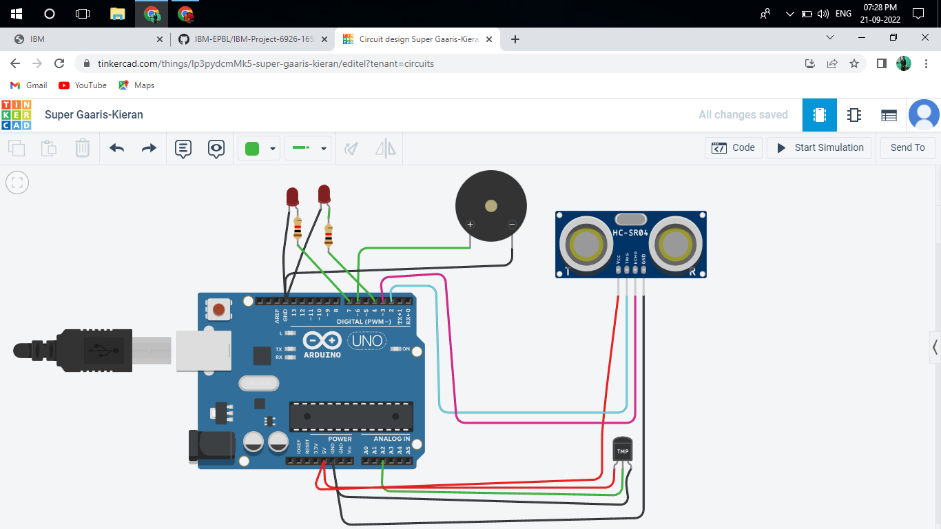

SIMULATION:

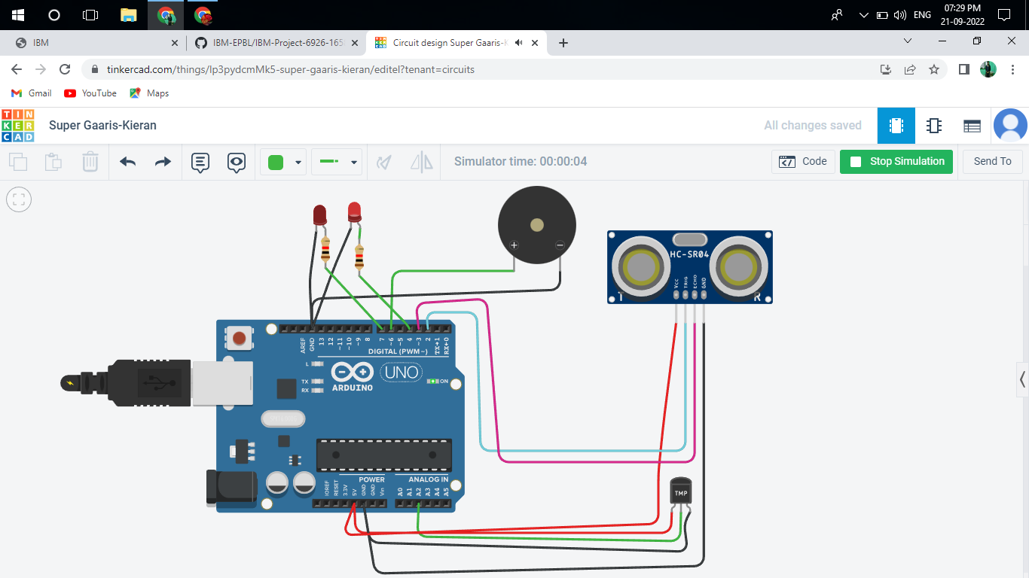

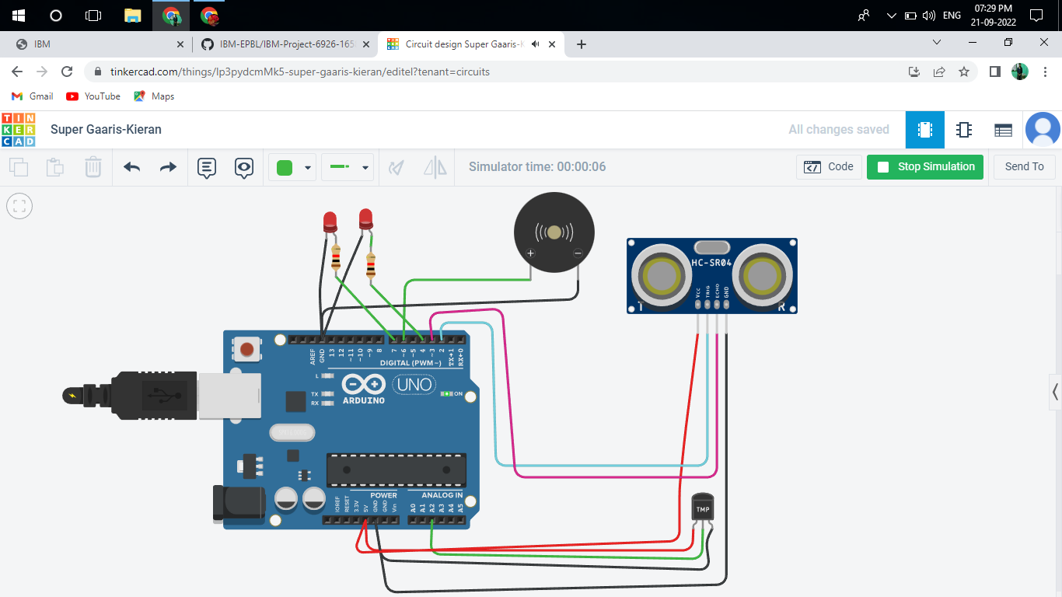

**CODE:**

// C++ code

int trig = 2;

int echo = 3;

int led=4;

int buz=6;

int led1=7;

void setup()

{

  Serial.begin(9600);

  pinMode(trig,OUTPUT);

  pinMode(echo,INPUT);

  pinMode(led,OUTPUT);

  pinMode(led1,OUTPUT);

  pinMode(buz,OUTPUT);

}

void loop()

{

  // temperature sensor

  double t = analogRead(A2);

  Serial.print("Analog data: ");

  Serial.println(t);

  double n= t/1024;

  double v=n*5;

  Serial.print("Voltage data: ");

  Serial.println(v);

  double c=v-0.5;

  double k=v*100;

  Serial.print("Temperature value:");

  Serial.println(k);

  delay(1000);

  //ultasonic sensor

  digitalWrite(trig,LOW);

  digitalWrite(trig,HIGH);

  delayMicroseconds(10);

  digitalWrite(trig,LOW);

  float dur=pulseIn(echo,HIGH);

  float dist=(dur*0.0343)/2;

  Serial.print("Distance in cm : ");

  Serial.println(dist);

  //led

  if(dist>=100)

  {

    digitalWrite(led,HIGH);

  }

  else

  {

    digitalWrite(led,LOW);

  }

  //buzzer

  digitalWrite(buz,LOW);

  digitalWrite(led1,LOW);

  delay(1000);

  digitalWrite(buz,HIGH);

  digitalWrite(led1,HIGH);

  delay(1000);

}

|  |  |
| --- | --- |
|  |  |