**Lab 2**

# Deadline: Feb 7, 2024

# You are tasked with implementing a program that allows a user to dynamically sort a list of integers based on their preferred sorting order. The user should be able to specify whether the sorting should be in ascending or descending order.

# You are provided with a skeleton file, you are not allowed to modify any other part of code except selection_sort() function from line 16.

# 

### Requirements

1. **Input**

* The skeleton file contains an initialized list of 10 numbers.
* A command line argument is used to specify the sorting order e.g ‘A’ for ascending and ‘D’ for descending.

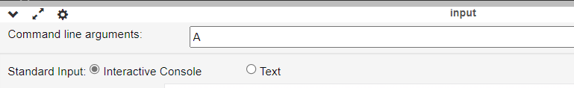

2. **Order Preference**

* Allow the user to specify whether the sorting should be in ascending or descending order.

3. **Sorting**

* Implement the simple selection sort algorithm to sort the list based on the user's preferences.
* Example: Let first element as minimum or maximum, loop through the list and compare it with next element.

4. **Output**

* The program should only print the sorted list which is already defined in the skeleton file, you are not allowed to write any print statement in the code.

5. **Save the File Offline**

* Click the “Download Code” button/icon to save the file offline.

6. **Submission**

* Include your Student ID as comment at the top of your code i.e #012345. Rename the main.py file to lab2.py. Place the lab2.py in a folder and compress to a zip file. Submit it to moodle.

7. **Grading**

* (1 point) Correct submission of working code with no errors and loop implementation.
* (5 point) Correct solution to the problem.