PERSONAL PORTFOLIO PROJECT
Olist E-Commerce Analytics
From raw CSV files to a fast, insight-driven Power BI report
Technical documentation: what was built, why it was built that way, what caused each problem, and how it was fixed
Item | Detail
Dataset | Olist Brazilian E-Commerce Public Dataset (Kaggle), 9 CSV files, about 100,000 orders
Analysis period | Jan 2017 to Aug 2018 (months with complete data)
Tools | Python (pandas, Jupyter), Power BI Desktop, DAX, DAX Studio (VertiPaq Analyzer, Server Timings), Performance Analyzer, seaborn
Deliverables | Python cleaning notebook, 8 cleaned tables, a Power BI data model, a multi-page report, a performance audit
Author | [Your name]
Version and date | 2.0, October 2026

Contents
1. Executive summary
2. Project overview
3. Skills demonstrated
4. Data profiling
5. Data cleaning methodology
6. Data model
7. DAX and filter context
8. Power BI report
9. Key findings and recommendations
10. Performance engineering
11. Code documentation
12. Root-cause log and lessons learned
13. Assumptions and limitations
14. Future improvements
15. How to reproduce the project
Appendix A. Data dictionary for derived fields
Appendix B. DAX measure reference
Appendix C. Glossary
Appendix D. Pre-publication checklist
How to read this document. Every major decision follows the same pattern: what was observed, why it happened (the root cause), what was done, and the evidence that it worked. Sections 5, 7, 10 and 12 are the most technical.

1. Executive summary
This document records, from start to finish, a personal analytics project built on the Olist Brazilian e-commerce dataset. It was designed to show practical skill in four areas: cleaning messy relational data with Python, designing a sound data model, communicating insight through a multi-page Power BI report, and measuring and tuning the performance of that report.
The project follows the path of a real analyst. Nine raw CSV files were profiled, each null and duplicate was interpreted before anything was changed, and the data was cleaned with an auditable pipeline that flags problems instead of silently deleting them. The cleaned tables were reconciled against the source, modeled in Power BI, and used to answer one central question: how does delivery performance affect customer satisfaction? A performance audit then measured where the report actually spends its time.

1.1 Headline numbers
Delivered orders, Jan 2017 to Aug 2018, as shown in the Power BI report.
Metric | Value | Meaning
Product sales | R$13.18M | Sum of item prices for delivered orders, excluding freight
Delivered orders | 96,211 | Orders with status delivered in the period
Average order value incl. freight | R$159.79 | Item prices plus freight, per delivered order
Unique customers | 95,780 | Distinct customer_unique_id values (people, not orders)
Average review score | 4.09 | Mean of 1 to 5 star reviews
Late delivery rate | 5.94% | Share of delivered orders that arrived at least one full day after the estimate

1.2 Business findings
- Late delivery sharply lowers satisfaction. Late orders average 2.27 stars against 4.29 for on-time orders. 53.75% of late-order reviews are 1 star, compared with 8.53% for on-time orders.
- Delivery is fast, but estimates are padded. Orders arrive in 12.07 days on average, about 11.8 days earlier than promised, so only 5.94% are late. Lateness clusters in the north and northeast (AL 19.95%, MA 15.80%, SE 13.71%) and in Rio de Janeiro (10.61%).
- Sellers are concentrated far from customers. Sellers based in São Paulo generate about 64% of product sales, while São Paulo customers account for about 39%.
- Most unhappy reviews are not about lateness. 14.64% of reviews are 1 or 2 stars, but only 5.94% of deliveries are late.
- Retention is weak. Only 3.12% of customers placed more than one order.

1.3 Engineering findings
- The DAX is already fast. The slowest measured query takes 87 ms (DAX Studio) and the slowest visual query in the report is 350 ms. Rewriting measures would gain little.
- The Python box plot is the performance problem. It takes 7.8 s on a first visit and 18.4 s on a repeat run, against under 1 s for every other page. About 99% of that time is the script itself.
- The model is larger than it needs to be. 92.9 MB, of which about 39 MB is 32-character text IDs and about 33 MB is columns nothing in the model uses. Integer keys and removing unused columns could bring it to roughly 25 MB.
- Two relationships are bidirectional without need, and four inactive relationships are unused. These are modeling clean-ups, documented in section 10.

1.4 What the project demonstrates
- Python and data cleaning: profiling, null semantics, flags instead of deletions, validation at every step, and a notebook that runs on pandas 2 and 3.
- Data modeling: a hub-and-spoke model with correct cardinalities, a role-playing dimension, a date table, and a collapsed geolocation table to avoid many-to-many joins.
- Power BI and DAX: measures that handle filter context correctly, field parameters, drill-through, tooltip pages, bookmarks and a styled Python visual.
- Performance engineering: Performance Analyzer, DAX Studio server timings and VertiPaq Analyzer used to find root causes before changing anything.
- Analytical judgment: honest definitions, minimum-sample filters, and findings framed as associations, not proven causes.

2. Project overview

2.1 Objectives and business questions
- How are sales trending, and what drives them (categories, states, seasonality)?
- Where and when do deliveries run late?
- Do late deliveries lower review scores, and by how much?
- Which sellers and product categories need attention?
- Who are the customers, and how often do they come back?
- Is the report fast enough to use, and where does it spend its time?

2.2 Scope
In scope | Out of scope
Profiling and cleaning all nine source files  A dimensional data model for Power BI  Report pages for sales, delivery, satisfaction and sellers  Performance measurement and tuning plan  Documentation of decisions, causes and validation | Predictive modeling or forecasting  Olist's own revenue or commission (not in the data)  Production deployment and scheduled refresh  Row-level security

2.3 Source data
The raw files are never edited: all cleaning is written to separate output files, so the pipeline can always be rerun from the originals.
Source file | Rows | Grain and content
olist_orders_dataset | 99,441 | One row per order: status and five timestamps
olist_order_items_dataset | 112,650 | One row per item in an order: product, seller, price, freight
olist_order_payments_dataset | 103,886 | One row per payment on an order (orders can have several)
olist_order_reviews_dataset | 99,224 | Customer reviews with score, text and dates
olist_customers_dataset | 99,441 | customer_id is created per order; customer_unique_id identifies the person
olist_products_dataset | 32,951 | Category, size and weight of each product
olist_sellers_dataset | 3,095 | Seller zip code, city and state
olist_geolocation_dataset | about 1,000,000 | Many latitude and longitude points per zip prefix
product_category_name_translation | 71 | Portuguese to English category names

2.4 Workflow
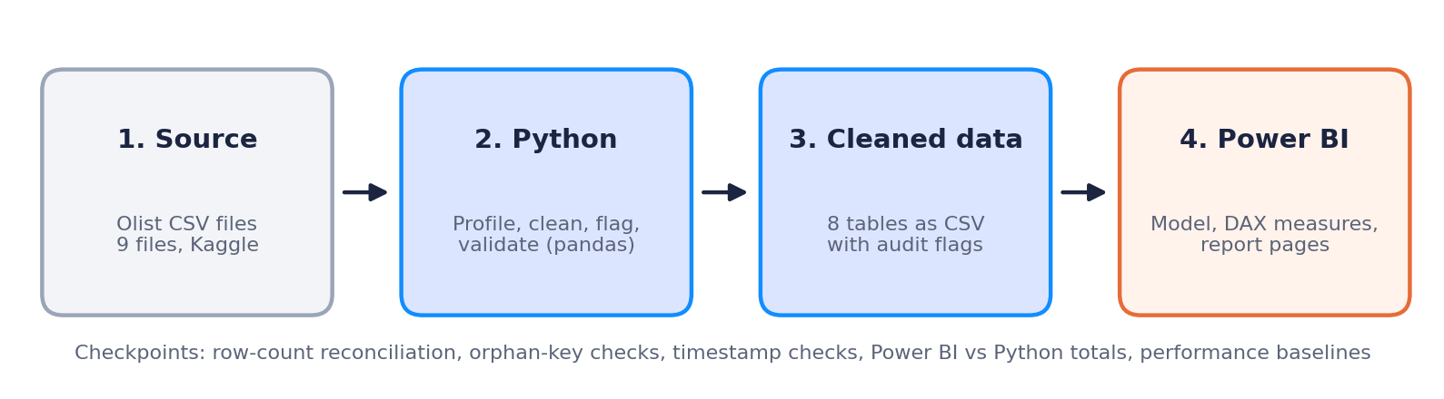
Figure 1. End-to-end workflow, with validation checkpoints between stages
Power BI totals were reconciled against Python totals before any report page was built, which caught an import locale bug (section 12). Performance was measured only after the report was finished, so the measurements describe the real thing.

2.5 Tools and environment
Tool | Use
Python 3.12 and pandas 3.0 | Profiling, cleaning, validation, export (cells also tested on pandas 2.x)
Jupyter notebook | Reproducible, documented cleaning pipeline
Power BI Desktop | Data model, DAX measures, report pages
Performance Analyzer | Per-visual timing: DAX query, visual display and other
DAX Studio | Server Timings (formula engine versus storage engine) and VertiPaq Analyzer (model size)
seaborn and matplotlib | Styled Python visual (box plot) inside Power BI

3. Skills demonstrated
Skill area | What was done | Where to look
Python and pandas | Profiling loop across nine files, dictionary-based pipeline, vectorised cleaning, compatibility with pandas 2 and 3 | Sections 5 and 11
Data cleaning judgment | Interpreted nulls (an undelivered order has no delivery date), flagged anomalies instead of deleting, never used a blanket dropna | Section 5.2
Validation | Row-count reconciliation, orphan-key checks, timestamp logic checks, Power BI totals checked against Python | Section 5.4
Data modeling | Hub-and-spoke model, correct cardinalities, role-playing dimension, marked date table, collapsed geolocation table | Section 6
DAX | Context-safe measures, variables, CROSSFILTER and REMOVEFILTERS, blank guards, minimum-sample logic inside measures | Section 7, Appendix B
Power BI features | Field parameter, synced slicers, drill-through, tooltip page, bookmark toggles, navigation, info button | Section 8
Python in Power BI | Seaborn box plot styled to match the report, and the cost analysis that followed | Sections 8.5 and 10
Performance engineering | Baseline with Performance Analyzer, query analysis in DAX Studio, memory analysis with VertiPaq, prioritised plan | Section 10
Visual design | Consistent palette (orange for late, blue for neutral), readable titles, source footer on every page | Section 8.1
Debugging and root-cause analysis | Locale bug, circular dependency, phantom table rows, filter direction, cold-start cost | Section 12

4. Data profiling
Before any cleaning, every file was loaded and summarised: shape, data types, missing values per column, sample rows and descriptive statistics. The goal was to decide what each anomaly meant, not to remove it.

4.1 What the profiling revealed
Table | Observation | Interpretation
orders | Nulls: approved 160, carrier date 1,783, customer delivery date 2,965 (4,908 in total) | Mostly orders that were canceled or never delivered, so the nulls carry meaning
reviews | Comment title null in 87,656 rows, message null in 58,247 rows (145,903 in total) | Most customers write no text. Normal, not an error
products | 610 products missing category, name length, description length and photo count; 2 missing weight and size | A block of products with no listing data
geolocation | About 1,000,000 rows for roughly 19,000 zip prefixes, with many exact duplicates | Several coordinates per zip: needs collapsing before it can be joined
customers | 99,441 customer_id values but 96,096 customer_unique_id values | customer_id is created per order, so repeat buyers have several
order_items | 112,650 rows for 98,666 distinct orders; every product and seller appears at least once | Some orders have several items (up to 21)
payments | 103,886 rows for 99,440 orders; up to 29 payments on one order | Orders can be paid with several methods
categories | 73 product categories against 71 translations | Two categories have no English name

Why it matters: The null counts reconcile exactly (for example 160 + 1,783 + 2,965 = 4,908 in orders), which confirmed that the files were read correctly before any decisions were made.

5. Data cleaning methodology

5.1 Principles
- Understand a null before touching it. A missing delivery date on a canceled order is information. The same gap on a delivered order is a defect.
- Flag, do not delete. Anomalies get a 0/1 flag column so they can be filtered later. Deleted rows cannot be recovered.
- Never edit raw data. Cleaned files go to a separate folder, so the pipeline can always be rerun.
- Check every step with counts. Each change prints before and after numbers that can be reconciled.
- Keep an audit trail. Original columns sit next to corrected ones (for example seller_city and seller_city_clean).
- Clean first, merge later. Joining before cleaning multiplies nulls and duplicates across tables, so the tables stay separate.

5.2 Issues, causes and decisions
The cause column says why the data looks the way it does. Where the cause could not be proven from the data, it is worded as a likely explanation.
Area | Finding | Cause | Decision | Result
Zip codes | 4-digit values in profiling | The profiling loop let pandas infer integers, which drops leading zeros. The raw files hold 5-digit codes | Load as text, pad to 5 digits as a safeguard | 0 four-digit zips on text load
Dates | Stored as text | CSV files carry no types | Convert to datetime, keep nulls | 2,965 null delivery dates kept as 'not delivered'
Order anomalies | 8 delivered orders without a delivery date; 6 canceled orders with one | Status and tracking events come from different steps, so an event can be missing or can precede a later cancellation (likely returns) | Flag only | delivered_missing_date = 8, canceled_with_delivery = 6
No items or payment | 775 orders without items (603 unavailable, 164 canceled, 5 created, 2 invoiced, 1 shipped); 1 without payment | Early or failed statuses never reach the item stage. The shipped order is a gap in the source | Flag with has_items and has_payment | All 96,478 delivered orders have items
Timestamp order | 166 carrier before purchase, 23 delivered before carrier, 1,359 carrier before approval | Timestamps written by different systems or entered by sellers | Flag impossible cases only (carrier_date_suspect) | 189 orders flagged
Reviews | 814 repeated review_id; 551 orders with several reviews | The pattern suggests one review can cover orders placed together, and some orders get a second review | One review per order, the latest | 99,224 rows to 98,673
Review text | Line breaks inside comments | Free text, and a quoted line break splits rows in some importers | Replace with spaces, keep nulls, add has_comment | About 41% have a comment
Products | 610 without category; 2 untranslated categories; a typo in a translation | A block of products with no listing data; the translation table is incomplete | 'unknown', manual mapping, typo fixed | No product rows lost
Product weight | 4 products with weight 0 | A placeholder, since nothing weighs 0 g | Null plus weight_was_zero. Keep size columns, add volume | 6 weights now null
Geolocation | About 1,000,000 rows; 29 coordinates outside Brazil | Several GPS points per zip, some noisy | Blank bad coordinates, collapse to one row per zip (median) | 19,015 rows; 4 zips with no coordinates
Unmatched zips | 278 customers (157 zips) and 7 sellers (253 items) without a geolocation zip | The geolocation file is a sample that lacks some zips (the top ten are all in Brasília) | Leave unmatched, add flags | Reported, not guessed
Seller cities | Digits, slashes, state names, an email in the city field | Free text typed by sellers | seller_city_clean with geolocation fallback | 34 fixed
Payments | 9 zero-value rows, 2 credit-card rows with 0 installments, a not_defined type | Voucher rows with no value, an installment entry gap, an undefined method on canceled orders | Flag; relabel not_defined as unknown | 11 rows flagged
Customers | customer_id is per order | A design choice of the dataset | Count people with customer_unique_id | 96,096 distinct people

5.3 Decisions explained

Zip codes: a loading artifact, not a data defect
What happened | Zip codes looked 4 digits long, and a string method later failed with 'can only use .str with string values'.
Why | Pandas infers numbers for numeric-looking columns and drops leading zeros (01046 becomes 1046). A notebook cell still held integer columns from an earlier load.
Fix | Read zip columns as text, and pad with a helper that converts to text first.
Evidence | On a text load the diagnostic found 0 four-digit zips, so the raw files were already correct. Test a suspicion before fixing it.

Reviews: why deduplicate on order_id
What happened | 814 review IDs repeat, 0 (review_id, order_id) pairs repeat, and 551 orders have more than one review.
Why | Removing duplicates by review_id would delete valid links between orders and reviews. The same review_id belongs to different orders.
Fix | Keep one review per order (the latest answered), which makes the order-to-review relationship one-to-one.
Cost | 551 older reviews are excluded and review_id is no longer unique, so order_id is the key.

Geolocation: do not lose zips
What happened | The first version dropped out-of-range rows. That removed a few zips entirely and created extra unmatched customers.
Why | Dropping rows removes the zip if all of its points were bad. A join then finds nothing for that zip.
Fix | Blank the bad coordinates instead, keep every zip, and use the median so one stray point cannot move the result.
Evidence | Only 1 of the 279 originally unmatched customers had been caused by the cleaning. The other 278 customers and 7 sellers are genuine source gaps.

Products: keep weight and dimensions
Weight and size help freight and delivery analysis, so the columns were kept. Rows with missing values were not dropped, because order items reference those products and dropping them would create orphan records. Photo counts stayed null instead of 0: for those 610 products the null means 'no listing information', and a zero would distort averages.

5.4 Validation checks
Check | Result
Null totals reconcile with per-column nulls | orders 4,908; reviews 145,903; products 2,448 (all match)
Order statuses add up to the order count | 99,441
Orphan keys between core tables | 0 (orders, items, payments, reviews, products, sellers)
Orders delivered before purchase | 0
Reviews answered before the survey was sent | 0
Review scores outside 1 to 5 | 0
Review key check after deduplication | order_id unique: true. review_id unique: false (by design)
Timestamp order checks | approved before purchase 0; carrier before purchase 166; carrier before approval 1,359; delivered before carrier 23
Delivered orders missing approval or carrier date | 14 and 2
Zip code lengths | All customer, seller and geolocation zips are 5 characters
Exported row counts | customers 99,441; geolocation 19,015; orders 99,441; order_items 112,650; payments 103,886; reviews 98,673; products 32,951; sellers 3,095
Power BI against Python | Order, customer and review counts matched. The money totals did not at first (section 12, locale bug)
Notebook compatibility | Cleaning cells tested on synthetic data under pandas 2.x and 3.x

5.5 Cleaned output
Cleaned table | Rows | Columns | Main additions
orders | 99,441 | 17 | order_purchase_date, delivery_days, delivery_delay_days, is_late, delivered_missing_date, canceled_with_delivery, has_items, has_payment, carrier_date_suspect
order_items | 112,650 | 7 | Unchanged
payments | 103,886 | 7 | is_zero_payment, installments_missing
reviews | 98,673 | 9 | has_comment, review_response_days
products | 32,951 | 12 | English category, weight_was_zero, product_volume_cm3
sellers | 3,095 | 8 | has_geo_match, has_coordinates, seller_city_clean, seller_city_fixed
customers | 99,441 | 7 | has_geo_match, has_coordinates
geolocation | 19,015 | 6 | source_rows (raw points behind each zip)

The translation table is merged into products and is not exported separately. Section 10 describes a further, optional step that replaces the long text IDs with integers.

6. Data model
The cleaned tables stay separate and are related in Power BI. They are not merged into one wide table because they have different grains: merging orders, items, payments and reviews would repeat order-level values on every item or payment row and inflate every total.
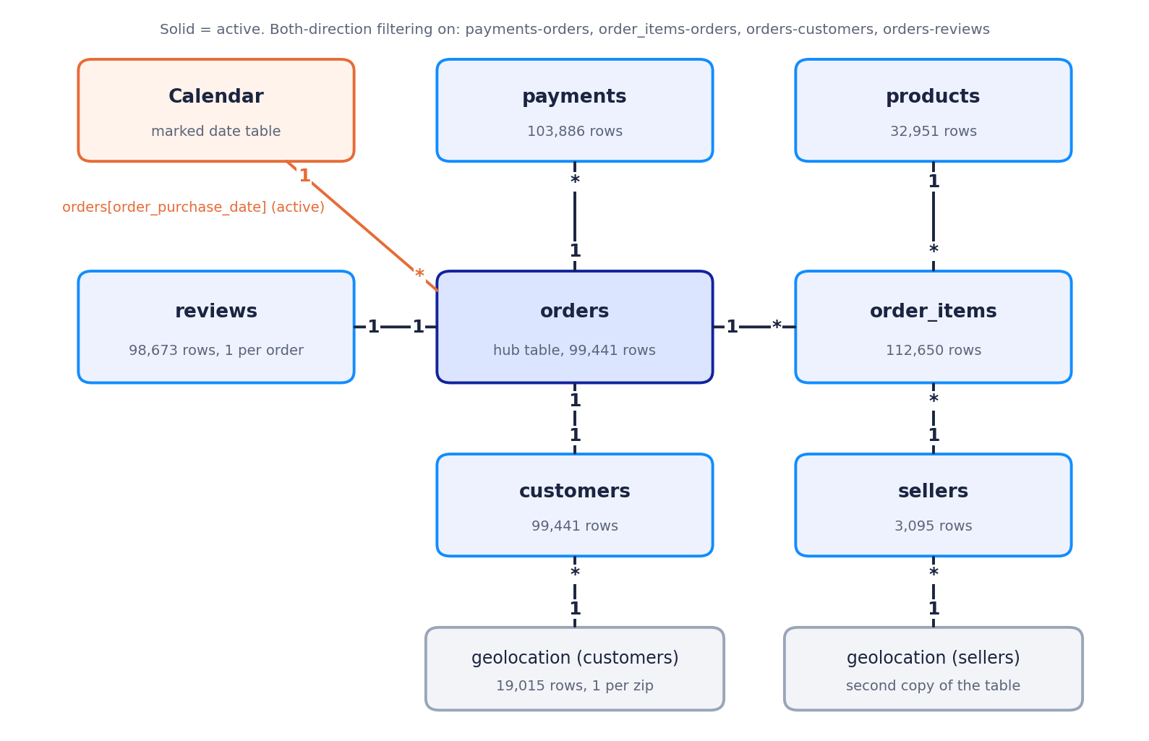
Figure 2. Data model: orders is the hub; geolocation is used twice; a date table sits on the purchase date

6.1 Relationships as built
From the VertiPaq export: 13 relationships, 9 active and 4 inactive.
From (many side) | To (one side) | Type | Filter direction | Notes
order_items[order_id] | orders[order_id] | * : 1 | Both | 98,666 distinct orders have items
order_items[product_id] | products[product_id] | * : 1 | Single | All 32,951 products are sold at least once
order_items[seller_id] | sellers[seller_id] | * : 1 | Single | All 3,095 sellers appear
payments[order_id] | orders[order_id] | * : 1 | Both | 99,440 distinct orders have payments
orders[customer_id] | customers[customer_id] | 1 : 1 | Both (forced) | customer_id is per order
orders[order_id] | reviews[order_id] | 1 : 1 | Both (forced) | 98,673 orders have a review
customers[zip prefix] | geolocation (customers) | * : 1 | Single | 14,994 distinct zips used of 19,015
sellers[zip prefix] | geolocation (sellers) | * : 1 | Single | 2,246 distinct zips used
orders[order_purchase_date] | Calendar[Date] | * : 1 | Single | The only active date relationship
4 inactive links | Calendar[Date] | * : 1 | Single | Delivered date, estimated date, review creation date, shipping limit date (not used)

6.2 Design decisions and their causes
- Orders as the hub. Order-level facts live in orders, item-level facts in order_items. Each fact is stored once at its own grain.
- Geolocation collapsed before modeling. The raw table has many rows per zip, which would force a many-to-many join. One row per zip gives clean 1-to-many relationships.
- A role-playing dimension. Customers and sellers both link to geolocation. Power BI allows only one active path between two tables through different routes, so sellers use a second copy of the table.
- Date table on purchase date. Sales are analysed by when the customer bought. Delivery-date views would need date-only columns, because the timestamp columns carry a time of day and cannot match a date table.
- Sales come from order_items, not payments. Payments are per order and include freight and interest, so they cannot be split by category or seller.
- Customer counts use customer_unique_id. customer_id is one per order, so counting it would count orders.

6.3 Filter direction: what the model actually does
Four relationships filter in both directions. Two of them (orders to customers and orders to reviews) are one-to-one, and Power BI always makes one-to-one relationships bidirectional. The other two (order_items to orders and payments to orders) were set to both directions so that product, seller and payment selections would reach orders and reviews.
Cause of the issue | Filters flow from the one side to the many side. Without bidirectional filtering, a product or seller selection filters order_items but never reaches orders or reviews, so review scores come out identical for every category.
Side effect | The measures also contain CROSSFILTER, which repeats what the relationship already does. Bidirectional relationships can create ambiguous filter paths and extra work for the engine.
Recommended change | Set the two optional relationships to single direction and keep the explicit CROSSFILTER inside the measures that need it, then confirm that every card still reconciles. Status: pending (section 10).

6.4 Table grain and keys
Table | Grain | Key
orders | One row per order | order_id
order_items | One row per item in an order | order_id + order_item_id
payments | One row per payment on an order | order_id + payment_sequential
reviews | One row per order (after deduplication) | order_id (review_id is not unique)
customers | One row per order's customer record | customer_id (person: customer_unique_id)
products | One row per product | product_id
sellers | One row per seller | seller_id
geolocation | One row per zip prefix | geolocation_zip_code_prefix

7. DAX and filter context
Most report bugs in this project came from one idea: a DAX measure is calculated inside a filter context (the filters coming from slicers, axes and other visuals), whereas a calculated column is calculated one row at a time inside a row context. This section explains the technical causes behind the measure patterns used.

7.1 Row context versus filter context
Object | Evaluated | Stored | Can be an axis or slicer field
Calculated column | Once per row, at refresh | Yes, in the model (costs memory) | Yes
Measure | At query time, per visual cell | No (only the formula) | No

Error 1 | 'A single value for column cannot be determined'. A formula written for a calculated column (comparing orders[delivery_delay_days] with a number row by row) was pasted as a measure. A measure sees thousands of rows at once, so the column reference needs an aggregation such as MIN or AVERAGE.
Fix 1 | Create it with New column on the orders table. A bucket label has to be a column anyway, because only columns can sit on a chart axis.
Error 2 | 'A circular dependency was detected'. A calculated column that crossed relationships (RELATEDTABLE, RELATED) was combined with measures, in a model where the Calendar table is itself computed from orders.
Fix 2 | Use measures only. If a helper date is needed per seller, compute it in Python so the model holds a plain column.

7.2 Patterns and the problems they prevent
Pattern | Why it is needed | Where it is used
Status filter inside CALCULATE (status = delivered) | Defines the business rule once, so every card agrees. Side effect: it overrides the status of any table row (see 7.3) | Product Sales, Freight, Late Delivery Rate
DIVIDE instead of / | Returns blank on a zero denominator instead of an error | All ratios
Variables (VAR) | The expression is evaluated once and reused, which is faster and easier to read | Sales MoM %, Top 10% Sellers Share
Blank guards | A month-over-month change against a blank or tiny previous month produced -100% and 1000K% | Sales MoM %
Minimum sample inside the measure | Top N is applied before a separate minimum filter, so the filter order left only 3 bars | Avg Score (Category, 100+ reviews)
CROSSFILTER(..., BOTH) | Lets filters reach reviews from products and sellers without changing the relationship | Avg Score (by Category), Seller Late Rate
REMOVEFILTERS | Builds an 'all sellers' baseline that ignores seller, product and customer selections | Late Rate (All Sellers)
AVERAGE of a 0/1/blank flag | Average ignores blanks, so is_late gives the late share of delivered orders directly | Late Delivery Rate
Disconnected tables | A field parameter and a minimum-orders control can drive a measure without relationships | Field parameter on Overview

7.3 Three bugs explained in detail

Phantom rows in the Seller Detail order table
Symptom | The same date appeared under canceled, delivered, processing, shipped and unavailable, always with the same value.
Cause | A table shows a row for each combination of its fields and keeps it if any measure is not blank. Product Sales contains status = delivered, which replaces the row's own status, so it returned the delivered value on every status row. The table also had no order_id, so rows were not tied to individual orders.
Fix | Use an unfiltered measure, put order_id in the table, and rank with a measure that is blank for other sellers' orders (otherwise Top N ranks every order in the dataset first).

Order Value = SUM(order_items[price])
Latest Order Time =
IF(NOT ISBLANK([Order Value]), MAX(orders[order_purchase_timestamp]))

Identical review scores for every category
Cause | Filters flow from the one side to the many side. A category filters order_items, but nothing carries that filter to orders and then to reviews.
Fix | Apply the filter path inside the measure.

Avg Score (by Category) =
CALCULATE(AVERAGE(reviews[review_score]),
CROSSFILTER(order_items[order_id], orders[order_id], BOTH))

Bottom 10 categories showed only 3 bars
Cause | Power BI evaluates the Top N filter over all 73 categories first. The lowest ten are tiny categories with extreme averages, and the separate 100-review filter then removed most of them.
Fix | Put the minimum inside the measure so small categories are blank, and Top N ignores blanks.

Avg Score (Category, 100+ reviews) =
VAR n = [Reviews (by Category)]
RETURN IF(n >= 100 && SELECTEDVALUE(products[product_category_name_english]) <> "unknown",
[Avg Score (by Category)])

8. Power BI report
The report has a left navigation panel with page buttons and an info button, and a row of slicers (customer state, product category and date) that is synced across pages. Every page carries a source footer. The central question, how delivery affects satisfaction, runs through the pages in order.

8.1 Design system
Element | Choice | Reason
Blue (default series) | Bright blue, with navy for a second series | Neutral measures such as sales and counts
Orange | Reserved for late deliveries and at-risk sellers | One color means one idea on every page, and it is readable for color-blind viewers
Page background and cards | Light grey page, white cards with a thin border | Clean separation between visuals
Titles | What by dimension, with units (R$, %) | A chart can be read without opening the field list
Navigation | Side panel buttons, current page highlighted | Consistent movement between pages
Info button | Opens definitions for the page | Keeps chart titles short and the rules visible

8.2 Pages at a glance
Page | Purpose | Status
Overview | Scale, trend, categories, states, payments | Complete
Delivery Performance | Where and when orders arrive late | Complete, open items in Appendix D
Customer Satisfaction | Link between lateness and review scores | Complete, open items in Appendix D
Products and Sellers | Seller concentration, freight, seller performance | Complete, open items in Appendix D
Seller Detail (hidden) | Drill-through page for one seller | Complete
Tip-State (hidden) | Report-page tooltip for state visuals | Built
AI insights | Key influencers and decomposition tree | Prototype, redesign planned

8.3 Overview
Purpose: the scale of the business and the main drivers on one screen.
- Six KPI cards, with the late delivery rate in orange.
- Monthly chart with a field parameter: buttons switch the measure between product sales, delivered orders, average order value, late delivery rate, average score and month-over-month change.
- Top 10 categories, product sales by customer state, and a payment-value funnel.
- A donut of assumed subscription revenue by seller state (section 13).
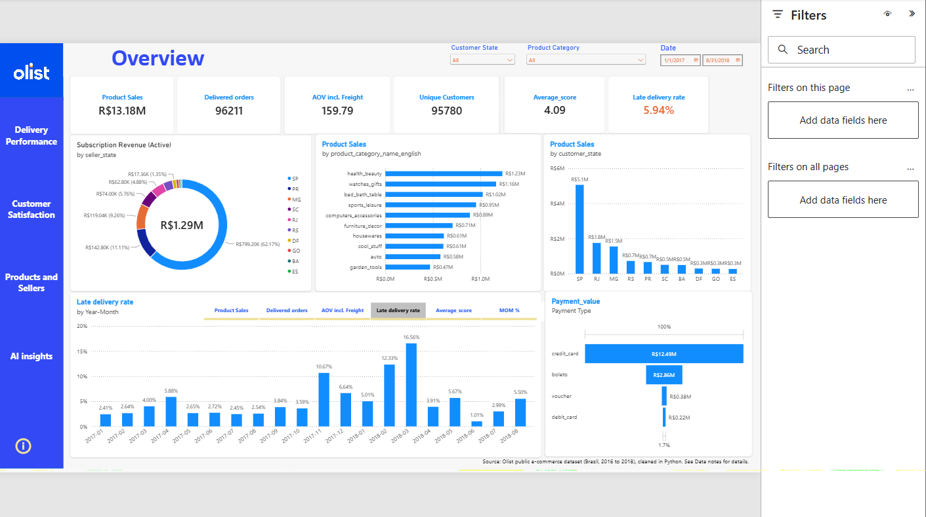
Figure 3. Overview page (monthly chart set to late delivery rate through the field parameter)

8.4 Delivery Performance
Purpose: how quickly orders arrive, how that compares with the promise, and where lateness concentrates.
- Cards for average days versus the estimate (-11.81), average delivery days (12.07), late orders and the late rate (5.94%).
- Monthly late-delivery line, peaking in November 2017 (10.67%) and March 2018 (16.56%).
- Delivered orders by delivery-time bucket, delivery days by state, and late rate by state (AL highest at 19.95%).
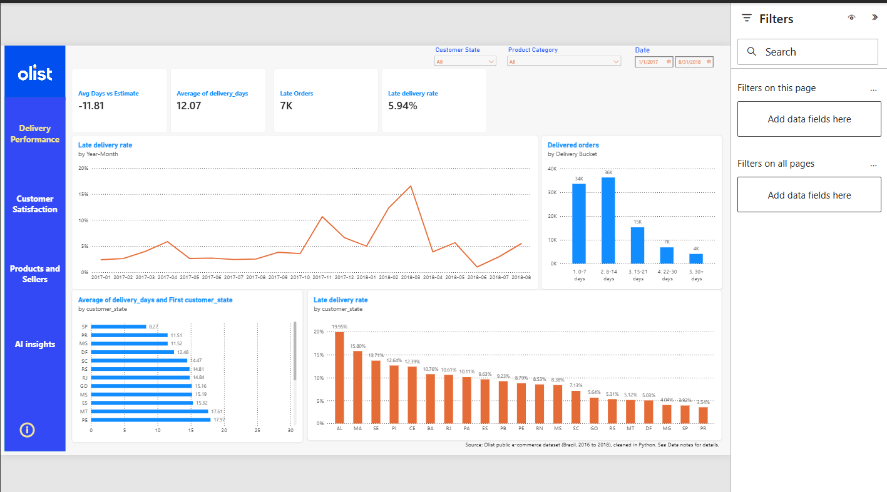
Figure 4. Delivery Performance page

8.5 Customer Satisfaction
Purpose: test whether late delivery is linked to worse reviews.
- Cards: low score rate 14.64%, average score 4.09, late 2.27 and on-time 4.29.
- A star-mix chart of late and on-time reviews, in orange and blue, and average score by delay bucket.
- A seaborn box plot (a Python visual styled to match the report) of delivery delay for each review score. Its performance cost is analysed in section 10.
- A state scatter of late rate against average score, and the lowest-scoring categories (100 or more reviews).
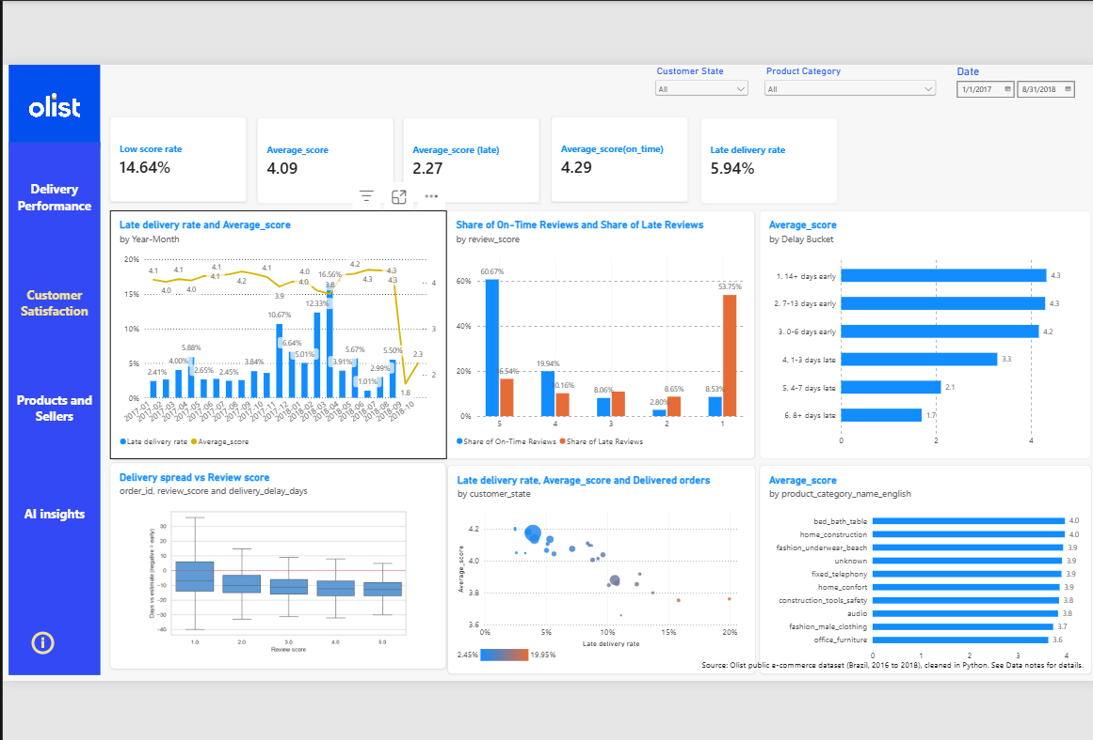
Figure 5. Customer Satisfaction page, including the Python box plot

8.6 Products and Sellers
Purpose: where sales and sellers sit, what shipping costs, and which sellers perform worst.
- Cards: freight share of sales (16.63%), sellers, share of sales held by the top 10% of sellers (67.04%) and products sold.
- Share of sales versus share of sellers by seller state, a state scorecard, freight share by category, and average freight against average weight.
- Two bookmark buttons switch between the seller scatter and the freight-versus-weight view.
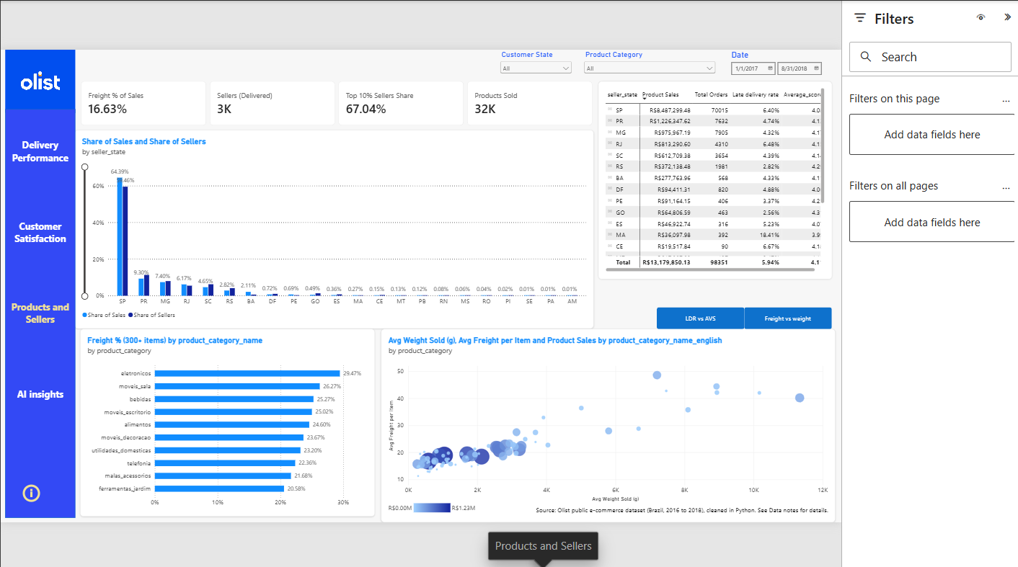
Figure 6. Products and Sellers page

8.7 Seller Detail (drill-through)
Purpose: move from a pattern to a cause. Right-clicking a seller opens this hidden page, filtered to that seller, with cards compared against the all-seller average and a table of the seller's latest orders.
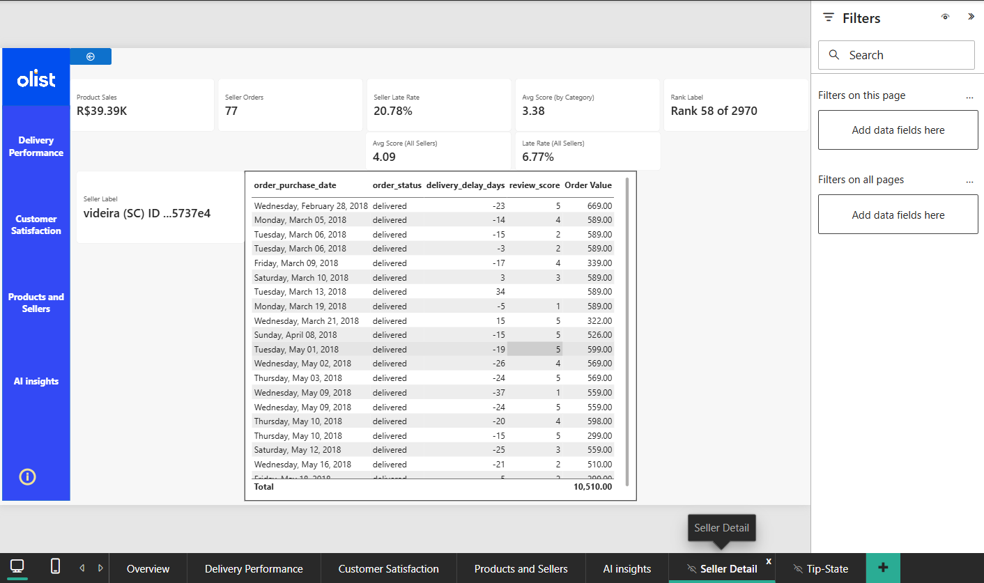
Figure 7. Seller Detail drill-through page, shown for one seller in Santa Catarina
Reading the example: This seller has a 20.78% late rate against 6.77% for all sellers and an average score of 3.38 against 4.09. The table lets the viewer inspect the orders behind those numbers.

8.8 Tooltips and AI insights
A hidden tooltip page, Tip-State, shows a mini late-rate trend and key figures for the state under the pointer. The AI insights page currently holds a key influencers visual as a prototype. It analyses seller-level measures against each other, which tends to produce trivial results (for example, more revenue means more items sold). The planned redesign analyses a review outcome using order-level fields.
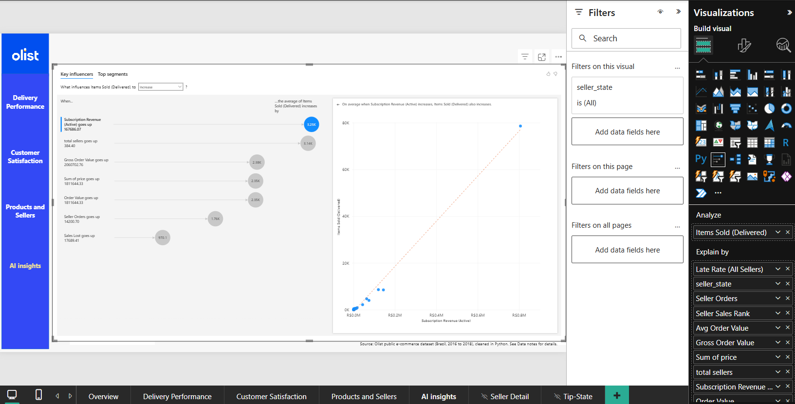
Figure 8. AI insights page (prototype)

8.9 Interactive features used
Feature | Where | Purpose
Synced slicers | All main pages | One date, state and category selection across the report
Field parameter | Overview monthly chart | One visual, six metrics
Drill-through | Seller Detail | Move from a pattern to a single seller
Report-page tooltip | State visuals | Extra context on hover
Bookmarks | Products and Sellers | Switch between two views in the same space
Python visual | Customer Satisfaction | A statistical chart not available natively
Edit interactions | Satisfaction | Stops a selected star rating from flattening other charts

9. Key findings and recommendations
All figures are for Jan 2017 to Aug 2018 and are read from the Power BI report unless stated. They describe associations in observational data and do not prove cause.

9.1 Findings

F1. Sales grew quickly through 2017 and peaked in November
Monthly product sales rose steadily through 2017 and peaked in November 2017 at about R$1.0M, the Black Friday month. The 2018 months stayed close to that level (about R$0.8M to R$1.0M). Early 2017 shows large month-over-month jumps because the business was still ramping up, so those growth rates should not be projected forward.

F2. Customers are spread out, but sellers are concentrated in São Paulo
Customers in São Paulo account for R$5.1M of sales (about 39%), followed by Rio de Janeiro (R$1.8M) and Minas Gerais (R$1.5M). Sellers based in São Paulo generate R$8.49M, about 64% of product sales, and the top 10% of sellers hold about 67% of all sales. Most goods therefore travel from São Paulo to customers across the country.

F3. Delivery is fast, but promises are padded
The average delivery takes 12.07 days, 11.81 days earlier than the estimate, so estimates average about 24 days. About 73% of orders arrive within 14 days (34K in 0 to 7 days and 36K in 8 to 14), and about 4K orders take more than 30 days.

F4. Lateness clusters in the north, northeast and Rio de Janeiro
State | Late rate | Note
AL | 19.95% | Highest among states with enough orders
MA | 15.80% | Northeast
SE | 13.71% | Northeast
PI | 12.64% | Northeast
CE | 12.39% | Northeast
RJ | 10.61% | Second-largest market, so its impact is large
SP, PR, MG | 3.5% to 4.1% | Best performers, closest to the sellers

Late rates also vary over time: 10.67% in November 2017 and a peak of 16.56% in March 2018.

F5. Late delivery is strongly linked to bad reviews (the central finding)
Measure | On-time orders | Late orders
Average review score | 4.29 | 2.27
Share of reviews with 1 star | 8.53% | 53.75%
Share of reviews with 5 stars | 60.67% | 16.54%

Average score by how early or late an order arrived shows a cliff at the estimate: 4.3 for orders 14 or more days early, 4.3 for 7 to 13 days early, 4.2 for 0 to 6 days early, then 3.3 for 1 to 3 days late, 2.1 for 4 to 7 days late and 1.7 for 8 or more days late.

F6. Lateness is not the whole story
14.64% of reviews are 1 or 2 stars, while only 5.94% of deliveries are late. Even if every late order were unhappy, lateness could explain at most about 40% of low scores (5.94 divided by 14.64, a rough bound because the two rates use slightly different populations). The box plot supports this: the typical 1-star order still arrived earlier than its estimate.

F7. Freight is a material cost and depends on category and weight
Freight is 16.63% of product sales. It is the largest share of price for electronics (29.47%), living-room furniture (26.27%), beverages (25.27%) and office furniture (25.02%). Average freight per item rises with average weight, from about R$15 for light categories to R$40 to R$50 for categories averaging 7 to 11 kg.

F8. Some categories score lower
Among categories with at least 100 reviews, the lowest average scores are office furniture (3.6), men's fashion (3.7), audio and construction tools and safety (3.8), against 4.09 overall. Office furniture is bulky, which fits the freight findings, but the data cannot confirm the reason for any of these scores.

F9 to F11. Retention, payments and sellers
- Repeat purchases are rare: 3.12% of 96,096 distinct customers ordered more than once. One customer placed 17 orders.
- Credit cards dominate payments: R$12.49M (78.33%), boleto R$2.86M (17.93%), vouchers R$0.38M and debit R$0.22M. Payment value includes freight and interest, so it exceeds product sales.
- Seller performance varies widely: one seller in Santa Catarina has a 20.78% late rate and a 3.38 score against 6.77% and 4.09 for all sellers.

9.2 Recommendations
- Improve delivery promises and performance in the northeast and in Rio de Janeiro.
- Reduce reliance on São Paulo fulfilment by encouraging sellers or stock closer to other regions.
- Review sellers with high late rates and low scores, starting with those that have the most sales.
- Investigate non-delivery causes of low scores (product quality, wrong items), since lateness explains only part of them.
- Review freight pricing and logistics for heavy categories such as furniture and electronics.
- Build retention with post-purchase offers, since fewer than 4 in 100 customers return.

9.3 Caveats
- Findings describe associations. Late orders may also differ in other ways that affect reviews.
- Late is measured in whole days against an estimated date that has no time of day.
- State and category comparisons use minimum-size filters, so small groups are excluded.
- 278 customers and 7 sellers have no map coordinates, so map-based views would omit them.

10. Performance engineering
The report was measured before anything was changed. The aim was to find out where the time actually goes, because the obvious suspect (complex DAX) turned out not to be the problem.

10.1 Method: three tools, three questions
Tool | Question it answers | What it reports
Performance Analyzer (Power BI) | Which visual is slow, and is the time spent in DAX, in drawing, or elsewhere? | Per visual: DAX query, visual display and other, in milliseconds
DAX Studio, Server Timings | Inside one slow query, is the time in the formula engine or the storage engine? | Total, FE and SE time, number of storage queries, cache hits
DAX Studio, VertiPaq Analyzer | Why is the model this large, and which columns cost the most? | Size per table and column, dictionary and data size, encoding, relationships

Cold means the first visit after opening the file, with an empty cache. Warm means a repeat visit. Both were recorded.

10.2 Baseline results
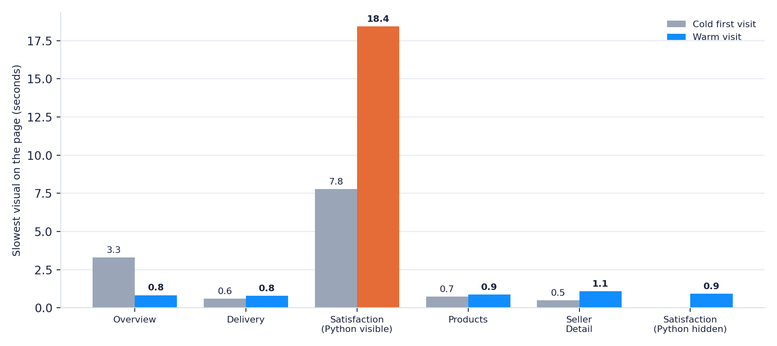
Figure 9. Slowest visual per page, cold first visit and warm visit (seconds)
Page (slowest visual) | Cold first visit | Warm visit | Warm refresh
Overview | 3.3 s | 0.83 s | 0.79 s
Delivery | 0.59 s | 0.78 s | 0.69 s
Satisfaction, Python visual visible | 7.8 s | 18.4 s | not recorded
Satisfaction, Python visual hidden | not recorded | not recorded | 0.92 s
Products | 0.73 s | 0.87 s | 0.70 s
Seller Detail | 0.49 s | 1.09 s | 0.62 s

With the Python visual out of the picture every page loads in about one second or less.

10.3 Root cause 1: the Python visual
What happened | The box plot took 7,778 ms on the first run and 18,432 ms on a later one. Its DAX query took only 171 ms and 261 ms, and drawing took about 8 ms.
Why | About 99% of the time is the script. For every refresh Power BI starts a Python process, writes the visual's rows (about 98,000) to a temporary file, the script imports pandas, matplotlib and seaborn, builds the figure, and returns an image. The result is not cached and it reruns after any filter change. The cost also varies a lot between runs (7.8 s against 18.4 s), which points to process start-up and data transfer, not plotting.
Evidence | Hiding the visual in the Selection pane took the page from 18.4 s to 0.92 s. Hidden visuals do not run their queries.
Options | (1) Show it on demand with a bookmark toggle, so normal visits pay nothing. (2) Send pre-grouped data (a few hundred rows of counts) and compute the quartiles in the script. (3) Replace it with a native chart of the median with error bars. Option 1 is the simplest and keeps the Python skill on show.

10.4 Root cause 2: the cold start
What happened | On first load every Overview visual took about 3.1 to 3.3 s, although its DAX took only 14 to 96 ms.
Why | The time sits in query preparation, not in calculation: 'Resolve Parameters' took up to 2.9 s and the semantic-query layer up to 1.9 s. The first query of a session pays for starting the engine and resolving the field parameter table.
Evidence | The warm run of the same page took 0.83 s. No measure change is needed. The practical advice is to judge speed on warm runs and to open the report once before a demonstration.

10.5 Query analysis in DAX Studio
The slowest Overview visual was the monthly chart with the field parameter set to late delivery rate. Its query uses TREATAS to apply the parameter, SUMMARIZECOLUMNS to group by month, and TOPN(1001) as Power BI's standard result window.
Server Timings result | Value
Total | 87 ms (matches the 87 ms in Performance Analyzer)
Formula engine (FE) | 24 ms (27.6%)
Storage engine (SE) | 63 ms (72.4%)
Storage queries | 7, with 1 served from cache
Largest storage scan | 50 ms: order_items joined to Calendar

How to read it | The formula engine runs the DAX logic and is single-threaded. The storage engine scans the compressed columns and runs in parallel. A high FE share points to heavy formulas. A high SE share or many storage queries points to the model or to how many scans a measure triggers.
Conclusion | At 87 ms with a 50 ms scan of a 112,650-row table, there is nothing worth tuning in this query.

Heaviest measures that remain
Visual | First run | Warm run | Why it costs more
Seller scatter (Seller Late Rate, CROSSFILTER) | 266 ms | 350 ms | One value per seller (about 3,000 points) with a filter path through orders
State scorecard matrix | 194 ms | 295 ms | Several measures per state
Freight % by category | 117 ms | 155 ms | Minimum-items guard over 73 categories
Card visual | 105 ms | 153 ms | Measure with a cross-table filter

All remaining query times are under 0.4 s, so measure rewrites would gain little.

10.6 Root cause 3: model size (VertiPaq Analyzer)
The model is 92.92 MB across 11 tables, 100 columns, 55 measures and 13 relationships. No hidden auto date tables exist (Auto date/time is already off).
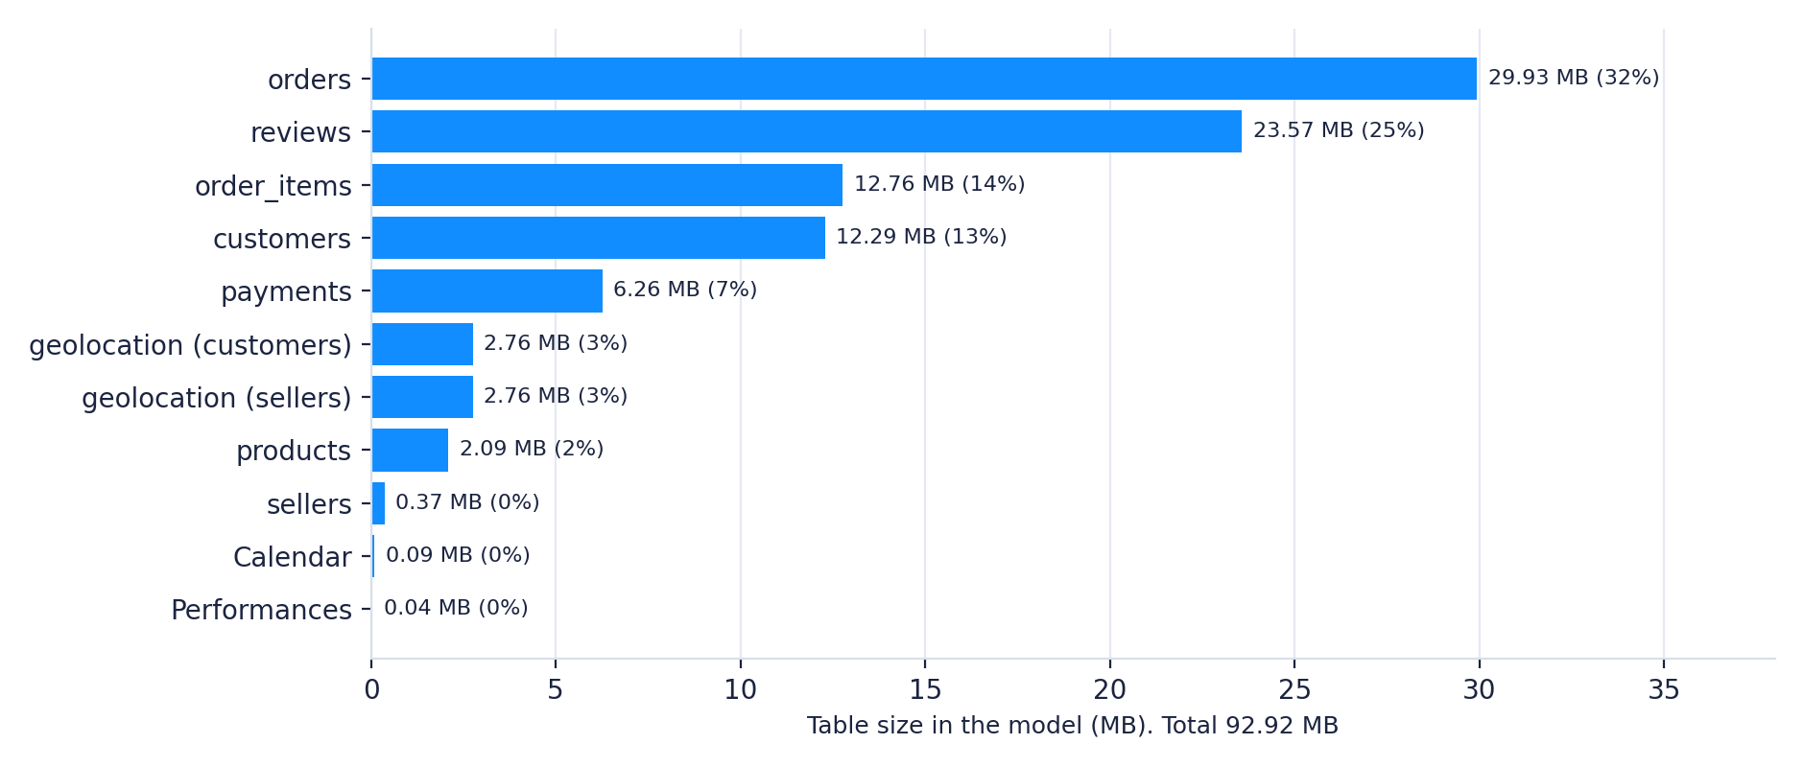
Figure 10. Model size by table (MB)
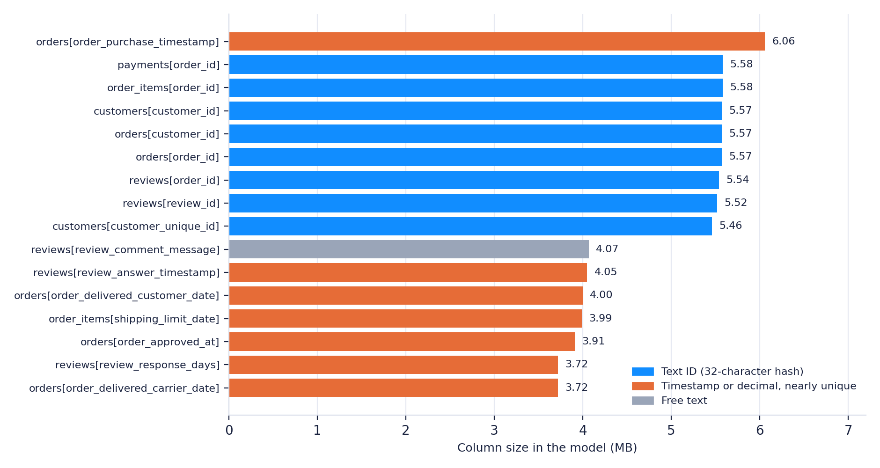
Figure 11. The 16 largest columns (MB), coloured by kind
Why a column is big | Power BI stores each column as a dictionary of its distinct values plus a list of references per row. Size therefore follows the number of distinct values, not the number of rows. A 32-character hash ID is nearly unique per row, so its dictionary is as large as the column (for order_id, 4.51 MB of dictionary against 0.27 MB of row references). Timestamps with seconds, and decimals such as response time in days, are almost unique too.
Encoding | 83 columns use hash (dictionary) encoding and 17 use value encoding. Whole numbers can use value encoding, which needs no dictionary.
Hierarchies | Hidden attribute hierarchies add 13.77 MB (orders 4.53 MB, reviews 3.33 MB), and they grow with the number of high-cardinality columns.
Biggest groups | Text IDs: about 39 MB (order_id in four tables, customer_id in two, customer_unique_id). Unused timestamp, text and decimal columns: about 33 MB.

10.7 Relationship audit
- Four inactive relationships point from Calendar to delivered date, estimated date, review creation date and shipping limit date. Two of those columns carry a time of day (about 95,000 and 93,000 distinct values), so they could never match a date table properly. None is used by a visual.
- Four bidirectional relationships. Two are forced by one-to-one cardinality. The other two are optional and duplicate the CROSSFILTER already inside the measures (section 6.3).
- Measure placement. The 55 measures are spread across six tables, and some are leftovers. Unused measures cost nothing at runtime, so this is housekeeping, not speed.

10.8 Optimization plan
Status is as of this document: the baseline is measured and the changes are pending, except where noted.
# | Change | Cause addressed | Expected effect | Risk
1 | Show the Python box plot on demand with a bookmark toggle | Script time (7.8 to 18.4 s) | Normal page loads about 0.9 s. Hiding it was measured at 0.92 s | Low
2 | Remove nine unused columns: review_id, comment text and title, answer timestamp, response days, approved date, carrier date, delivered date, shipping limit date | Unused, nearly unique columns | About 33 MB, plus their hierarchy overhead | Low. Confirm no visual uses them
3 | Replace order_id and customer_id (and customer_unique_id) with integers in the notebook | Hash dictionaries | About 35 MB | Medium. Retype keys in Power Query and recheck relationships
4 | Delete the four inactive Calendar relationships | Unused, mismatched keys | Cleaner model | Low
5 | Set the two optional relationships to single direction, keep CROSSFILTER | Ambiguity and duplicated logic | Safer filter paths | Medium. Reconcile every card
6 | Move kept measures into one table and delete leftovers | Scattered measures | Maintainability | Low
7 | Reduce non-data objects per page (8 to 10 today) | Render time of shapes, buttons and text | Small | Low
8 | Send pre-grouped data to the Python visual | Rows transferred | Faster on-demand render | Medium. Script rewrite

Together, changes 2 and 3 could bring the model from about 93 MB to roughly 25 MB (an estimate from the VertiPaq sizes). Because queries already run in 20 to 350 ms, this mainly improves file size, memory and refresh time.

10.9 Verification protocol and results
After each change: reconcile the cards against Python, record Performance Analyzer on every page (cold and warm), and rerun VertiPaq Analyzer. Fill in the table as changes are applied.
Metric | Before | After
Model size (VertiPaq) | 92.92 MB | [to fill]
Satisfaction page, slowest visual (warm) | 18.4 s | [to fill]
Overview page (warm) | 0.83 s | [to fill]
Slowest DAX query in the report | 350 ms | [to fill]
Largest column | 6.06 MB | [to fill]

10.10 What the measurements do not show
- Each page was recorded once per condition, so small differences (for example 0.78 against 0.87 s) are within normal variation.
- The Python visual's time varied by more than 2x between runs. The 7.8 s figure is a best case.
- Measurements were taken in Power BI Desktop on one machine. A published report adds network time.

11. Code documentation
The cleaning pipeline lives in one Jupyter notebook. Its design rules: every step is a short cell, every cell prints a number that can be checked, and tables are held in one dictionary so nothing depends on variable names from earlier cells.

11.1 Notebook structure
Stage | What the cells do | Output
Profiling | Collect the CSV paths, loop over the files, record shape, columns, null counts, describe and samples | Profile tables per file
Setup and load | Imports, paths, and one dictionary d of DataFrames with short names. Zip columns are read as text | d['orders'], d['customers'], and so on
Diagnostics | Duplicate counts, the review duplicate pattern, and the zip length test | Printed counts
Type fixes | Pad zip codes, convert dates | Typed columns
Orders logic | Null check by status, derived delivery columns, anomaly flags, timestamp order checks, item and payment flags | Flags and delivery metrics
Customers and reviews | Customer key check, deduplicate reviews, review text clean-up | 98,673 reviews
Products and geolocation | Fix names and nulls, merge translations, collapse geolocation to one row per zip | 19,015 geolocation rows
Text and zips | Standardise city text, orphan zip diagnostic, seller city check and fix | Geo flags, seller_city_clean
Payments and items | Sanity checks and flags | Payment flags
Integrity | Orphan-key check across all relationships | 0 orphans on core keys
Optional: integer keys | Replace long text IDs with integers, with proofs | Key map files
Export | Final null check and write the cleaned CSV files | 8 cleaned files

11.2 Function reference
Function | Purpose | Design note
zip5(s) | Turn a column into clean 5-character zip text | Converts to text first, so it works whether the column was loaded as text, integers or floats
clean_text(s) | Lowercase, trim and remove accents | Null-safe (na_action='ignore'), so missing values do not become the text 'nan'
top_value(df, col) | Most frequent value of a column within each zip | Vectorised with groupby and sort, instead of a slow per-group mode on 1,000,000 rows
orphans(child, col, parent, pcol) | Count child keys missing from the parent table | Prints counts instead of asserting, so one finding does not hide the others
zip_report(...) | Classify unmatched and coordinate-less zips for customers and sellers, and add flags | Separates source gaps from cleaning side effects
join_counts(frames) | Row counts of the joins the report relies on | A fingerprint compared before and after re-keying
make_key(ids) | Integer key (1 to n, int32) per distinct ID | Deterministic: sorted input gives the same keys on every run
replace_key(tables, col, map) | Swap an ID for its integer in several tables | Stops with an error if any ID has no key (an orphan)

11.3 Key code, with the reason for each choice

Zip codes
def zip5(s):
return (s.astype("string").str.strip()
.str.replace(r"\.0$", "", regex=True)
.str.zfill(5))

Converting to text first avoids the 'only use .str with string values' error. The replace removes a trailing '.0' that appears when a column with blanks is read as floats. zfill restores a lost leading zero.

Reviews: one per order
rev = d["reviews"].copy()
for col in ["review_comment_title", "review_comment_message"]:
rev[col] = rev[col].str.replace(r"[\r\n]+", " ", regex=True).str.strip()
rev["has_comment"] = rev["review_comment_message"].notna().astype(int)
rev = (rev.sort_values("review_answer_timestamp")
.drop_duplicates(subset="order_id", keep="last"))

The flag is computed before any filling so nulls stay null. Sorting by answer time first makes keep='last' mean the latest answered review.

Delivery metrics with honest blanks
orders["delivery_delay_days"] = (orders["order_delivered_customer_date"]
- orders["order_estimated_delivery_date"]).dt.days.astype("Int16")
delay = orders["delivery_delay_days"]
orders["is_late"] = (delay > 0).astype("Int8").where(delay.notna())

Nullable integer types keep undelivered orders blank instead of inventing a 0, and a blank exports as an empty field that Power BI reads as blank. This is what lets AVERAGE(is_late) in DAX return the late share of delivered orders.

Geolocation: about 1,000,000 rows to one row per zip
inside = g["geolocation_lat"].between(-35, 6) & g["geolocation_lng"].between(-75, -28)
geo = g.assign(geolocation_lat=g["geolocation_lat"].where(inside),
geolocation_lng=g["geolocation_lng"].where(inside),
geolocation_city=clean_text(g["geolocation_city"]))

def top_value(df, col):
counts = df.groupby([ZIP, col]).size().reset_index(name="n")
counts = counts.sort_values([ZIP, "n"], ascending=[True, False])
return counts.drop_duplicates(ZIP).set_index(ZIP)[col]

out = (geo.groupby(ZIP)[["geolocation_lat", "geolocation_lng"]].median()
.join(top_value(geo, "geolocation_city")).join(top_value(geo, "geolocation_state")))

assign builds a new frame without copying the whole table first. where blanks a value instead of dropping its row, so no zip disappears. The median ignores blanks and is not moved by one stray point.

11.4 Engineering practices in the code
- Vectorised operations only. No row loops or apply on large tables. The 1,000,000-row geolocation step runs in seconds.
- Pandas 2 and 3 compatibility. A table taken out of the dictionary is a reference in pandas 2 but behaves as a copy in pandas 3 (copy-on-write). The pattern orders = d['orders'] ... d['orders'] = orders makes the result stored under both. Edits made through d['name']['col'] modify the stored table in either version.
- Assertions for integrity, prints for data quality. A broken key must stop the notebook. A data-quality finding (for example 278 unmatched customers) must be reported without stopping.
- Flags instead of deletions, so every exclusion decision stays reversible and auditable.
- Rerun safety. Most cells can be rerun. The geolocation collapse and the key replacement change a table's shape or type, so after rerunning a middle cell, restart from the load cell.

11.5 Step: integer keys (cleaning_integer_keys.ipynb)
Why | Text IDs are 39 MB of the 92.9 MB model. A whole number needs no dictionary and uses value encoding.
What it does | Builds one integer per distinct order_id, customer_id and customer_unique_id, replaces the IDs in every table that carries them, and writes the old-to-new mapping to key_maps/ so any record can be traced back. product_id can be switched on too (about 3 MB).
Key order | Order keys follow purchase time, and customer keys follow customer_unique_id, so related records get neighbouring numbers and a rerun gives identical keys.

def make_key(sorted_ids):
ids = pd.Series(sorted_ids).drop_duplicates()
return pd.Series(np.arange(1, len(ids) + 1, dtype="int32"), index=ids.values)

def replace_key(tables, column, mapping):
for t in tables:
new = d[t][column].map(mapping)
assert new.notna().all(), f"{t}.{column}: orphan IDs have no key"
d[t][column] = new.astype("int32")

Proofs the step runs before it is trusted
- Join row counts (items to orders, payments to orders, reviews to orders, orders to customers, items to products) are equal before and after.
- Distinct counts of every key are unchanged, and keys that must be unique still are.
- The orphan check is rerun on the new keys.
- An injected orphan ID makes the step stop with a clear message (tested).

After exporting, in Power BI
- Replace the CSV files, then set each key column to Whole number in Power Query.
- Close and apply, and confirm that all 13 relationships still exist.
- Recheck the reconciliation cards (99,441 orders, 96,096 customers, 98,673 reviews and the sales total), then rerun VertiPaq Analyzer.

11.6 Testing approach
The pipeline was tested on a small synthetic dataset built to contain every edge case: zips that are missing from geolocation, zips whose points are all out of range, a delivered order with no delivery date, a canceled order with one, an order with no items, an order with no payment, zero and missing weights, a translation typo, duplicated review IDs, review text with line breaks, and hand-typed seller cities. The notebook ran end to end under pandas 3.0 and 2.3, and the exported files were inspected for correctness (leading zeros kept, blanks left blank, one review per order).

11.7 Known limitations of the code
- The data path is hard-coded in the first code cell and must be edited per machine.
- There is no automated test suite. Validation is done by printed checks inside the notebook.
- The pipeline is a notebook, not a module, so it cannot be imported or scheduled as is.

12. Root-cause log and lessons learned
Every problem below was found by checking results against an independent source, and each led to a better design. The log records the root cause, not only the fix.
# | Problem | Root cause | Fix | Lesson
1 | Zip codes looked 4 digits long; a string method failed on them | Pandas inferred integers and dropped leading zeros; an older cell kept the integer columns | Text types at load; a helper that converts to text before padding | Test a suspicion before fixing it. The raw files were fine
2 | 814 review IDs repeated | One review ID belongs to several orders, and some orders have several reviews | Deduplicate on order_id | Understand what a key means before deduplicating on it
3 | Extra customers without coordinates | Dropping out-of-range points removed whole zips | Blank the coordinates, keep every zip, use the median | Prefer blanking to dropping when other tables join on the row
4 | Sales cards showed R$431M and freight R$194.61M instead of about R$13.6M and R$2.25M | A decimal-comma locale read decimal points as thousands separators on import | Import locale set to English (United States); types reapplied | Reconcile money totals, not only counts. Counts matched while sums were wrong
5 | Circular dependency error | A calculated column crossing relationships was mixed with measures, with a Calendar computed from orders | Measures only | Keep calculated columns within one table
6 | 'A single value for column cannot be determined' | Row-by-row column logic was pasted as a measure | Create it as a calculated column | Know which context a formula runs in
7 | Seller table repeated each date under every status | A measure with a hard-coded status filter overrode each row's status; no order_id in the table | Unfiltered Order Value, order_id in the table, seller-aware ranking measure | A measure's own filters can invent rows
8 | Same review score for every category | Filters flow one-to-many and never reached reviews | CROSSFILTER inside the measure | Filter direction is a modeling decision
9 | Every visual flatlined at 5.0 after clicking a star bar | Selecting a score filters other visuals, and the average of 5-star reviews is 5 | Edit interactions set to none | Plan visual interactions deliberately
10 | Bottom 10 categories showed 3 bars | Top N is evaluated before a separate minimum filter | Minimum inside the measure | Evaluation order matters
11 | Month-over-month axis showed 1000K% | First month compared with a tiny previous month | Blank guards and a start date after ramp-up | Guard ratios against tiny denominators
12 | Map visual blank, then a location conflict error | Map tiles unavailable; both location and coordinates were set | Bar and scatter views | Not every visual is needed
13 | Imported theme clashed with existing formatting | A wildcard style overrode defaults for every visual | A lighter theme with palette only | Themes set defaults; keep them minimal
14 | Drill-through rank read '1 of 12' | Keep all filters carried a highlight selection into the page | Baseline and rank measures remove other filters | Test drill-through from a filtered state
15 | Satisfaction page took 7.8 to 18.4 s | The Python visual runs a script, and moves about 98,000 rows, on every refresh | On-demand display (planned), lighter data (option) | Measure before tuning. The DAX was not the cause
16 | Overview took 3.3 s on first load | Cold start: parameter resolution and engine start | None needed. Warm load is 0.83 s | Separate cold and warm timings
17 | Model is 92.9 MB | Near-unique text IDs and timestamps stored with dictionaries, plus unused columns | Integer keys and removing unused columns (planned) | Cardinality drives size, not row count
18 | Late Orders card (7K) disagrees with the late rate (5.94% of 96,211 is about 5.7K) | Not yet confirmed. Likely a different lateness rule between the two measures | Open: base both on is_late | One definition, one column

12.1 Lessons
- A total that looks plausible can still be wrong by a factor of 30. Always reconcile to an independent source.
- Measure before optimising. The suspected cause (DAX) took under 0.4 s, while the real causes were a Python script and cardinality.
- A measure's own filters can silently change what a visual shows. Keep measures that feed tables free of hard-coded filters.
- Minimum-sample rules belong inside the measure, so every visual applies them in the right order.
- Flag, do not delete. Every exclusion was reversible because it was a flag.
- Report timings cold and warm, and say how many runs they come from.

13. Assumptions and limitations
- Sales definition. Product sales is the item price (gross merchandise value) for delivered orders. It is not Olist's income, which the dataset does not contain. Freight is reported separately.
- Subscription revenue is assumed. The dataset has no fee information. The report models an assumed R$80 monthly fee for each seller that sold something in the month, about R$1.29M for the period. It is labelled as an assumption and is not used in any finding.
- Late rule. An order is late if it arrives at least one full day after the estimated date. The estimate has no time of day, so a same-day delivery counts as on time. Comparing raw timestamps would give a higher late rate.
- Analysis period. Jan 2017 to Aug 2018. 2016 and Sep to Oct 2018 have too few orders to trend.
- One review per order. 551 older reviews on orders with several reviews were excluded.
- Geography. 278 customers and 7 sellers have zips missing from the source and carry no coordinates. State and city fields are complete, so grouping is unaffected.
- Observational data. The findings describe associations. No experiment or causal model was used.
- Performance figures come from single recordings in Power BI Desktop on one machine.
- Historical sample. The data covers 2016 to 2018, in nominal Brazilian reais, not adjusted for inflation.

14. Future improvements

14.1 Performance (the plan in section 10.8)
- Apply the changes one at a time, with a reconciliation and a Performance Analyzer run after each, then fill in section 10.9.
- Consider a Tabular Editor pass to turn off the hidden attribute hierarchy on high-cardinality key columns.
- Reduce the number of objects per page by building the navigation panel once and reusing it.

14.2 Report
- Redesign the AI insights page: key influencers on an unhappy-review outcome using order-level fields (delay bucket, customer state, purchase month), and a decomposition tree on unhappy reviews. Leave out fields that happen after the review, such as whether a comment exists.
- Add hierarchies and drill down (year, quarter, month and state, city) and numeric parameters (late tolerance in days, minimum orders for sellers).
- Add bookmarks for reset and info panels, and more tooltip pages (category and seller).
- Add a Data Notes page that carries the cleaning log inside the report.

14.3 Pipeline and analysis
- Parameterise file paths and move the notebook logic into a tested Python module with automated data tests.
- Load the cleaned tables into SQL Server and cross-check the main KPIs with SQL queries.
- Customer segmentation (recency, frequency, monetary value) to target retention.
- A delivery-time prediction model using distance, weight and seller state.
- Publish to the Power BI Service with scheduled refresh and row-level security by region.

15. How to reproduce the project

15.1 Steps
- Download the nine CSV files from Kaggle (Brazilian E-Commerce Public Dataset by Olist) and place them in a data/raw folder.
- Install Python 3.10 or later with pandas, numpy and jupyter. For the Python visual in Power BI, also install matplotlib and seaborn.
- Open the notebook, set the DATA path in the first code cell, and run all cells. Cleaned files are written to a Cleaned folder next to the data folder.
- Optional: run the integer-key step before the export cell, then retype the key columns in Power Query.
- Open the Power BI file and update the data source path if prompted (Transform data, Data source settings).
- Set the import locale to English (United States) under Options, Current file, Regional settings. Otherwise decimal columns import 10 to 100 times too large.
- Mark the Calendar table as the date table and confirm the relationships in section 6.
- To repeat the performance audit: record in Performance Analyzer, connect DAX Studio, run Server Timings and View Metrics (VertiPaq Analyzer).

15.2 Suggested repository structure
olist-analytics/
README.md
notebooks/datacleaning.ipynb
notebooks/cleaning_integer_keys.ipynb
data/raw/ (not committed)
data/cleaned/ (not committed)
powerbi/olist_report.pbix
powerbi/olist_theme_light.json
python-visuals/seaborn_visual_template.py
performance/ (Performance Analyzer exports, VertiPaq .vpax file)
docs/project_documentation.docx
images/ (report screenshots)

The raw data is not committed because of its size and license. Check the dataset page for current terms.

Appendix A. Data dictionary for derived fields
Table | Field | Definition
orders | order_purchase_date | Date part of the purchase timestamp. Used to link the date table
orders | delivery_days | Whole days from purchase to customer delivery. Null if not delivered
orders | delivery_delay_days | Customer delivery date minus estimated date, in whole days. Negative means early
orders | is_late | 1 if delivery_delay_days is above 0, 0 otherwise, null if not delivered
orders | delivered_missing_date | 1 for delivered orders without a delivery date
orders | canceled_with_delivery | 1 for canceled orders that have a delivery date
orders | has_items | 1 if the order has rows in order_items
orders | has_payment | 1 if the order has rows in payments
orders | carrier_date_suspect | 1 if the carrier date is before purchase or after customer delivery
orders | Delivery Bucket, Delay Bucket | Calculated columns in Power BI: delivery time bands and days-early or late bands
payments | is_zero_payment | 1 if payment_value is 0
payments | installments_missing | 1 for credit-card payments with 0 installments
payments | payment_type | not_defined relabelled unknown
reviews | has_comment | 1 if the review has comment text
reviews | review_response_days | Days between survey creation and answer. Approximate, because the creation date has no time of day
products | product_category_name_english | English category name, two names mapped by hand and one typo fixed
products | weight_was_zero | 1 if the original weight was 0 (now null)
products | product_volume_cm3 | Length times height times width
sellers | seller_city_clean | Corrected city name, with the geolocation city used for unusable values
sellers | seller_city_fixed | 1 if seller_city_clean differs from the original
sellers, customers | has_geo_match | 1 if the zip exists in the geolocation table
sellers, customers | has_coordinates | 1 if the zip has usable latitude and longitude
geolocation | source_rows | Number of raw points collapsed into the zip's single row
key_maps (planned) | order_key, customer_key, customer_unique_key | Integer keys that replace the long text IDs, with files mapping them back

Appendix B. DAX measure reference
Measure names follow the report. Formulas are shown in their final form.

Sales and delivery
Product Sales = CALCULATE(SUM(order_items[price]), orders[order_status] = "delivered")
Freight = CALCULATE(SUM(order_items[freight_value]), orders[order_status] = "delivered")
Gross Order Value = [Product Sales] + [Freight]
Freight % of Sales = DIVIDE([Freight], [Product Sales])

AOV incl. Freight =
DIVIDE([Gross Order Value],
CALCULATE(DISTINCTCOUNT(order_items[order_id]), orders[order_status] = "delivered"))

Avg Delivery Days = CALCULATE(AVERAGE(orders[delivery_days]), orders[order_status] = "delivered")
Late Delivery Rate = CALCULATE(AVERAGE(orders[is_late]), orders[order_status] = "delivered")

Satisfaction
Avg Review Score = AVERAGE(reviews[review_score])
Avg Score (Late) = CALCULATE([Avg Review Score], orders[is_late] = 1)
Avg Score (On Time) = CALCULATE([Avg Review Score], orders[is_late] = 0)

Low Score Rate =
DIVIDE(CALCULATE(COUNTROWS(reviews), reviews[review_score] <= 2), COUNTROWS(reviews))

Share of Late Reviews =
DIVIDE(CALCULATE(COUNTROWS(reviews), orders[is_late] = 1),
CALCULATE(COUNTROWS(reviews), orders[is_late] = 1, ALL(reviews[review_score])))

Delay Bucket = -- calculated column on orders
SWITCH(TRUE(),
ISBLANK(orders[delivery_delay_days]), BLANK(),
orders[delivery_delay_days] <= -14, "1. 14+ days early",
orders[delivery_delay_days] <= -7, "2. 7-13 days early",
orders[delivery_delay_days] <= 0, "3. 0-6 days early",
orders[delivery_delay_days] <= 3, "4. 1-3 days late",
orders[delivery_delay_days] <= 7, "5. 4-7 days late",
"6. 8+ days late")

Time
Sales MoM % =
VAR CurDate = MAX('Calendar'[Date])
VAR Cur = [Product Sales]
VAR Prev = CALCULATE([Product Sales], DATEADD('Calendar'[Date], -1, MONTH))
RETURN IF(ISBLANK(Cur) || ISBLANK(Prev) || CurDate < DATE(2017, 2, 1),
BLANK(), DIVIDE(Cur - Prev, Prev))

Sellers and categories
Seller Late Rate =
CALCULATE(AVERAGE(orders[is_late]),
CROSSFILTER(order_items[order_id], orders[order_id], BOTH),
orders[order_status] = "delivered")

Top 10% Sellers Share =
VAR Tbl = FILTER(ADDCOLUMNS(VALUES(sellers[seller_id]), "@s", [Product Sales]), NOT ISBLANK([@s]))
VAR TopTbl = TOPN(ROUNDUP(COUNTROWS(Tbl) * 0.1, 0), Tbl, [@s], DESC)
RETURN DIVIDE(SUMX(TopTbl, [@s]), SUMX(Tbl, [@s]))

Late Rate (All Sellers) =
CALCULATE([Seller Late Rate], REMOVEFILTERS(sellers), REMOVEFILTERS(products), REMOVEFILTERS(customers))

Assumed subscription revenue
Monthly Fee = 80
Active Sellers = DISTINCTCOUNT(order_items[seller_id])
Subscription Revenue (Active) =
SUMX(VALUES('Calendar'[Year-Month]), [Active Sellers] * [Monthly Fee])

The other measures used in the report follow the same patterns (see sections 7.2 and 7.3).

Appendix C. Glossary
Term | Meaning
AOV | Average order value: sales divided by the number of orders
Boleto | A Brazilian bank-slip payment method
Cardinality | How rows in two tables relate (1:1 or 1:*). Also, in VertiPaq, the number of distinct values in a column
Cold and warm run | The first run after opening the file, with an empty cache, and a repeat run with a filled cache
CROSSFILTER | A DAX function that changes filter direction for one calculation
Dictionary encoding | How a column is stored: a list of its distinct values plus a reference per row. Size grows with distinct values
Drill-through | A page that opens filtered to the item the viewer selected
FE and SE | Formula engine (runs DAX logic) and storage engine (scans compressed columns)
Field parameter | A slicer that lets the viewer choose which measure or field a visual shows
Filter context | The set of filters that applies when a DAX measure is calculated
Flag | A 0/1 column that marks rows with a property, without deleting them
GMV | Gross merchandise value: the value of goods sold, not the platform's income
Grain | What one row of a table represents
Late delivery | Delivered at least one full day after the estimated delivery date
Orphan key | A key in one table with no matching row in the related table
Role-playing dimension | One dimension table used in more than one role, such as geolocation for customers and sellers
Surrogate key | An integer that replaces a long text ID, with a mapping file to trace it back
VertiPaq | The in-memory columnar engine behind Power BI models
Zip prefix | The first five digits of a Brazilian postal code

Appendix D. Pre-publication checklist
These items were noticed in the report screenshots and measurements used for this document. Fix or verify them before sharing the project, then delete this appendix.
Area | Item to fix or verify
Delivery page | The Late Orders card shows 7K, but 5.94% of 96,211 is about 5.7K. Base Late Orders and the late rate on the same column (is_late)
Delivery page | The card and state bar chart use the default 'Average of delivery_days'. Replace them with the Avg Delivery Days measure and rename the titles
Satisfaction page | The monthly chart still shows 2018-09 and 2018-10 although the date slicer ends in August. Check the axis field and slicer sync
Satisfaction page | The lowest-scoring categories chart includes 'unknown' and starts at zero. Exclude unknown and use a gap-versus-average axis or start at 3.0
Satisfaction page | Box plot x-axis labels show 1.0 to 5.0. Convert review_score to an integer in the script. Show the plot on demand
Products page | The state table's Total Orders column counts all statuses while other columns use delivered orders. Use English category names in the freight chart
Overview | Rename remaining default titles (Payment_value, Average_score). Label the subscription donut as assumed
AI insights | Rebuild the key influencers visual around review outcomes with order-level fields
Model | Apply or consciously skip the plan in section 10.8, then fill in section 10.9 and update section 6.1
Numbers | Recheck the figures quoted in section 9 against the live report and Python, especially the top 10% seller share and state shares
Claims | Only list hierarchies, numeric parameters, reset bookmarks and the optimization results once they are built and measured
Placeholders | Author name, repository link and screenshots

