POWER BI PORTFOLIO PROJECT
Handling the Data from the Stores of a Company Around the Country
Retail sales and inventory analytics: project documentation
Author: Shaik Mohammad Arshad
Date: October 2026
Tools: Power BI Desktop, Power Query, DAX, Python (seaborn)
Contact: arshadamsus@gmail.com

Contents

If the list above is empty, right-click it in Word and choose Update Field.

1. Project at a Glance
This project turns raw CSV files from a toy retailer with 50 stores in 29 cities across Mexico into an interactive, seven-page Power BI report. It brings together sales, product, store and inventory data so a manager can see at a glance where revenue comes from, which products earn the most profit, and how stock levels compare with what is selling.

1.1 Business questions the report answers
- Which cities and store types (Downtown, Commercial, Residential, Airport) generate the most revenue and profit?
- Which product categories and individual products perform best?
- How do revenue, cost and profit change from month to month?
- How does stock on hand compare with units sold in each category?
- What factors drive higher revenue? (answered with Power BI AI visuals)

1.2 Project summary
Scenario | A retail company with stores across the country needs one place to review sales performance and inventory.
Data source | Six CSV files from the Maven Toys dataset on Kaggle, kept in a local folder named "Maven Toys Data"; four are loaded into the model. Source: https://www.kaggle.com/datasets/tanvir25/maven-toys
Data size | 50 stores, 35 products, 5 product categories, 4 store location types, and a sales table with one row per sale.
Period covered | Sales from 1 January 2022 to 30 September 2023.
Data model | Five tables and five relationships: two fact tables (sales, inventory) and three dimension tables (stores, products, Sales_calender).
Report | Seven pages: Overview, Store Sales, Product Sales, AI page, Inventory, Detailed page and a ToolTip page.
Calculations | Revenue, Cost, Profit, Goal, three inventory measures, and a DAX calendar table.
Security | One static row-level security role (Electronics) that limits the data to a single product category.
Tools | Power BI Desktop, Power Query (M), DAX, Python with seaborn for one visual.

2. Skills Demonstrated
This table maps the skills a Power BI role typically asks for to where they appear in this project.
Skill | Where it is shown in this project
Data import and cleaning (Power Query) | Folder connector combining CSV files; promoting headers, changing data types, trimming text, splitting and renaming columns.
Data modelling | Fact and dimension tables joined by many-to-one relationships; a dedicated date table; hidden technical key columns.
DAX | SUMX with RELATED, CALCULATE, variables (VAR/RETURN), ALLSELECTED, DIVIDE, and a CALENDAR calculated table.
Data visualisation | Column, pie, donut, line, area, scatter, treemap, matrix and KPI visuals, styled with a consistent red and green theme.
AI visuals | Decomposition tree and Key influencers on the AI page.
Interactivity | Page navigation buttons, synced slicers, bookmarks, a report-page tooltip and gradient conditional formatting.
Security | Row-level security role that filters the model by product category.
Python in Power BI | A seaborn scatter plot of revenue against cost on the Store Sales page.

3. Data Source and Preparation

3.1 Where the data comes from
All data is loaded with Power BI's Folder connector from X:\Powerbi\Data\Maven+Toys\Maven Toys Data. The folder holds six files: calendar.csv, data_dictionary.csv, inventory.csv, products.csv, sales.csv and stores.csv. Power Query lists them in a helper query called "Maven Toys Data" (not loaded into the model), and each table query then picks out its own file, expands the content, imports it as a CSV and promotes the first row to headers.
The files come from the Maven Toys dataset on Kaggle: https://www.kaggle.com/datasets/tanvir25/maven-toys

3.2 Queries and cleaning steps
Query | Steps applied | Result
products | Filtered Rows, Removed Other Columns, Content expand, Imported CSV, Promoted Headers, Changed Type, Trimmed Text, Split Column by Position (twice), Removed Columns (twice), Renamed Columns. | 35 products in 5 categories with numeric Product_Cost and Product_Price. The split steps separated the leading $ sign from the numeric text of Product_Cost and Product_Price. The $ columns were then removed and the remaining text converted to decimal numbers.
sales | Filtered Rows, Removed Other Columns, Content expand, Imported CSV, Promoted Headers, Changed Type, Renamed Columns. | Columns: Sale_ID, Date, Store_ID, Product_ID, Units_Sold.
stores | Filtered Rows, Removed Other Columns, Content expand, Imported CSV, Promoted Headers, Changed Type. | 50 stores. Columns: Store_ID, Store_Name, Store_City, Store_Location, Store_Open_Date.
inventory | Filtered Rows, Imported CSV, Promoted Headers, Changed Type. | Columns: Store_ID, Product_ID, Stock_On_Hand.
Sales_calender | Not a Power Query table. Created in the model with DAX (see section 5). | One row per date from the first to the last sale date.

The folder also contains calendar.csv and data_dictionary.csv. Neither is loaded. The model builds its own date table with DAX instead of using calendar.csv, and data_dictionary.csv appears to be reference documentation for the dataset.
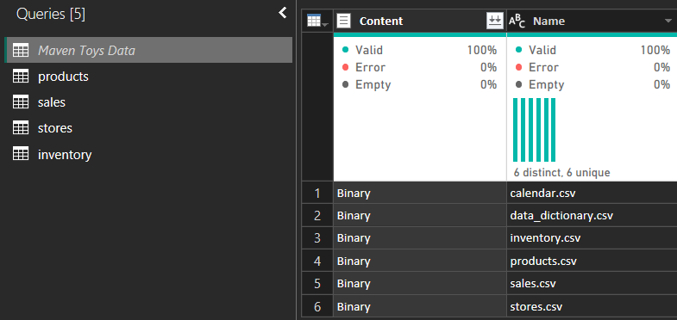
Figure 1: Power Query: the helper query listing the six source files, and the four loaded tables
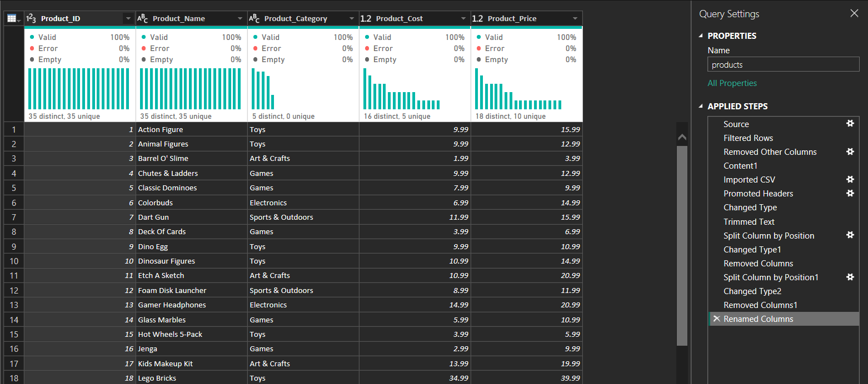
Figure 2: Power Query view of the products table with its applied steps

3.3 How to refresh the data
- Add or replace the CSV files in the source folder.
- In Power BI Desktop, choose Home > Refresh.
- Check that the KPI cards and charts on the Overview page update.
- If the folder moves, change the path in Transform data > Data source settings.
- Scheduled refresh and sharing through the Power BI Service are outside the scope of this project.

4. Data Model
The model follows a star-schema layout. The two fact tables (sales and inventory) record what happened. The three dimension tables (stores, products, Sales_calender) describe it and are used to slice the numbers.
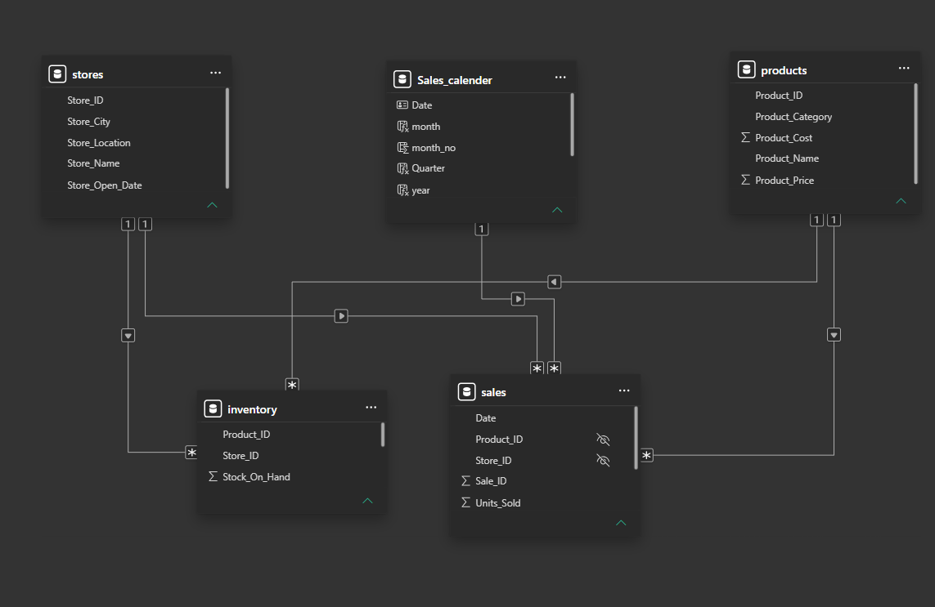
Figure 3: Data model view in Power BI Desktop

4.1 Tables
Table | Type | What it holds | Key columns
sales | Fact | One row per sale: which product, in which store, on which date, and how many units. | Sale_ID, Date, Store_ID, Product_ID, Units_Sold
inventory | Fact | Current stock of each product in each store. | Store_ID, Product_ID, Stock_On_Hand
stores | Dimension | Store name, city, location type and opening date. | Store_ID, Store_City, Store_Location
products | Dimension | Product name, category, unit cost and unit price. | Product_ID, Product_Category, Product_Cost, Product_Price
Sales_calender | Dimension (date) | One row per day, with month, month number, quarter and year for time analysis. | Date, month, month_no, Quarter, year

4.2 Relationships
From (many side) | To (one side) | Cardinality | Cross-filter / status
sales[Date] | Sales_calender[Date] | Many to one | Single direction, active
sales[Product_ID] | products[Product_ID] | Many to one | Single direction, active
sales[Store_ID] | stores[Store_ID] | Many to one | Single direction, active
inventory[Product_ID] | products[Product_ID] | Many to one | Single direction, active
inventory[Store_ID] | stores[Store_ID] | Many to one | Single direction, active

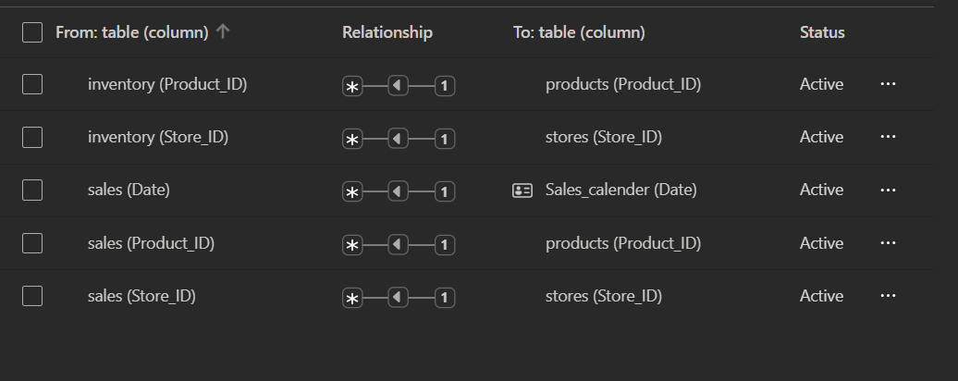
Figure 4: Manage relationships view

4.3 Design notes
- Shared dimensions. Sales and inventory both connect to stores and products, so one category or city filter applies to both fact tables at the same time. This is what lets the Inventory page compare stock with units sold.
- No date link for inventory. Stock on hand is a single snapshot with no date column, so inventory is not connected to Sales_calender.
- Hierarchy. Sales_calender also has a year Hierarchy (year, then Quarter) that supports drilling from year to quarter.
- Hidden keys. Product_ID and Store_ID in the sales table are hidden from the report view so users pick fields from the dimension tables instead.
- Calendar columns. The month, month_no, Quarter and year columns in Sales_calender are calculated columns derived from the Date column of that table.

5. Measures and Calculations
Revenue and Cost multiply units sold by the unit price or unit cost stored in the products table. Because the price is on a different table, each measure uses SUMX to go row by row through sales and RELATED to look up the matching product value.
Name | DAX | What it does
Revenue | Revenue =  SUMX(  sales,  sales[Units_Sold] *  RELATED(products[Product_Price])  ) | Total sales value: units sold times selling price, summed over all sales in the current filter.
Cost | Cost =  SUMX(  sales,  sales[Units_Sold] *  RELATED(products[Product_Cost])  ) | Total cost of the goods sold: units sold times unit cost.
Profit | Profit =  [Revenue] - [Cost] | Revenue minus Cost.
stocksold | stocksold =  VAR stockonhand =  SUM(sales[Units_Sold])  VAR totalStock =  CALCULATE(  SUM(inventory[Stock_On_Hand])  + SUM(sales[Units_Sold]),  ALLSELECTED())  RETURN  DIVIDE(stockonhand, totalStock, 0) | Units sold as a share of all stock on hand plus all units sold, across the categories currently selected. The variable named stockonhand actually holds units sold.
stocksoldvsonhand | stocksoldvsonhand =  VAR stockonhand =  SUM(inventory[Stock_On_Hand])  VAR totalStock =  CALCULATE(  SUM(inventory[Stock_On_Hand])  + SUM(sales[Units_Sold]),  ALLSELECTED())  RETURN  DIVIDE(stockonhand, totalStock, 0) | Stock on hand as a share of the same combined total. The two inventory measures always add up to 100% in the Total row.
% of Total Stock | % of Total Stock =  DIVIDE(  SUM(inventory[Stock_On_Hand]),  CALCULATE(  SUM(inventory[Stock_On_Hand]),  ALLSELECTED()),  0) | Each category's share of total stock on hand. ALLSELECTED keeps the percentages relative to whatever the user has selected.
Highest Profit Month (card) | Not a DAX measure.  A card showing the month field with a visual-level Top N filter: Top 1 by Profit. | Shows the single month with the highest profit on the Overview page (currently "Mar").
Goal | Goal = 600000 | The company's monthly revenue target of 600,000, stored as a fixed value and used as the target of the Revenue KPI card on the Overview page.

5.1 Calendar table
Sales_calender = CALENDAR(MIN(sales[Date]), MAX(sales[Date]))

This creates one row per day between the earliest and latest sale, so time analysis has no gaps. It is related to sales[Date] and marked as the date table. The month, month_no, Quarter and year columns are calculated columns built from its Date column.

5.2 Python visual
The scatter plot on the Store Sales page is a Python visual. It uses seaborn to plot Revenue against Cost, coloured by Store_Location and sized by Profit.
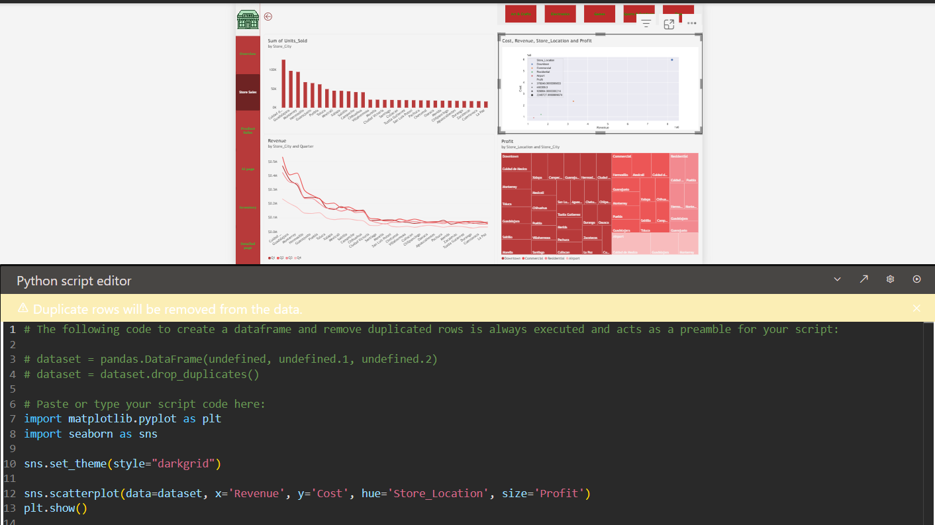
Figure 5: Python script behind the scatter plot on the Store Sales page

6. Report Pages
Every page shares a red navigation panel on the left, so a viewer can jump between pages without using the tabs at the bottom. The active page is shown in a darker red.

6.1 Overview
Purpose: A one-page summary of company performance, meant to be read first.
What is on the page:
- Year slicer (2022 and 2023) at the top right, which filters the whole page to one year. The figure below shows 2022 selected.
- KPI card: Revenue (value) by month (trend axis) against the Goal measure (target).
- Profit and Highest Profit Month cards.
- Revenue by Store_City (column chart) and by Store_Location (pie chart).
- Revenue by quarter and Product_Category (line chart).
- Revenue and Cost by Product_Category (clustered column chart).
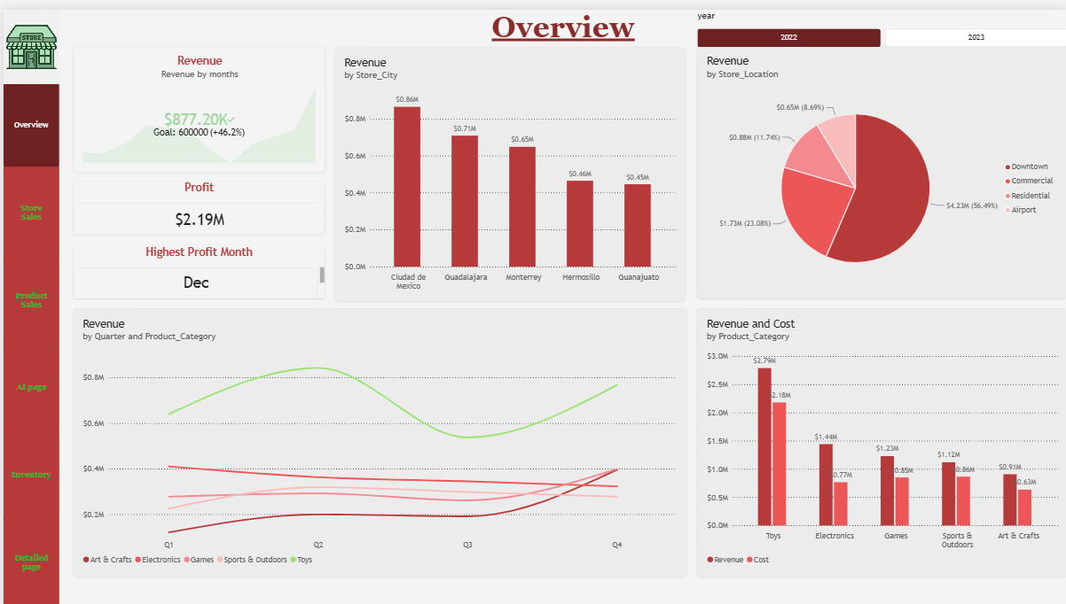
Figure 6: Overview page with the Year slicer set to 2022
What it shows:
- With 2022 selected (as in the figure): revenue is about $7.49M and profit is $2.19M. December is the Highest Profit Month. Downtown stores bring in $4.23M (56.5%), and Ciudad de Mexico is the top city at $0.86M.
- With no year selected (both years): profit is $4.01M and the Highest Profit Month is March. Downtown stores bring in $8.22M (56.9% of revenue), and Ciudad de Mexico is the top city at $1.65M, followed by Guadalajara ($1.32M) and Monterrey ($1.26M).
- The KPI card shows revenue of $877.20K for December, the last month on its axis, which is 46.2% above the company's monthly goal of 600,000.
- Toys has the highest revenue ($2.79M in 2022) and leads in every quarter, peaking in Q2. Electronics has the widest gap between revenue ($1.44M) and cost ($0.77M).
- With one year selected, the four quarters are comparable. Without a year selected, Q1 to Q3 include two years of sales and Q4 only one, so Q4 looks lower.
The next two figures show how the KPI card and the Highest Profit Month card are set up.
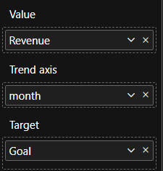  Figure 7: KPI card fields: Value = Revenue, Trend axis = month, Target = Goal | 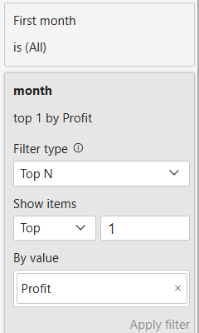  Figure 8: Highest Profit Month card: Top N filter, top 1 month by Profit

6.2 Store Sales
Purpose: Compare stores and store types on volume, revenue and profit.
What is on the page:
- Category buttons across the top filter the whole page (Art & Crafts, Electronics, Games, Sports & Outdoors, Toys).
- Units sold by Store_City (column chart, sorted high to low).
- Cost vs Revenue by Store_Location (Python scatter plot, sized by profit).
- Revenue by Store_City and Quarter (line chart).
- Profit by Store_Location and Store_City (treemap).
- The line chart and the treemap both show the ToolTip page when hovered (see section 6.7).
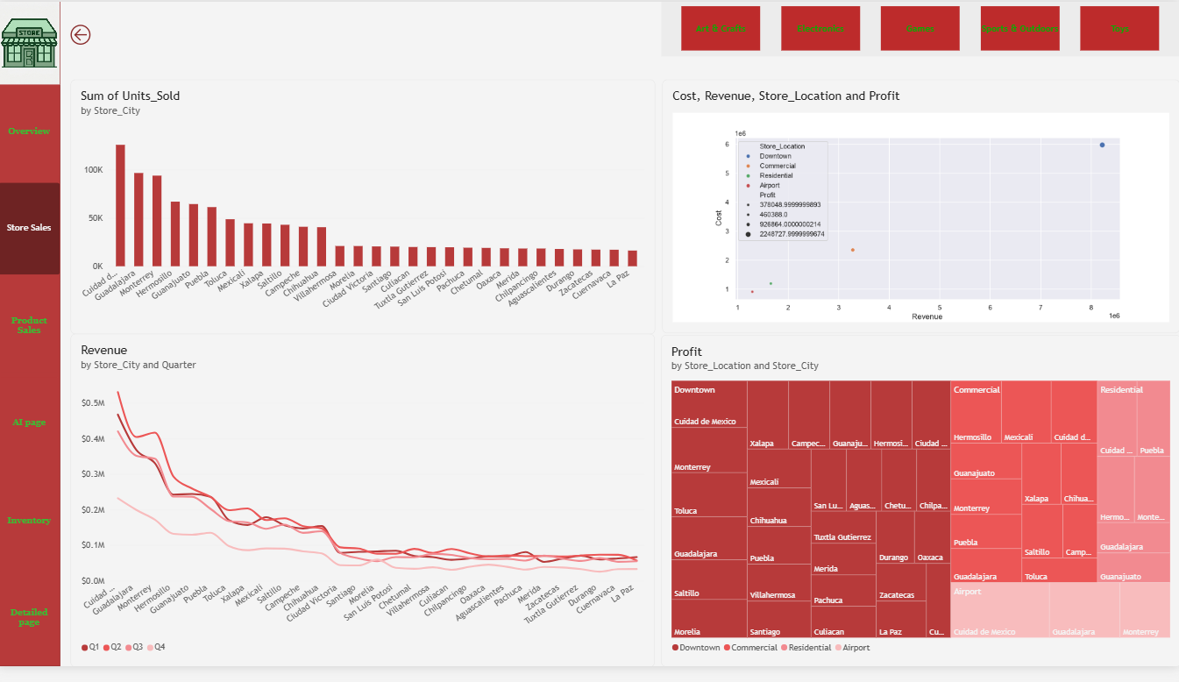
Figure 9: Store Sales page
What it shows:
- A few cities sell far more units than the rest, and the chart then trails off in a long tail of smaller stores.
- The treemap shows how profit is spread across store types and, within each type, across cities.
- The scatter plot has four points by design, one for each store location type.

6.3 Product Sales
Purpose: Understand which categories and products earn the most, and how price relates to cost.
What is on the page:
- Revenue and Profit by Product_Category (columns with a line).
- Product_Price and Product_Cost by Product_Name (area chart).
- Cost and Profit by Product_Name (scatter plot, coloured by category).
- Stock_On_Hand by Product_Category (donut chart, 30K units in total).
- Store_City drop-down slicer.
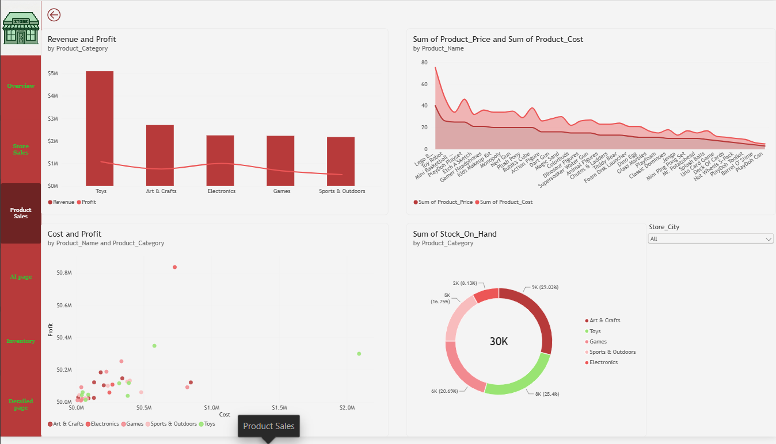
Figure 10: Product Sales page
What it shows:
- Toys earns the most revenue by a wide margin; the other four categories are close to each other.
- Most products sit at low cost and low profit, with a few outliers with higher cost or profit.
- The donut shows how stock is split, with Art & Crafts holding the largest share.

6.4 AI page
Purpose: Use Power BI's AI visuals to explain what drives revenue. Two buttons at the top switch between the two views using bookmarks.
What is on the page:
- Decomposition tree: breaks Revenue down by Product_Category, then Store_Location, then Product_Name.
- Key influencers: shows what is most associated with an increase in Revenue.
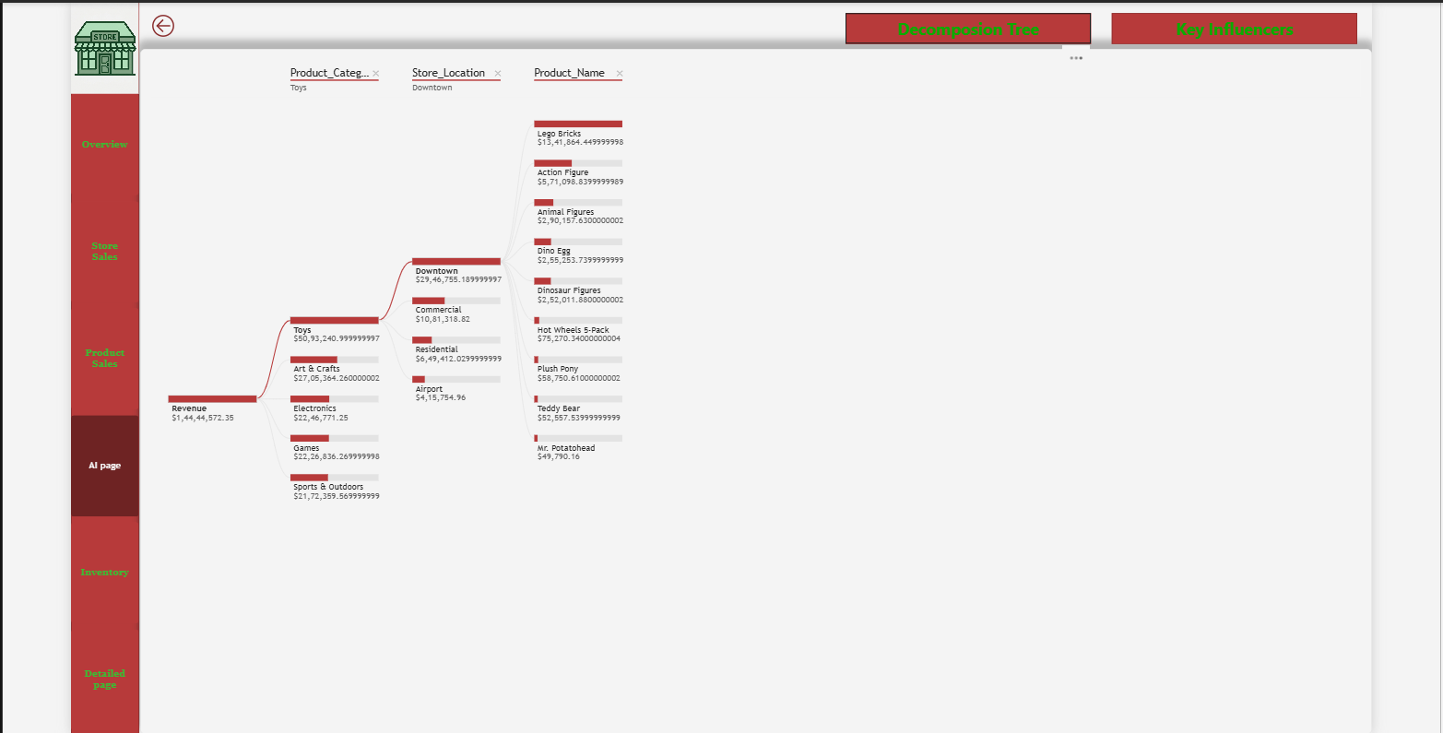
Figure 11: AI page: decomposition tree view
What it shows:
- Total revenue is about $14.44M. Following the largest branch: Toys ($5.09M), then Downtown stores ($2.95M), then Lego Bricks ($1.34M).
- Lego Bricks alone is about 9% of total revenue.
- In Key influencers, "Product_Name is Lego Bricks" is the strongest factor, lifting average revenue by about $40K. Colorbuds, Magic Sand, Action Figure and Rubik's Cube follow.
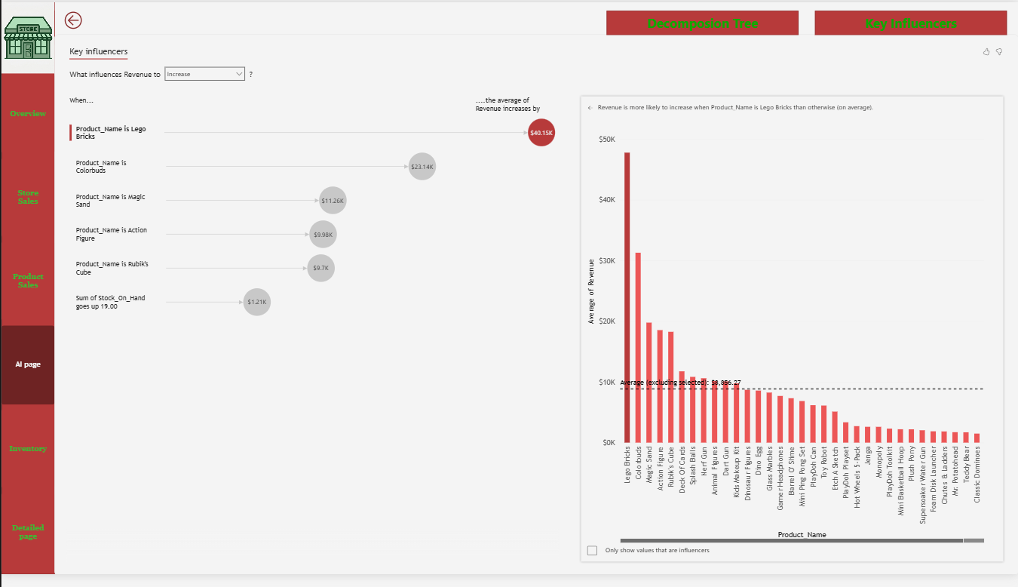
Figure 12: AI page: key influencers view

6.5 Inventory
Purpose: Compare how much stock is on hand with how much has sold, by category.
What is on the page:
- Stock on Hand vs Sold (bar chart by category).
- Table with Stock_On_Hand, % of Total Stock, stocksoldvsonhand and stocksold.
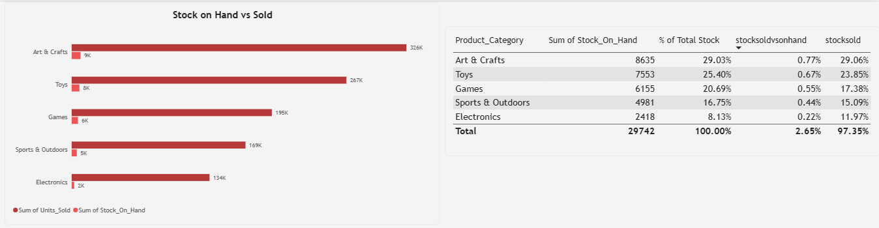
Figure 13: Inventory page
What it shows:
- Total stock on hand is 29,742 units. Art & Crafts holds the most (8,635 units, 29.0%), then Toys (25.4%).
- Electronics has the least stock (2,418 units, 8.1%).
- Units sold are far higher than stock on hand because stock is a snapshot while sales cover the whole period, so compare the two with care.
- Inventory has no date link, so a selected year changes units sold but not stock on hand. Keep this in mind when reading the page with a year selected.

6.6 Detailed page
Purpose: A matrix for users who want the exact numbers behind the charts.
What is on the page:
- Matrix with month as rows and Cost, Revenue and Profit as columns, plus a Total row.
- A gradient font colour on Profit: the lowest value is shown in black and the highest in red, so strong and weak months stand out. It applies to values only.
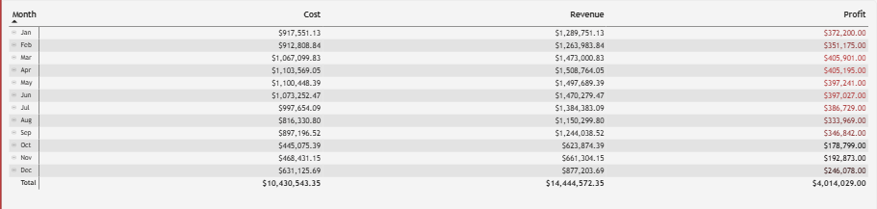
Figure 14: Detailed page matrix with gradient font colour on Profit
What it shows:
- The Total row covers the whole company: Cost $10.43M, Revenue $14.44M and Profit $4.01M, matching the Overview page.
- Cost, Revenue and Profit now use one consistent dollar format with two decimals.
- Profit is highest in March ($405.901K) and April ($405.195K), and lowest in October ($178.799K).
- October to December ($0.62M, $0.66M and $0.88M revenue) look about half as large as earlier months. The months are grouped by name only and the data runs from January 2022 to September 2023, so January to September include two years of sales and October to December only one. The Year slicer, synced from the Overview page, removes this effect when a single year is selected.
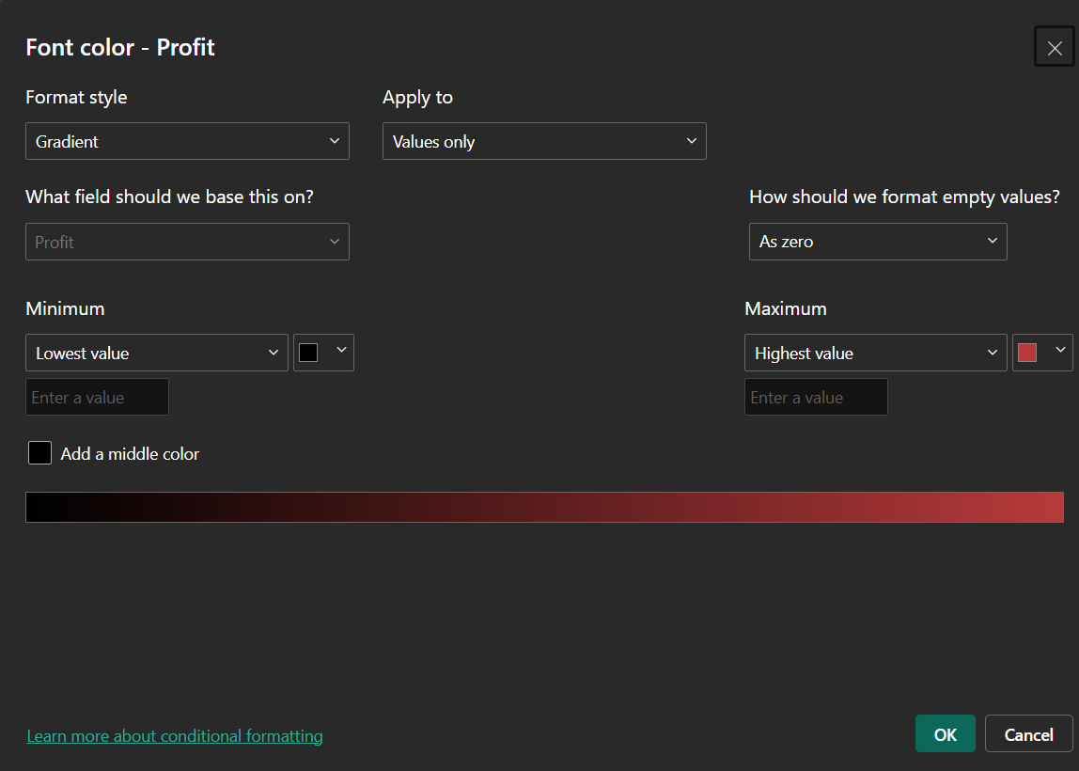
Figure 15: Conditional formatting setup: gradient font colour on Profit, from black (lowest) to red (highest)

6.7 ToolTip page
Purpose: A small hidden page that appears when a user hovers over a visual, giving extra context without cluttering the main pages.
What is on the page:
- Profit by Product_Category (pie chart).
- It is attached through the Tooltips field of two visuals on the Store Sales page: the Revenue by Store_City and Quarter line chart and the Profit treemap.
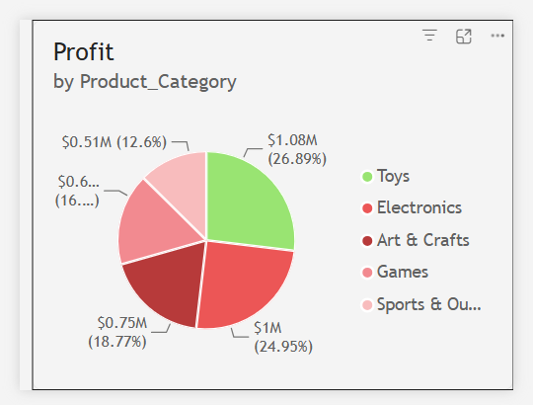
Figure 16: ToolTip page
What it shows:
- Toys has the largest profit share overall (26.9%), followed by Electronics (25.0%), Art & Crafts (18.8%), Games (about 16.8%) and Sports & Outdoors (12.6%).
- On the Store Sales page the pie responds to the point being hovered, so it shows profit by category for that city, quarter or store type.
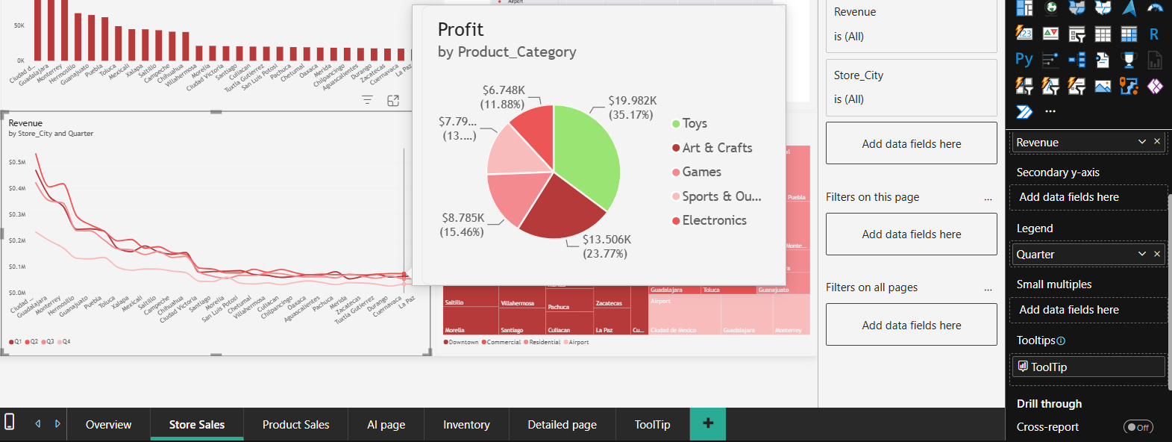
Figure 17: Tooltip shown when hovering over the revenue line chart on Store Sales
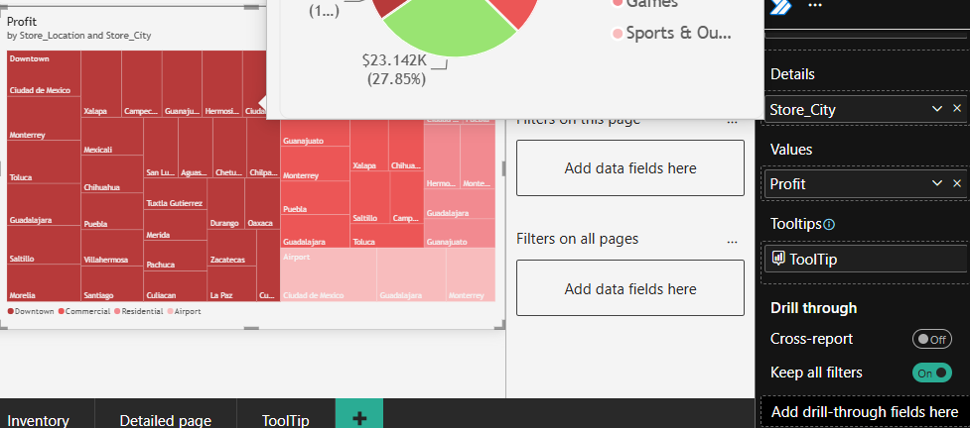
Figure 18: Tooltip shown when hovering over the profit treemap on Store Sales

7. Interactivity and Navigation
Feature | Where | How it works
Navigation panel | Every page | Buttons on the left jump to Overview, Store Sales, Product Sales, AI page, Inventory and Detailed page.
Back button | Sub-pages | An arrow at the top left returns the viewer to the previous page.
Category buttons (slicer) | Store Sales | Filter the page by product category. Synced with the Product Sales page.
Store_City drop-down (slicer) | Product Sales | Filters by city. Synced across Store Sales, Product Sales and Detailed page.
Year slicer | Overview (synced to all other pages) | Buttons for 2022 and 2023 filter to a single year, so quarters and months can be compared fairly. The selection carries across the pages. It does not change stock on hand, because inventory has no date link.
Bookmarks | AI page | The "Decomposition Tree" and "Key Influencers" buttons use bookmarks to show one visual and hide the other.
Tooltip page | Store Sales (line chart, treemap) | Shows Profit by Product_Category for the hovered point in a small pop-up.
Conditional font colour | Detailed page | A gradient on the Profit column runs from black (lowest) to red (highest).

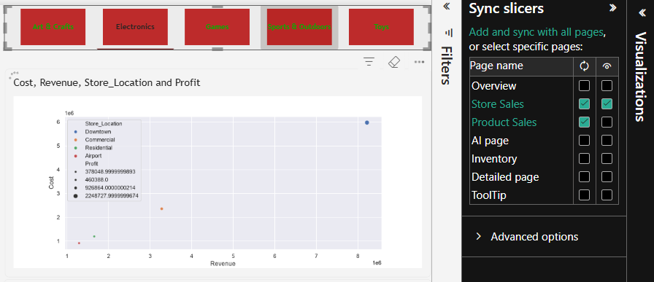
Figure 19: Sync slicers pane for the category buttons: synced on Store Sales and Product Sales, visible on Store Sales

8. Security (Row-Level Security)
The model contains one row-level security (RLS) role, Electronics, which restricts what a viewer can see to a single product category.
Role | Electronics
Table filtered | products
Rule | products[Product_Category] = "Electronics"
Type | Static role: the category is fixed in the rule, not looked up from the signed-in user.

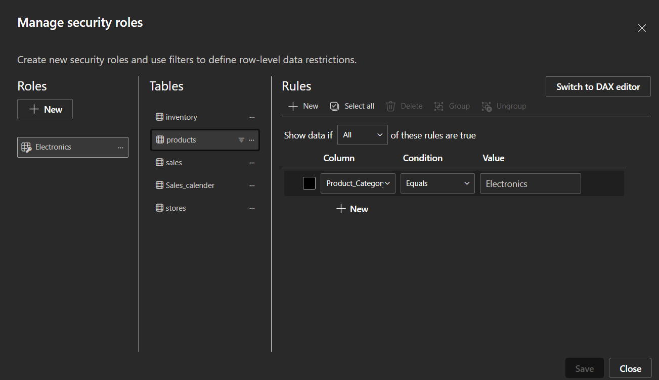
Figure 20: Manage security roles dialog with the Electronics role

8.1 How it works
- The filter sits on the products table. Because products is on the one side of its relationships, it also filters sales and inventory. A member of the role therefore sees only Electronics sales, stock, cost, revenue and profit, and every KPI and AI visual recalculates for that category.
- The stores and Sales_calender tables are not filtered, so slicers can still list every city and date even where there are no Electronics rows.

8.2 Using the role
- Test it in Power BI Desktop with Modeling > View as and the Electronics role.
- In the Power BI Service, publish the report and add people to the role under the dataset's Security settings. RLS applies to viewers; people with edit rights in the workspace (Admin, Member, Contributor) see all data.

9. Key Insights
These are observations from the report as it currently stands. Figures come from the visuals and are rounded.
- Between January 2022 and September 2023 the business earned about $14.44M in revenue and $4.01M in profit, a profit margin of roughly 28%.
- Downtown stores are the engine of the business, producing 56.9% of revenue.
- Toys is the largest category by revenue (about 35% of the total), but its margin is low. Electronics earns almost as much profit as Toys (about $1.0M against $1.08M) on less than half the revenue.
- Lego Bricks is the single strongest product, at about $1.34M or 9% of revenue, and the top revenue influencer.
- Across both years March is the most profitable month (about $405.9K), with April close behind ($405.2K). In 2022 alone, December is the most profitable month.
- Revenue and profit look much lower in October to December when both years are combined, but that is because those months contain one year of data and the others two. Selecting a year on the Overview page removes the effect.
- 2022 revenue was about $7.49M. The remaining $6.95M of the $14.44M total comes from January to September 2023.
- Electronics has the lowest stock (8.1% of units on hand), which is worth reviewing if demand is strong.

10. Issues Log and Resolutions
These points were found while documenting the project. Each row shows how the item was resolved, and all 18 items are now closed. Add a new row here if further issues are found.
# | Area | What was observed | Suggested action / resolution | Status
1 | Overview KPI card | The Revenue KPI card showed values that did not match the totals, and its goal was unclear. | Resolved: the card shows December revenue against a fixed Goal measure of 600,000 (sections 5 and 6.1). See item 17. | Closed
2 | Date range | The first and last sale dates were not known. | Resolved: sales run from 1 January 2022 to 30 September 2023 (section 1.2). The effect on the charts is tracked in item 16. | Closed
3 | Calendar columns | How the month, month_no, Quarter and year columns are built was not documented. | Resolved: they are calculated columns derived from the Date column (sections 4.3 and 5.1). | Closed
4 | Highest Profit Month | The method behind the card was not documented. | Resolved: built with a visual-level Top N filter, not a measure (section 5). The KPI goal is tracked under item 1. See also item 15. | Closed
5 | Inventory measures | stocksold and stocksoldvsonhand are shares of one combined pool (stock plus units sold), not sell-through rates, and a variable in stocksold is named stockonhand but holds units sold. | Resolved: stocksold is used as the sold share, so no separate sell-through measure is needed. Both measures are explained in section 5. | Closed
6 | Number formatting | The matrix showed long decimals, Indian-style grouping and mixed units. | Resolved: the Detailed page matrix uses one consistent dollar format with two decimals (section 6.6). | Closed
7 | Detailed page icons | The icon rules were undocumented. | Resolved: icons replaced by a gradient font colour on Profit (section 6.6). | Closed
8 | Refresh and sharing | The source is a local folder (X:\ drive), and Power BI Service refresh and sharing were not defined. | Not required for this portfolio project, so out of scope. Row-level security is documented in section 8. | Closed
9 | Model housekeeping | Diagnostics queries remained and Profit used an unnecessary CALCULATE. | Resolved: diagnostics queries deleted; Profit is now [Revenue] - [Cost]. | Closed
10 | Data quality | The store city name was misspelt, and two of the six folder files were unexplained. | Resolved: the spelling now reads Ciudad de Mexico; the other files are calendar.csv and data_dictionary.csv (section 3.2). | Closed
11 | Python visual | The scatter plot shows only four points, one per Store_Location. The script drops duplicate rows and needs Python installed to edit in Desktop. | Accepted as designed: one point per store location type (section 5.2). | Closed
12 | Tooltip page | It was unclear which visuals use the ToolTip page. | Resolved: used by the Store Sales line chart and treemap (section 6.7). | Closed
13 | Cover details | Author, contact and dataset credit were placeholders. | Resolved: author, email and the Kaggle dataset link are added (sections 1.2 and 3.1). | Closed
14 | Detailed page totals | The matrix total revenue ($2.71M) matched Art & Crafts only, not the company total. | Resolved: the matrix is no longer filtered, and its totals now match the Overview (section 6.6). | Closed
15 | Highest Profit Month card | The card showed April although March has slightly higher profit. | Resolved: the Top N filter ranks by Profit and the card now shows March (section 6.1). | Closed
16 | Month and quarter charts combine two years | The data runs from January 2022 to September 2023, but the Overview charts grouped by month or quarter name without the year, so Q4 looked about half as large as other quarters. | Resolved on the Overview page: a Year slicer (2022, 2023) now filters the page (sections 6.1 and 7). See item 18 for the other pages. | Closed
17 | KPI goal | The meaning of the 600,000 goal was not documented, and its label showed no currency symbol. | Resolved: it is the company's monthly revenue target (section 5). The card label still shows the plain number 600000, which is cosmetic. | Closed
18 | Year slicer on other pages | The Year slicer was confirmed on the Overview page only, so month and quarter charts on other pages could still combine both years. | Resolved: the Year slicer is synced to all other pages (sections 6.6 and 7). | Closed

11. Version History
Version | Date | Notes
1.0 | September 2026 | First version, written from screenshots of the model, report pages, DAX and Power Query.
1.1 | October 2026 | Added the row-level security section and tooltip details. Updated the Detailed page (gradient font colour), Profit measure, and source file list. Removed notes about the deleted diagnostics queries. Reviewed and updated the open items.
1.2 | October 2026 | Added the Kaggle dataset link. Documented the Highest Profit Month Top N filter and the calendar columns. Updated the Detailed page screenshot and totals. Closed items 3, 4, 5, 8, 11, 13 and 14, and added item 15.
1.3 | October 2026 | Added the data period and the Goal measure. Documented the Top N filter and the KPI card setup. Updated the Overview and Detailed page screenshots, the split-column note and the explanation of the Q4 dip. Closed items 1, 2, 6 and 15, and added items 16 and 17.
1.4 | October 2026 | Added the Year slicer to the Overview page and updated the Overview screenshot and figures for 2022. Added 2022 and 2023 insights. Closed item 16 and added item 18.
1.5 | October 2026 | Confirmed the Goal as the company's monthly revenue target. Synced the Year slicer to all pages and added a note about inventory. Closed items 17 and 18; all items are now closed.

