|  |
| --- |
| **> summary(LifeCycleSavings)**  **sr pop15 pop75**  **Min. : 0.600 Min. :21.44 Min. :0.560**  **1st Qu.: 6.970 1st Qu.:26.21 1st Qu.:1.125**  **Median :10.510 Median :32.58 Median :2.175**  **Mean : 9.671 Mean :35.09 Mean :2.293**  **3rd Qu.:12.617 3rd Qu.:44.06 3rd Qu.:3.325**  **Max. :21.100 Max. :47.64 Max. :4.700**  **dpi ddpi**  **Min. : 88.94 Min. : 0.220**  **1st Qu.: 288.21 1st Qu.: 2.002**  **Median : 695.66 Median : 3.000**  **Mean :1106.76 Mean : 3.758**  **3rd Qu.:1795.62 3rd Qu.: 4.478**  **Max. :4001.89 Max. :16.710**  **> attach(LifeCycleSavings)**  **>**  **> # Tukey’s Five Number Summary**  **> fivenum(sr)**  **[1] 0.60 6.86 10.51 12.64 21.10** |

**Life Cycle Savings**

**LifeCycleSaving - boxplot**

|  |
| --- |
| **boxplot(pop75,horizontal=TRUE,col="lightblue")** |

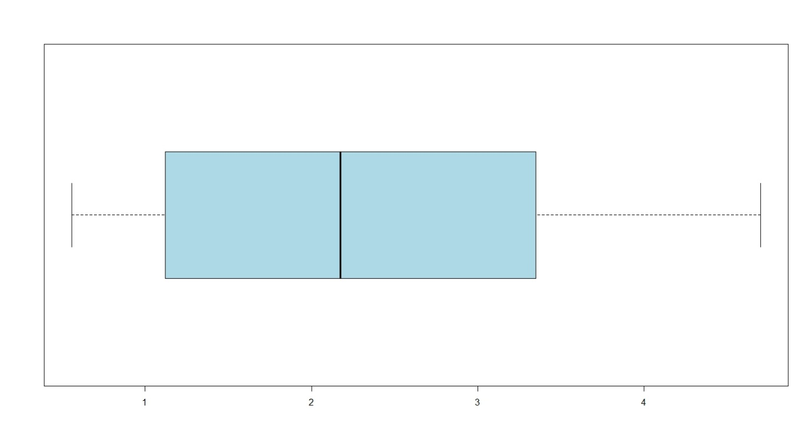

We can enhance this further with titles and labels