|  |  |
| --- | --- |
| SEAT NO: | 2706 |
| STUDENT SIGN |  |
| EXAMINAR 1: |  |
| EXAMINAR 2: |  |

1)DEVELOP A WIREFLOW DIAGRAM FOR A ‘PIZZA DELIVERY APP

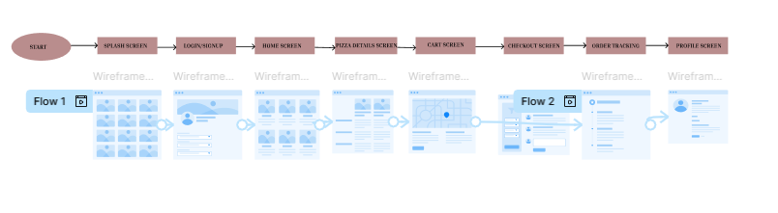

2)DESIGN A INDEPENDENCE DAY INVITATION IN MOBILE VIEW

