

**American International University- Bangladesh**

**Spring2019-2020**

**Project Report**

**Advance Database Management System**

**Project Title: Car Shop Management System**

**Section: B**

|  |  |
| --- | --- |
| Student Name | Student Id |
| A.M. Rakibul Hossain | **16-31399-1** |
| Kh. Shakib Ebna Atiq | **18-36914-1** |
| Md. Rofiqul Islam | **17-34588-2** |
| Taohidul hasan | **17-34698-2** |

Contents

Introduction: 4

Project Proposal: 4

Class Diagram: 5

Use Case Diagram: 6

Activity Diagram: 7

User Interface: 8

Landing: 8

Sign Up: 9

Customer Sign In: 10

Manager Sign In: 11

Owner Sign In: 12

Customer Profile: 13

Manager Profile: 14

Owner Profile: 15

Customer Dashboard: 16

Manager Dashboard: 17

Owner Dashboard: 18

Add Car: 19

Add Customer: 20

Add Manager: 21

See My Car: 22

Manage Car: 23

ER Diagram: 24

Normalization 25

Schema Diagram: 27

Table Creation: 28

Owner: 28

Manager: 29

Customer: 30

Car: 31

Create User: 32

Owner: 32

Manger: 33

Customer: 33

INSERTION 34

Owner table 34

Manager table 34

Customer table 35

Car table 35

SQL 36

Single Row Functions: 36

Group Functions: 37

Subquery: 38

Joining: 39

View: 41

Synonym: 42

PL/SQL 43

Function: 43

Procedure: 46

Record: 48

Cursor: 51

Trigger: 54

Package: 56

# Introduction:

The “Car Shop Management System” has been developed to override the problems prevailing in the practicing manual system. This software is supported to eliminate and, in some cases, reduce the hardships faced by this existing system. Moreover, this system is designed for the particular need of the company to carry out operations in a smooth and effective manner.

# Project Proposal:

The purpose of the car shop management system is to automate the existing manual system by the help of computerized equipment and full-fledged computer software, fulfilling their requirements, so their valuable data can be stored for a longer period with easy accessing and manipulation of the same. The required software and hardware are easily available and easy to work with.

The main objective of the project on car shop management system is to manage the details of car, customer, payment order. It manages all the information about the car. The purpose of the project is to build an application program to reduce the manual work for managing the car.

Here are three types of user – owner, manager, customer.

Manager can add car, delete car and sell car. Owner can also do that, but the main work is to maintain the manager. User can search any car; they can show everything and can booked a car and can buy it.

# Class Diagram:

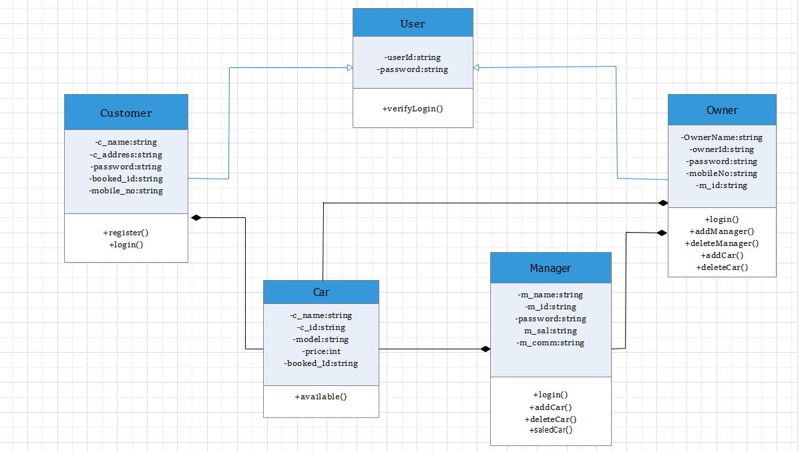

Fig 1: Class diagram.

# Use Case Diagram:

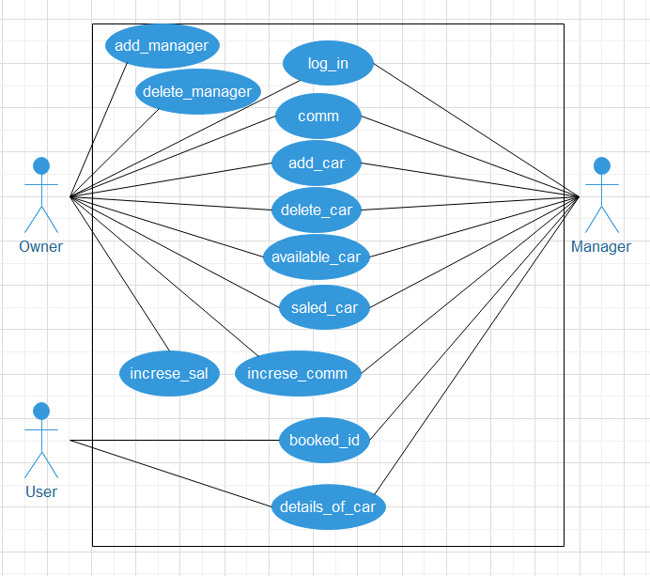

Fig 2: Use Case diagram.

# Activity Diagram:

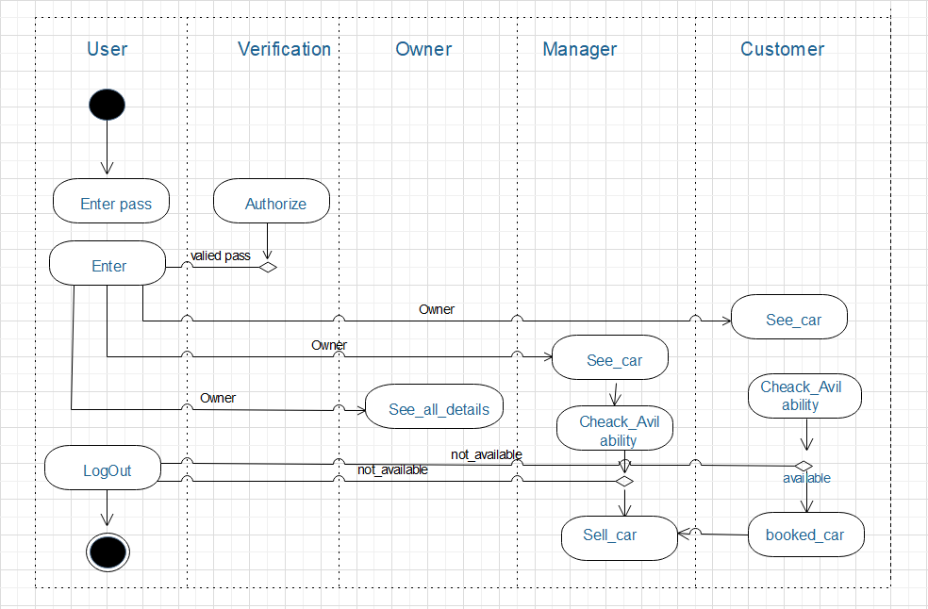

Fig 3: Activity diagram.

# User Interface:

## Landing:

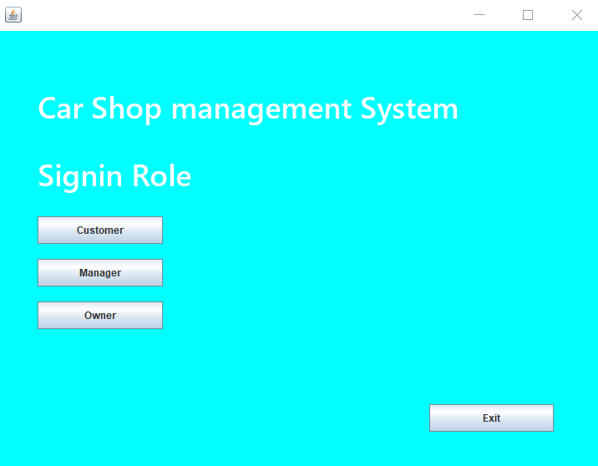

## Sign Up:

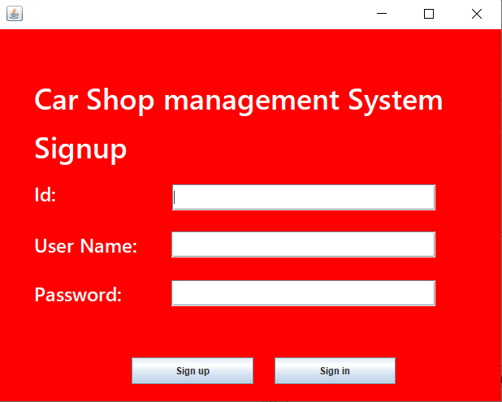

## Customer Sign In:

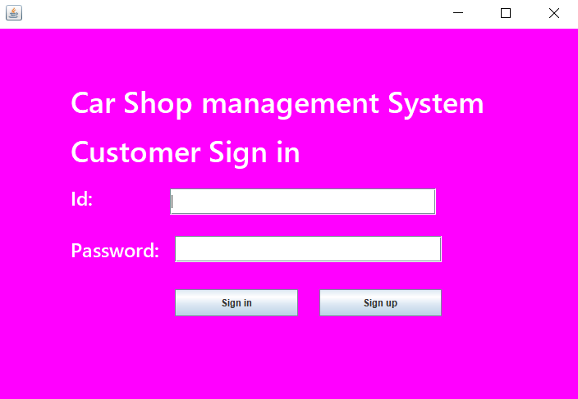

## Manager Sign In:

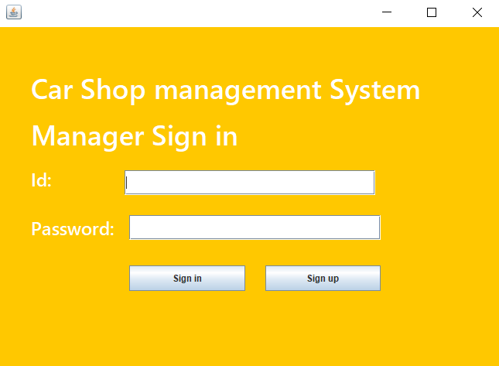

## Owner Sign In:

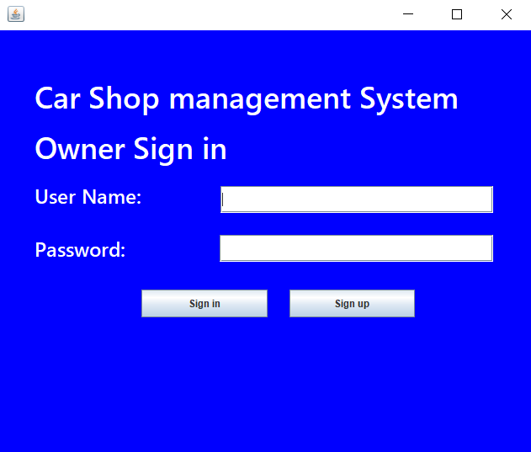

## Customer Profile:

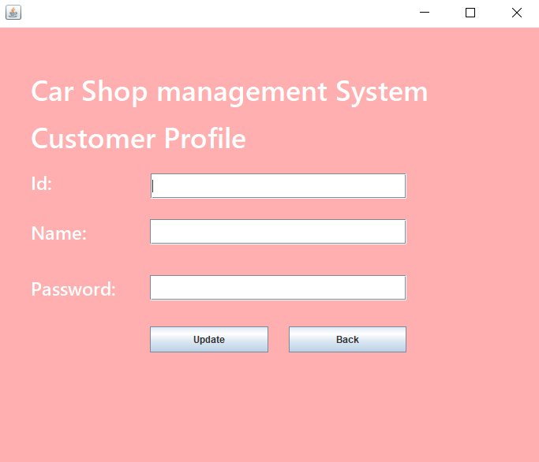

## Manager Profile:

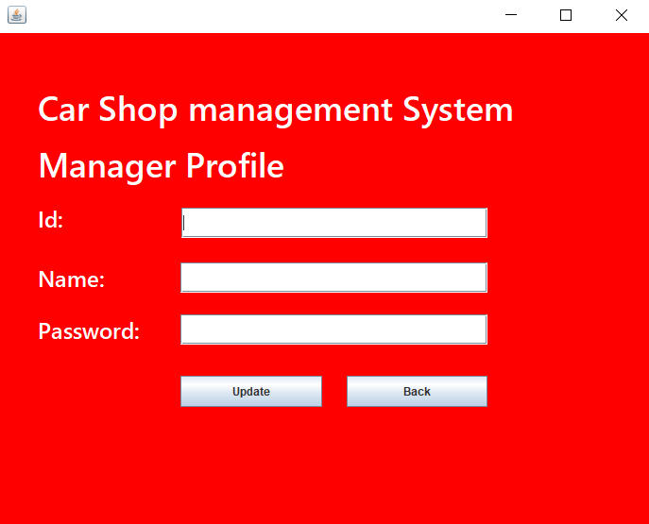

## Owner Profile:

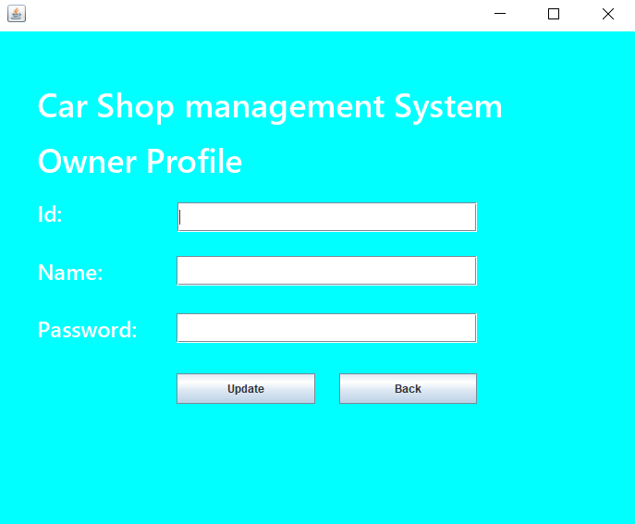

## Customer Dashboard:

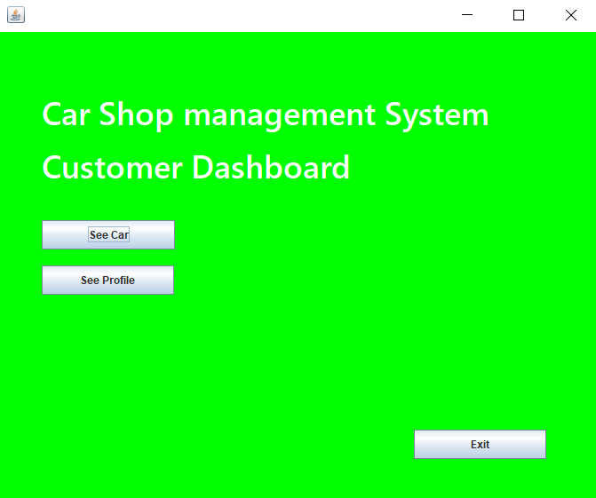

## Manager Dashboard:

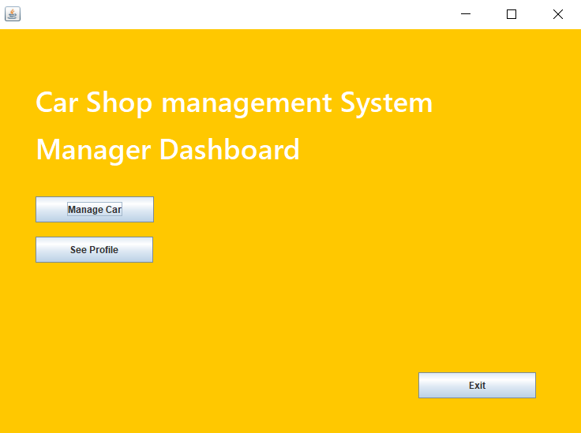

## Owner Dashboard:

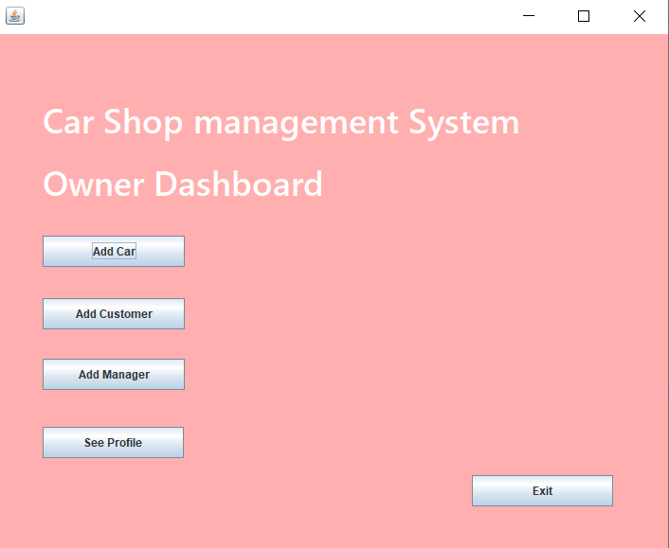

## Add Car:

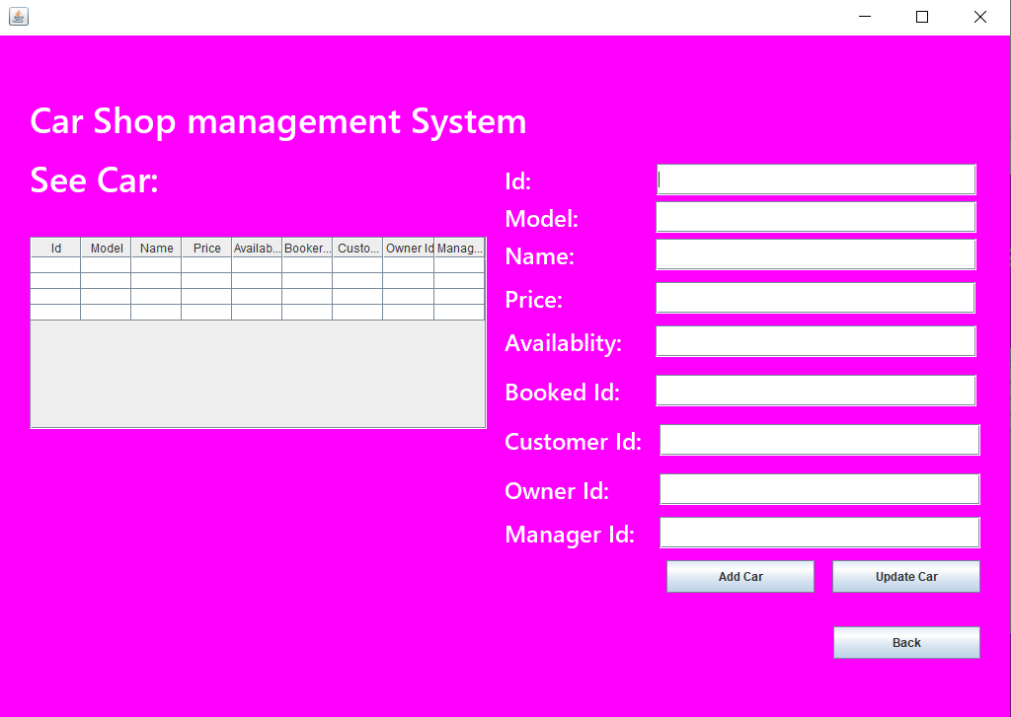

## Add Customer:

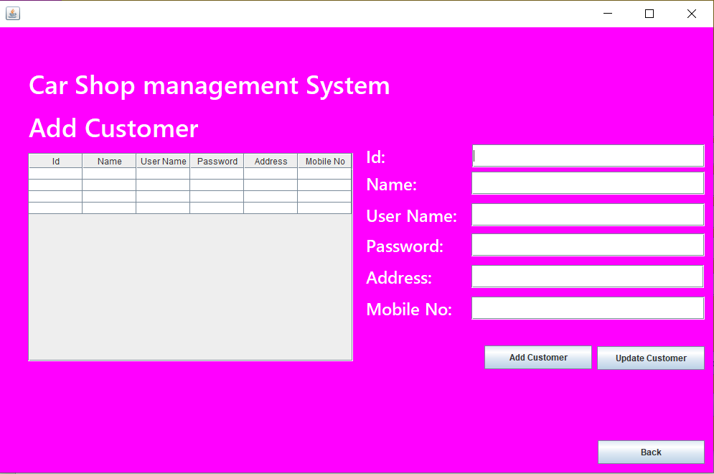

## Add Manager:

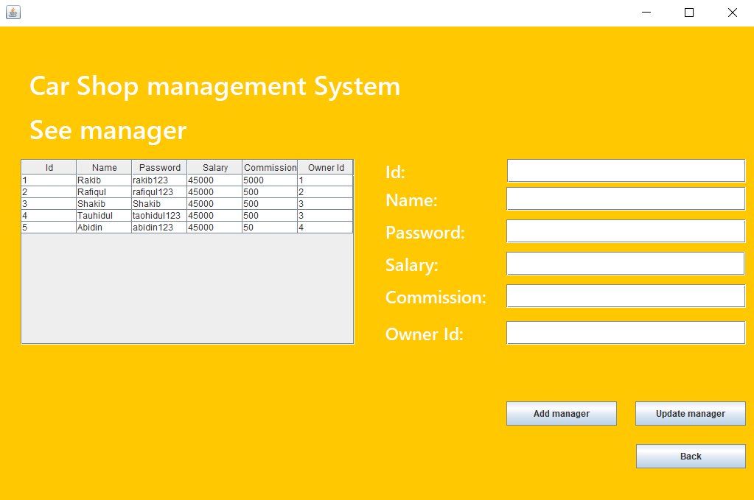

## See My Car:

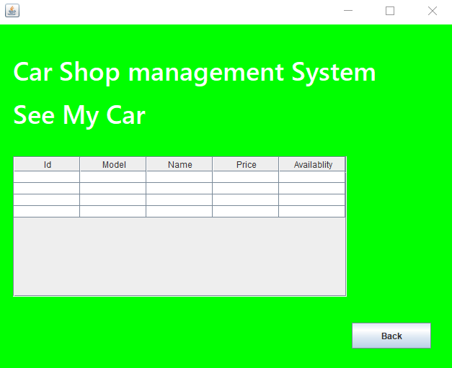

## Manage Car:

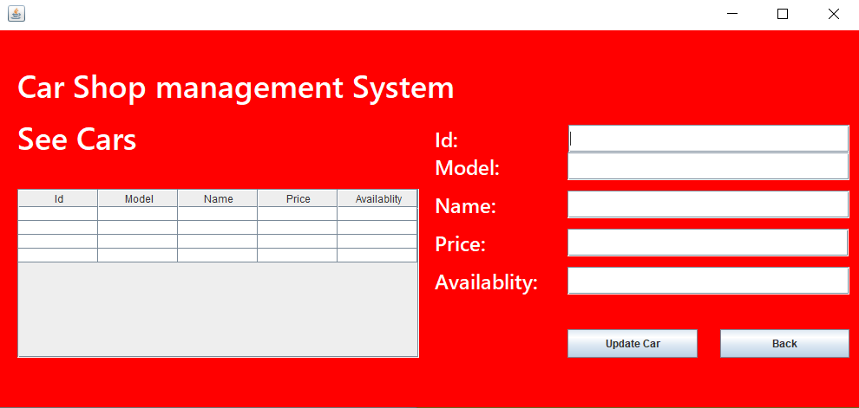

# ER Diagram:

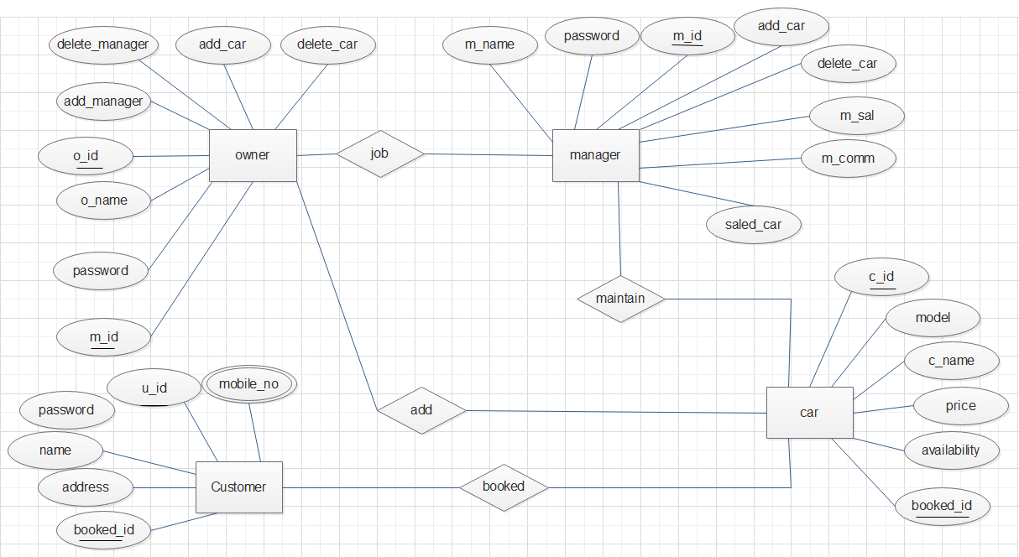

Fig 4: ER Diagram

# Normalization

**JOB**(#o_id, o_name, o_password, m_name, m_password, #m-id, m_sal, m_comm)

**1NF:-**

There is no multi-valued attribute

**2NF:-**

1. #o_id, o_name, o_password

2. #m_id, m_name, m_password, m_sal, m_comm

**3NF:-**

1. #o_id, o_name, o_password

2. #m_id, m_name, m_password, m_sal, m_comm

**MAINTAIN**(m_name, password, #m_id, m_sal, m_comm, c_id, model, c_name, price, availability, booked_id)

**1NF:-**

There is no multi-valued attribute

**2NF:-**

1. #m_id, m_name, m_password, m_sal, m_comm

2. #c_id, model, c_name, price, availability, booked_id

**3NF:-**

1. #m_id, m_name, m_password, m_sal, m_comm

2. #c_id, model, c_name, price, availability, booked_id

**ADD**(#o_id, o_name,password, #c_id, model, c_name, price, availability, booked_id)

**1NF:-**

There is no multi-valued attribute

**2NF:-**

1. #o_id, o_name, o_password

2. #c_id, model, c_name, price, availability, booked_id

**3NF:-**

1. #o_id, o_name, o_password

2. #c_id, model, c_name, price, availability, booked_id

**Booked**(#c_id, model, c_name, price, availability, booked_id, booked_id, address, name, password, #u_id, mobile_no)

**1NF:-**

mobile_no is an multi-valued attribute

**2NF:-**

1. #c_id, model, c_name, price, availability, booked_id

2. #u_id, address, name, password, mobile_no

**3NF:-**

1. #c_id, model, c_name, price, availability, booked_id

2. #u_id, address, name, password, mobile_no

# Schema Diagram:

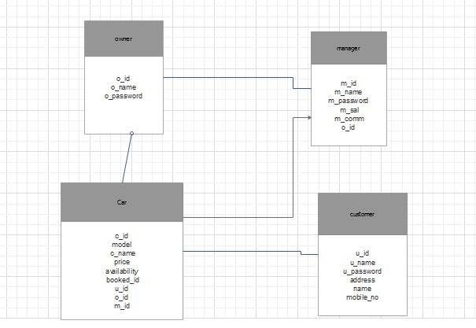

Fig 5: Schema Diagram

# Table Creation:

## Owner:

CREATE TABLE owner(

o_id number(10),

o_name varchar(30),

o_password varchar(20),

constraint pk_owner primary key(o_id)

)

CREATE SEQUENCE seq_o_id

start with 1

increment by 1

nomaxvalue

nominvalue

Nocycle;

INSERT INTO owner VALUES (seq_o_id.nextval, 'Rakib', 'rakib123');

Desc owner;

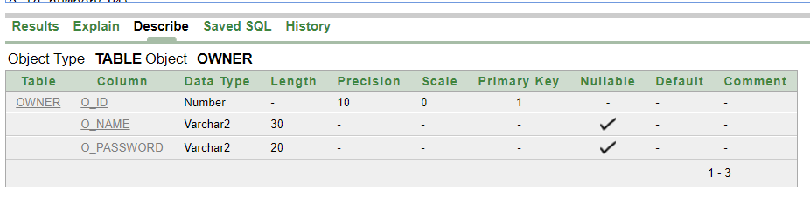

## Manager:

CREATE TABLE manager(

m_id number(10),

m_name varchar(30),

m_password varchar(20),

m_sal number(10),

m_comm number(10),

o_id number(10),

constraint pk_manager primary key(m_id),

constraint fk_man_own foreign key(o_id) references owner(o_id)

)

CREATE SEQUENCE seq_m_id

start with 1

increment by 1

nomaxvalue

nominvalue

Nocycle;

INSERT INTO manager VALUES (seq_m_id.nextval, 'Rakib', 'rakib123', '45000', '5000', '1');

Desc manager;

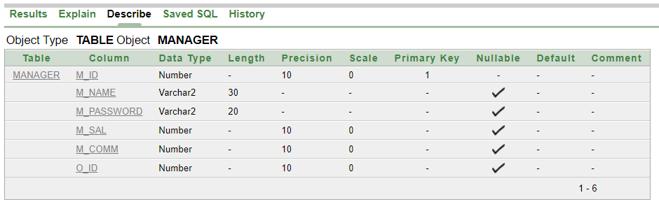

## Customer:

CREATE TABLE customer(

u_id number(10),

u_name varchar2(30),

u_password varchar2(20),

address varchar2(10),

name varchar2(10),

mobile_no number(10),

constraint pk_customer primary key(u_id)

)

CREATE SEQUENCE seq_u_id

start with 4

increment by 1

nomaxvalue

nominvalue

Nocycle;

INSERT INTO customer VALUES (seq_u_id.nextval, 'Rakib', 'rakib123', 'dhanmondi', 'Dhaka', '546548432');

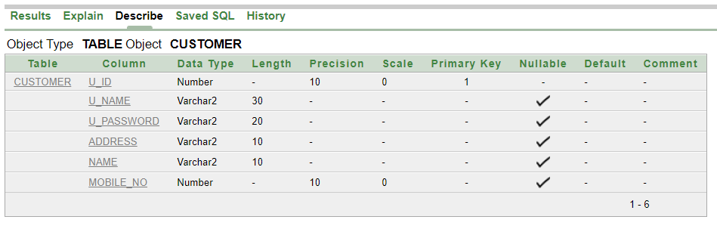

## Car:

CREATE TABLE car(

c_id number(10),

c_name varchar(30),

price number(10),

model varchar2(20),

availability varchar2(20),

booked_id number(10),

m_id number(10),

o_id number(10),

u_id number(10),

constraint pk_car primary key(c_id),

constraint fk_car_man foreign key(m_id) references manager(m_id),

constraint fk_car_own foreign key(o_id) references owner(o_id),

constraint fk_car_cus foreign key(u_id) references customer(u_id)

)

CREATE SEQUENCE seq_c_id

start with 1

increment by 1

nomaxvalue

nominvalue

Nocycle;

INSERT INTO car VALUES (seq_c_id.nextval, 'Ferari', '5000000', 'r1', 'yes', '1', '1', '1', '6');

Desc car;

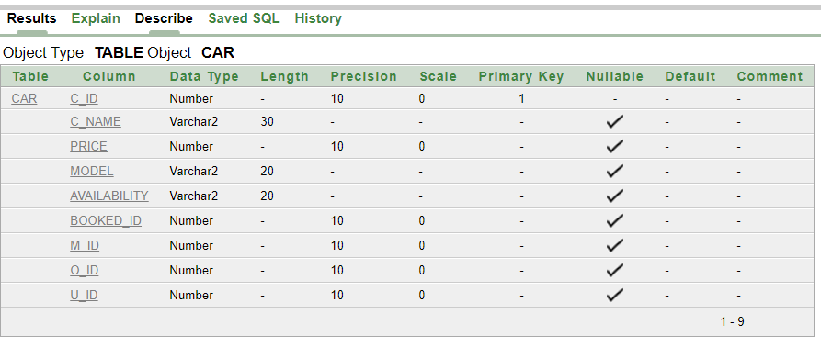

## Create User:

### Owner:

1. **CREATE USER owner IDENTIFIED BY owner;**

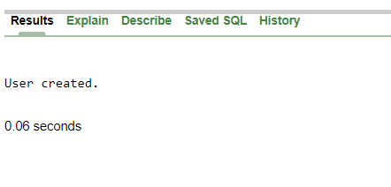

1. **GRANT UNLIMITED TABLESPACE TO owner;**

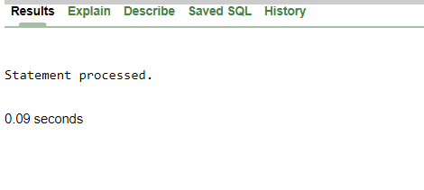

1. **GRANT create table, create sequence, create view TO owner;**

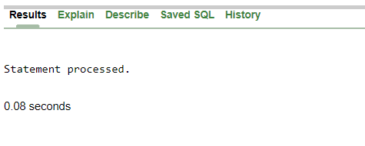

## Manger:

1. CREATE USER manager IDENTIFIED BY manager;

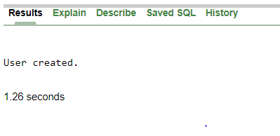

1. GRANT create table, create sequence, create view TO manager;

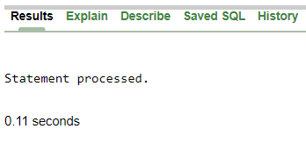

## Customer:

1. CREATE USER customer IDENTIFIED BY customer;

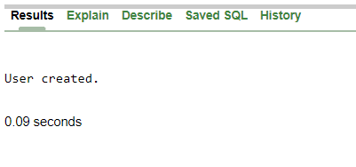

# INSERTION

## Owner table

INSERT INTO owner VALUES (seq_o_id.nextval, 'Rakib', 'rakib123');

INSERT INTO owner VALUES (seq_o_id.nextval, 'Rafiqul', 'rafiqul123');

INSERT INTO owner VALUES (seq_o_id.nextval, ‘Shakib’, 'shakib123');

INSERT INTO owner VALUES (seq_o_id.nextval, ‘Tauhidul', 'taohidul123');

INSERT INTO owner VALUES (seq_o_id.nextval, 'Abidin', ‘abidin123');

select * from owner;

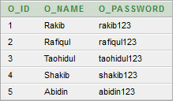

## Manager table

INSERT INTO manager VALUES (seq_m_id.nextval, 'Rakib', 'rakib123', '45000', '5000', '1');

INSERT INTO manager VALUES (seq_m_id.nextval, 'Rafiqul', 'rafiqul123', '45000', '500', '2');

INSERT INTO manager VALUES (seq_m_id.nextval, 'Shakib', 'Shakib', '45000', '500', '3');

INSERT INTO manager VALUES (seq_m_id.nextval, 'Tauhidul', 'taohidul123', '45000', '500', '3');

INSERT INTO manager VALUES (seq_m_id.nextval, 'Abidin', 'abidin123', '45000', '50', '4');

select * from manager;

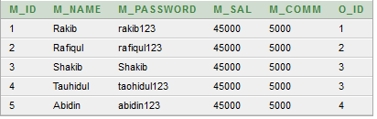

## Customer table

INSERT INTO customer VALUES (seq_u_id.nextval, 'Rakib', 'rakib123', 'dhanmondi', 'Dhaka', '546548432');

INSERT INTO customer VALUES (seq_u_id.nextval, 'Rafiqul', 'rafiqul123', 'uttara', 'Dhaka', '546548432');

INSERT INTO customer VALUES (seq_u_id.nextval, 'Shakib', 'shakib123', 'Mirpur', 'Dhaka', '546548432');

INSERT INTO customer VALUES (seq_u_id.nextval, 'Taohidul', 'taohidul123', 'Motijheel', 'Dhaka', '546548432');

INSERT INTO customer VALUES (seq_u_id.nextval, 'Abidin', 'abidin123', 'Kuratoli', 'Dhaka', '546548432');

select * from customer;

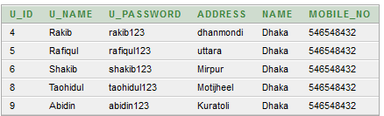

## Car table

INSERT INTO car VALUES (seq_c_id.nextval, 'Ferari', '5000000', 'r1', 'yes', '1', '1', '1', '6');

INSERT INTO car VALUES (seq_c_id.nextval, 'BMW', '6000000', 'q51', 'yes', '5', '4', '2', '4');

INSERT INTO car VALUES (seq_c_id.nextval, 'Audi', '4000000', 'r8', 'yes', '3', '3', '3', '5');

INSERT INTO car VALUES (seq_c_id.nextval, 'Tata', '1000000', 'c7', 'yes', '4', '4', '2', '8');

INSERT INTO car VALUES (seq_c_id.nextval, 'Royal', '9000000', 'ghost', 'no', '2', '3', '1', '9');

select * from car;

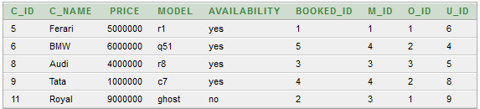

# SQL

## Single Row Functions:

1. Display car’s name and model as “car_details”.

select concat(c_name,model) as car_details from car;

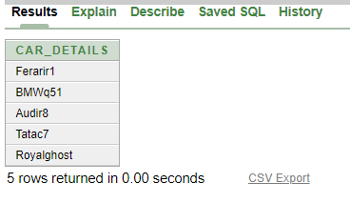

1. Display first 3 letters of all the cars.

select substr(c_name,1,3) from car;

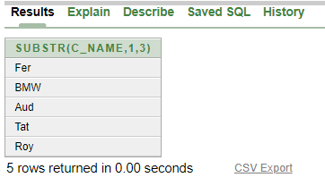

1. Display all the manager’s name in upper case.

select upper(m_name) from manager;

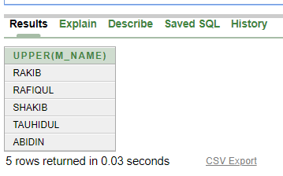

## Group Functions:

1. Calculate the sum of price of all the cars.

select sum(price) from car;

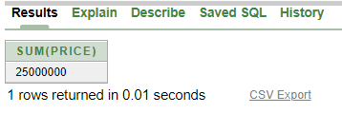

1. Find out the lowest price from the cars.

select min(price) from car;

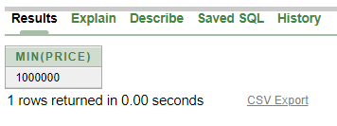

1. Find out the highest price from the cars.

select max(price) from car;

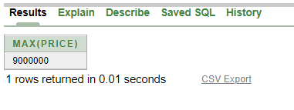

## Subquery:

1. Find out the managers data whose commission is more than the manager id 4.

select * from manager where m_comm> (select m_comm from manager where m_id=4)

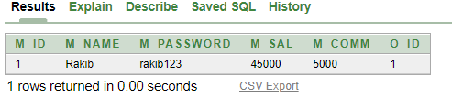

1. Find out the managers whose commission is more than the manager name Abidin.

select * from manager where m_comm> (select m_comm from manager where m_name='Abidin')

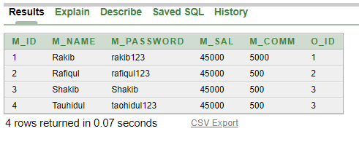

1. Find out the cars which price is more than the model r8;

select * from car where price> (select price from car where model='r8')

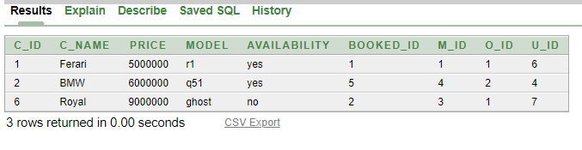

## Joining:

1. Display all the managers and their respective owners.

select m.m_name, o.o_name from manager m, owner o where m.o_id = o.o_id;

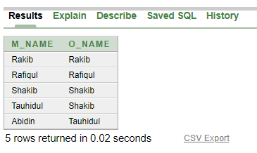

1. Display all the managers and their assigned cars.

select m.m_name, c.c_name from manager m, car c where m.o_id = c.o_id;

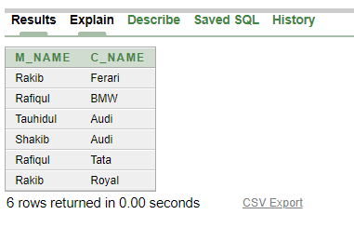

1. Display all the customers and their owned cars.

select c.c_name, cu.u_name from customer cu, car c where cu.u_id = c.u_id;

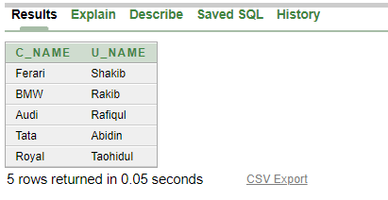

## View:

1. Create a view to display customer name and their id.

create view view_customer as select u_name, u_id from customer;

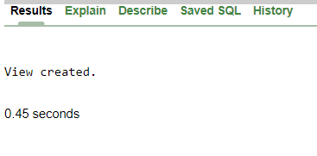

1. Create a view to display car name and their id.

create view view_car as select c_name, c_id from car;

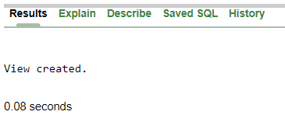

1. Create a view to display manager and their id.

create view view_manager as select m_name, m_id from manager;

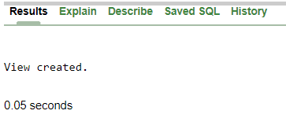

## Synonym:

1. Create a synonym for manager table.

create synonym syn_man for manager;

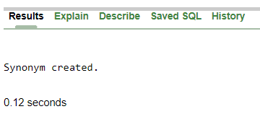

1. Create a synonym for customer table.

create synonym syn_cus for customer;

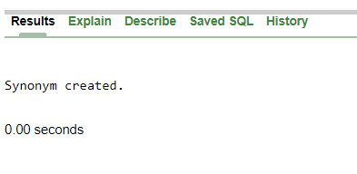

1. Create a synonym for owner table.

create synonym syn_own for owner;

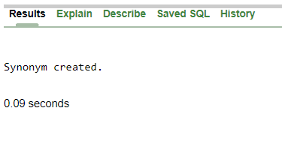

# PL/SQL

## Function:

1. Create a function to display data from manager table.

CREATE OR REPLACE FUNCTION selectMsg(p_name IN VARCHAR2)

RETURN VARCHAR2

IS

BEGIN

RETURN (p_name);

END;

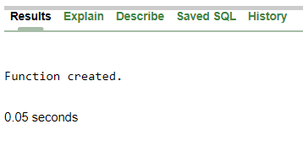

SELECT selectMsg(m_name), selectMsg(m_id) FROM manager WHERE m_id=1;

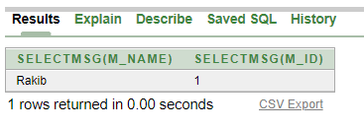

1. Create/replace a function to show the number of total customers.

CREATE OR REPLACE FUNCTION totalCustomer

RETURN NUMBER

IS

total NUMBER := 0;

BEGIN

SELECT count(*) INTO total

FROM customer;

RETURN total;

END;

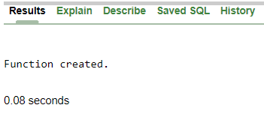

DECLARE

customer NUMBER(10);

BEGIN

customer := totalCustomer();

dbms_output.put_line('Customer: '||customer);

END;

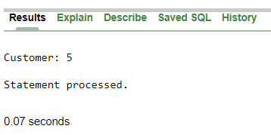

1. Create a function to display total number of cars.

create or replace function totalCar

return number as

totalnum number(10);

begin

select count(c_id) into totalnum from car;

return totalnum;

end;

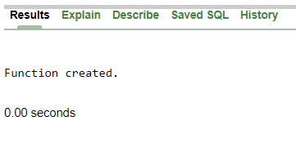

declare

totalnum number(10);

begin

totalnum:=totalCar();

dbms_output.put_line('Total Cars: '||totalnum);

end;

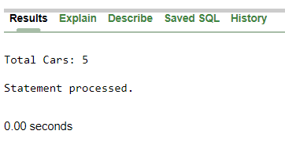

## Procedure:

1. Create a procedure to update customer.

CREATE OR REPLACE PROCEDURE updateCustomer

(id IN NUMBER,

username IN VARCHAR2,

password IN VARCHAR2,

address IN VARCHAR2,

state IN VARCHAR2,

phone IN NUMBER)

IS

BEGIN

UPDATE customer SET u_name=username, u_password=password, address=address, name=state, mobile_no=phone WHERE u_id=id;

END;

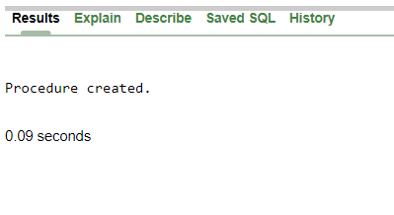

1. Create a procedure to print car details.

CREATE OR REPLACE PROCEDURE print_car

(id IN NUMBER)

IS

car_details car%ROWTYPE;

BEGIN

SELECT * INTO car_details

FROM car WHERE c_id=id;

dbms_output.put_line(car_details.c_name || ' price is: ' || car_details.price || ' and Model is: ' || car_details.model);

END;

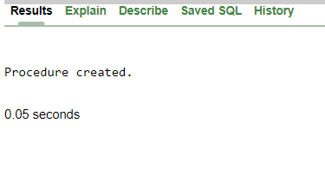

1. Create a procedure to update owner.

CREATE OR REPLACE PROCEDURE updateOwner

(id IN NUMBER,

username IN VARCHAR2,

password IN VARCHAR2)

IS

BEGIN

UPDATE owner SET o_name=username, o_password=password WHERE o_id=id;

END;

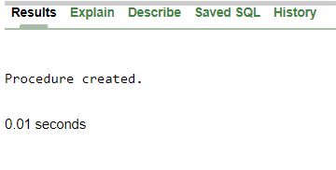

## Record:

1. Create a user defined record to display car name and car model whose id is 6.

DECLARE

TYPE rec_car IS RECORD(

car_name car.c_name%TYPE,

car_model car.model%TYPE

);

var rec_car;

BEGIN

SELECT c_name, model INTO var.car_name, var.car_model FROM car WHERE c_id=6;

dbms_output.put_line(var.car_model ||' '||var.car_name);

END;

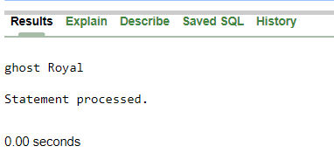

1. Create a cursor based record to display manager name and manager salary.

DECLARE

CURSOR c_manager IS

SELECT m_name, m_sal FROM manager;

var_man c_manager%ROWTYPE;

BEGIN

OPEN c_manager;

LOOP

FETCH c_manager INTO var_man;

EXIT WHEN c_manager%NOTFOUND;

dbms_output.put_line(var_man.m_name || ' ' || var_man.m_sal);

END LOOP;

CLOSE c_manager;

END;

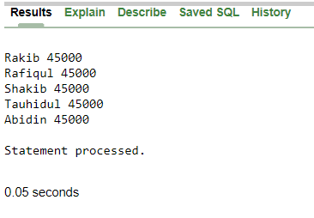

1. Create a cursor based record to display all customer’s name and their address.

DECLARE

CURSOR c_customer IS

SELECT u_name, address FROM customer;

var_cus c_customer%ROWTYPE;

BEGIN

OPEN c_customer;

LOOP

FETCH c_customer INTO var_cus;

EXIT WHEN c_customer%NOTFOUND;

dbms_output.put_line(var_cus.u_name || ' ' || var_cus.address);

END LOOP;

CLOSE c_customer;

END;

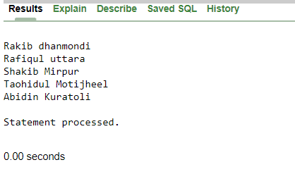

## Cursor:

1. Create an implicit cursor to add 200tk for each manager in their commission.

DECLARE

total NUMBER(2);

BEGIN

UPDATE manager

SET m_comm = m_comm + 200;

IF sql%NOTFOUND THEN

dbms_output.put_line('No Manager Updated');

ELSIF sql%FOUND THEN

total := sql%ROWCOUNT;

dbms_output.put_line(total||' Manager Updated');

END IF;

END;

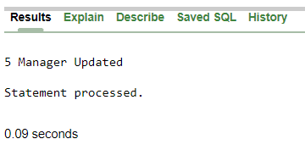

1. Create an explicit cursor to display owner id and name.

DECLARE

c_id owner.o_id%TYPE;

c_name owner.o_name%TYPE;

CURSOR cursor_owner IS

SELECT o_id, o_name FROM owner;

BEGIN

OPEN cursor_owner;

LOOP

FETCH cursor_owner INTO c_id, c_name;

EXIT WHEN cursor_owner%NOTFOUND;

dbms_output.put_line('Id: '||c_id||' Name: '||c_name);

END LOOP;

CLOSE cursor_owner;

END;

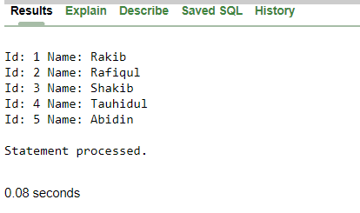

1. Create a cursor using for loop to display car name and price.

DECLARE

CURSOR c_car IS

SELECT c_name, price FROM car;

BEGIN

FOR loop_index IN c_car

LOOP

dbms_output.put_line('Car Name: '||loop_index.c_name || ' | Car Price: '||loop_index.price);

END LOOP;

END;

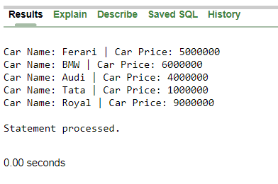

## Trigger:

1. Create a trigger for any new customer inserted into the customer table.

create trigger customer_t

after insert on customer

for each row

when (new.u_id > 0)

begin

dbms_output.put_line('New Customer Added');

end;

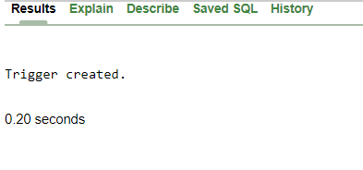

1. Create a trigger for any new manager inserted into the manager table.

create trigger manager_t

after insert on manager

for each row

when (new.m_id > 0)

begin

dbms_output.put_line('New Manager Added');

end;

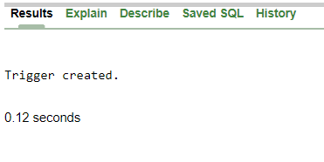

1. Create a trigger for any new car inserted into the car table.

create trigger car_t

after insert on car

for each row

when (new.m_id > 0)

begin

dbms_output.put_line('New Car Added');

end;

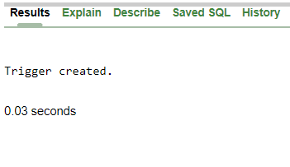

## Package:

1. Create a package which has a procedure to update car model.

CREATE OR REPLACE PACKAGE pkg_car IS

PROCEDURE update_model(model in varchar);

END pkg_car;

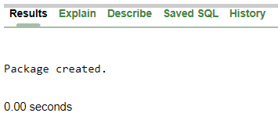

CREATE OR REPLACE PACKAGE BODY pkg_car IS

PROCEDURE update_model(model in varchar)

as

begin

update car set model=model;

dbms_output.put_line(model);

end;

END pkg_car;

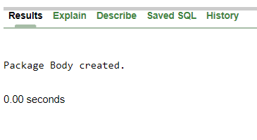

1. Create a package with a procedure to update salary of the managers.

CREATE OR REPLACE PACKAGE pkg_manager IS

PROCEDURE update_salary(salary in number);

END pkg_manager;

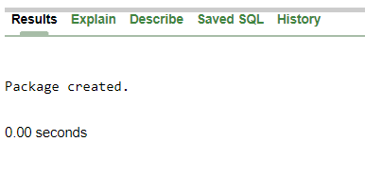

CREATE OR REPLACE PACKAGE BODY pkg_manager IS

PROCEDURE update_salary(salary in number)

as

begin

update manager set m_sal=salary;

dbms_output.put_line(salary);

end;

END pkg_manager;

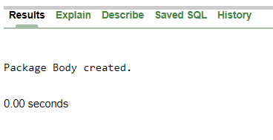

1. Create a package with a procedure to update owner name.

CREATE OR REPLACE PACKAGE pkg_owner IS

PROCEDURE update_name(name in varchar);

END pkg_owner;

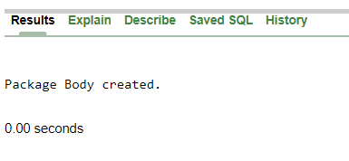

CREATE OR REPLACE PACKAGE BODY pkg_owner IS

PROCEDURE update_name(name in varchar)

as

begin

update owner set o_name=name;

dbms_output.put_line(name);

end;

END pkg_owner;

