**Module–1(Fundamental)**

1. **What is SDLC?**

* SDLC stands for Software Development Life Cycle. It is a series of steps and phases which is used for Development and Lifecycle Management of Software.
* It defines the process for Planning, Implementation, Testing, Documentation, Deployment and Ongoing Maintenance for the development of a software product.
* It is divided into 6 Phases:
  + 1. Requirement Collection/ Gathering
    2. Analysis
    3. Design
    4. Implementation
    5. Testing
    6. Maintenance

1. **What is Agile Methodology?**

* This model is a combination of Iterative and Incremental model that focuses on process adaptability and customer satisfaction by rapid delivery of working software.
* The product is broken into several small incremental builds which are executed in nultiple iterations.
* Every iteration involves cross functional teams working on various areas like planning, requirement analysis, design, coding, unit testing and acceptance testing which can last from 1 to 3 weeks.
* A working product is displayed to the customer and the end of each iteration.
* Each build is incremental in terms of features and final build contains all the feature.

1. **What is SRS?**

* SRS stands for Software Requirements Specification and is used to describe the behaviour of the system.
* It contains set of use cases that describes all the user interaction with the software.
* The use cases contain Functional Requirements as well as Non-Functional Requirements.
  + 1. **Functional Requirements:** They are very important in the system design Process. They include Technical Specifications, system design parameters and guidelines, data manipulation, data processing and calculation modules, etc.
    2. **Non-Functional Requirements:** They specify the criteria that used to judge the operation of a system. They are the qualities and standards a system under development must have like Operating System, Anti-Virus, etc. But are not the tasks that are performed by the system.

1. **What is OOPs?**

* OOPs stands for Object Oriented Programming which identifies objects and assigns responsibilities to these objects.
* Objects communicate with other objects by sending them messages.

1. **Write Basic Concepts of OOPs.**

* There are 6 Basic concepts of OOPs:
  + 1. Object
    2. Class
    3. Encapsulation
    4. Inheritance
    5. Polymorphism:

1. Overriding
2. Overloading
   * 1. Abstraction
3. **What is Object?**

* It is an instance of a class. It is the most basic unit of OOPs.
* It is used to create memory for that class to access all the properties of a class except private.
* Both data and functions that operate on data are bundled as a unit called as object.
* It includes tangible things, roles, incidents, interactions, specifications, etc.

1. **What is class?**

* It is a collection of data member (variable) and member of function (process method) with its behaviour.
* It is an abstraction of the object, and, abstracts the properties and behaviour of the object.

1. **What is encapsulation?**

* Wrapping up of data into single unit i.e. data hiding, is called encapsulation.
* It is the process of wrapping data (properties) and behaviour (methods) of an object into a dingle unit.
* Encapsulation enables hiding irrelevant information from the user and showing only relevant information required by the user.

1. **What is inheritance?**

* It means properties of parent class are derived into child class.
* Its main purpose is to be helpful in reusability and extensibility OOPs.
* It is the process of forming new class from an existing class, where existing class is called base class and new class is called derived class.
* There 5 types of Inheritance:

1. Single
2. Multilevel
3. Heirarchical
4. Multiple
5. Hybrid

* Some languages do not support the last two types of Inheritance.

1. **What is polymorphism?**

* Polymorphism means the ability of an object to take one name having different forms i.e. having many forms.
* It allows different objects to respond to the same message in different ways, the response is specific to the type of object.
* The ability to change form is also known as Polymorphism.
* There are 2 types of Polymorphism:

1. Compile time Polymorphism (Overloading)
2. Runtime Polymorphism (Overriding)
3. **What is RDBMS?**

* RDBMS stands for Relational DataBase Management System.
* It is a type of Database Management system that stores data in structured format using rows and columns.
* This helps in making it easy to locate and access data in relation to another piece of data in the database.

1. **What is SQL?**

* SQL stands for Structured Query Language
* It is a domain specific language used in programming and is designed for managing data held in a RDBMS.

1. **Write SQL Commands.**
2. DDL: Data Definition Language.

* CREATE DATABASE, CREATE TABLE, USE, TRUNCATE, ALTER, etc.

1. DML: Data Manipulation Language.

* INSERT, UPDATE, DELETE

1. DQL: Data Query Language

* SELECT

1. DCL/TCL: Data/ Transactional Control Language

* GRANT, PRIVILEGES, REVOKE, COMMIT, SAVE POINT, etc.

1. **Draw Usecase on Online book shopping.**
2. **Draw Usecase on online bill payment system (paytm).**
3. **Write SDLC phases with basic introduction.**
   * 1. **Requirement Collection:**
     2. **Analysis**
     3. **Design**
     4. **Implementation**
     5. **Testing**
     6. **Maintenance**
4. **Explain Phases of the waterfall model.**
   * 1. **Requirement Collection:**
     2. **Analysis**
     3. **Design**
     4. **Implementation**
     5. **Testing**
     6. **Maintenance**
5. **Write phases of spiral model.**
6. **Planning:** In this phase the initial customer requirements and objectives and project constraints are determined.
7. **Risk Analysis:** In this phase the risks like delay in project or cost increase are analysed and suitable alternatives and resolutions are decided for the risks. Depending on the risk, the go or no go decision for project is taken.
8. **Engineering:** In this phase a working model of the product is developed, which is also called as first prototype.
9. **Customer Evaluation:** The first prototype is known as Alpha demo, is given to Customer for assessment.
10. **Write agile manifesto principles.**
11. **Individuals and Interactions:** In Agile development, self-organisation and motivation are important, as are interactions like co-location and pair programming.
12. **Working Software:** Demo working software is considered the best means of communication with the customer to understand their requirement,
13. **Customer Collaboration:** As the requirements cannot be gathered completely at the beginning of the project, continuous customer interaction is important to get proper product requirement.
14. **Responding to Change:** Agile Development is focused on quick responses to change and continuous development.
15. **What is JOIN?**

* A **JOIN** clause is used to combine rows from two or more tables, based on a related column between them.

1. **Write type of JOINs.**

* **Basically there are 2 types of JOINs:**

1. **Inner Join:** Returns records that have matching values in both tables
2. **Outer Join:** It is further divided into 3 types:

* **Left (Outer) Join:** Returns all records from the left table, and the matched records from the right table
* **Right (Outer) Join:** Returns all records from the right table, and the matched records from the left table
* **Full (Outer) Join:** Returns all records when there is a match in either left or right table

1. **Explain working methodology of agile model and also write pros and cons.**
2. **Draw usecase on Online shopping product using COD.**

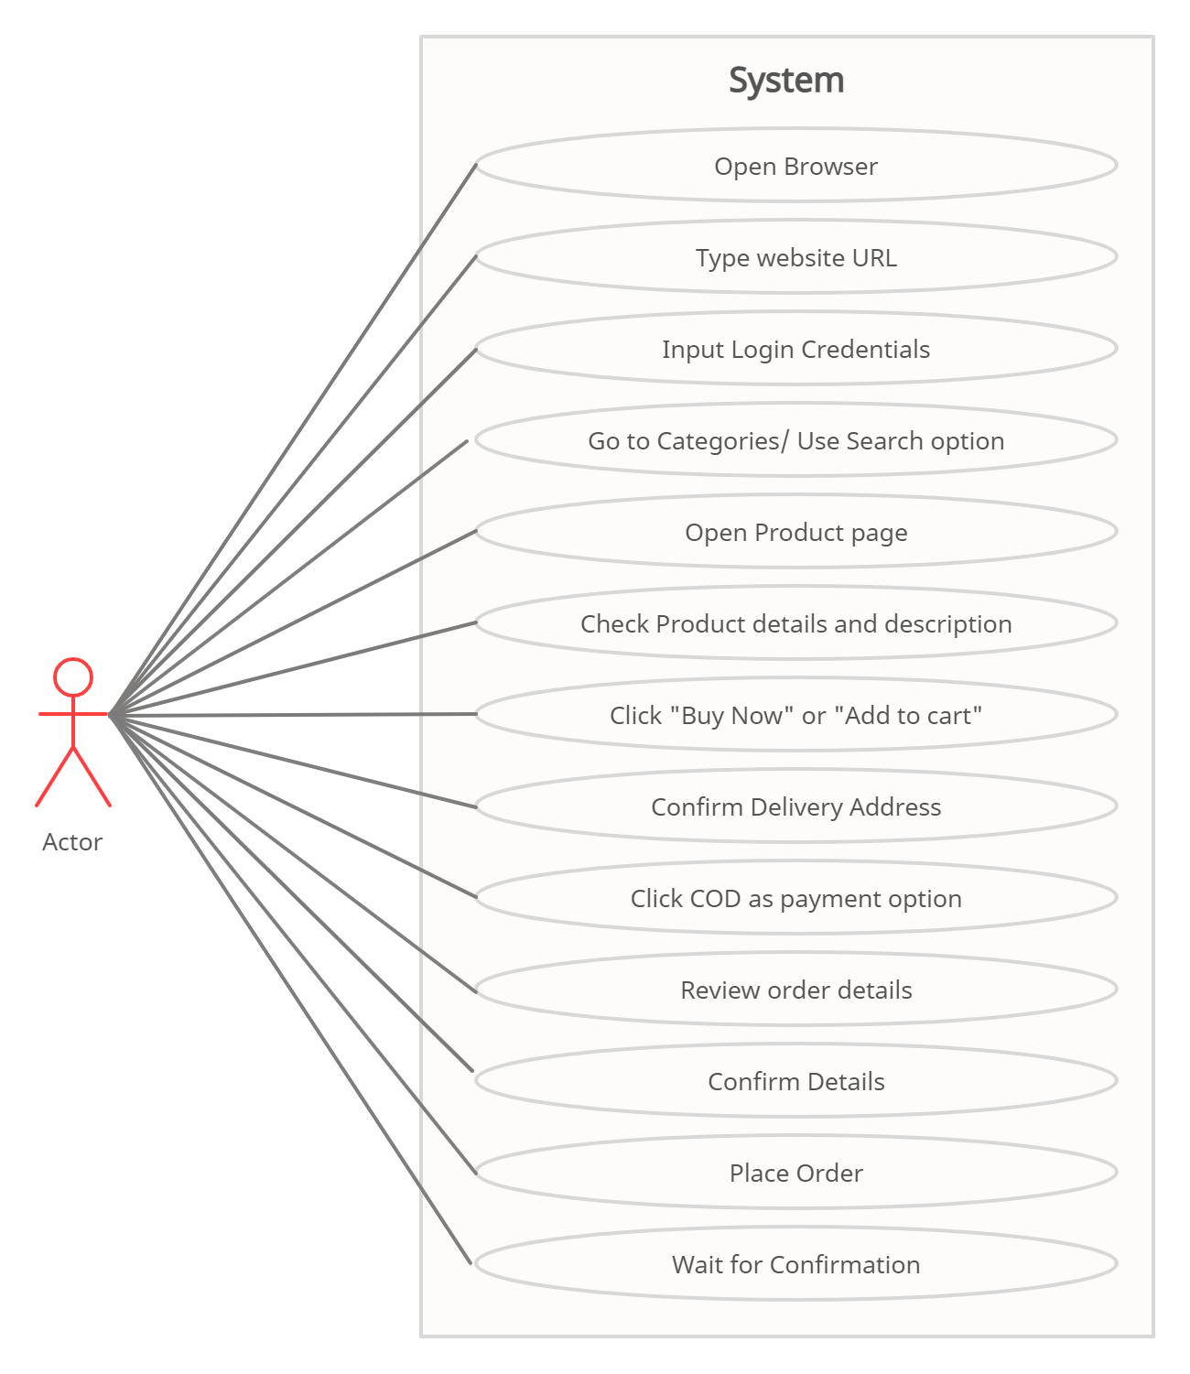

1. **Draw usecase on Online shopping product using payment gateway.**