1) swap

echo " enter value to a "
read a
echo " enter value to b "
read b
temp=$a
a=$b
b=$temp
echo " a is :$a "
echo " b is :$b "
-------------output------------

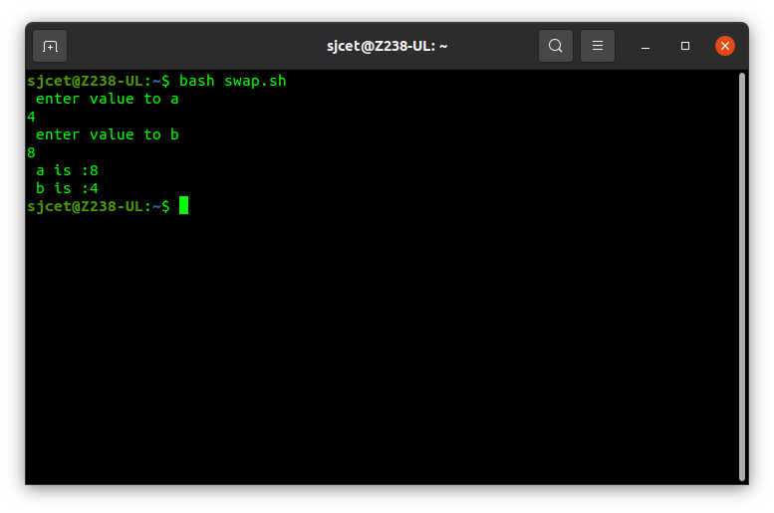

2) prime

echo " enter the number to check "
read n
for((i=2;i<$n;i++))
do
if(( $n % $i == 0 ))
then
echo " is not prime "
exit
fi
done
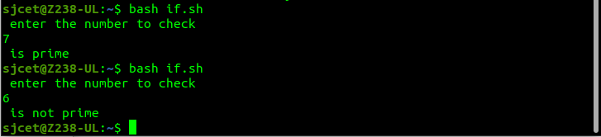
echo " is prime "

3) for loop

for((i=0;i<10;i++))
do
echo " $i "
done
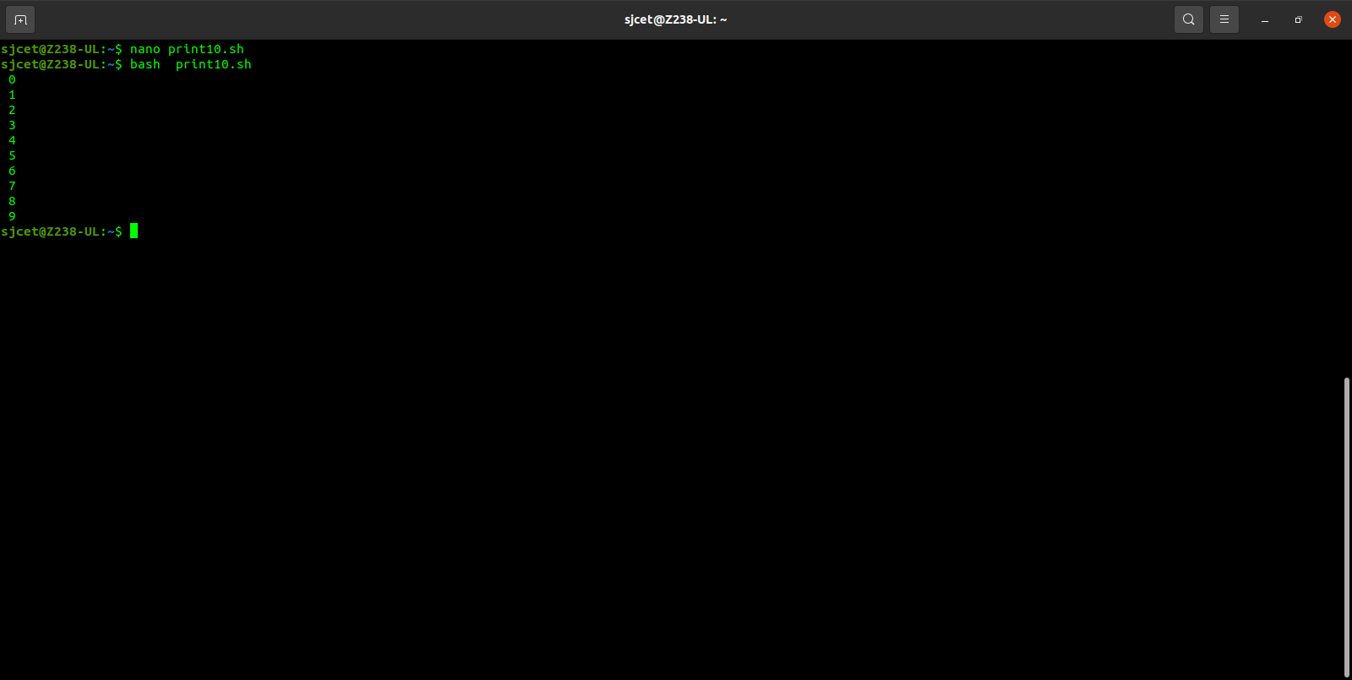

4) odd or even

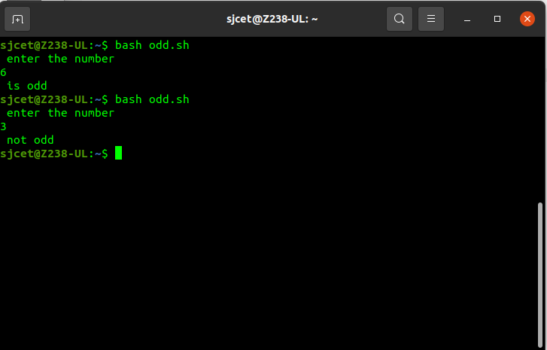

5) area

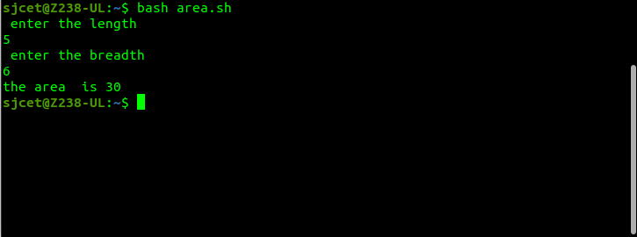

6) if else

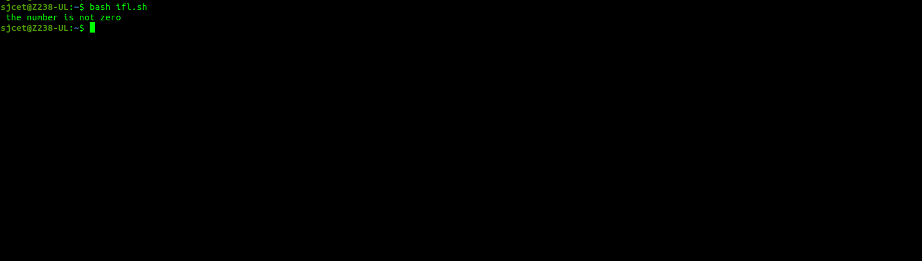
7) add 2 numbers

#!bin/bash
echo " enter the first number to add "
read a
echo " enter the second number to add "
read b
c=$((a+b))
echo " the sum is $c "
