Sonobuoy Deployment System

Table of Contents
Introduction Overview
Code Package Layout Design Patterns Diagrams

Introduction
The National Oceanic and Atmospheric Administration (NOAA) has tasked your team with the development of software for a sonobuoy. A sonobuoy, a combination of sonar and buoy, is a small cylindrical device dropped from an airplane over the ocean. Once it drops into the ocean it expands leaving a floating hydrophone on the surface while the rest of the sensing equipment sinks to an appropriate depth.
A sonobuoy comes in several different flavors:
Active: Emit sound into the water and listen for the returning echo. Reports the range and bearing of any returns.
Passive: Emit nothing, just for sound from ships or submarines. Any sound recorded is reported
Special Purpose: Not used specifically for submarine detection. They monitor oceanic data and can act as distress signals among other things.
Sonobuoys can be deployed in large groups as well as on an individual scale. They are capable of working together as well. For example, a large grouping of passive sonobuoys can be deployed alongside an active sonobuoy. When one or more of the sonobuoys detects something, the active sonobuoy is used to relay the coordinates to a nearby aircraft or ship.
Video Link: Sonobuoy Deployment

Overview
The Sonobuoy Deployment system provides software for use in any Active, Passive or Special Purpose Sonobuoy type. Furthermore, the primary feature of this software is that it specifically automates the process of deployment by transitioning through a series of steps/states that lead to deployment. The software was designed with object oriented principles and incorporates a variety of object oriented design patterns throughout the system. This document describes the software and the resulting designs used to create the deployment system.

Code Package Layout
The Sonobuoy Deployment System is comprised of a set of distinct code packages. These collections of code classes can be enhanced for software updates and have been designed for maintainability as well as future upgrades. The packages are defined as follows: Comms, Config, Controls, Factory, Main, Sensors, State.

Design Patterns

Abstract Factory Pattern
We utilized the abstract factory pattern to construct the Sonobuoy deployment system. The main method will query the Configuration Data class to determine the Sonobuoy type: Active, Passive or Special. Based on this value a Sonobuoy object will be constructed and provided the appropriate factory object. There is an Active

Factory, a Passive Factory and a Special Factory. Each factory implements the Sonobuoy Factory interface. Each factory will construct the controls, sensors, comms and states associated with the respective Sonobuoy type.
The abstract factory pattern was appropriate since there was a need to construct different families of objects depending on the Sonobuoy type. This allows the system to be independent of how it is constructed. It also isolates clients from the concrete implementations. This design enhances the extendibility of the system by providing the ability to easily add new Sonobuoy types.
Dependency Injection
The dependency injection technique is utilized throughout our Sonobuoy deployment system. Wherever possible, construction logic was separated from business logic.
Abstract versions of concrete objects were passed to objects through their constructors or other methods. Using this technique managed dependencies and resulted in a more decoupled design. Minimizing dependencies allows for more flexibility within the system.
Observer Pattern
We use the observer pattern in the Sonobuoy Deployment System in the communication between Sonobuoys. Each Sonobuoy can register with any other Sonobuoy to receive updates when something changes with that Sonobuoy. When a change occurs on a Sonobuoy it will send out a message to all Sonobuoys registered with it. This message contains updated values that other Sonobuoys are looking for.

We thought this was the best choice to use here because the observer pattern acts just like a communication system. The objects observing another object are waiting for that object to tell them something. Just like in a communication system, anyone tuned into (or registered to) a certain frequency will get the message.
Façade Pattern
We selected the use of the Façade pattern to provide a simple integrated interface for the interested classes to interact with. Classes that need any type of module level access to function(s), they would use the high-level interface defined by the façade to gain entry and execute the functions. For example, in the Control package, there is a controlFacade that is an interface that provides outside classes the allowed procedures that are permitted within the control functionality. This pattern helps our system minimize complexity by cutting back on multiple accesses. Façade objects can be created to provide a single, simplified interface to the more general facilities of the subsystem. The classes accessing it do not need to have any knowledge of the façade. The clients simply send all the requests to the façade, which will result in the façade interface forwarding them to the appropriate subsystem objects. Therefore classes do not directly access the subsystems.
State Pattern
The Sonobuoy naturally transitions through phases or states during it's deployment and it was decided to capture these states in the software itself. During the analysis of the transitions, five states were identified: Pre-Deploy State, Sinking State, Releasing State, Unfolding State, and Deployed State. Originally an enumeration (or integer value such as 0...4) was considered for use to maintain the states. Further analysis showed that using an

enumeration was an inefficient way of keeping track of the states. It would eventually lead to less encapsulation of states and high maintenance of common code. Therefore it was decided to use the State Pattern in this case. The State Pattern is object oriented in nature and requires that every state in the system be defined as a class. Each of these classes implement a common State interface which provides common methods for running the state. With a high-level State manager (which contains each specific state), the states are able to encapsulate the functionality required in it's own state without effecting others. This object oriented design pattern was an essential choice in the Sonobuoy deployment system.
Strategy Pattern
It was determined that the Sonobuoy deployment system required functionality to deploy a variety of Sonobuoy types (Active, Passive, and Special Purpose). During our analysis of the natural Sonobuoy state transitions, we discovered that, of the five states, four were common to all Sonobuoy types. However, one state (the deployment state) was different for each Sonobuoy type. In order to solve this problem we decided to use the Strategy Pattern. For each of the Sonobuoy types, we created a specific deployment state (class). Since all Sonobuoys will be deployed, the system can determine at run-time which type of Sonobuoy is currently being deployed. It will then use the specific version of the deployment state based on the Sonobuoy type. The specific deployment functionality is contained within the state, therefore encapsulating the functionality and providing the ability to easily switch in the required functionality based on Sonobuoy type at run-time.

Diagrams

Factory

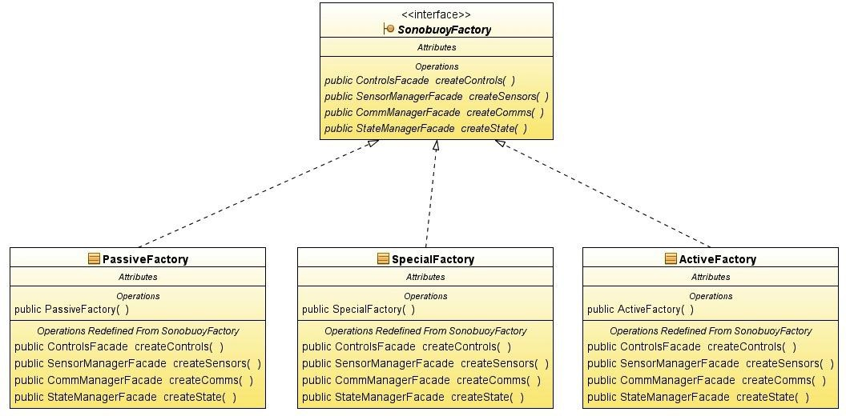

State
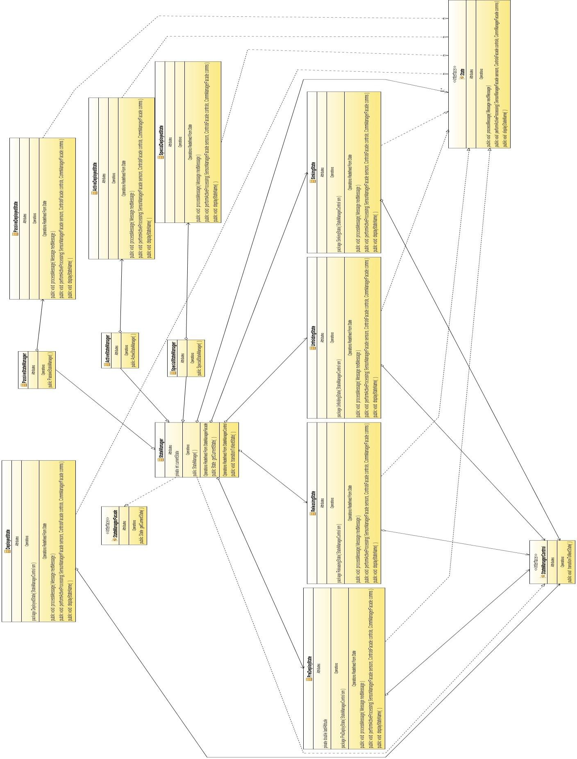

Main
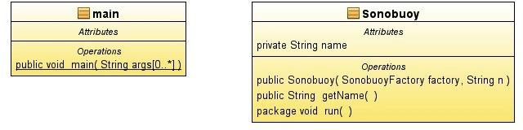

Configuration
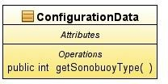

Comms

publicvoid sendMessage(Message m )
§ CommReceiver
Allribules p_riv_at_e_st_rin_g_na_m_e
operotions
publicCommReceiver(Stringname ) publicvoid receiveMessage(Messagem) publicboolean messagePending() publicString getName()
publicMessage getNextMessage()
§Antenna
Altr1bllles
Operations
publicAntenna()
Opera/ions Redefined FromComnNanagerFacade

publicvoid registerForMessage(CommReceiverrecClass)
publicvoid deregisterForMessage(CommRecer.-errecClass) publicvoid rece eMessage(Message m)
publicboolean messagePending( ) publicMessage getNextMessage( )
_L
«intertace»
loCommManaa_erFacade
Attribllles
OperJti0llS
pubilc vo,d dereg,slerForMessage(CommReceiver recC/ass J
public vo,d receiveMessage( Message m)
public void reg,slerForMessage(CommReceiverrecC/ass) public void sendMessage( Message m)
public booleanmessagePending(.)
public Message getNex/Message( )

§ Commsender
Attributes
privateStringname
Operations
publicCommSender(Stringname) publicvoid sendMessage(Messagem)
publicvoidregisterForMessage(CommRece errecClass) publicvoid deregisterForMessage(CommRece errecClass) publicString getName()

.
§Messa_g_e
Attributas
privaledoubledepth privaleint xCoord privaleint yCoord privaleint zCoord
privaleint bearingOfReturnSound privatefioatwaterTemp
Oper1,li0ris
publicMessage( doubledepth,int xCoord,int yCoord,int zCoord,int bearingOfReturnSound,fioal waterTemp) publicMessage(Message message)
publicdouble getDepth( ) publicint gelXCoord() publicint gelyCoord() publicint gelZCoord() publicint gelBearing( ) publicfioat getWaterTernp() publicvoid setDepth(int depth)
publicvoid geiXCoord(int xCoord) publicvoid getyCoord(int yCoord) publicvoid getZCoord(int zCoord) publicvoid setBearing(int bearing) publicvoid setWaterTemp(int walerTemp)

Controls

Sensors
