Dr. Rafiq Zakaria College for Women
Department of Computer Science
Departmental activities
2018 – 2019

- Guest lecture on Advances in DBMS was conducted on 15th Sep – 2018, the guest of honor was Dr. Mukta Dhopeshwarkar Asst. Prof. at Dr. BAMU, A’bad.
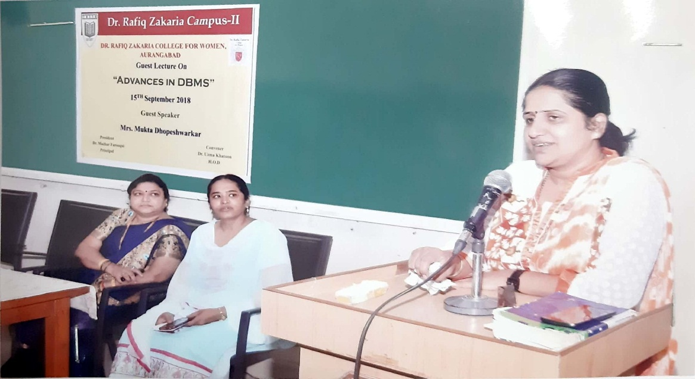
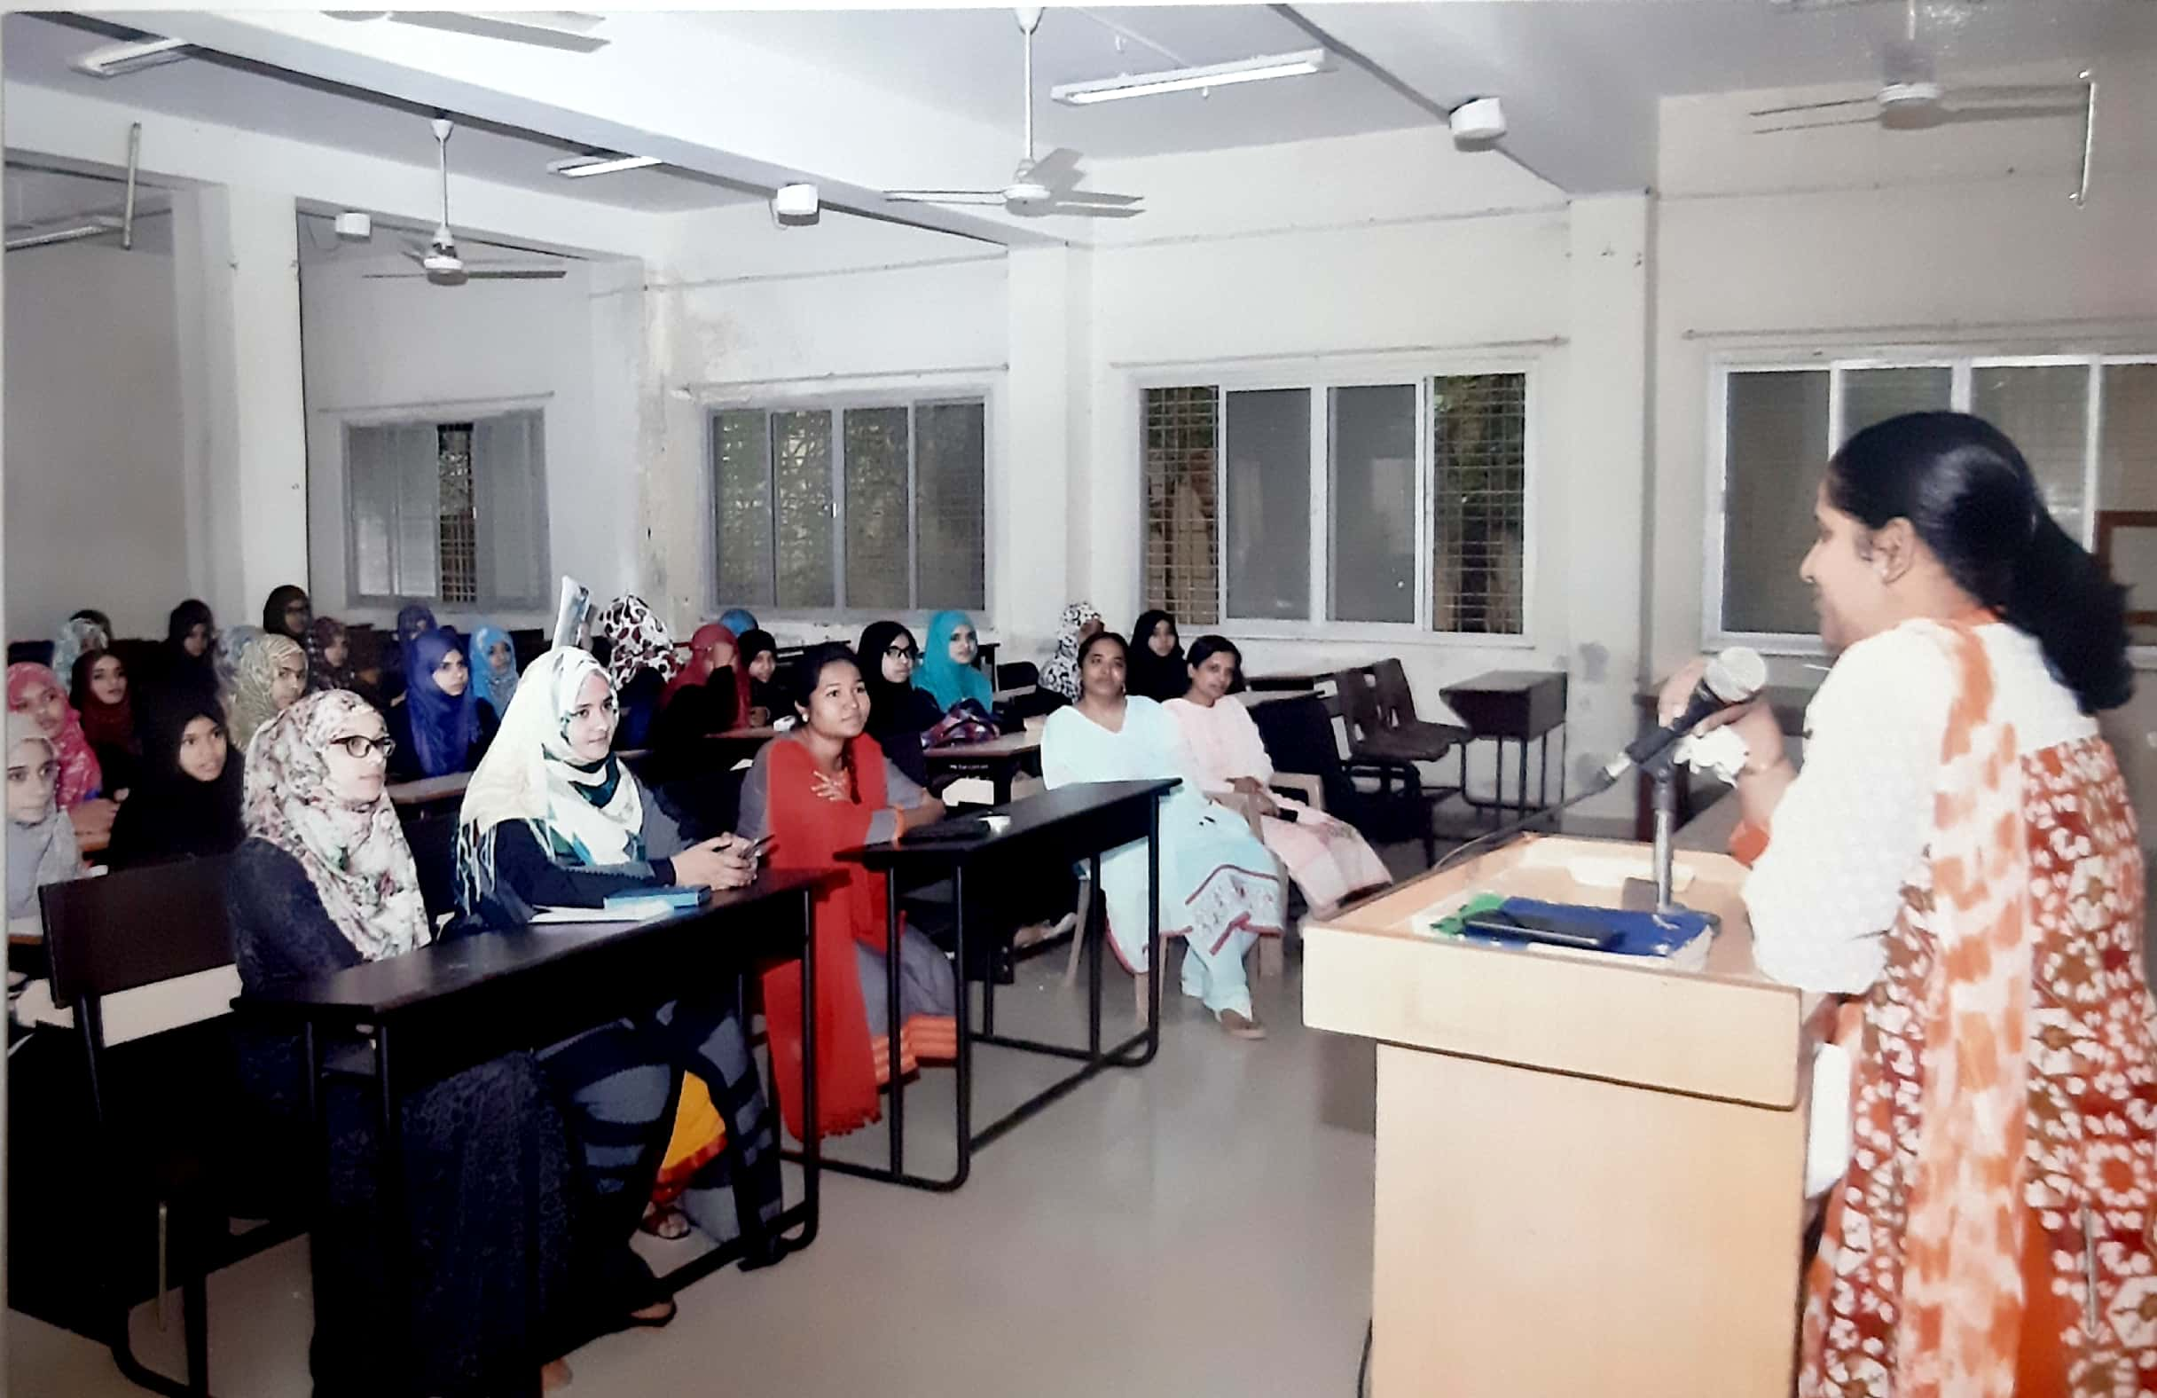
- Students of BCS have participated in Aurangabad district AVISHKAR 2018 organized by Dr. BAMU and M.S.P MandalsDeogri college, Aurangabad on 11th December.
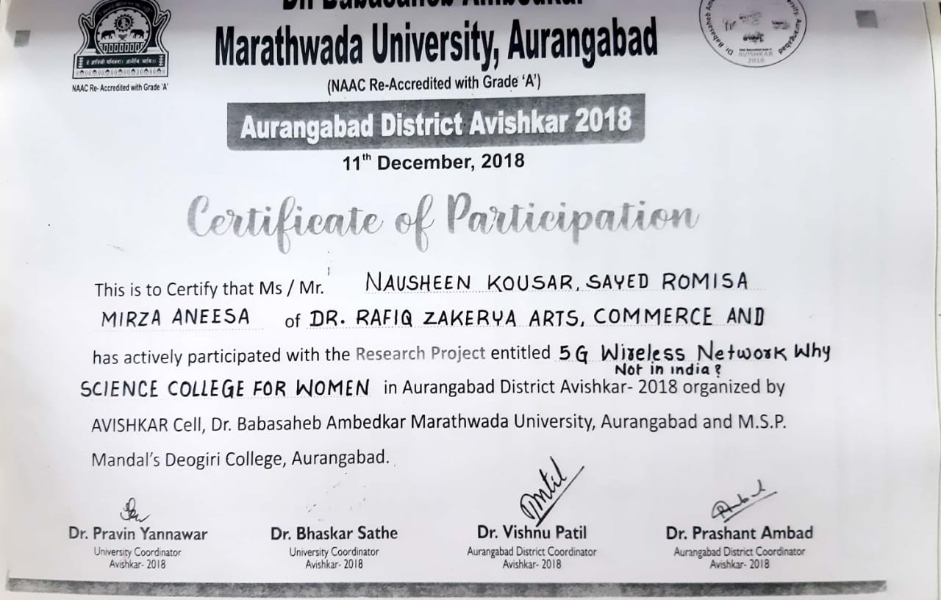

- Guest lecture on Internet of things (IOT) was conducted on 12th Feb 2019, the guest of honor was Dr. Bin- Naser Aziz Abdullah Asst. Prof. Sir Sayyed College, Aurangabad.
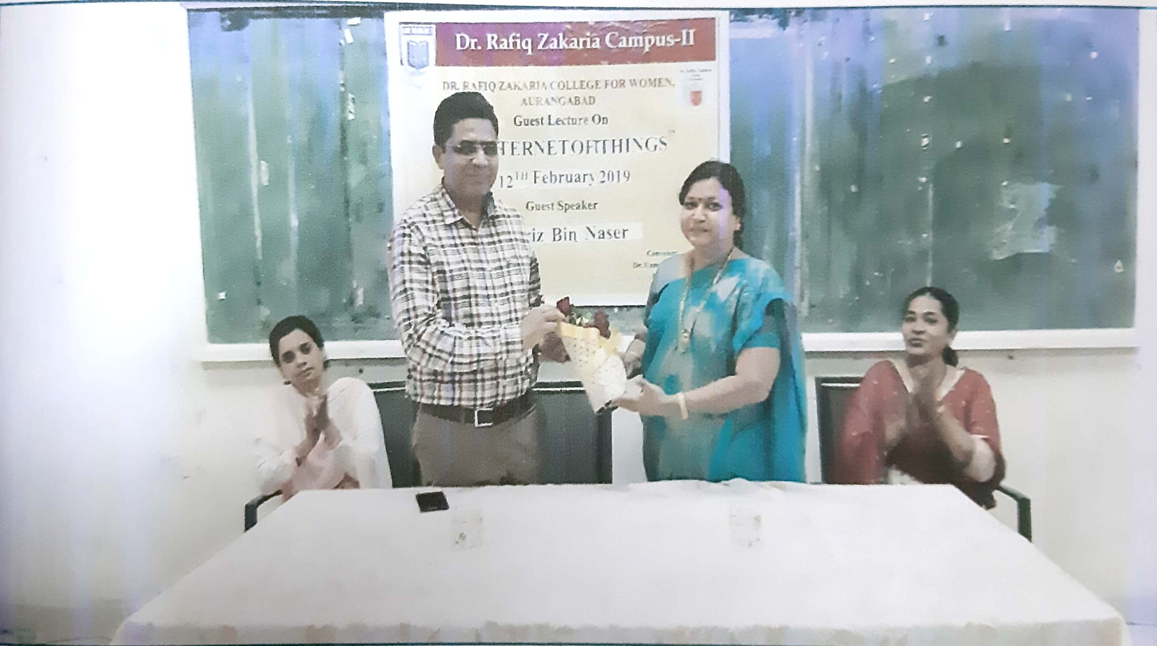

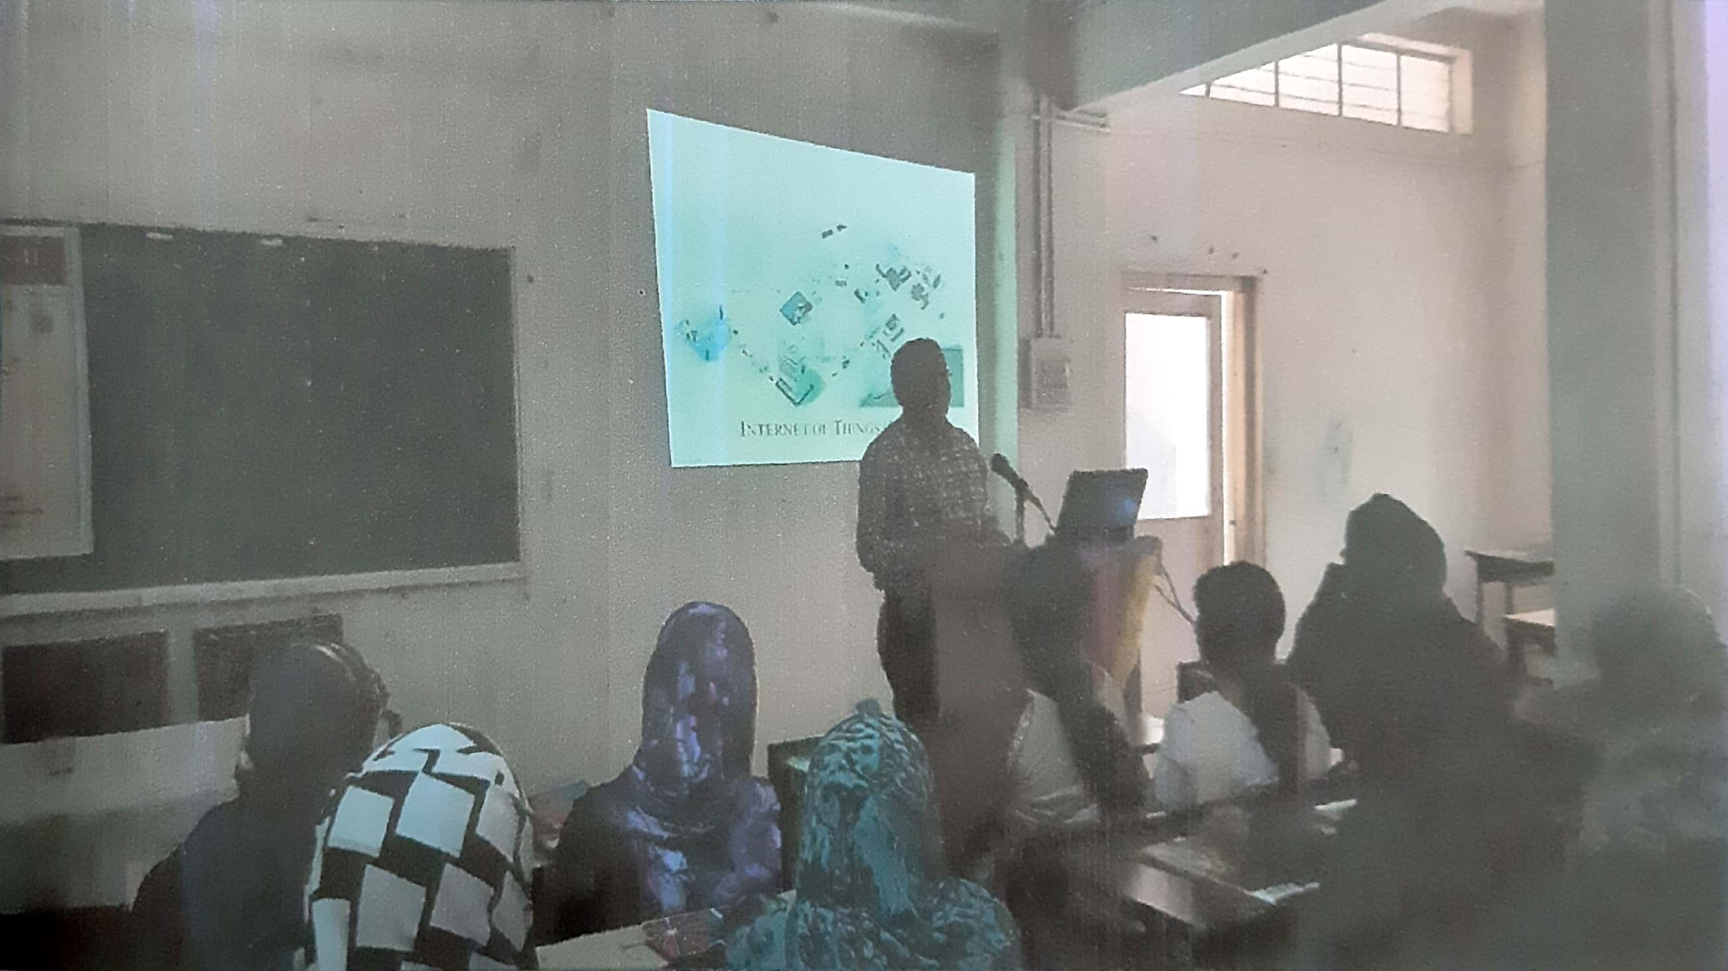

Dr. Khan UzmaKhatoon
H.O.D
Dr. Rafiq Zakaria Campus-II
Dr. Rafiq Zakaria College for Women
Navkhanda Jublee Park, Aurangabad
Computer Science Department

Departmental Activity Detail 2019-20

- Departmental Study Tour to Pulsi: To study Land Degradation and Soil Detection on 3-8-2019.
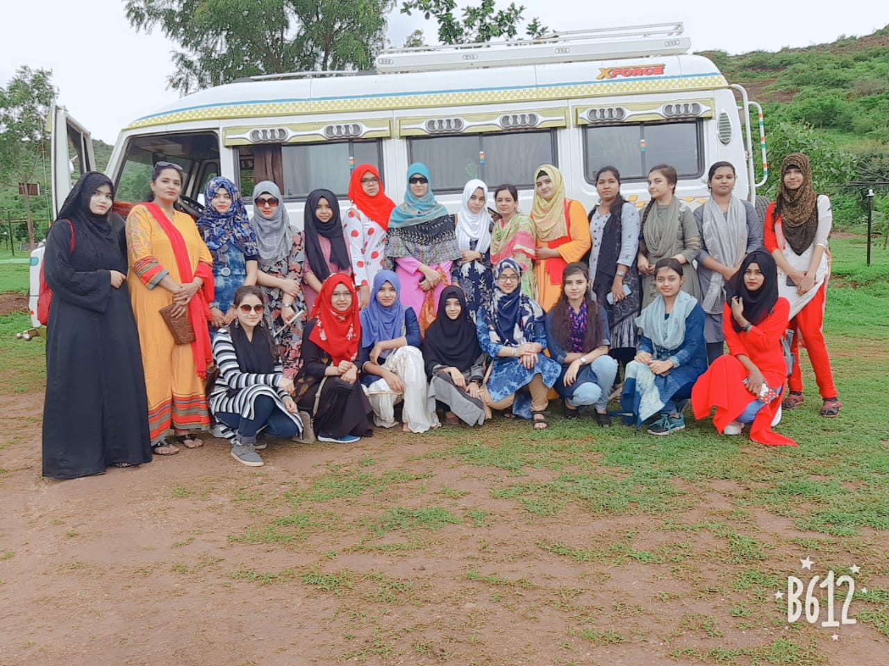

- Guest Lecture on “Operating System & Scheduling Algorithms by Dr. Mukti Eknathrao Jhadav Principal MIT College Aurangabad on 4-9-2019.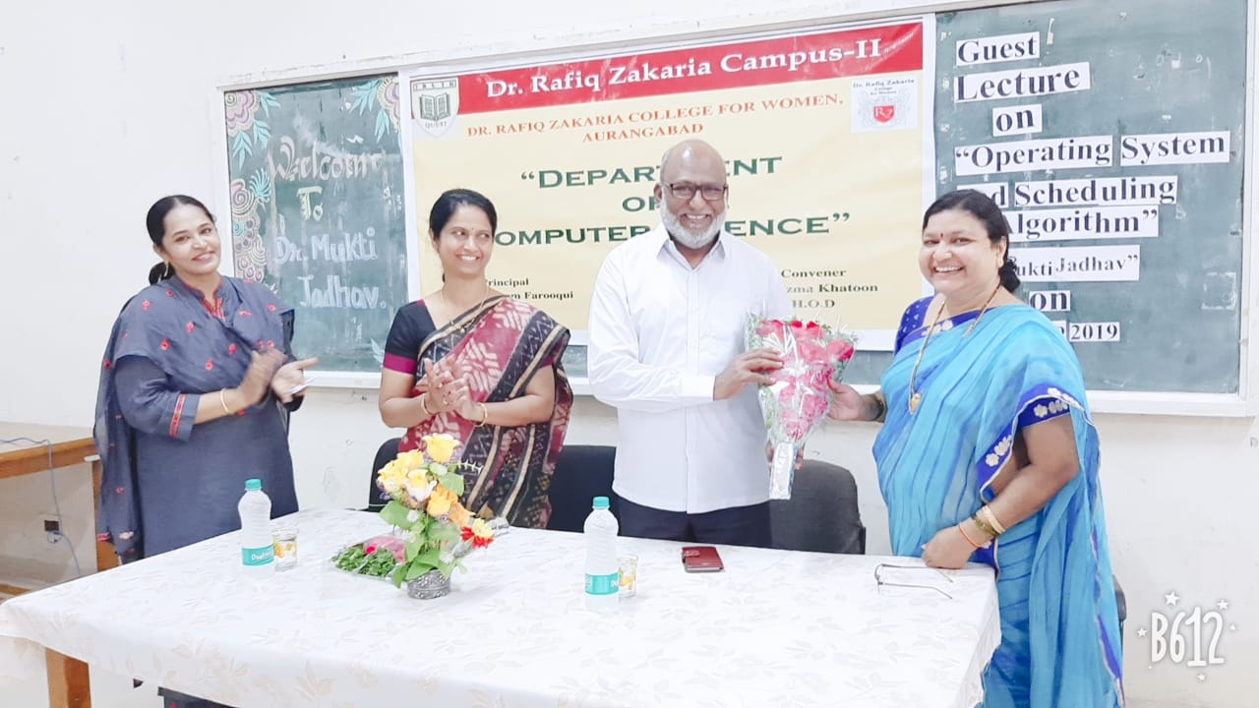

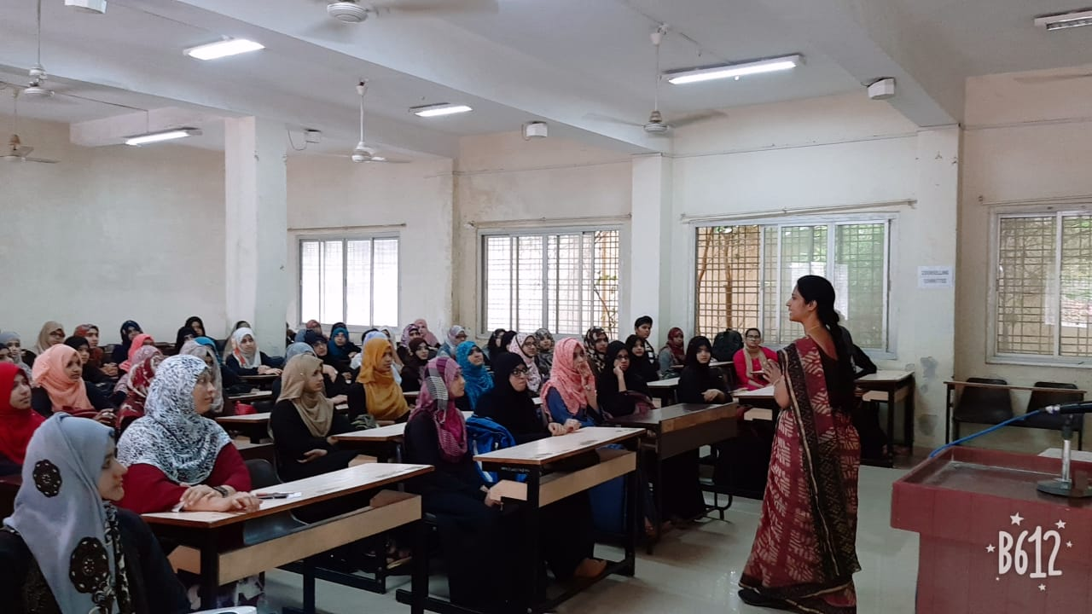

- Inter-College University level Poster Competition held on 14/9/2019. The Judges were Dr. Shobha K. Bawiskar Asst.Prof. Dept. of Digital and Cyber Forensics.Govt. Institute of Forensic Science Aurangabad and Mr. G. K. N. Awasthi Asst. Prof. Vivekanand College.

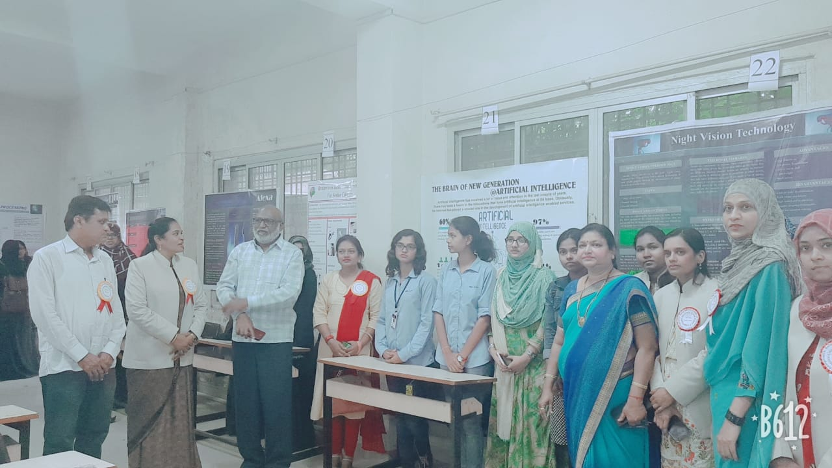

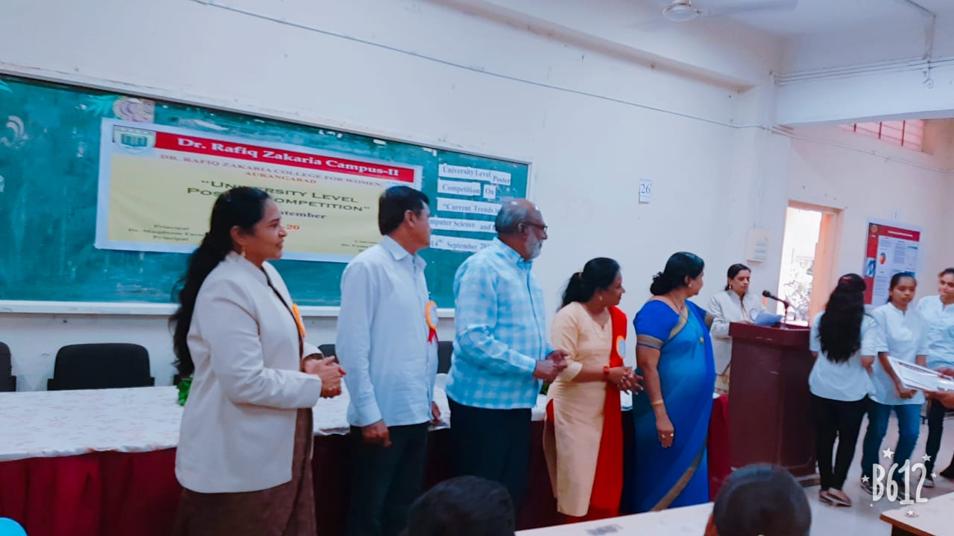

- Guest Lecture on “Statistical Methods & Software used to Analyze Data” by Dr. Mansi Baheti Asst. Prof. Computer Science & IT Dr. BAMU on 19-12-2019.
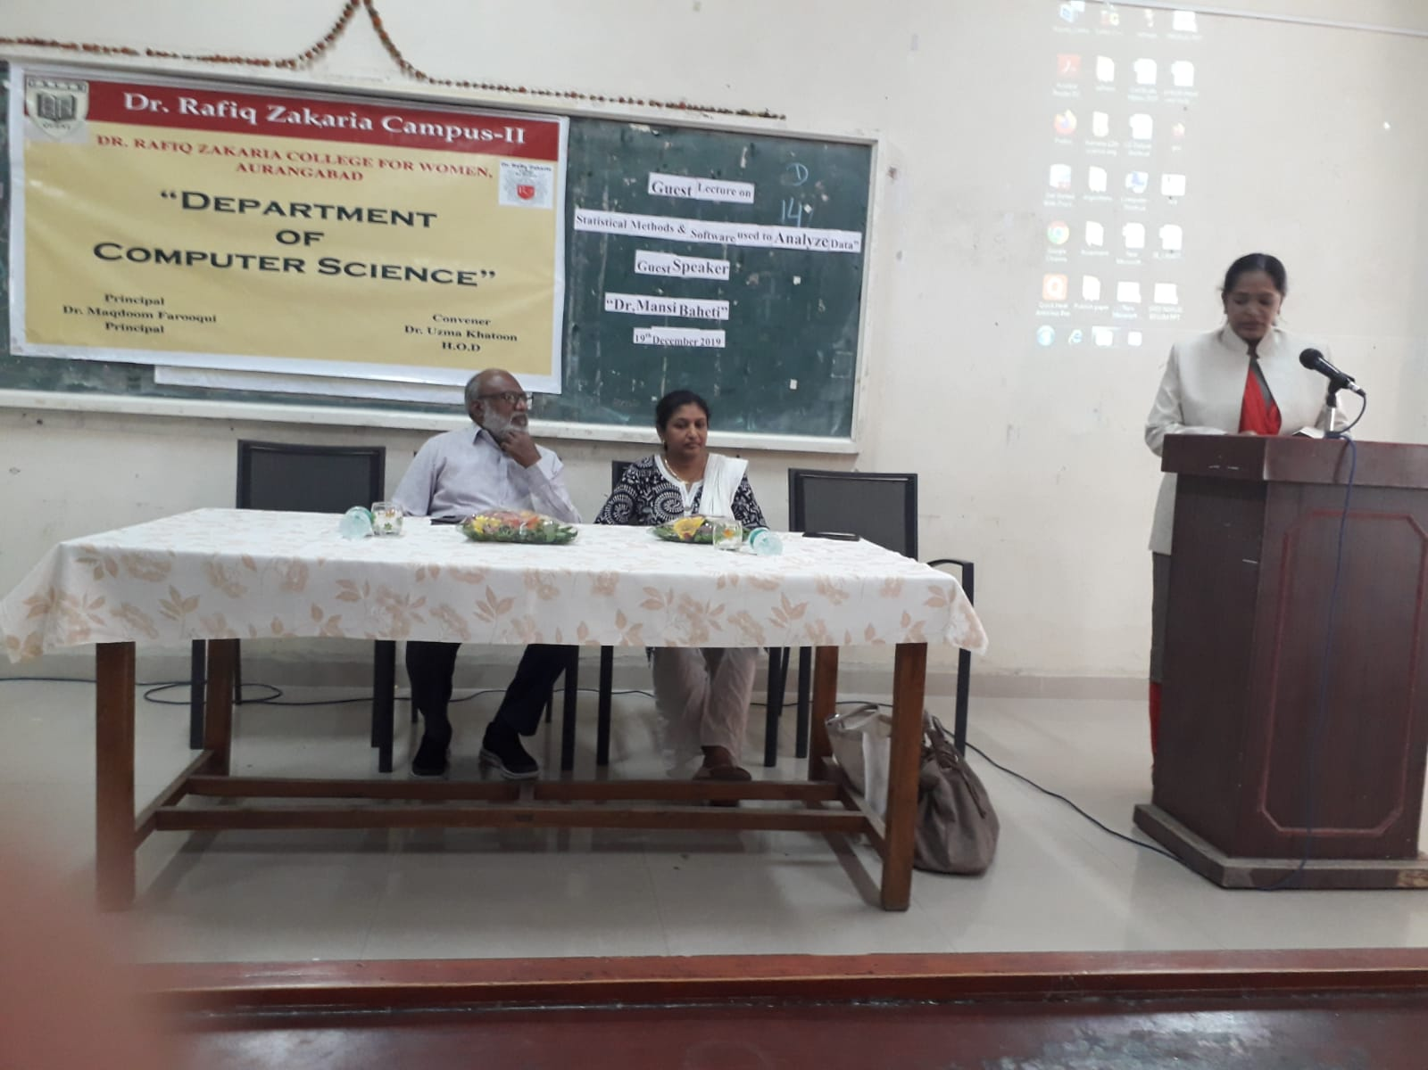
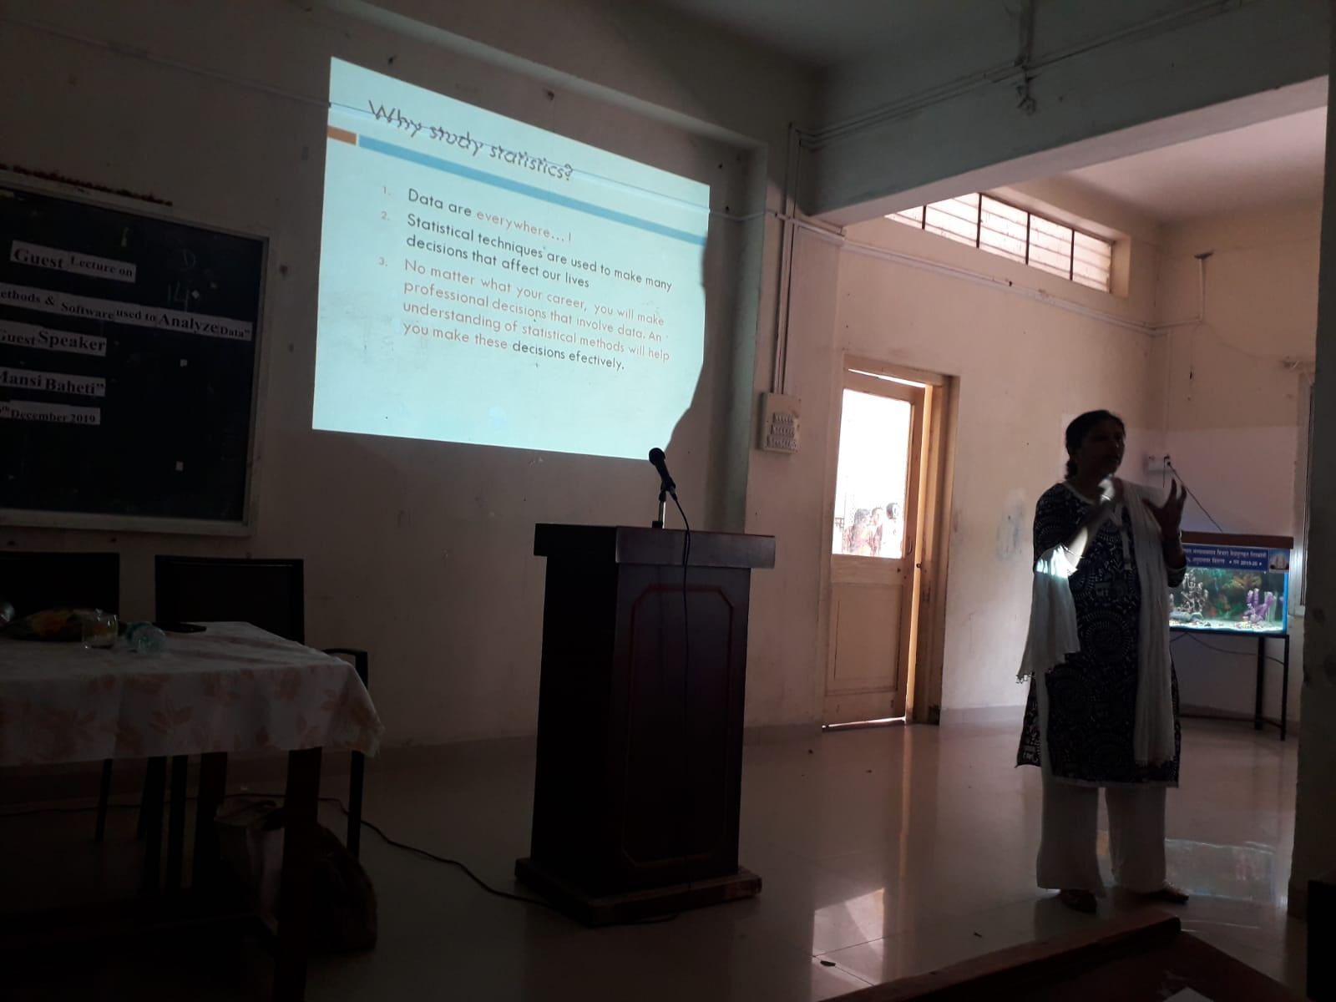

Dr. Khan UzmaKhatoon
H.O.D
Dr. Rafiq Zakaria College for Women
Department of Computer Science
Departmental activities
2020 – 2021

- Workshop on “Crimping and Fixing own Ethernet cable” by Shaikh Usama Hardware Engineer Maulana Azad college Aurangabad on 18th Oct 2020.
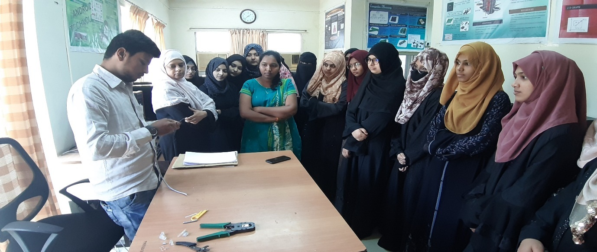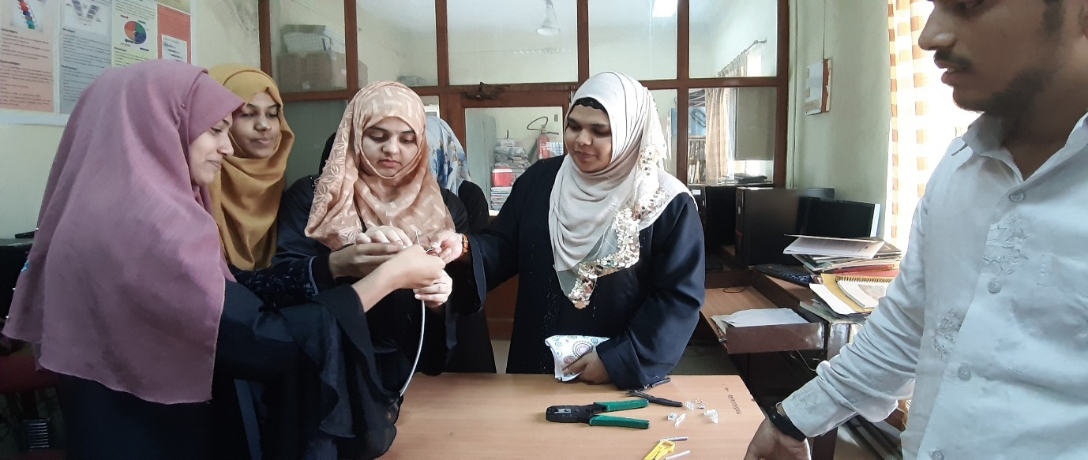

- Workshop on “Formatting and Installation of Windows 7 and 10” by Shaikh Usama Hardware Engineer Maulana Azad college Aurangabad on 29th Nov 2021.

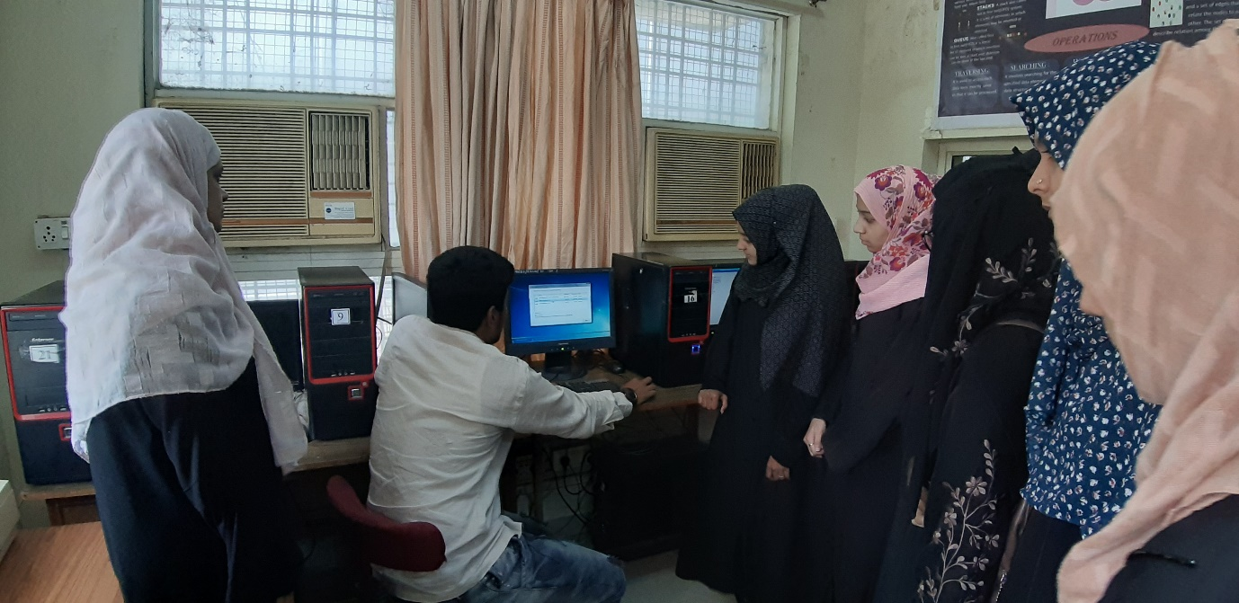

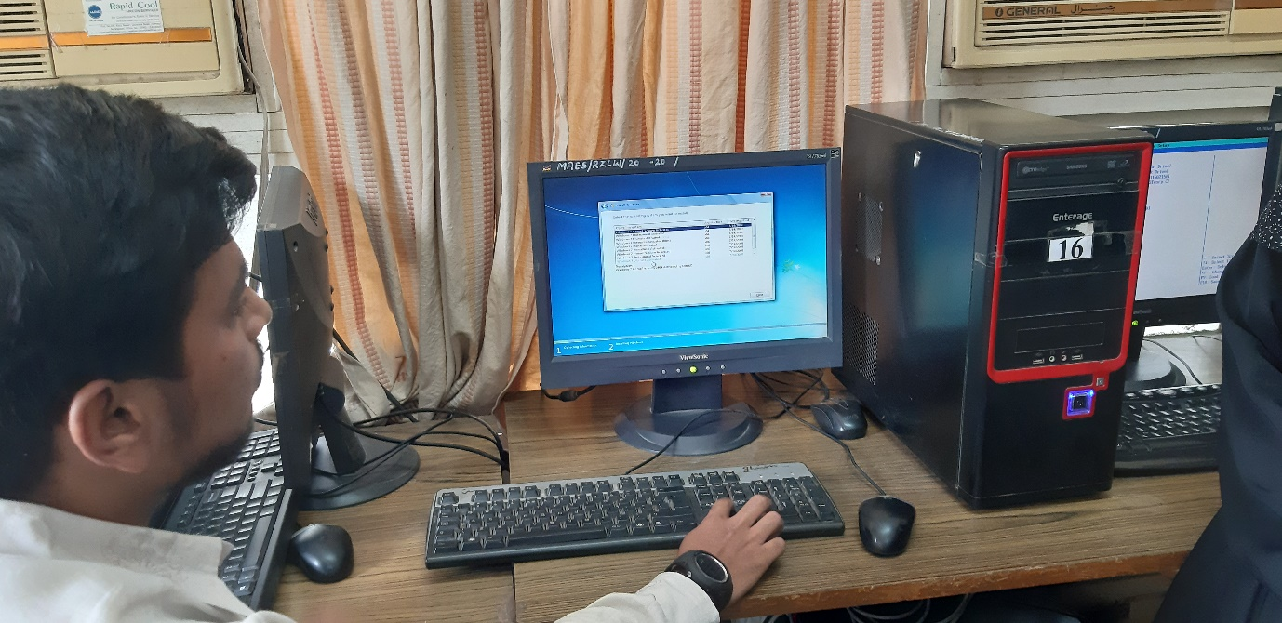

Dr. Siddiqui Bushra Zareen
H.O.D

