Dr. RAFIQ ZAKARIA COLLEGE FOR WOMEN, DR. RAFIQ ZAKARIA CAMPUS-ll NAVKHAND PALACE, JUBILEEAURANGABADM.S.

PART A: GENERAL INFORMATION AND ACADEMIC BACKGROUND 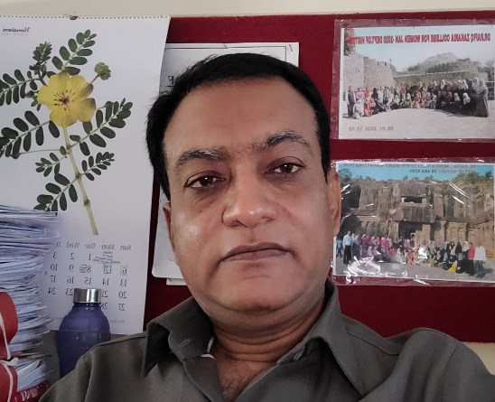

1. Name (in Block Letters): Dr. ABDULLAH BASIT CHAOUSH
2. Department : HISTORY
3. Current Designation & Academic Level : ASST. PROFESSOR
4. Address (With Pin code: Department of History, Dr. Rafiq Zakaria College for women, Navkhanda, Jubilee Park, Aurangabad Pin. 431001 M.S. India. Mobile No. : 9028212147
5. E-mail : abdullahchaoush@gmail.com
6. Academic Qualifications (UG & PG) : Examinations Name of the Board / University / Year of Passing Percentage of Marks Obtained /Division / Class / Grade Subject:
1. U.G. Dr. B.A.M.U. Aurangabad Mar/Apr 1988 55.20%II History, Sociology & Urdu
2. P.G. MANUU, Hyderabad 2008 69.50% I History.
3. P. G. Dr. B.A.M.U. Aurangabad 1993 50.50% II History
4. Research Degree(s):
Degrees---- Title------ Date of Award------ Name of University---- Ph.D. / D.Phil.:
“BHARTIYA SWATANTRA CHDWADIT MAULANA MAHEMUDUL HASAN YANCHE YOGDAN”
5 Th October2007 - Dr. Babasaheb Marathwada University, Aurangabad. M.S.
5. Posts held after appointment at this institution:
Assistant Professor in History Department: 21-10-2016
6. Period of teaching experience: 6 YEARS
7. Fields of Specialization under the Subject / Discipline: Modern Indian History: Medieval Indian History
8. Human Resource Development Center Orientation / Refresher Course / FDP/ MOOC / One-Two week courses attended so far:
Name of the Course--- Place------ Duration---- Date--- Name of Organizer---
9. 121st Orientation Course programme Successfully Completed Grade-A UGC_ASC, Dr. Babasaheb Ambedkar Marathwada University, Aurangabad.
(Four Weeks) 01-10-2012 to 31-10-2012, UGC New Delhi & ASC Dr. BAMUA.
10. Refresher course in “Managing Online Classes and Co-creating Moocs: 2.0” Teaching Learning Ramanujan College University of Delhi (Online) 14 days 18.05.2020 to 03.06.2020 Govt. of India M.H.R.D. & Ramanujan College University of Delhi
11. Refresher course in “Managing Online Classes and Co-creating Moocs.0” Teaching Learning Ramanujan College University of Delhi (Online) 14 days 25.07.2020 to 10.08.2020 , Govt. of India M.H.R.D. & Ramanujan College, University of Delhi
12. One Week FDP Programme on “Open Sources Tools for Research” Teaching Learning Ramanujan College University of Delhi (Online) & MHRD Pandit Madan Mohan Malaviya NMTT 7 Days , 08.06.2020 to 14.06.2020 Govt. Of India M.H.R.D. & Ramanujan College, University of Delhi, & Madan Mohan Malaviya NMTT
13. One Week FDP Programme on Teaching Learning Ramanujan College University of Delhi (Online) & MHRD Pandit Madan Mohan Malaviya NMTT 7 Days , 23.06.2020 to 29.06.2020 ,Govt. of India, M.H.R.D. & Ramanujan College, University of Delhi, & Madan Mohan Malaviya NMTT

Department of History Learning Goals and Objectives
- Learning Goal: Students will analyze and demonstrate knowledge of the history, or change over time, of different regions of the world.
Objectives:
1. Examine the history of the India and the new nation.
2. Critique the domestic and foreign policy of the India.
3. Evaluate the historical importance of the all phases of Indian History.
4. Appraise the historical significance of modern India in the global arena.
5 Examine the historical significance of different cultures of the world.
6 Assess the historical importance of modern cultures.

- Learning Goal: Students will acquire and demonstrate skills in critical analysis of primary and secondary historical sources.
Objectives:
- Interpret documents, and other forms of evidence, in their historical context.
- Differentiate between historiographical theories and debates in the field.

- Learning Goal: Students will be able to develop in written papers well-reasoned historical arguments, supported by judicious use of sources.
Objectives:
- Formulate important historical questions.
- Articulate a persuasive and well-structured historical argument.
- Employ multiple forms of evidence in this historical argument.

- Learning Goal: Students will be able to articulate historical arguments orally.
Objectives:
1. Participate in debates and other forms of verbal historical discussion.
2. Deliver a historical presentation orally.
- Learning Goal: Students will be able to conduct intensive research in primary and secondary sources, and to complete a major research paper on an original topic.
Objectives:
- Conduct original research in published or unpublished primary sources
- Develop, under supervision, a substantial research paper.
- Engage in an ongoing process of writing and revision
4. Report orally on research and written work

Student Learning Outcomes
- The ability to demonstrate content knowledge of world cultures and their interconnection to global forces as they change over time.
- The ability to think historically: identifying the unique characteristics of past eras, articulating causality, and analyzing change over time.
- The ability to interpret in their historical contexts an array of primary sources, including manuscripts, artifacts, quantitative, oral or visual sources.
- The ability to engage critically with historical argument: identifying underlying theories, assumptions, and approaches.
- The ability to conduct original historical research using primary and secondary sources, and placing one’s own work within historical debates.
- The ability to communicate historical knowledge, interpretations, and arguments clearly in writing, oral presentations, or public history projects.

CHB TEACHER IN HISTORY DEPARTMENT

