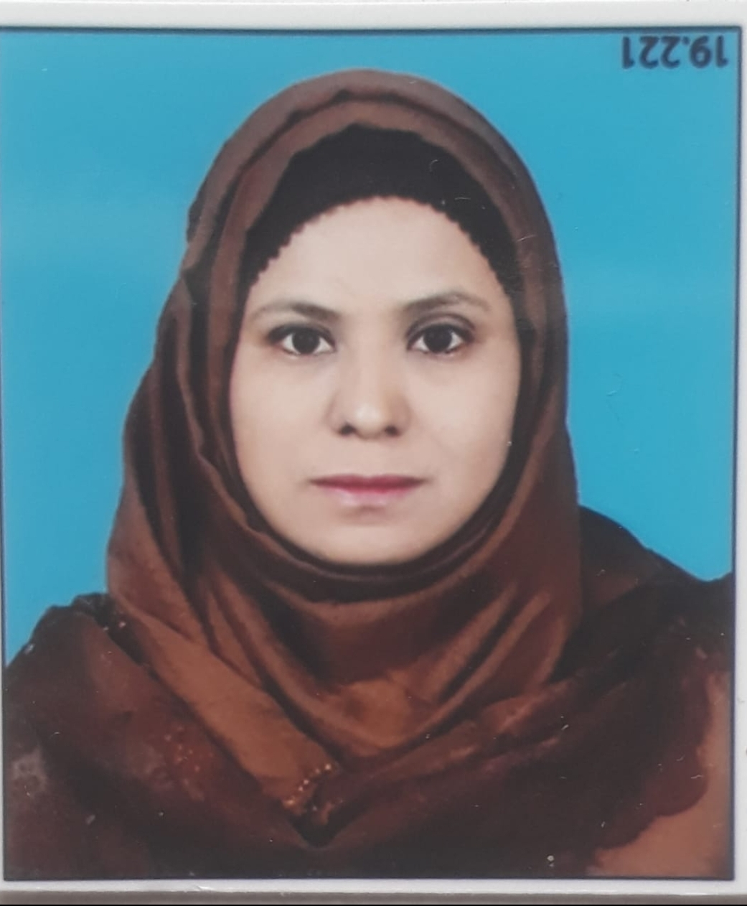
Curriculum Vitae.
Dr. Shaikh Kaneez Fatima
D/O Shaikh AbdulGaffar.
Address :- H. No. 5-1-50 mill Corner,
Barapulla Gate, Aurangabad.
Pin Code 431001.
Contact No :- 7769969646

Objective :- ( To accept challenges, dare to innovate and to utilise my skills to attain organization. Mission through sincerity, hard work, determination.)

General information
Name :-Dr. Shaikh Kaneez Fatima D/O Shaikh AbdulGaffar.

Address :- H. No. 5-1-50 mill Corner, Barapulla Gate, Aurangabad.
Pin Code 431001.

Contact No :- 7769969646

Email id:- dr.kaneezfatima07@gmail.com

Gender :- Female.

Nationality :- indian.

Religion:- Islam.

Cast :- Open.

Academic Qualification

___Examination___
SSC:- Borad/University:- MSBSHS
Subject:-Urdu.English,Marathi, Mathematics, History geography.
Year/Month:-Mar-1999
Division:-1st
Percentage:-63.20%
HSC:- Borad/University:- MSBSHSE
Subject :-Urdu , English, History, Political science.
Year/Month:- Feb, 2001.
Division:- 1st.
Percentage:-62.00%
B. A. :- Borad/University:- Dr. B. A. M. U. Aurangabad.
Subject :- Urdu, Political sciencee,Home Science.
Year/Month :- Mar-2004.
Year/Month :- Mar-2004.
Year/Month :- Mar-2004.

Division:-2nd.
Percentage:-56.88%.

B, ed:-
Dr. B. A. M. U. Aurangabad.
Subject:- Urdu, Geography.
Year/Month:- March 2011.
Division:-1st. .
Percentage:-62%

M. A. :-
Dr. B. A. M. U. Aurangabad.
Subject:-Urdu.
Year/Month:- March 2006.
Division.1st.
Percentage:- 73%

Phd:-
Dr. B. A. M. U. Aurangabad
Subject:- Urdu.
. Topic :- "Urdu Prose in Marathwada After Independence "

List Of Publications :-
(A)
1:-Kitabi Silsila No3, AalamgeerAalamgeer urdu AdabAdab.
"Chubti Hui Apnayat khaka Nigaar"
Page No 89.
2:-:- Kitabi Silsila No3, AalamgeerAalamgeer urdu AdabAdab.
"Sachaiyun ka Imandaar fankaar"
2015 Page No 112.

3:- Kitabi Silsila No 7,Noor ull Husnain: Shaksiyat Aur Adabi Jihaat.
"Noor Ull Hasnain Bhasiyat Afsana Nigaar " 2018. Page No 89.

One of my Article Published in daily newspaper Dated 30.04.2022.
Topic :- Akhbaaraat ki Taeekh, Ahmiyat, Manviyat O Ifadiyat.

(B)
List of Books /Reviews/Written :-

"Naya Afsana Naye Naam" By Noor ull Husnain.
ISSN-NO:- 978-93-8109-29-9

Year :-2012.

Page No 323

* Two Books are under publish.

Awards And Honours Received :-
1. International:-

2:- National :- 1
Padmshri Sikander Ali Wajd Urdu Paritoshik For Having Secured Highest Number of Marks in M. A Urdu Examination Held in March 2006.

Job Experience.

1:- I Have Working as an Assistant Professor (CHB) In Dr. Rafiq Zakariya College For Women Since 2012 to date.

2:- I Have been Working as a Compere Of Urdu Program SABRANG. in All India Radio Aurangabad Since 2006 to date.

Other Diplomas & Certificate Course :-
1:-
Diploma in Computer Software.
2:-N. S. S. Certificate :- completed Two years in NSS as a volunteer 2002/2004.

3:- Class 5th"Idaara e Imtehaan Deeniyaat" SIO Examination. jan1995. 2nd.
4:- Class 6th, Bombai Hindi University, Hindi pravash Pariksha 26.jan 1996.2nd.

5:-Class 7th Idaraa-Imtehaan
Mutallim Deeniyaat Awwal. 1st rank Nov 1997.
6:-Class 8th
"Majlees e Ishaat e islam Aurangabad". Deeniyaat Aug 1998.
7:- Class 11th
Mutala e Deeniyaat 1st.

Awards & Prizes.

1:- When I was a Second year BA student at Aurangabad College for Women, I won second prize in essay writing competition in 2002.

2:- When I was a third year BA student at Aurangabad College for Women, I won first prize in a debate competition. in 2004.

3:- When I was a third year BA student at Aurangabad College for Women, I won the first prize in baitbazi competition. In 2004.

4:-I have been working in Akashwani Aurangabad for the last 16 years.

* Many of my articles were broadcast on All India Radio.

* During this time I did many programs, including literary and social topics.

* I have Conducted many times the literary program "Bemisal adabi shaksiyat " and I have also participated in this program
Such as
1:-Quli Qutb Shah.
Date of Broadcast ......

2:-Bahadur Shah Zafar
Date of Broadcast .....

3:-Nazeer Akbar Abadi
Date of Broadcast .....

4:-Khwaja Mir Dard Date of Broadcast .....

5:-Maulana Abul Kalam Azad
Date of Broadcast ....

6:- Qurrat-ul-Ain Haider
Date of Broadcast ....
Etc.

*I have interviewed many writers and poets under the program name
"Main Aur Meri Qalamkari"
Such as, The poet,
* Shah Hussain Nahri,
Date of Broadcast....

Poet,
*Athar Aurangabadi,
Date of Broadcast....

* Poet, Rana Haideri,
Date of Broadcast....

Short story writer,

* Dr. Azeem Rahi.
Date of Broadcast....

Critic,
* Dr. Siddique Mohiyyudin.
Date of Broadcast....

Critic and commentator
* Dr. Irtekaz Afzal Khan.
Date of Broadcast...
Etc.

* I have interviewed the specialist doctors several times about various diseases under the program Jan Hai To Jahan Hai.

* I have presented programs many times for youth under the youth programme Karavan E Nawjawan program.

* I did and presented programs like Shagufta Bayani Meri, Science Nama, Bazm-e-Sukhan, Khilti Kaliyan etc.
* Many times I have written programs on Mujahideen Independence in view of 75 years of Independence Day celebrations like Shaheed Ashfaqullah Khan, Maulana Muhammad Ali Johar, Bhagat Singh, Maulana Abul Kalam Azad etc.
* I have directed the Women's Program. several times.
* Many times I have presented programs on famous women under the program of women historians such as Razia Sultana, Azizan Fatima Sheikh, Savtri Bai Phule, Amina Tayyab G, B Amman etc.
* I have done many programs on All India Radio under Baatein Filmon ki , such as "Hindustani Filmon mein ghazal"
* The role of Urdu writers and poets in Indian films,
Hubbul watni se sharsaar filmein. Hindustani Filmon mein Hasrat Jay Puri ki Naghma nigaari, Hindustani Filmon mein Majrooh Sultanpuri ka Kirdaar etc.
* I have directed the literary program Aina many times.
* This is certifieisd that that I have attended VANI Certificate Course at All India Radio Aurangabad From 16th June 2014 to 20th June 2014.
* I have Presented & Conducted The Special Programe on Padmshri Fatima Zakariya.
"Padmshiri Fatema Zakariya Ek Mayanaaz Shaksiyat "
Date of Broadcast . 08.04.04.2021.

