COP AND English Communication SKILLS PROGRM (Dept of English)
2016-2017
Enrolled students: 30
Activities:
20/12/2016: Poster Presentation (more than 20 students of B.A BSc and M.A English participated)
27/12/2016: Elocution Competition (students of Junior and senior college students participated)
There was an individual presentation on the topics My Ideal, My Favourite Season, My Favourite Author etc. on which students expressed their ideals eloquently.
The students were made to participate in Group Discussions on the Topic liked Global Warming, Trees, Our Best Friends, My Idea of Happiness etc. they also presented a Pair Work Conversation between the Bus conductor and Passenger, Public Librarian and customer, Vegetable vendor and Customer.
Movie Screening: 1. Life of Pi
2. Harry Potter and the Order of the Phoenix
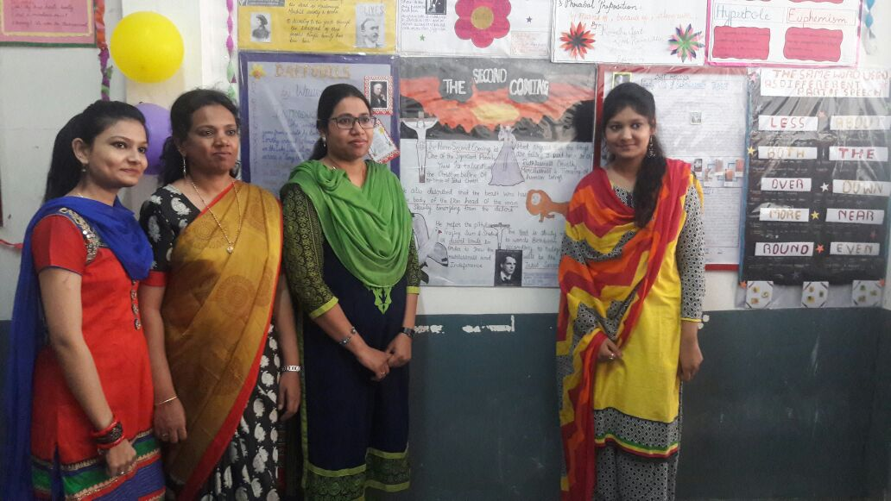
Poster Presentation

2017-2018
Enrolled students:27

There was an individual presentation on the topics My Ideal, My Favourite Season, My Favourite Author etc. on which students expressed their ideals eloquently.
The students were made to participate in Group Discussions on the Topic liked Global Warming, Trees, Our Best Friends, My Idea of Happiness etc. they also presented a Pair Work Conversation between the Bus conductor and Passenger, Public Librarian and customer, Vegetable vendor and Customer
Movie Screening: Around the World in 80 Days

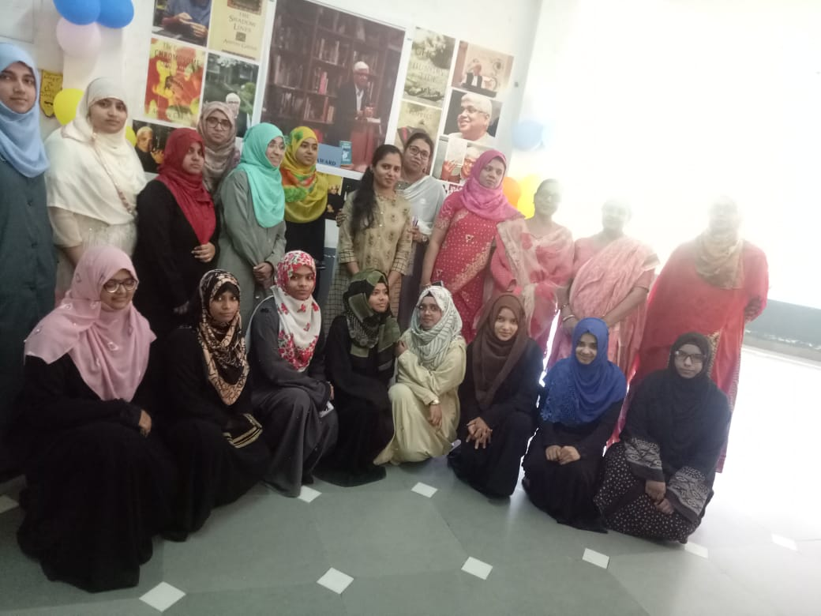

2018-2019
Enrolled students: 25
Activities:
31/07/2018 Guest lecture on Writing Skills
25/09/2018: My Corner Activity was inaugurated by Dr. Rupali Palodkar for developing creative writings among students.
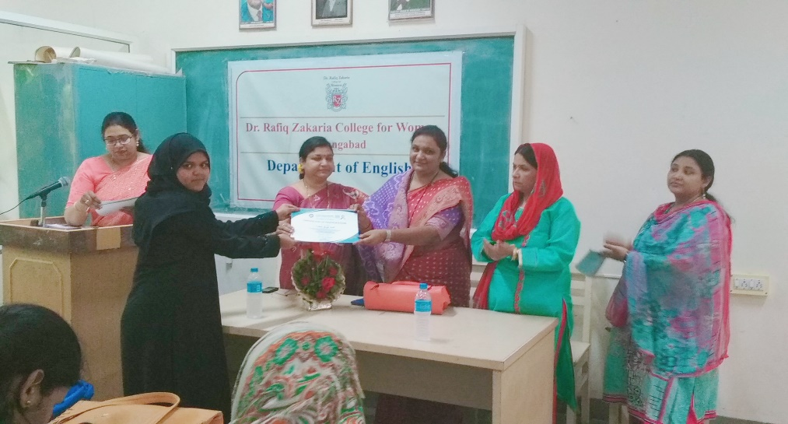

13/12/2018: Elocution Competition (students of Junior and senior college students participated)
11/01/19 Grammar PPT presentation by Dr. Nilofer Shakir
24/01/2019 Guest Lecture on Seminar skills by Dr. Abdullah Jilani

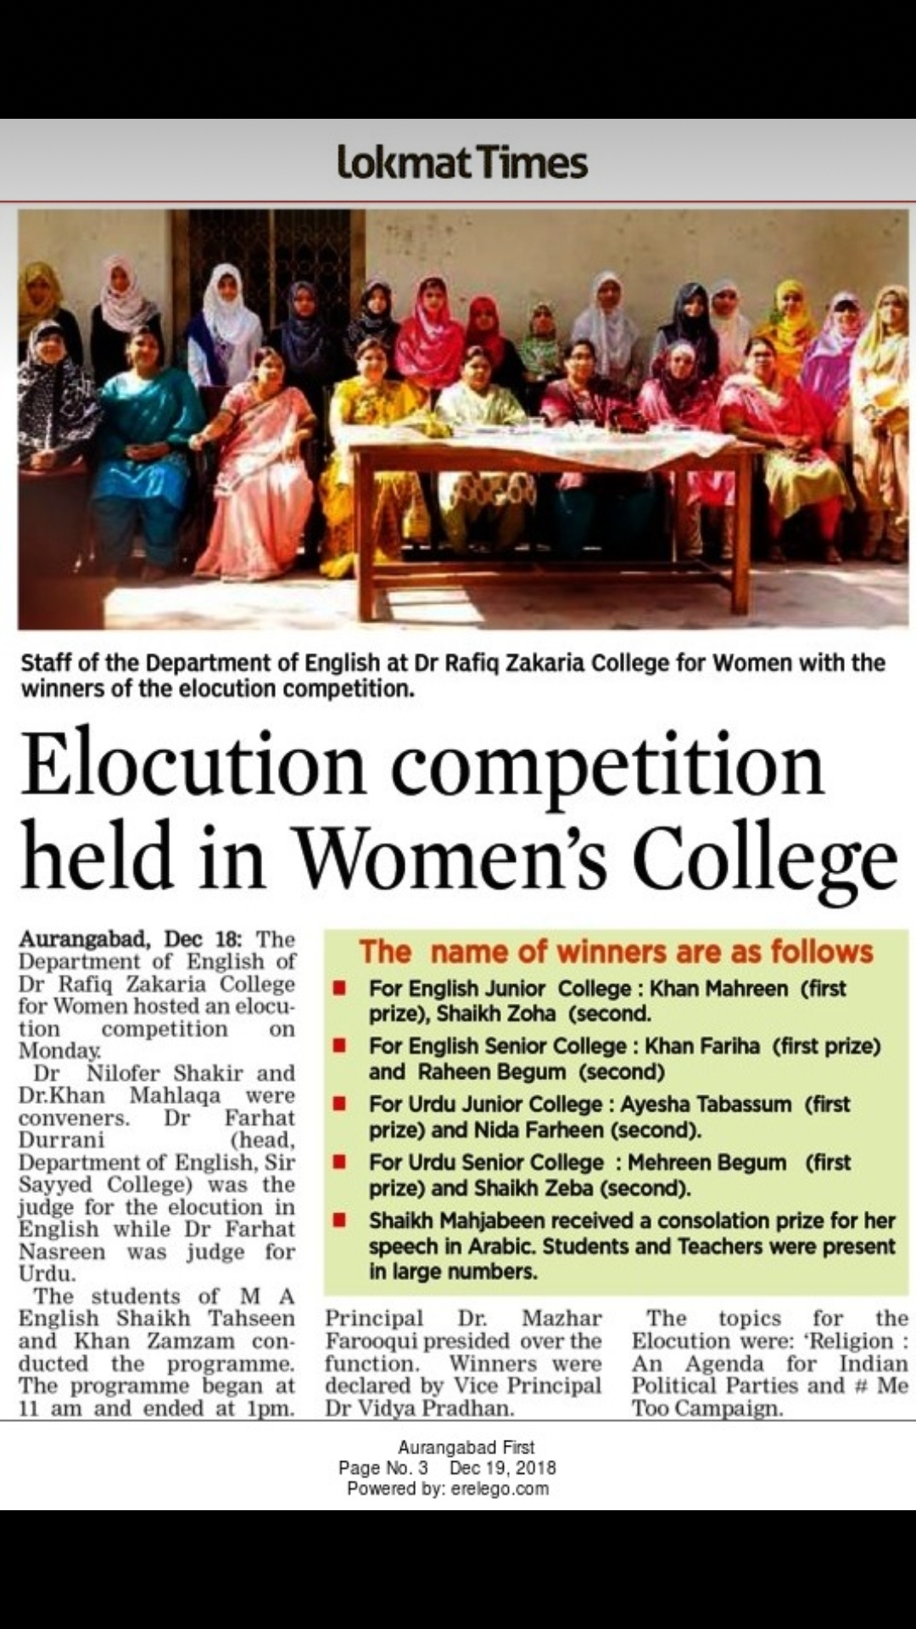

There was an individual presentation on the topics My Ideal, My Favourite Season, My Favourite Author etc. on which students expressed their ideals eloquently.
The students were made to participate in Group Discussions on the Topic liked Global Warming, Trees, Our Best Friends, My Idea of Happiness etc. they also presented a Pair Work Conversation between the Bus conductor and Passenger, Public Librarian and customer, Vegetable vendor and Customer.
Movie Screening: Born Free (students were asked to write review )

2019-2020
Enrolled students: 26
There was an individual presentation on the topics My Ideal, My Favourite Season, My Favourite Author etc. on which students expressed their ideals eloquently.
The students were made to participate in Group Discussions on the Topic liked Global Warming, Trees, Our Best Friends, My Idea of Happiness etc. they also presented a Pair Work Conversation between the Bus conductor and Passenger, Public Librarian and customer, Vegetable vendor and Customer.
The small videos on English pronunciation, Grammar and Writing skills were also sent to the students for the development of English language skills.

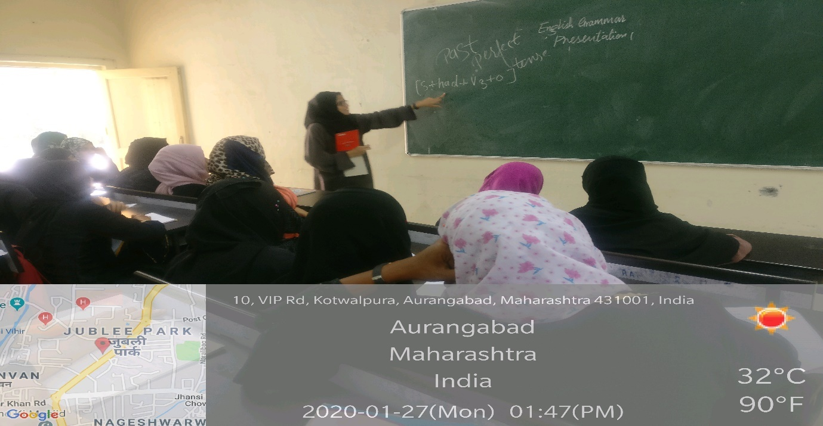

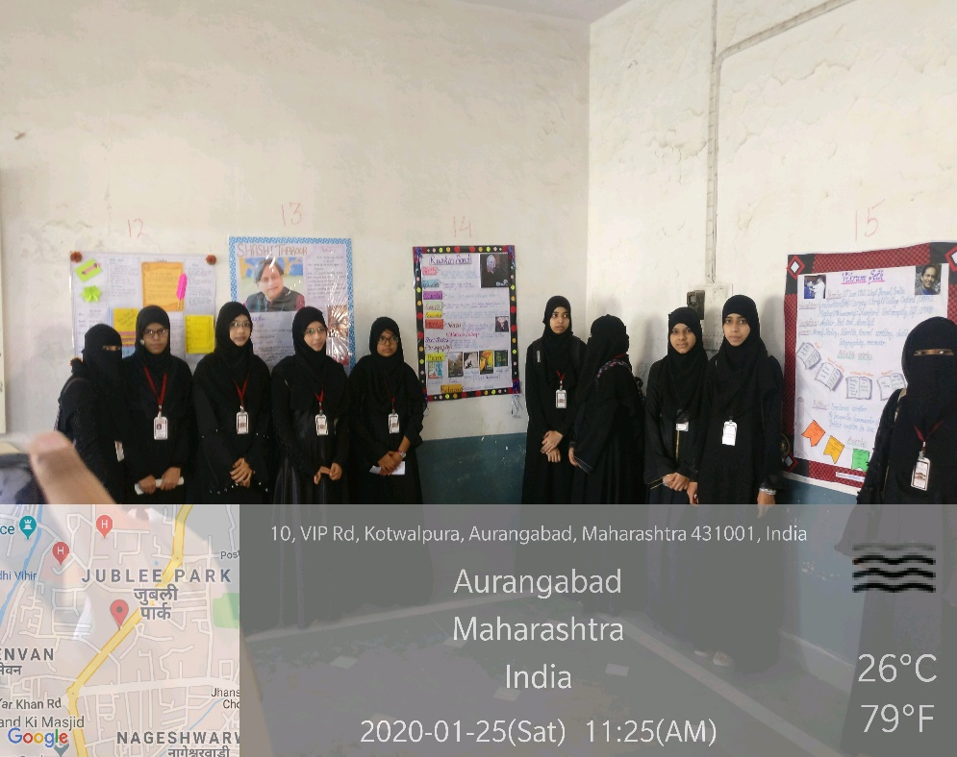

\

2020-2021
Enrolled students:30
Activities:
Due to the covid 19 pandemic most of the lectures were engaged online. The department also organised An Online Course in Communication skills specially for the students of BA/BSc First year from 7/12/2020 to 12/12/2020. The small videos on English pronunciation, Grammar and Writing skills were also sent to the students for the development of English language skills in collaboration with Sir Sayyed College of Arts Commerce and science, Aurangabad
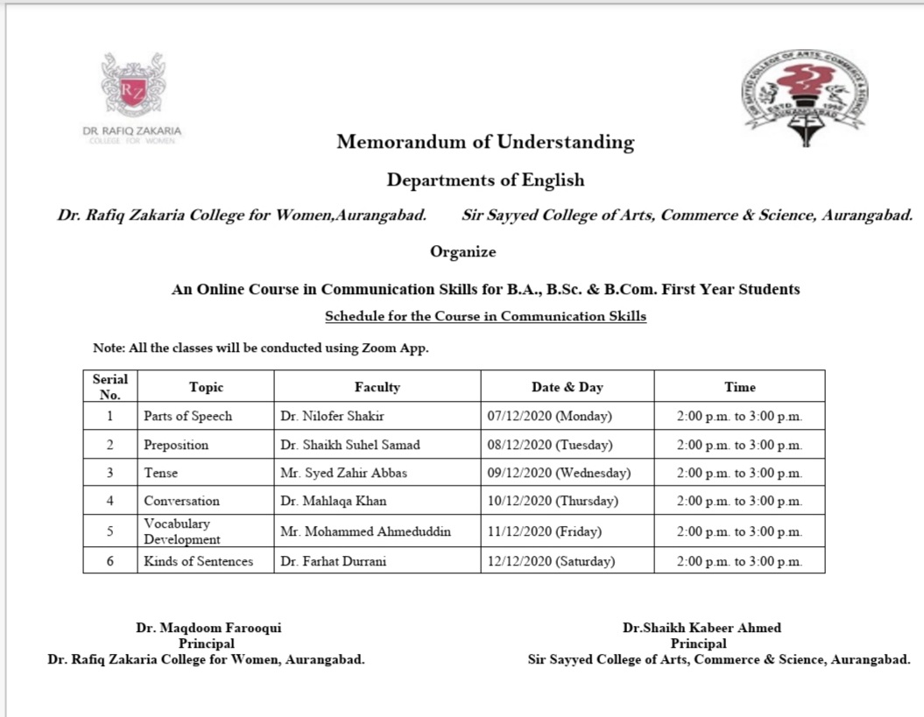
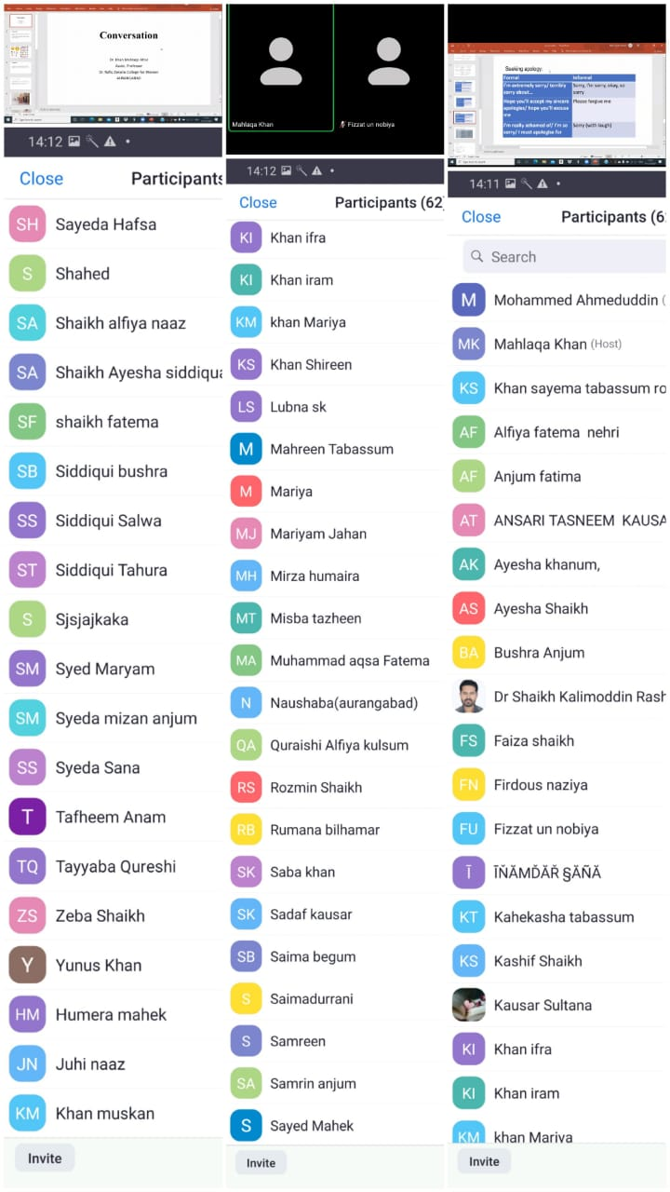

2021-2022
Enrolled students:30
Activities:
12/02/2022Online guest lecture by Dr. Shilpa Deshpande on Personality Development and Communication skills
17/02/2022 A guest lecture by Inamdar Sayed Mehboob sir from Lokmat times onNews Writing.
There was an individual presentation on the topics My Ideal, My Favourite Season, My Favourite Author etc. on which students expressed their ideals eloquently.
The students were made to participate in Group Discussions on the Topic liked Global Warming, Trees, Our Best Friends, My Idea of Happiness etc. they also presented a Pair Work Conversation between the Bus conductor and Passenger, Public Librarian and customer, Vegetable vendor and Customer

