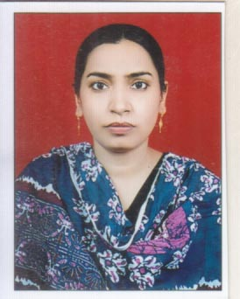

Biodata
Dr. Quadri Firdose Basheer
Assistant Professor
Department of Physics
Dr. Rafiq Zakaria College for Women, Aurangabad.
Mobile No. 9730960361
Email id: firdose_q@rediffmail.com

An active assistant professor and researcher in the subject of Physics with a teaching experience of 12 + years to undergraduate and post graduate students. She is the active member of different college committees. Has published about 30 research papers in different national and international journals of repute. She has authored one book on Quantum Mechanics and is, an active life member of Indian Science Congress and Indian Association of Physics Teachers.
Education:
Passed her MSc from University of Pune presently known as Savitribai Phule Pune University, in the subject of Physics with a distinction grade and, then cleared her SET examinations. Since then she is working as an Assistant Professor in the department of Physics, Dr. Rafiq Zakaria College for Women, Aurangabad (MS).Obtained her PhD in dielectrics of matter from Dr. Babasaheb Ambedkar Marathwada University, Aurangabad.
Expertise:
Her area of research is dielectrics of materials, nanomaterials and thin films.

