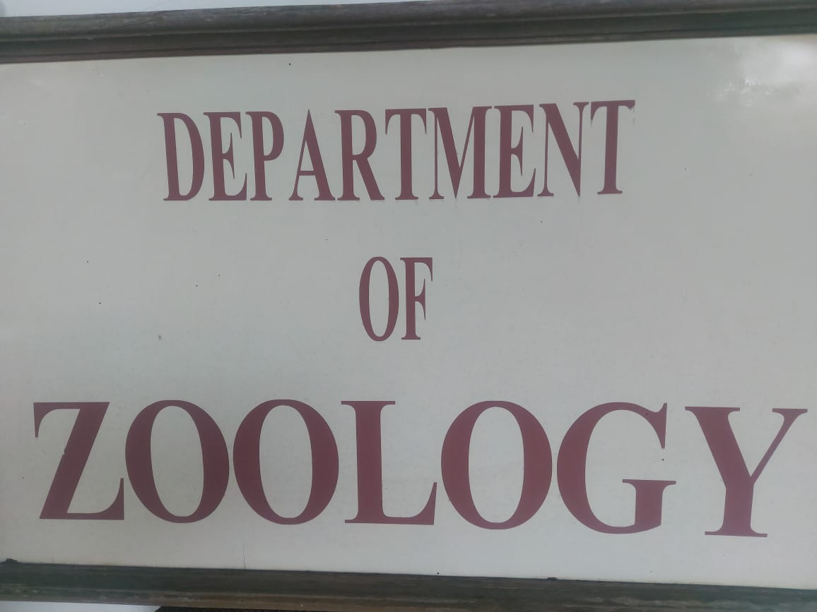

ZOOLOGY DEPARTMENT
2020-21
Sericulture lecture | Silk worm Rearing 29 Nov 2020
Dr. Salim Ali Lecture Series (Inauguration) | 12 Nov 2020
Bird watching (Jayakvedi Bird Scantuary) | 20 Feb 2021
Celebration of wild Life Week | 6 Oct 2020
AID’S Day (Poster Exhibition) | 3 Dec 2020
Visit to Aquarium | 18 Nov 2020
Study Tour to Siddharth Garden | 18 Nov 2020
Sericulture Visit to KiKat Jalgaon (small scale Farmers) | 19 Nov 2020
Blood Group Testing | 1 Dec 2020
Anti-Dengue Poster Exhibition | 15 Feb 2021
Vermi Composite (Farmers) | 21 Nov 2020
Bee-Keeping (Importance for Healthy Fruit Growing for Farmers) | 29 Jan 2021
Group Discussion | 7 Jan 2021
Seminar on Time Management | 17 Nov 2020
Applied for Certificate Course in Beekeeping (YCMU) Nasik | 27 Nov 2020
National Seminar on  “ Multi-Disciplinary Approach in Research” March 2020 in Collaboration with analytical chemistry Teacher’s & Research’s Association | (9 Feb 2020)
National Conference on “Recent Developments in Life Science” | 23 Feb 2020

Best Practice
- Fund For AID’S Effected Children.
- Aware Various Diseases & Environment Consecration.
- Various Composite.

NSS Activities
2020-21

Eye Checkup Camp | 6 Jan 2021
Blood Group Testing | 2 Dec 2020
Gandhi Jayanti Celebration | 2 Oct 2020
Constitution Day Celebration | 2 Oct 2020
Nam Vistar Diwas Celebration | 14 Jan 2021
Blood Bank Visit
Dental Check of
- Nutan Madhanj School
- Hebibs School (120 Student Participate)

“COVID-19”
Prof. Arun Sankrit Farmer V.C University of Reyashthan700 Registration
Phenyl Preparation by NSS Volunteers Distributed.

Women Cell 2020-21

- Visit To Begumpura Police Station - 24 Oct 2020
- Nutritional Balanced Diet Reciepe - 10 Nov 2020
- Exhibition on “Preparation of Home Decoration - 19 Oct 2020
(Interior Design)
- Women Empowerment Lecture Dr. Mubeen Zehera - 20 Jan 2021
(Dept of History) Delhi University.
- Visit of Dattaji Bhale Blood Bank- 12 Dec 2020
- Rangoli AID’S Awareness- 4 Dec 2020

