1. Creating and Renaming Files/Directories

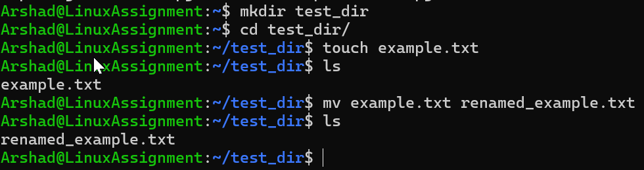

Step 1: Created test_dir with mkdir command (mkdir test_dir)

Step 2: Changed directory to test_dir with cd command (cd test_dir)

Step 3: Created empty file name example.txt with touch command (touch example.txt)

Step 4: renamed example.txt to renamed_example.txt with mv command (mv example.txt renamed_example.txt)

2. Viewing File Contents

Used cat /etc/passwd to view content in passwd file

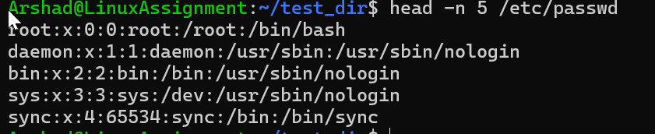

Used head -n 5 /etc/passwd to view first 5 lines from passwd file (-n is option for defining number of line required)

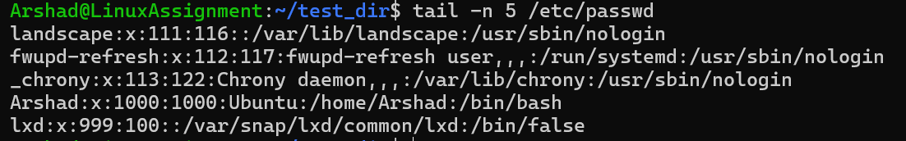

Used tail -n 5 /etc/passwd to view last 5 lines from passwd file

3.Searching for Patterns



Used cat /etc/passwd | grep root to find line containing “root“ in /ect/passwd

4. Zipping and Unzipping

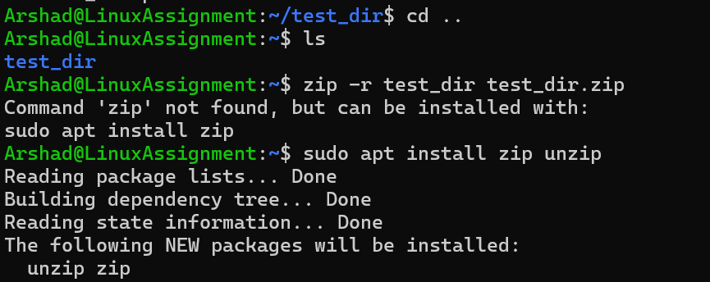

Used cd.. to change directory to move out of test_dir and entered zip which says zip unzip package not available.

Installed zip command using sudo apt install zip unzip (sudo is super user do and apt is ubuntu package manager used to install packages)

Entered zip -r test_dir.zip test_dir command to zip test_dir into test_dir.zip test_dir ( -r is option for recursive to zip internal files and dir

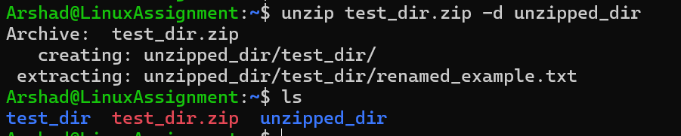

Entered unzip test_dir.zip -d unzipped_dir to unzip test_dir.zip in to unzipped_dir ( -d is option for destination

5. Downloading Files

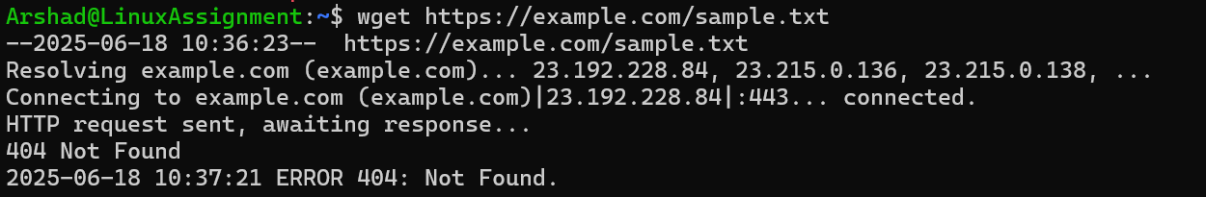

Used wget and given URL to download file however it shows not found

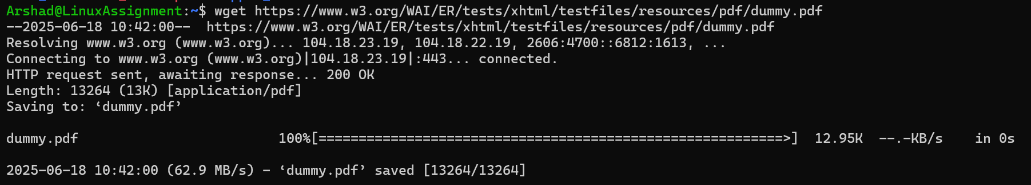

Wget worked with other URL file download successfully

6. Changing Permissions

Step 1: Created empty file secure.txt with touch command (touch secure.txt) and checked permission with ls -l secure.txt ( list command with -l option to view details of a file mentioned)

Step 2: Used Chmod 444 secure.txt chmod used to change permission, 4 is read only permission applied to user groups and other.

7. Working with Environment Variables

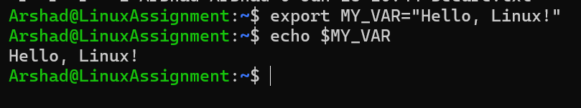

Export is used to assign a value to env vairiable

Used export MY_VAR=“Hello, Linux!“ to assign =“Hello, Linux!“ value to MY_VAR

Used echo $MY_VAR to view value in MY_VAR variable using $