**Checkpoint #3**

1. In the last two weeks we have proposed the abstract and written the research questions. Including how the application can be improved from its previous versions. Determined the data mining technologies need to be used for visualizing the data. We have represented them through graphs, and even took the sample screenshots of how the result looks like.

The data is collected from the open sources provided and stored in excels sheets for analyzing them. Text Mining is the data mining technology used here more analyzing the numeric data which is more important in this application.

1. In the next two weeks we will be submitting the excel sheets where the data has been stored and also how the text mining technology helps to evaluate the numeric data. Here are some of the screen shots and graphs :



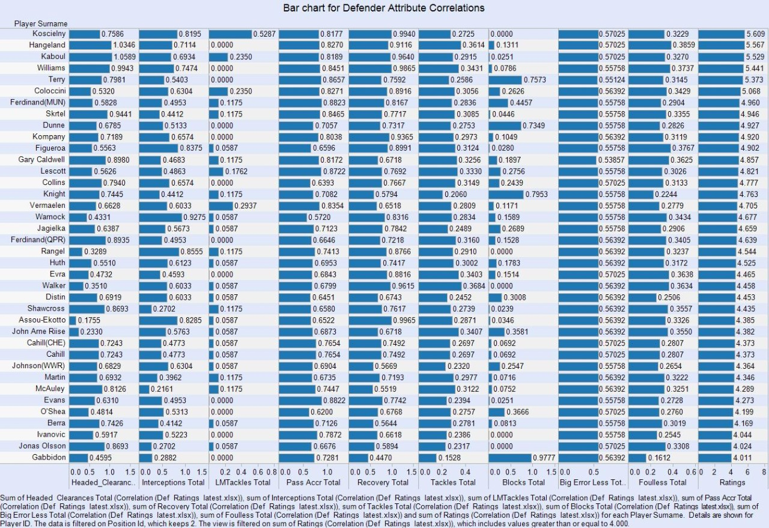

And also how the Apriori Algorithm used in this project for analyzing the player’s data. For possessing the ball in the in different phases matching all the events that can be performed.

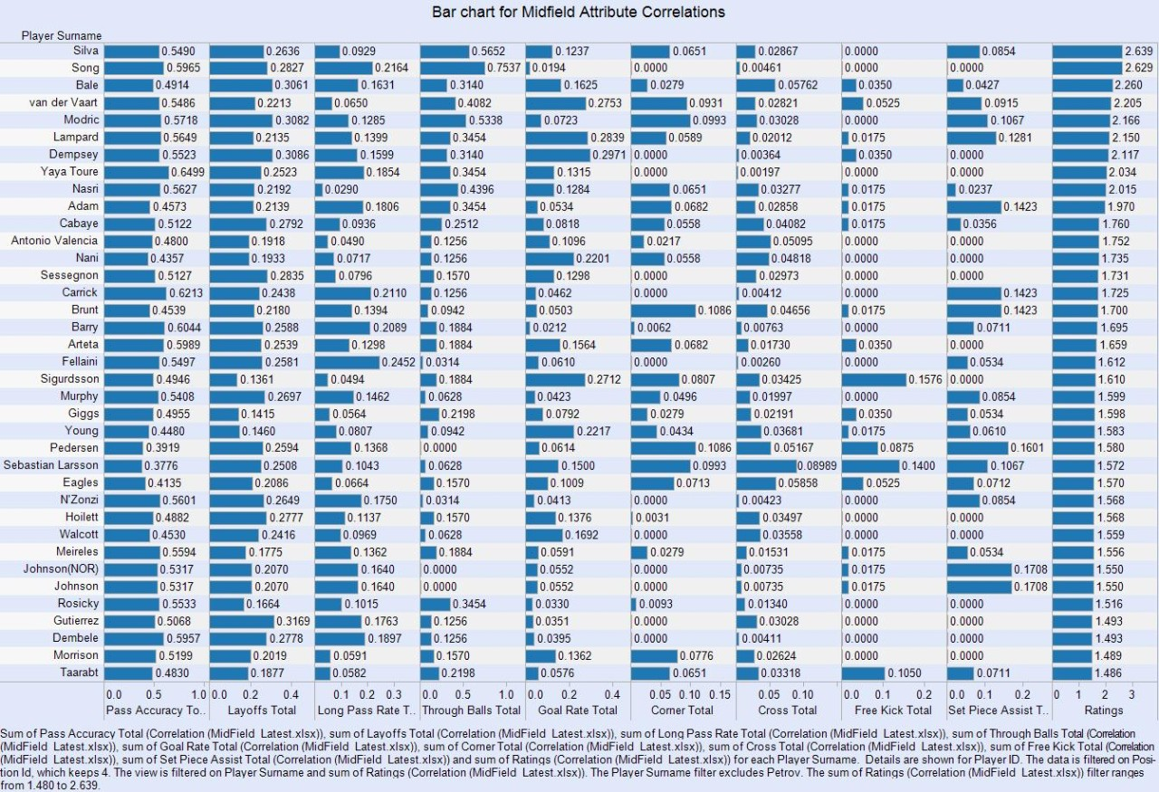

3)

Here is the Github link for the updates:

: https://github.com/arshadmohammed/Soccer..git