# https://upload.wikimedia.org/wikipedia/en/f/f1/Capital_University%2C_Jharkhand_logo.png

# CAPITAL UNIVERSITY - KODERMA

ELECTRO-MAGNETIC FIELD THEORY ASSIGNMENT

Name : Arshad Nazir

Electrical and Electronics Engineering

# How are unit vector defined in cylindrical coordinate systems?

The unit vectors in the cylindrical coordinate system are functions of position. It is convenient to express them in terms of the cylindrical coordinates and the unit vectors of the rectangular coordinate system which are not themselves functions of position.

!ˆ = ! ! ! = xx ˆ + yy ˆ

! = x ˆ cosq" + y ˆ sin q" q " = sinq " + ˆ y cos q" z = z ˆ

# State Stoke’s theorem.

The Stoke's theorem states that “the surface integral of the curl of a function over a surface bounded by a closed surface is equal to the line integral of the particular vector function around that surface.”



# Mention the sources of electromagnetic fields.

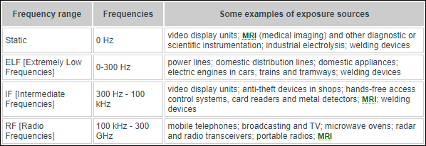

1. **State the physical significance of curl of a vector field.**

In physics, vectors are useful because they can visually represent position, displacement, velocity and acceleration. When drawing vectors, you often do not have enough space to draw

them to the scale they are representing, so it is important to denote somewhere what scale they are being drawn at.

# State the conditions for a vector A to be (a) solenoidal (b) irrotational

An example of a solenoid field is the vector field V(x,y)=(y,−x)V(x,y)=(y,−x).

This vector field is ''swirly" in that when you plot a bunch of its vectors, it looks like a vortex.

It is solenoid since

divV=∂∂x(y)+∂∂y(−x)=0.divV=∂∂x(y)+∂∂y(−x)=0.

The divergence being zero means that locally no field is being "created" at each point, much as is the case with this vector field. For real world examples of this, think of the magnetic field, B⃗ B→. One of [Maxwell's Equations](http://en.wikipedia.org/wiki/Maxwell%27s_equations) says that the magnetic field must be solenoid.

An irrotational vector field is, intuitively, irrotational. Take for example W(x,y)=(x,y)W(x,y)=(x,y).

At each point, WW is just a vector pointing away from the origin. When you plot a few of these vectors, you don't see swirly-ness, as is the case for VV.

# State divergence theorem.

In vector calculus, the divergence theorem, also known as Gauss's theorem or Ostrogradsky's theorem, is a theorem which relates the flux of a vector field through a closed surface to the divergence of the field in the volume enclosed.

# Define divergence and its physical meaning.

Fdel ·FThe divergence of a [vector field](https://mathworld.wolfram.com/VectorField.html) , denoted div(F) or (the notation used in this work), is defined by a limit of the [surface integral](https://mathworld.wolfram.com/SurfaceIntegral.html)

 del ·F=lim_(V->0)(∮_SF·da)/V  (1)

FS=partialVVdel ·F=0del where the surface integral gives the value of integrated over a closed infinitesimal boundary surface surrounding a volume element , which is taken to size zero using a limiting process. The divergence of a."

The physical significance of the divergence of a [vector field](https://mathworld.wolfram.com/VectorField.html) is the rate at which "density" exits a given region of space. The definition of the divergence therefore follows naturally by noting that, in the absence of the creation or destruction of matter, the density within a region of space can change only by having it flow into or out of the region. By measuring the net flux of content passing through a surface surrounding the region of space, it is therefore immediately possible to say how the density of the interior has changed. This property is fundamental in physics, where it goes by the name "principle of continuity." When stated as a formal theorem, it is called the [divergence theorem,](https://mathworld.wolfram.com/DivergenceTheorem.html) also known as Gauss's theorem. In fact, the definition in equation ([1](https://mathworld.wolfram.com/Divergence.html#eqn1)) is in effect a statement of the [divergence theorem.](https://mathworld.wolfram.com/DivergenceTheorem.html)

# What are the different coordinate systems?

* 1. Number line.
  2. Cartesian coordinate system.
  3. Polar coordinate system.
  4. Cylindrical and spherical coordinate systems.
  5. Homogeneous coordinate system.

# Mention the criteria for choosing an appropriate coordinate system for solving a field problem easily. Explain with an example.

The coordinate system is chosen based on the geometry of the given problem. From a point charge +Q, the electric field spreads in all 360 degrees. The calculation of electric field in this case will be spherical system.

# Give the practical examples of diverging and curl field.

* Tubing Down a River
* Area and Divergence

# Define potential differences.

Potential difference is the difference in the amount of energy that charge carriers have between two points in a circuit. A potential difference of one Volt is equal to one Joule of energy being used by one Coulomb of charge when it flows between two points in a circuit.

V = I x R

* Electric field due to an infinite long straight charged wire
* Electric field due to an infinite charged plane sheet
* Electric field due to two parallel charged sheets
* Electric field due to uniformly charged spherical shell
* Electrostatic shielding

# State the properties of electric flux lines.

* The field lines never intersect each other.
* The field lines are perpendicular to the surface of the charge.
* The magnitude of charge and the number of field lines, both are proportional to each other.
* The start point of the field lines is at the positive charge and end at the negative charge.
* For the field lines to either start or end at infinity, a single charge must be used.

# Define electric dipole moment.

The electric dipole moment is a measure of the separation of positive and negative electrical charges within a system, that is, a measure of the system's overall polarity.

The SI unit for electric dipole moment is the coulomb-meter.

# Define dielectric strength.

Dielectric strength, also known as dielectric breakdown strength (DBS), is the maximum electrical potential that a material can resist before the electrical current breaks through the material and the material is no longer an insulator.

# What is meant by dielectric breakdown?

Dielectric breakdown is the failure of an insulating material to prevent the flow of current under an applied electrical stress. The breakdown voltage is the voltage at which the failure occurs, and the material is no longer electrically insulating.

# State the expression for polarization.

Polarization occurs when an electric field distorts the negative cloud of electrons around positive atomic nuclei in a direction opposite the field. One of the measures of polarization is [electric dipole moment](https://www.britannica.com/science/electric-dipole-moment), which equals the distance between the slightly shifted centres of positive and negative charge multiplied by the amount of one of the charges. Polarization *P* in its quantitative meaning is the amount of dipole moment *p* per unit volume *V* of a polarized material, *P* = *p*/*V.*

# Define energy density.

Energy density is the amount of energy stored in a given system or region of space per unit volume. It may also be used for energy per unit mass, though a more accurate term for this is specific energy.

# Write the equation for capacitance of coaxial cable.



Two concentric perfectly-conducting cylinders of radii a and b Ideal dielectric having permittivity ϵs.

# Distinguish between displacement and conduction currents.

* Conduction current obeys ohm's law as V i R  but displacement current does not obey ohm's law.
* Conduction current density is represented by



whereas displacement current density is given by



* Conduction current is the actual current whereas displacement current is the apparent current produced by time varying electric field.

# What is Lorentz law of force?

**Lorentz force**, the [force](https://www.britannica.com/science/force-physics) exerted on a [charged](https://www.britannica.com/science/electric-charge) particle *q* moving with velocity ***v*** through an [electric](https://www.britannica.com/science/electric-field) field ***E*** and [magnetic field](https://www.britannica.com/science/magnetic-field) ***B***. The entire [electromagnetic](https://www.britannica.com/science/electromagnetism) force ***F*** on the charged particle is called the Lorentz force.

***F*** = *q****E*** + *q****v*** × ***B***.

# State ohms law for magnetic circuits.

Ohm’s law for magnetic circuit’s states that the MMF is directly proportional to the magnetic flux.

Hence as the magnetic flux decreases, the MMF also decreases.

1. **State Ampere’s circuital law.**

Ampere's circuital law states that the line integral of magnetic field (→B) around any closed path or circuit is equal to μ0(absolute permeability of free space) times the total current (I) encircling the closed circuit.

Mathematically, ϕB⋅dl=μ0I

# State Biot savarts law.

Biot Savart law states that the magnetic field due to a tiny current element at any point is proportional to the length of the current element, the current, the sine of the angle between the current direction and the line joining the current element and the point, and inversely proportional to the square of the distance of that point. The direction of the magnetic field is in the direction of dl cross r.

# What is the expression for inductance of a toroid?

Calculating the self-inductance of a rectangular toroid. **L=NΦmI=μ0N2h2πlnR2R1.**

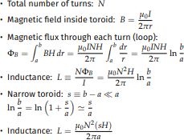

The magnetic moment is the magnetic strength and orientation of a magnet or other object that produces a magnetic field. Examples of objects that have magnetic moments include: loops of electric current, permanent magnets, elementary particles, various molecules, and many astronomical objects.

Magnetic permeability is defined as the ratio of the magnetic induction to the magnetic intensity. It is a scalar quantity and denoted by the symbol μ. Magnetic permeability helps us measure a material's resistance to the magnetic field or measure of the degree to which magnetic field can penetrate through a material.

# State the law of conservation of magnetic flux.

Lenz's law. it states that an induced electric current flows in a direction such that the current opposes the change that induced it

# Draw the BH curve for classifying magnetic materials.

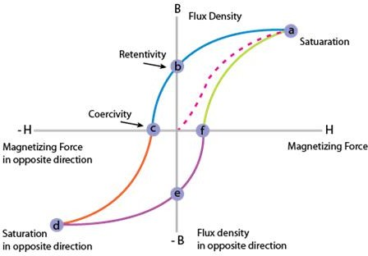

1. **Define vector magnetic potential.**

Magnetic vector potential, A, is the vector quantity in classical electromagnetism defined so that its curl is equal to the magnetic field.



Together with the electric potential φ, the magnetic vector potential can be used to specify the electric field E as well.

# Define self inductance and mutual inductance.

When there is a change in the current or magnetic flux of the coil, an opposed induced [electromotive force](https://byjus.com/physics/electromotive-force/) is produced. This phenomenon is termed as Self Induction.

Mutual inductance is the characteristic of a pair of coils.

The induced current developed in the neighboring coil opposes the decay of the current in the coil when the main current in the coil decreases.

# Distinguish between diamagnetic, paramagnetic and ferromagnetic materials.

Diamagnetic materials can easily be separated from other materials since they show repulsive forces towards magnetic fields. Paramagnetic materials and ferromagnetic materials can be separated using induced roll magnetic separators by changing the strength of the magnetic field used in the separator. The difference between diamagnetic, paramagnetic and ferromagnetic materials is that diamagnetic materials are not attracted to an external magnetic field, and paramagnetic materials are attracted to an external magnetic field whereas ferromagnetic materials are strongly attracted to an external magnetic field.

# Classify the magnetic material.

The magnetic behavior of materials can be classified into the following five major groups:

1. Diamagnetism
2. Paramagnetism
3. Ferromagnetism
4. Ferrimagnetism
5. Antiferromagnetism

# State the faraday’s law.

Faraday's law describes the magnitude of the electromotive force (emf), or voltage, induced (generated) in a conductor due to electromagnetic induction (changing magnetic fields). It states that the induced emf in a conducting circuit is proportional to the rate of change of magnetic flux linkage Φ within the circuit.

# State lenz’s law.

The induced electromotive force with different polarities induces a current whose magnetic field opposes the change in magnetic flux through the loop in order to ensure that original flux is maintained through the loop when current flows in it.



# Define displacement current density

In electromagnetism, displacement current density is the quantity ∂D/∂t appearing in Maxwell's equations that is defined in terms of the rate of change of D, the electric displacement field.

# Define reluctance.

Magnetic reluctance, or magnetic resistance, is a concept used in the analysis of magnetic circuits. It is defined as the ratio of magneto motive force to magnetic flux. It represents the opposition to magnetic flux, and depends on the geometry and composition of an object.

# Write to maxwell’s equations in integral form.

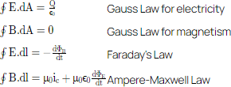

1. **Define a wave.**

Wave is a disturbance in which there is a transfer of energy from place to place. The particles of the medium vibrate during wave propagation. In the transverse wave, the particles vibrate up and down and are perpendicular to the direction of wave propagation.

# What is a uniform plane wave?

The uniform plane wave is defined as the magnitude of the electric and magnetic fields. They are the same at all points in the direction of propagation. The electric and magnetic fields are orthogonal to the direction of propagation. In terms of energy, the wave phenomenon is defined as the exchange of two different forms of energy. It is meant that the time rate of change of one form triggers the other to a spatial change. Waves do not have mass but contain energy, momentum, and velocity.

# What is phase velocity?

The phase velocity of a wave is the rate at which the wave propagates in any medium. This is the velocity at which the phase of any one frequency component of the wave travels. For such a component, any given phase of the wave will appear to travel at the phase velocity.

# What is skin effect?

Skin effect is the tendency of an alternating electric current to become distributed within a conductor such that the current density is largest near the surface of the conductor and decreases exponentially with greater depths in the conductor.

# Define Brewster angle.

Brewster's angle is an angle of incidence at which light with a particular polarization is perfectly transmitted through a transparent dielectric surface, with no reflection. When unpolarized light is incident at this angle, the light that is reflected from the surface is therefore perfectly polarized.

# State pointing theorem and derive an expression for pointing theorem.

Poynting theorem states that the net power flowing out of a given volume V is equal to the

losses. i.e. total power leaving the volume = rate of decrease of stored electromagnetic energy

– ohmic power dissipated due to motion of charge

Proof : The energy density carried by the electromagnetic wave can be calculated using Maxwell's equations as,

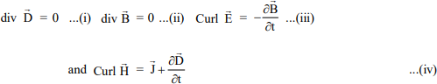

taking scalar product of (iii) with H and (iv) with E

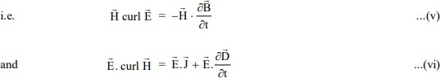

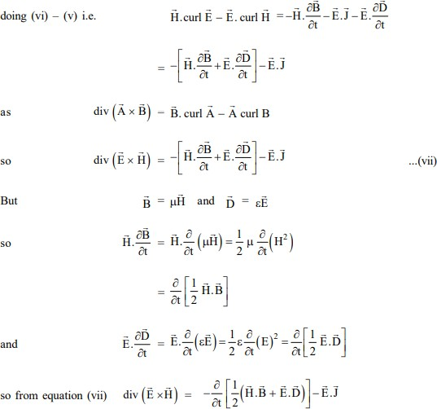

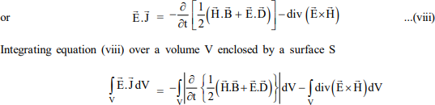

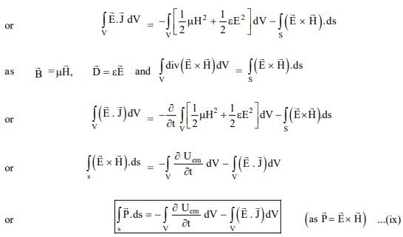

Total power leaving the volume = rate of decrease of stored e.m. energy - ohmic power dissipated due to charge motion This equation (ix) represents the poynting theorem according to which the net power flowing out of a given volume is equal to the rate of decrease of stored electromagnetic energy in that volume minus the conduction losses.

# Define polarization. What are the different types of wave polarization? Explain them with mathematical expression.

The electromagnetic waves such as visible light and microwaves consist of orthogonal electric and magnetic field both orthogonal to the propagation direction of the wave. The polarization of the electromagnetic wave is meant to describe the magnitude and the direction of the electric field of the wave. Specifically, the polarization of a radiated wave is defined as "that property of a radiated electromagnetic wave describing the time-varying direction and relative magnitude of the electric field vector; the trace and magnitude of the electric field vector are observed in the direction of light propagation"1,2,

**Introduction**

The polarization of electromagnetic wave (EMW) is the basic property of the EMW, which is widely used and controlled in Laser3,4, interferometer5,6 and photography7. The sketch for the linear polarization (red curves) of EMW is shown in Fig.1 below.

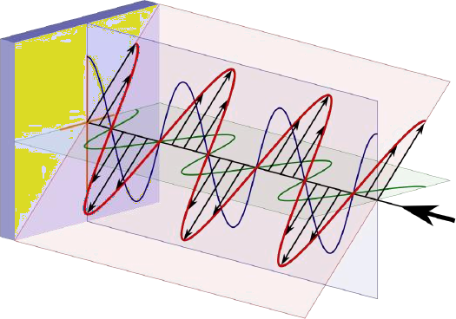

Figure 11: The sketch for polarization of EMW8

based on the Maxwell equations9 for EMW, the electric field can be split into orthogonal x- component Exand y-component E 10 :

y

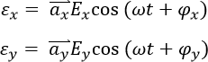

where Ex is the magnitude of the electric field in x-direction, Ey is the magnitude of the electric field in x-direction, Phix is the phase of the electric field in x-direction, Phiy is the phase of the electric field in y-direction and omega is the frequency of the EMW. The three major polarization state are defined based on the differences in phase and magnitude of x-direction and y-direction EMW.

**Linear Polarization**

Assume Ey in the mathematical expression for the electric field equals to zero, which gives the definition of electric field as:

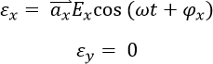

The electric field on certain propagation position will oscillate only on the x-axis with the angular frequency of omega, which is shown as below:

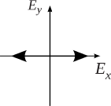

# Fig.2 x-axis linear polarization12

Thus, the similar polarization of electric field on only a specific straight direction is defined as linear polarization. On the other hand, Assume Ey equals to zero, which gives the electric field as:

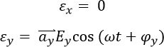

The electric field only oscillate on the y-axis with the angular frequency of omega, which is shown in Fig.3:

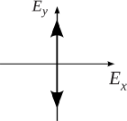

# Fig. 3 y-axis linear polarization13

Generally, with x-direction oscillation and y-direction oscillation share the same phase, the linear polarization field pattern can be express as:

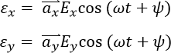

the angle of the linear oscillation towards the x-axis is calculated as:

8.PNG

The polarization sketch is shown in Fig. 4:

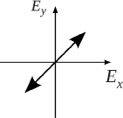

The circular polarization state is a special polarization state of elliptical polarization state, which satisfies the following conditions: 1) The field must have two orthogonal polarized components (such as x-direction and y-direction). 2) The two components mist have the same magnitude (Ex = Ey), 3) The two components must have a time-phase difference of multiples of 90 degrees. Thus the field pattern can be written as:

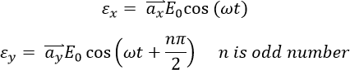

And the polarization pattern can be drawn as Fig.4 and Fig.5:

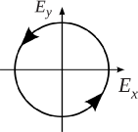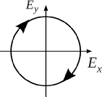

# Fig.5 left circular polarization15 Fig.6 right circular polarization16

the left circular polarization (counterclockwise) is achieved when number n equals to (4m-1) (m is integer) and the right circular polarization (clockwise) is achieved when number n equals to (4m+1).

**Elliptical Polarization**

The elliptical polarization is the general definition of the EMW polarization state whose field pattern can be expressed after make the simple math transformation of Ex and Ey:

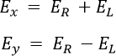

where :

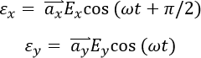

thus the electric field pattern can be calculated as :

15.PNG

The above is a elliptical polarization which can be seen as the superposition of two circular polarization possessing different magnitude and direction. And the general elliptical polarization pattern is shown below:

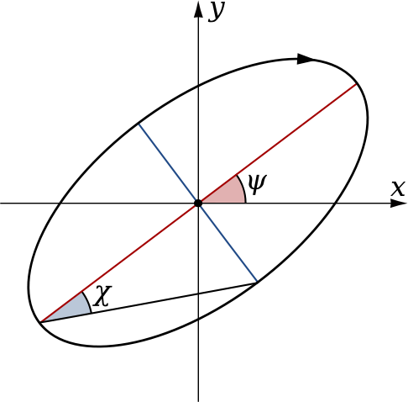

# Fig. 7 general elliptical polarization pattern 11

the major and minor axis slope (psi) is calculated by the phase difference between x-component and y-component.

# State maxwell’s equation and obtain them in integral and differential form.

Maxwell’s equations are the basic equations of [electromagnetism](https://oxscience.com/electromagnetism/) which are a collection of [Gauss’s law](https://oxscience.com/gausss-law/) for electricity, Gauss’s law for magnetism, [Faraday’s law of electromagnetic](https://oxscience.com/faradays-law-of-induction/) [induction](https://oxscience.com/faradays-law-of-induction/), and [Ampere’s law](https://oxscience.com/amperes-circuital-law/) for currents in conductors. Maxwell equations give a mathematical model for electric, optical, and radio technologies, like power generation, [electric](https://oxscience.com/electric-motor/) [motors](https://oxscience.com/electric-motor/), wireless communication, radar, and, Lenses, etc.

The First Maxwell’s equation (Gauss’s law for electricity)

[Gauss’s law](https://oxscience.com/gausss-law/) states that flux passing through any closed surface is equal to 1/ε0 times the total charge enclosed by that surface.

*The integral form of Maxwell’s 1st equation*

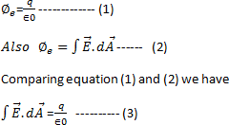

It is the integral form of Maxwell’s 1st equation.

*Maxwell’s first equation in differential form*

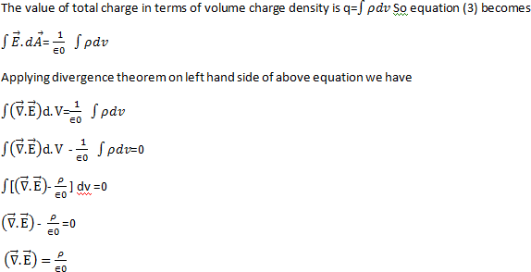

It is called the differential form of Maxwell’s 1st equation. The Second Maxwell’s equation (Gauss’s law for magnetism)

[Gauss’s law](https://oxscience.com/gausss-law/) for magnetism states that the net flux of the magnetic field through a closed surface is zero because monopoles of a magnet do not exist.

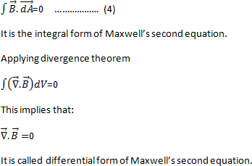

The Third Maxwell’s equation (Faraday’s law of electromagnetic induction )

According to [Faraday’s law of electromagnetic induction](https://oxscience.com/faradays-law-of-induction/)

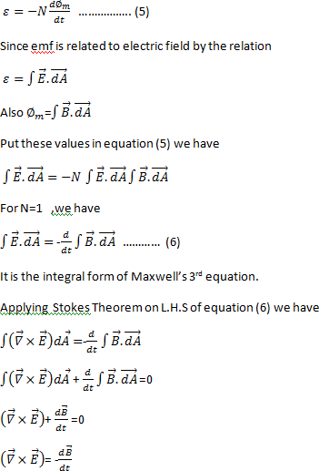

It is the differential form of Maxwell’s third equation.

The Fourth Maxwell’s equation ( Ampere’s law)

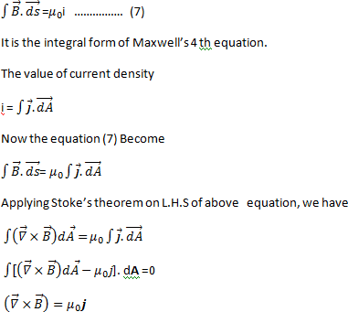The magnitude of the magnetic field at any point is directly proportional to the strength of the current and inversely proportional to the distance of the point from the straight conductors is called [Ampere’s law.](https://oxscience.com/amperes-circuital-law/)

# Derive the maxwell’s equation in phasor differential form.

Maxwell’s Equations in differential time-domain form are Gauss’ Law:

∇⋅D=ρv

the Maxwell-Faraday Equation (MFE):



Gauss’ Law for Magnetism (GSM):



and Ampere’s Law:



We define D˜D~ and ρ˜vρ~v as phasor quantities through the usual relationship:

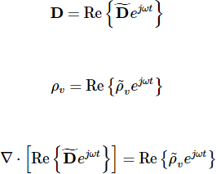

Divergence is a real-valued linear operator. Therefore, we may exchange the order of the “Re” and “∇.” Operations



the differentiation associated with the divergence operator is with respect to position and not with respect to time, so the order of operations may be further rearranged as follows:



Finally, we note that the equality of the left and right sides of the above equation implies the equality of the associated phasors ,



the differential form of Gauss’ Law for phasors is identical to the differential form of Gauss’ Law for physical time-domain quantities.

The same procedure applied to the MFE is only a little more complicated. First, we establish the phasor representations of the electric and magnetic fields:

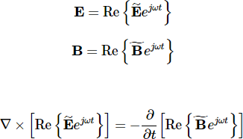

Both curl and time-differentiation are real-valued linear operations, so we are entitled to change the order of operations as follows:

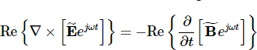

the left, we note that the time dependence ejωtejωt can be pulled out of the argument of the curl operator, since it does not depend on position:



On the right, we note that B˜B~ is constant with respect to time (because it is a phasor), so:

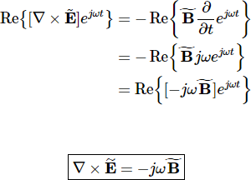

The procedure for conversion of the remaining two equations is very similar, yielding:

∇⋅B˜=0

∇×H˜=J˜+jωD˜

# State maxwell’s equations and obtain them in differential form. Also derive them harmonically varying field.

**Maxwell First Equation**

Maxwell first equation is based on the Gauss law of electrostatic which states that “when a closed surface integral of electric flux density is always equal to charge enclosed over that surface”

Mathematically [Gauss law](https://byjus.com/jee/gauss-law/) can be expressed as,

Over a closed surface the product of electric flux density vector and surface integral is equal to the charge enclosed.

∯→D..ds¯=Qenclosed ——(1)

Any closed system will have multiple surfaces but a single volume. Thus, the above surface integral can be converted into a volume integral by taking the divergence of the same vector. Thus, mathematically it is-

∯ ¯D.d¯s=∭▽.→Dd→vD¯ → —-(2) Thus, combining (1) and (2) we get-

∭▽.→Dd→v=Qenclosed —–(3)

Charges in a closed surface will be distributed over its volume. Thus, the volume charge density can be defined as –

ρv=dQdv measured using C/m3 On rearranging we get-

dQ=ρvdv

On integrating the above equation we get-

Q=∭ρvdv ——-(4)

The charge enclosed within a closed surface is given by volume charge density over that volume.

Substituting (4) in (3) we get-

∭▽.Ddv=∭ρvdv

Canceling the volume integral on both the sides, we arrive at Maxwell’s First Equation-

⇒▽.Ddv=ρv

# Maxwell Second Equation

Maxwell second equation is based on Gauss law on magnetostatics.

Gauss law on magnetostatics states that “closed surface integral of magnetic flux density is always equal to total scalar [magnetic flux](https://byjus.com/physics/magnetic-flux/) enclosed within that surface of any shape or size lying in any medium.”

Mathematically it is expressed as –

∯→B.ds=ϕenclosedB→.ds=ϕenclosed —–(1)

|  |  |
| --- | --- |
| **Scalar Electric Flux (**𝜓**)** | **Scalar Magnetic Flux (**𝜙**)** |
| They are the imaginary lines of force radiating in an outward direction | They are the circular magnetic field generated around a current-carrying conductor. |
| A charge can be source or sink | No source/sink |

Hence we can conclude that magnetic flux cannot be enclosed within a closed surface of any shape.

∯ →B.ds=0 ———(2)

Applying Gauss divergence theorem to equation (2) we can convert it(surface integral) into volume integral by taking the divergence of the same vector.

⇒∯ →B.ds=∭▽.→BdvB→.ds=∭▽.B→dv ——–(3) Substituting equation (3) in (2) we get-

∭▽.→Bdv=0 ——-(4)

Here to satisfy the above equation either ∭dv=0∭dv=0 or ▽.→B=0. The volume of any body/object can never be zero.

Thus, we arrive at Maxwell’s second equation.

▽.B→=0

Where,

→B=μ¯H is the flux density.

⇒▽.→H=0[solonoidal vector is obtained when the divergence of a vector is zero. Irrotational vector is obtained when the cross product is zero]

# Maxwell Third Equation

Statement: Time-varying magnetic field will always produce an electric field.

Maxwell’s 3rd equation is derived from Faraday’s laws of [Electromagnetic Induction](https://byjus.com/physics/electromagnetic-induction/). It states that “Whenever there are n-turns of conducting coil in a closed path which is placed in a time- varying magnetic field, an alternating electromotive force gets induced in each and every coil.” This is given by Lenz’s law. Which states that ”An induced electromotive force always opposes the time-varying magnetic flux.”

When two coils with N number of turns; A primary coil and Secondary coil. The primary coil is connected to an alternating current source and the secondary coil is connected in a closed loop and is placed at a small distance from the primary coil. When an AC current passes through

the primary coil, an alternating electromotive force gets induced in the secondary coil. See the figure below.

Mathematically it is expressed as –

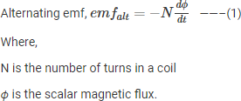

The negative sign indicates that the induced emf always opposes the time-varying magnetic flux.

Let N=1,

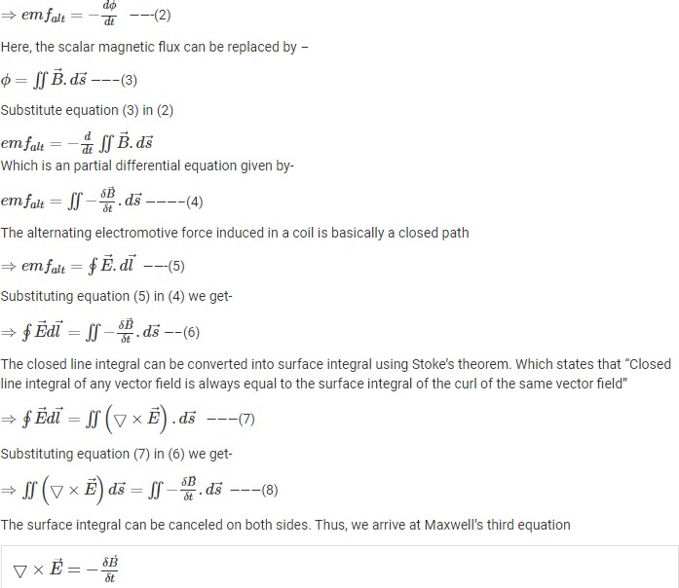

# Maxwell’s Fourth Equation

It is based on Ampere’s circuit law. To understand Maxwell’s fourth equation it is crucial to understand Ampere’s circuit law,

Consider a wire of current-carrying conductor with the current I, since there is an electric field there has to be a magnetic field vector around it. Ampere’s circuit law states that “The closed line integral of magnetic field vector is always equal to the total amount of scalar electric field enclosed within the path of any shape” which means the current flowing along the wire(which is a scalar quantity) is equal to the magnetic field vector (which is a vector quantity)

Mathematically it can be written as –

∮→H.d→l=Ienclosed —–(1)

Any closed path of any shape or size will occupy one surface area. Thus, L.H.S of equation (1) can be converted into surface integral using Stoke’s theorem, Which states that “Closed line integral of any vector field is always equal to the surface integral of the curl of the same vector field”

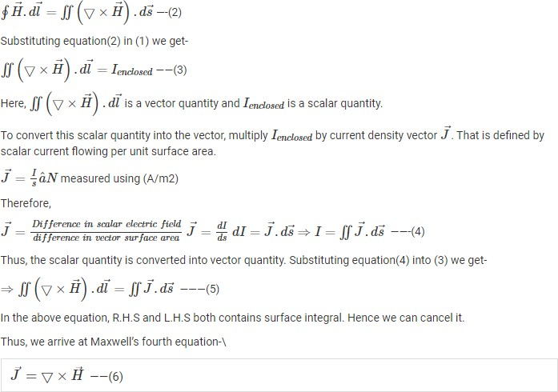

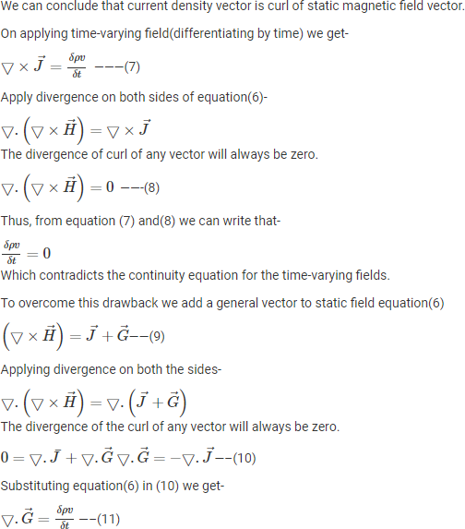

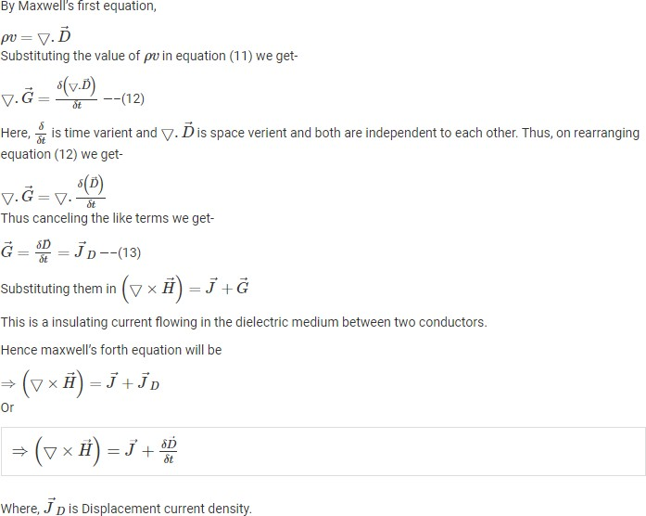

Electrostatic fields are usually produced by static electric charges whereas magnetostatic fields are due to motion of electric charges with uniform velocity (direct current) or static magnetic charges (magnetic poles); time-varying fields or waves are usually due to accelerated charges or time-varying current. ➢ Stationary charges  Electrostatic fields ➢ Steady current  Magnetostatic fields ➢ Time-varying current  Electromagnetic fields (or waves) Faraday discovered that the induced emf, Vemf (in volts), in any closed circuit is equal to the time rate of change of the magnetic flux linkage by the circuit This is called Faraday’s Law, and it can be expressed as,



where N is the number of turns in the circuit and  is the flux through each turn. The negative sign shows that the induced voltage acts in such a way as to oppose the flux producing it. This is known as Lenz’s Law, and it emphasizes the fact that the direction of current flow in the

circuit is such that the induced magnetic filed produced by the induced current will oppose the original magnetic field.

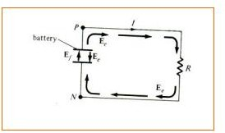

TRANSFORMER AND MOTIONAL EMFS Having considered the connection between emf and electric field, we may examine how Faraday's law links electric and magnetic fields. For a circuit with a single (N = 1), eq. (1.1) becomes



In terms of E and B, eq. (1.2) can be written as



where,  has been replaced by   S B dS and S is the surface area of the circuit bounded by the closed path L. It is clear from eq. (1.3) that in a time-varying situation, both electric and magnetic fields are present and are interrelated. Note that dl and dS in eq. (1.3) are in accordance with the right-hand rule as well as Stokes's theorem. This should be observed in Figure 2. The variation of flux with time as in eq. (1.1) or eq. (1.3) may be caused in three ways: 1. By having a stationary loop in a time-varying B field 2. By having a time-varying loop area in a static B field 3. By having a time-varying loop area in a time-varying B field.

1. STATIONARY LOOP IN TIME-VARYING B FIELD (TRANSFORMER EMF)

This is the case portrayed in Figure 2 where a stationary conducting loop is in a time varying magnetic B field. Equation (1.3) becomes

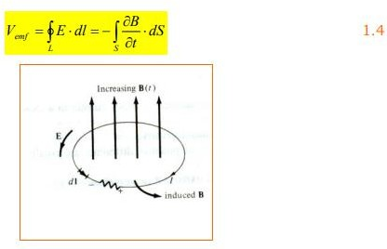

This emf induced by the time-varying current (producing the time-varying B field) in a stationary loop is often referred to as transformer emf in power analysis since it is due to transformer action. By applying Stokes's theorem to the middle term in eq. (1.4), we obtain



For the two integrals to be equal, their integrands must be equal; that is



This is one of the Maxwell's equations for time-varying fields. It shows that the time varying E field is not conservative ( x E  0). This does not imply that the principles of energy conservation are violated. The work done in taking a charge about a closed path in a time- varying electric field, for example, is due to the energy from the time-varying magnetic field.

1. MOVING LOOP IN STATIC B FIELD (MOTIONAL EMF)

When a conducting loop is moving in a static B field, an emf is induced in the loop. We recall from eq. (1.7) that the force on a charge moving with uniform velocity u in a magnetic field B is

Fm = Qu x B 1.7

We define the motional electric field Em as



If we consider a conducting loop, moving with uniform velocity u as consisting of a large number of free electrons, the emf induced in the loop is



This type of emf is called motional emf or flux-cutting emf because it is due to motional action. It is the kind of emf found in electrical machines such as motors, generators, and alternators.

1. MOVING LOOP IN TIME-VARYING FIELD

This is the general case in which a moving conducting loop is in a time-varying magnetic field. Both transformer emf and motional emf are present. Combining equation 1.4 and 1.9 gives the total emf as

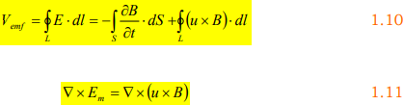

or from equations 1.6 and 1.11.



# Derive an expression for the force between two long straight parallel current carrying conductors.

Let the distance between the two conductors carrying current I1 and I2 be d.

Magnetic field produced by conductor 1 at a distance d, B1=4πμod2I1 Force acting the conductor 2 placed in this magnetic field F=B1I2L Thus we get F=4πμod2I1I2L

Force er unit length of conductor 1 f=4πμod2I1I2 Now put d=1m, I1=I2=1A and L=1m

We get F=2πμ2=2×10−7 N

Thus we define ampere as the current flowing in each conductor separated by a unit distance so that one conductor applies a force of 2×10−7 N on a unit length of another parallel conductor.

# Obtain the expression for energy stored in the magnetic field and also derive the expression for magnetic energy density.

[Magnetic field](https://www.electrical4u.com/magnetic-field/) can be of permanent magnet or electro-magnet. Both magnetic fields store some energy. Permanent magnet always creates the [magnetic flux](https://www.electrical4u.com/magnetic-flux/) and it does not vary upon the other external factors. But electromagnet creates its variable magnetic fields based on how much [current](https://www.electrical4u.com/electric-current-and-theory-of-electricity/) it carries. The dimension of this electro-magnet is responsible to create the strength the magnetic field and hence the energy stored in this electromagnet. First we consider the magnetic field is due to electromagnet i.e. a coil of several no. turns. This coil or [inductor](https://www.electrical4u.com/what-is-inductor-and-inductance-theory-of-inductor/) is carrying current I when it is connected across a [battery](https://www.electrical4u.com/battery-working-principle-of-batteries/) or [voltage source](https://www.electrical4u.com/voltage-source/) through a switch.

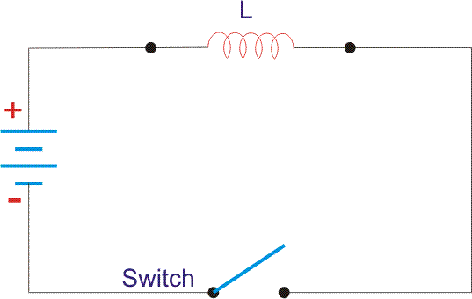

Suppose battery [voltage](https://www.electrical4u.com/voltage-or-electric-potential-difference/) is V volts, value of inductor is L Henry, and current I will flow at steady state.

When the switch is ON, a current will flow from zero to its steady value. But due to self induction a induced voltage appears which is



this E always in the opposite direction of the rate of change of current.

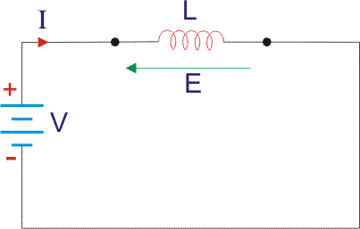

Now here the energy or work done due to this current passing through this inductor is U.

As the current starts from its zero value and flowing against the induced emf E, the energy will grow up gradually from zero value to U. dU = W.dt, where W is the small power and W = – E.I

So, the energy stored in the inductor is given by,



Now integrate the energy from 0 to its final value.

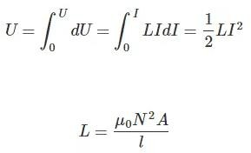

as per dimension of the coil, where N is the number of turns of the coil, A is the effective cross- sectional area of the coil and l is the effective length of the coil. Again,



Where, H is the magnetizing force, N is the number of turns of the coil and l is the effective length of the coil.

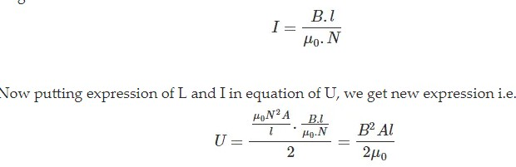

So, the stored energy in a electromagnetic field i.e. a conductor can be calculated from its dimension and flux density.

Magnetic flux density:

Total [flux](https://www.electrical4u.com/what-is-flux-types-of-flux/) flowing through the magnet cross-sectional area A is φ. Then we can write that φ = B.A, where B is the flux density. Now this flux φ is of two types, (a) φr this is remanent flux of the magnet and (b) φd this is demagnetizing flux.

So,



as per conservation of the magnetic flux Law.



Again, Bd = μ. H, here H is the magnetic flux intensity.

Now MMF or Magneto Motive Force can be calculated from H and dimension of the magnet.

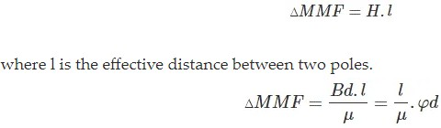

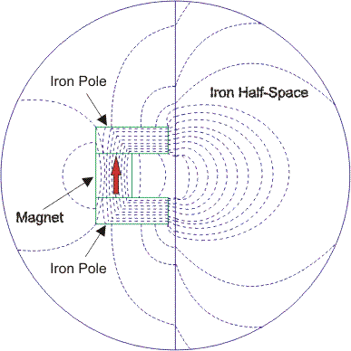

Magnet’s internal reluctance path that is for demagnetizing is denoted as Rm, And

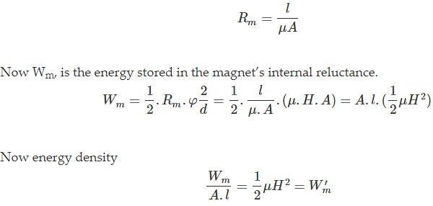

# Explain the different coordinate systems.

In [geometry,](https://en.wikipedia.org/wiki/Geometry) a **coordinate system** is a system that uses one or more [numbers](https://en.wikipedia.org/wiki/Number), or **coordinates**, to uniquely determine the [position](https://en.wikipedia.org/wiki/Position_(geometry)) of the [points](https://en.wikipedia.org/wiki/Point_(geometry)) or other geometric elements on a [manifold](https://en.wikipedia.org/wiki/Manifold) such as [Euclidean space.](https://en.wikipedia.org/wiki/Euclidean_space)

# Number line

The simplest example of a coordinate system is the identification of points on a [line](https://en.wikipedia.org/wiki/Line_(geometry)) with real numbers using the [*number line*](https://en.wikipedia.org/wiki/Number_line). In this system, an arbitrary point *O* (the *origin*) is chosen on a given line. The coordinate of a point *P* is defined as the signed distance from *O* to *P*, where the signed distance is the distance taken as positive or negative depending on which side of the line *P* lies. Each point is given a unique coordinate and each real number is the coordinate of a unique point.

# [Cartesian coordinate system](https://en.wikipedia.org/wiki/Cartesian_coordinate_system)

The prototypical example of a coordinate system is the [Cartesian coordinate system](https://en.wikipedia.org/wiki/Cartesian_coordinate_system). In the [plane,](https://en.wikipedia.org/wiki/Plane_(geometry)) two [perpendicular](https://en.wikipedia.org/wiki/Perpendicular) lines are chosen and the coordinates of a point are taken to be the signed distances to the lines.

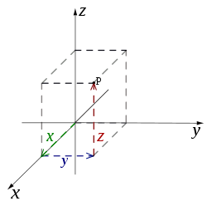

In three dimensions, three mutually [orthogonal](https://en.wikipedia.org/wiki/Orthogonality) planes are chosen and the three coordinates of

a point are the signed distances to each of the plane.

This can be generalized to create *n* coordinates for any point in *n*-dimensional Euclidean space.

Depending on the direction and order of the coordinate axes, the three-dimensional system may be a [right-handed](https://en.wikipedia.org/wiki/Right-hand_rule) or a left-handed system. This is one of many coordinate systems

# Polar coordinate system

A point is chosen as the *pole* and a ray from this point is taken as the *polar axis*. For a given angle θ, there is a single line through the pole whose angle with the polar axis is θ (measured counterclockwise from the axis to the line). Then there is a unique point on this line whose signed distance from the origin is *r* for given number *r*. For a given pair of coordinates (*r*, θ) there is a single point, but any point is represented by many pairs of coordinates. For example, (*r*, θ), (*r*, θ+2π) and (−*r*, θ+π) are all polar coordinates for the same point. The pole is represented by (0, θ) for any value of θ.

# Cylindrical and spherical coordinate systems

There are two common methods for extending the polar coordinate system to three dimensions. In the **cylindrical coordinate system**, a *z*-coordinate with the same meaning as in Cartesian coordinates is added to the *r* and *θ* polar coordinates giving a triple (*r*, *θ*, *z*). Spherical coordinates take this a step further by converting the pair of cylindrical coordinates (*r*, *z*) to polar coordinates (*ρ*, *φ*) giving a triple (*ρ*, *θ*, *φ*).

# Write short notes on gradient, divergence, curl and stokes theorem.

For a real-valued function f(x,y,z) on R3, the gradient ∇f(x,y,z) is a vector-valued function on R3, that is, its value at a point (x,y,z) is the vector.



In R3, where each of the partial derivatives is evaluated at the point (x,y,z)(x,y,z). So in this way, you can think of the *symbol* ∇ as being “applied” to a real-valued function ff to produce a vector ∇f.

It turns out that the divergence and curl can also be expressed in terms of the symbol ∇. This is done by thinking of ∇ as a *vector* in R3, namely



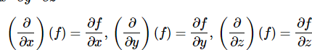

# Divergence

For example, it is often convenient to write the divergence div **f** as ∇⋅f∇⋅f, since for a vector field f(x,y,z)=f1(x,y,z)i+f2(x,y,z)j+f3(x,y,z)kf(x,y,z)=f1(x,y,z)i+f2(x,y,z)j+f3(x,y,z)k, the dot product of **f** with ∇∇ (thought of as a vector) makes sense:

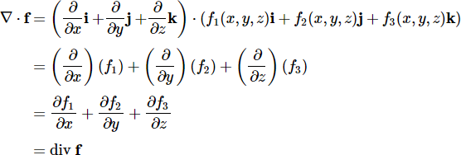

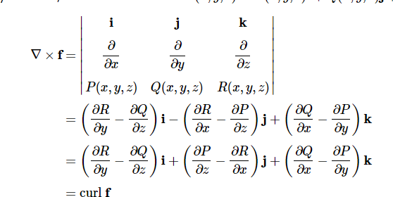We can also write curl **f** in terms of ∇, namely as ∇×f, since for a vector field f(x,y,z)=P(x,y,z)i+Q(x,y,z)j+R(x,y,z)k we have:

For a real-valued function f(x,y,z)f(x,y,z), the gradient

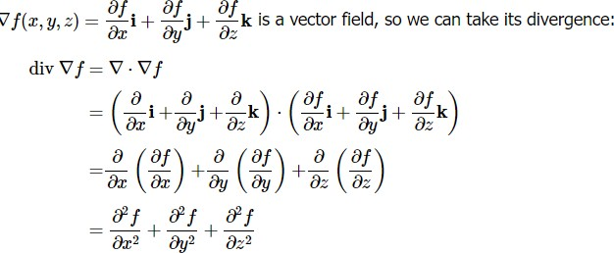

Stokes’ Theorem Formula

The Stoke’s theorem states that “the surface integral of the curl of a function over a surface bounded by a closed surface is equal to the line integral of the particular vector function around that surface.”

The line integral around S (the boundary curve) of F’s tangential component is equal to the surface integral of the normal component of the curl of F.

The positively oriented boundary curve of the oriented surface S will be ∂S. Thus, stokes theorem can also be expressed as:



Stokes’ Theorem Proof

We assume that the equation of S is Z = g(x, y), (x, y)D Where g has a continuous second-order partial derivative.

D is a simple plain region whose boundary curve C1 corresponds to C.

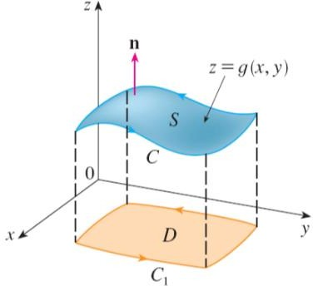

# Stokes Theorem Applications

Stokes’ theorem provides a relationship between line integrals and surface integrals. Based on our convenience, one can compute one integral in terms of the other. Stokes’ theorem is also used in evaluating the curl of a vector field. Stokes’ theorem and the generalized form of this theorem are fundamental in determining the line integral of some particular curve and evaluating a bounded surface’s curl. Generally, this theorem is used in physics, particularly in electromagnetism.