1. Difference between ‘this’ and ‘let’ and when to use what, explain with examples.

**Let**

**‘Let’ keyword is using to declare local variables in a block. It have block scope.**

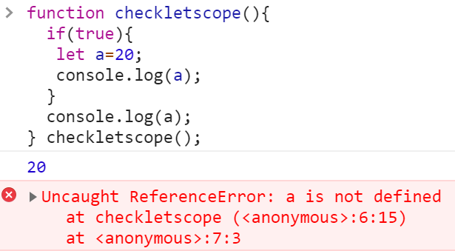

**This**

**‘this’ key word is a global object by default. It will return the window object if we use in a browser.**



**If we are using in a function call with ‘new’ operator it will refer to the newly created object. ‘this’ object is the current object from where we are calling**

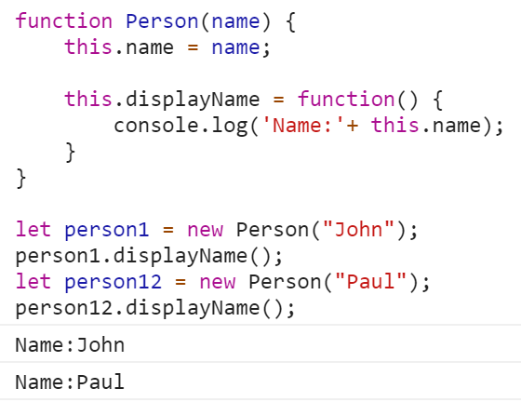

2.       Write a function which accepts an array of strings and returns a map of character to count of the character(including spaces and special characters).

Eg: input: [‘hello world’, ‘hello world’]  output: {h: 2, e: 2, l: 6, ‘ ‘: 1, o: 4 …… }

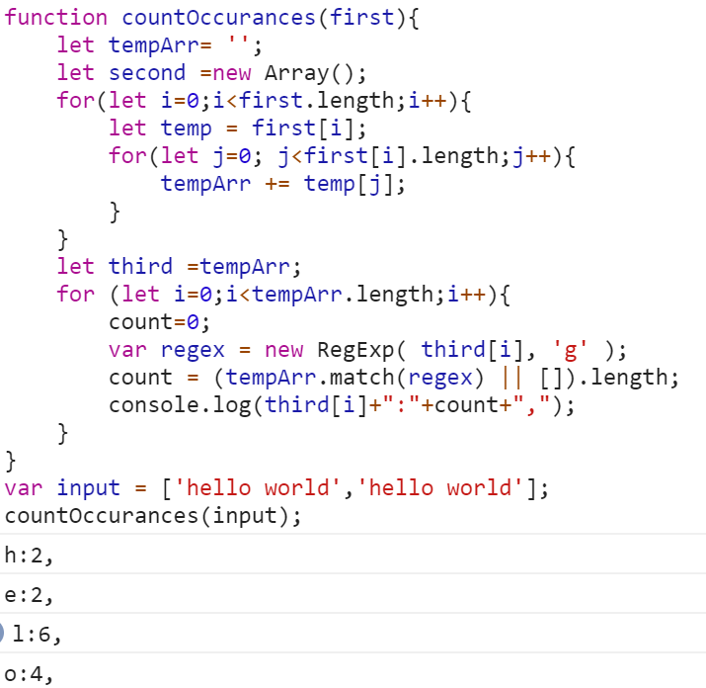 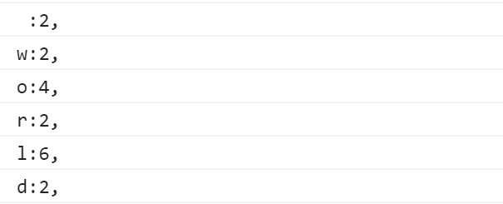

3.       Write a function to return all the keys present in an object at any level.

Eg: input: {  a: 5, b: { c: { d: 10 } }}   output: [a, b, c, d]

function returnKeys(input) {

var obj = {};

var newAr = [];

checkValue(input, obj, newAr);

return Object.keys(obj);

}

function checkValue(value, obj, newAr) {

if (Array.isArray(value)) return checkArray(value, obj, newAr);

if (value instanceof Object) return checkObject(value, obj, newAr);

}

function checkArray(array, obj, newAr) {

if (newAr.indexOf(array) >= 0) return;

newAr.push(array);

for (var i = 0, l=array.length; i < l; i++) {

checkValue(array[i], obj, newAr);

}

}

function checkObject(input, obj, newAr) {

if (newAr.indexOf(input) >= 0) return;

var keys = Object.keys(input);

for (var i = 0, l = keys.length; i < l; i++) {

var key = keys[i];

obj[key] = true;

checkValue(input[key], obj, newAr);

}

}

var inputArray = [{a:2,b:3,c:{d:5}}];

var result = inputArray.map(returnKeys);

console.log(result[0]);

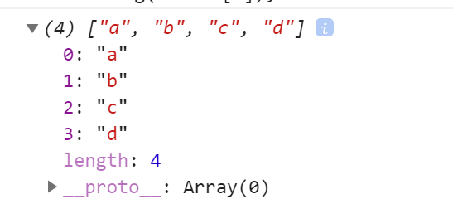

4.       Write a function to reverse every word of a string.

* Using split and reverse

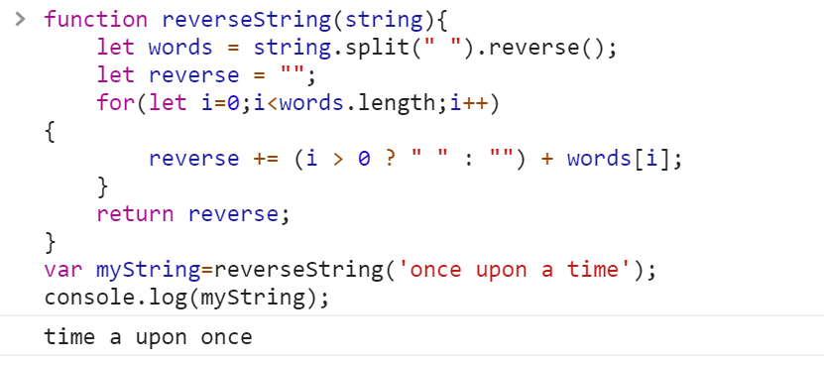

* Without using split and reverse and in O(1) space (since strings are immutable, assume that the input is a character array).

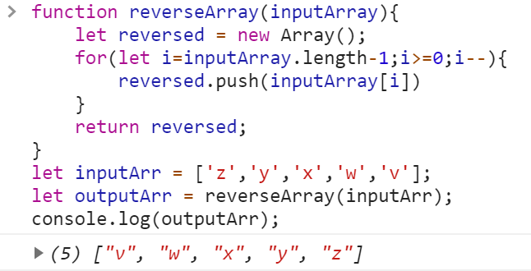

5.       Write a function to remove duplicate strings from an array of strings.

