# DON BOSCO COLLEGE

# SULTHAN BATHERY, WAYANAD

***Affiliated to the University of Calicut***

**NAAC Re-Accredited with 'B+' Grade**

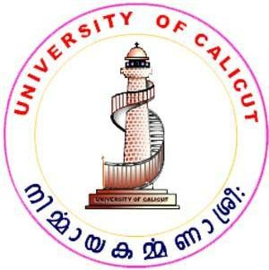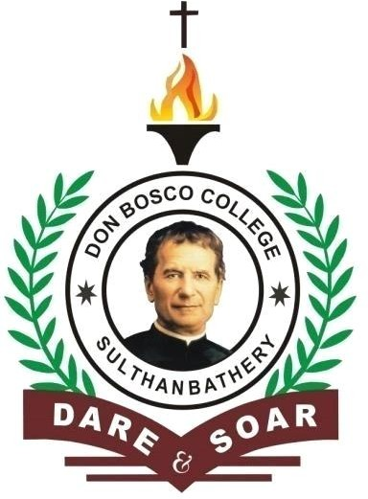

**DEPARTMENT OF COMPUTERSCIENCE**

**INDUSTRIAL VISIT REPORT**

# DON BOSCO COLLEGE

# SULTHAN BATHERY, WAYANAD

***Affiliated to University of Calicut***

**NAAC Re-Accredited with 'B+' Grade**

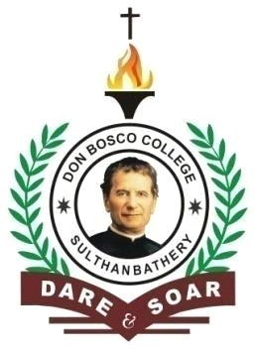

**Certificate**

### This is to certify that this is a bonafide report of industrial visit done by Mr./Ms. Arshal Abbas with Reg.No. BSAVSCS013 of VI Semester BSc. Computer Science during the Academic year 2021-2024.

**Head of the Department Staff in charge**

### External Examiner

**Place: Sulthan Bathery**

**Date:**